LTE FDD Optimization Guidelines
(FDD-LTE19B)

☒Regulated document | ☐Unregulated document
Version, status | 9.0
Date | 01-06-2020
Creator | Ian Horne
Owner | Ian Horne
Function | Global Services NCS
Approver | Lorena Serna
Doc ID | ULITPALIL5R3-1390467857-1462
Doc Location | Optimization Guidelines in SharePoint
Change History
Version | Status | Date | Handled by |  | Comments
1.0 | Issued | 29-01-2010 | Lorena Serna, Tomas Novosad, Jyri Lamminmaki | Update after review comments for draft
2.0 | Issued | 07-07-2010 | Navin Hathiramani, Lorena Serna | Addition of optimization items (chapter 5) and general update
2.1 | Issued | 12-01-2011 | Lorena Serna, Jari  Salo | Update to RL10. Addition of latest recommendations and troubleshooting cases
3.0 | Issued | 28-06-2011 | Navin Hathiramani, Lorena Serna | Update to RL20 with introduction to RL30 features/ cases. Msg3 Optimization, mobility management, handover and counter based optimization
4.0 | Issued | 16-01-2012 | Navin Hathiramani, Lorena Serna | Reviewed update to RL30. Addition of RL30 features and test results
4.1 | Issued | 22-05-2012 | Lorena Serna | Minor update of various topics
5.0 | Issued | 26-06-2015 | Chris Johnson | Updated to RL70

Change History

6.0 | Issued |  | 31-08-2016 |  | Chris Johnson | Updated to FDD-LTE16A. Addition of sections: Feature Summary, Interference Mitigation, Inactivity Timer, VoLTE and Example Optimization Process
6.1 | Issued |  | 31-10-2016 |  | Chris Johnson | Updated document structure and minor changes after document review
7.0 | Issued |  | 24-11-2017 |  | Chris Johnson | Updated to FDD-LTE17A
7.1 | Issued |  | 12-12-2017 |  | Chris Johnson | Correction to Cell Reselection Ranking equation
8.0 | Issued |  | 11-02-2019 |  | Chris Johnson | Updated to FDD-LTE18A incl. mMIMO section
9.0 | Issued |  | 02-06-2020 |  | Ian Horne | Updated to LTE19B incl. TDD Multi-User MIMO section & links towards 4G-5G interworking & LAA NPO material

This material, including documentation and any related computer programs, is protected by copyright controlled by Nokia. All rights are reserved. Copying, including reproducing, storing, adapting or translating, any or all of this material requires the prior written consent of Nokia. This material also contains confidential information, which may not be disclosed to others without the prior written consent of Nokia.

Table of Contents
1 References 5
2 Scope 6
3 Optimization Process 8
3.1 Identification and Understanding of KPI 8
3.2 Initial Checks 9
3.3 KPI Improvement 11
4 RF Optimization 21
4.1 Antenna Tilt 21
4.2 Crossed feeders 24
4.3 Feeder Loss Imbalance 28
4.4 Interference Checks 30
4.5 Automatic Cell Planning (ACP) 33
5 Feature Summary 35
6 Parameter Optimization 46
6.1 Idle Mode Mobility Management 47
6.2 Random Access 61
6.3 Radio Admission Control 95
6.4 Physical Downlink Control Channel (PDCCH) 109
6.5 Physical Uplink Control Channel (PUCCH) 126
6.6 Downlink Power Control 135
6.7 Uplink Power Control 147
6.8 MIMO Mode Control 173
6.9 TDD Multi-User MIMO 180
6.10 Downlink Throughput 185
6.11 Uplink Throughput 198
6.12 Interference Mitigation 214
6.13 RSRQ Mobility 230
6.14 Latency 239
6.15 Connection Setup Delay 247
6.16 Inactivity Timer 253
6.17 CS Fallback 258
6.18 VoLTE 266
6.19 Massive MIMO 288
7 4G-5G Interworking 294
7.1 Introduction 294
7.2 Guidelines 294
8 License Assisted Access 295
8.1 Introduction 295
8.2 Guidelines 295
9 Minimisation of Drive Testing 296
9.1 Introduction 296
9.2 Use Cases 297
10 Internet of Things (IoT) 298
10.1 Introduction 298
10.2 Guidelines 298

References

- ‘LTE Outdoor RF Design Guidelines’, Available to download from LTE Radio dimensioning and planning: Radio Network Design at this link.

- ‘LTE Capacity Solutions Guidelines’, Available to download from LTE Radio Optimization Wiki: Capacity Optimization at this link.

Scope
This document provides Network Planning and Optimization engineers with a set of processes and tasks to help guide them through the optimization of LTE FDD networks. The processes described are generic and the detailed implementation will vary from project to project depending upon the scope of those projects. This document focuses on Nokia software releases up to LTE19B.
Chapter 3 provides an example of an optimisation process which includes the identification of KPI, initial network checks and subsequent focus upon various management level performance metrics.
Chapter 4 describes the importance of RF optimisation prior to parameter optimisation, i.e. parameter optimisation will be relatively ineffective if antenna heights, azimuths and tilts are non-optimal. The various types of antenna tilts are introduced in this chapter. There is also an introduction to Automatic Cell Planning (ACP) tools which may be used to provide guidance upon optimal RF configurations.
Chapter 5 provides a summary of the main features associated with optimisation and performance improvement.
Chapter 6 includes sections to address various parameter optimisation topics. Each section is organised to provide:
- an overview of typical issues experienced in live networks
- counters and KPI which can be used to quantify performance
- parameters associated with the topic
- optimisation procedures which can be applied to improve performance
- practical results
Chapter 7 provides a brief introduction to 4G-5G interworking and includes a link to the 5G NPO Radio Wiki intranet page.
Chapter 8 provides a brief summary of Licence Assisted Access (LAA) and includes a link to the Small Cells NPO Radio Wiki page.
Chapter 9 introduces Minimisation of Drive Testing (MDT) and how it can be used to collect data from the population of live network subscribers. A set of typical use cases is included in this section.
Chapter 10 provides a brief introduction to solutions for the Internet of Things (IoT) market and provides a link to the relevant planning and dimensioning documentation.
The content of this document is updated at regular intervals as the quantity of practical experience increases. In order to ensure that the document covers the latest information, readers are encouraged to provide feedback from trials and projects. Please, provide feedback to Lorena.Serna@nokia.com. Additional sections can be requested at any time and they will be included as and when appropiate.

Optimization Process

Identification and Understanding of KPI
An optimisation process requires a set of KPI to quantify changes in performance as the network is tuned. These KPI could be based upon network statistics, UE measurements and reporting from Minimisation of Drive Testing (MDT), or UE measurements and reporting from actual drive testing. The requirement for actual UE drive testing depends upon the metrics to be improved. For example, quantifying reductions in VoLTE connection setup delay and improvements in VoLTE speech quality are likely to require UE drive testing. Optimisation activities which involve UE drive testing tend to be short term projects focused upon specific aspects of network performance. Longer term optimisation processes tend to rely upon network statistics due to the cost associated with drive testing.
An example set of KPI for an optimisation process is:
- Data Accessibility
- VoLTE Accessibility
- Data Drop Call Ratio
- VoLTE Drop Call Ratio
- Handover Success Ratio
- Cell Throughput
- User Throughput
The set of KPI should be kept relatively small and focused, while a larger set of PI can be used to support troubleshooting at a lower level. The initial set of PI can be extracted from the set of KPI. For example, Data Accessibility includes components for RRC Connection Setup, S1 Signalling Connection Setup and E-RAB Setup so the set of PI should allow these three components to be studied separately. Similarly, Handover Success Ratio includes components for Handover Preparation and Handover Execution, so the set of PI should allow these two components to be studied.
It is very important that the set of KPI are thoroughly understood in terms of their constituent counters, i.e. which counters are being used and how those counters are incremented. It may also be necessary to compare KPI definitions with those belonging to a different network vendor. If an operator uses different vendors in different parts of the network, then it is likely that KPI results will be compared across vendors. This requires an understanding of the counters implemented by both network vendors to ensure that any comparison is meaningful and fair.
KPI definitions are not always ideal and may vary between software releases. Implementations should be understood as much as possible to help generate an awareness of the likely impact of non-ideal definitions and changes between software releases.
The time interval used for KPI evaluation should be agreed when defining KPI targets. The results from daily averages are likely to be optimistic relative to busy hour performance. An example comparison of busy hour and daily average performance is shown in Figure 1 and Figure 2. This example is based upon the E-RAB Drop Ratio.
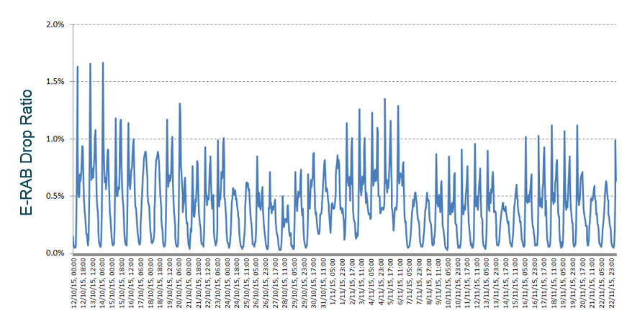
Figure 1: Busy Hour Drop Ratio
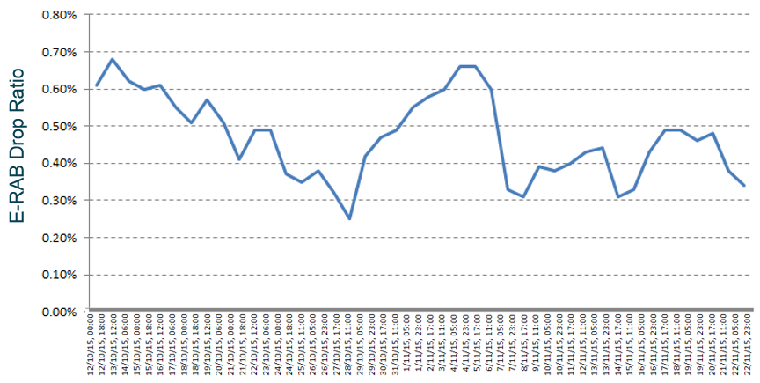
Figure 2: Daily Average Drop Ratio
The busy hour Drop Ratio is approximately double the daily average. If it is agreed to use busy hour results, then the method used to identify the busy hour should also be agreed. It is likely that different parts of the network will experience different busy hours. Shopping areas are likely to have a busy hour during the working day whereas residential areas are more likely to have a busy hour during the evening

Initial Checks
The optimization process should start with some initial checks to determine whether or not there are any significant issues which require resolution before optimisation can start. These initial checks should include:
- check all sites for alarms
- check all sites are reachable and are carrying traffic
- check for particularly high RSSI
- check each of the KPI included within the process
  - identify worst performing KPI relative to their targets
  - identify worst performing sites
  - compare daily averages with busy hour peaks
Alarms should be studied to identify any which could be directly impacting user experience or preventing features from operating. Some features rely upon X2 signalling so any alarm which indicates a loss of X2 connectivity can have a negative impact upon performance. For example, Radio Link Failure triggered Handover relies upon X2 signalling and has a significant impact upon Connection Drop Ratio. Similarly, Active Mode Load Equalisation relies upon X2 signalling and traffic management will be compromised if X2 connections are lost. Figure 3 illustrates an example of alarms indicating a loss of X2 connectivity for a pair of specific LNADJ objects.
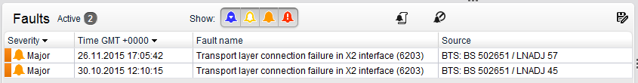
Figure 3: Example alarms indicating loss of X2 connectivity
Particularly high RSSI can be an indication of a hardware fault, i.e. faulty RF hardware. Figure 4 illustrates an example cell which experienced a step change in uplink RSSI. The high RSSI caused both poor Accessibility and a poor Drop Ratio. The issue was resolved by installing a replacement RF module.
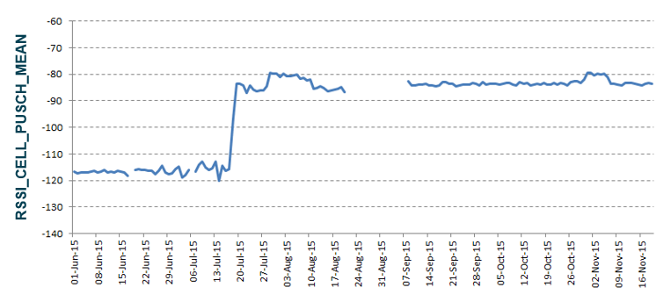
Figure 4: Example cell showing particularly high RSSI after step change
The initial checks activity should also include a first evaluation of the KPI. This can be used to direct the focus of the subsequent optimisation activity. All KPI below their target should be identified and an initial site level analysis should be completed to determine whether issues are network wide, cluster specific or site specific. There can also be some value in comparing the busy hour results with the daily averages. If issues predominantly occur during the busy hour, then any investigation with network logging is best done during that busy hour.

KPI Improvement

Accessibility
A general Accessibility KPI can be defined using LTE_5060. This KPI has a range of versions depending upon the software release being used. The FDD-LTE19B version of the KPI is given by:

E-UTRAN Initial E-RAB Accessibility (LTE_5060j) =
100 * (SIGN_CONN_ESTAB_COMP) / (SIGN_CONN_ESTAB_ATT_MO_S + SIGN_CONN_ESTAB_ATT_MT + SIGN_CONN_ESTAB_ATT_MO_D + SIGN_CONN_ESTAB_ATT_DEL_TOL + SIGN_CONN_ESTAB_ATT_HIPRIO + SIGN_CONN_ESTAB_ATT_EMG + SIGN_CONN_ESTAB_ATT_MO_VOICE + SIGN_CONN_ESTAB_ATT_OTHERS)
*
(S1_SIGN_CONN_ESTAB_SUCC_UE) / (S1_SIGN_CONN_ESTAB_ATT_UE))
*
(ERAB_INI_SETUP_SUCC_QCI1 + ERAB_INI_SETUP_SUCC_QCI2 + ERAB_INI_SETUP_SUCC_QCI3 +
ERAB_INI_SETUP_SUCC_QCI4 + ERAB_INI_SETUP_SUCC_QCI5 + ERAB_INI_SETUP_SUCC_QCI6 +
ERAB_INI_SETUP_SUCC_QCI7 + ERAB_INI_SETUP_SUCC_QCI8 + ERAB_INI_SETUP_SUCC_QCI9) /
(ERAB_INI_SETUP_ATT_QCI1 + ERAB_INI_SETUP_ATT_QCI2 + ERAB_INI_SETUP_ATT_QCI3 +
ERAB_INI_SETUP_ATT_QCI4 + ERAB_INI_SETUP_ATT_QCI5 + ERAB_INI_SETUP_ATT_QCI6 +
ERAB_INI_SETUP_ATT_QCI7 + ERAB_INI_SETUP_ATT_QCI8 + ERAB_INI_SETUP_ATT_QCI9)

This KPI has 3 distinct sections: an RRC Setup section, an S1 Signalling Connection section and an E-RAB Setup section. This immediately allows the definition of 3 PI to identify the section with the worst performance, i.e. the section which is most likely to benefit from optimisation.
The performance of each section should be studied to check for any unexpected results. For example, it is expected that the S1 Signalling Connection section should have a result very close to 100 % because this section does not involve the air-interface and only requires a simple handshake between the eNodeB and MME.
It may be observed that the S1 Signalling Connection Setup Success Rate is less than 100 %. This unexpected result should trigger an investigation of the root cause. The following example is based upon a change which occurred in a previous FDD-LTE release, but similar examples may also exist with FDD-LTE19B. For this example, the counter documentation prior to the release in question provided the following explanation for when the counters were incremented:

The S1_SIGN_CONN_ESTAB_ATT_UE counter is pegged by the “Transmission of an S1AP: INITIAL UE message (eNB->MME) that contains the first NAS signaling message to the MME (3GPP TS 36.413).”
The S1_SIGN_CONN_ESTAB_SUCC_UE counter is pegged by the “Reception of the first S1AP message (MME->eNB) containing NAS signaling, which was received as a consequence of a preceding transmission of the S1AP: INITIAL UE Message (3GPP TS 36.413).”

These counter descriptions correspond to the signalling flow illustrated in Figure 5. In the normal case, both the attempt and success counters are incremented.
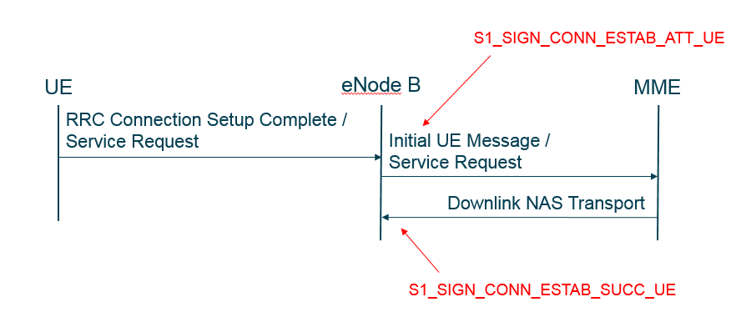
Figure 5: Attempt and success counters incremented for S1 Signalling Connection Setup
Network logging (Cell Trace, Emil or a protocol analyser) can be used to identify scenarios where the attempt counter is being incremented while the success counter is not being incremented. For this example, the Detach procedure can be identified as being responsible for the KPI generating a relatively low result (<100%). When completing the Detach procedure, the S1_SIGN_CONN_ESTAB_ATT_UE counter is incremented by the S1AP: Initial UE Message / Detach Request message, but the S1_SIGN_CONN_ESTAB_SUCC_UE counter is not pegged by the S1AP: UE Context Release message (because it does not contain a NAS message and the counter is only incremented when the response includes a NAS message). The Detach procedure scenario is illustrated in Figure 6.
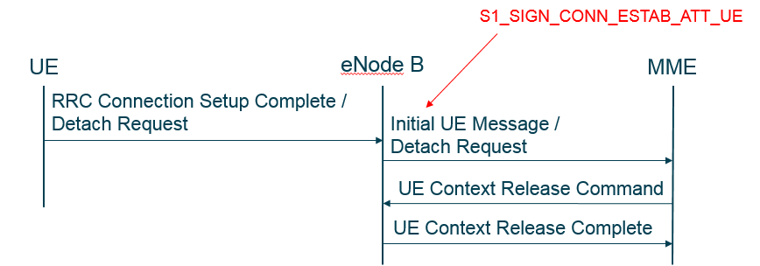
Figure 6: Only Attempt counter incremented for the Detach procedure
This means that prior to that release, the KPI calculation returned a result less than 100 % even though the network was performing in exactly the correct manner. This provides an example of counter implementation causing an apparent reduced performance while the actual performance is ideal. In this type of scenario, the KPI definition can be re-visited and it may be possible to agree that the offending section of the KPI is removed, i.e. the accessibility is then calculated as the product of the RRC Connection Setup Success Ratio and the E-RAB Setup Success Ratio.
In the next release, the counter implementation changed such that the success counter was incremented by the UE Context Release Command when completing the Detach procedure. The counter description was modified to remove the dependence upon the response including a NAS message:

“Reception of the first S1AP message (MME->eNB) which was received as a consequence of a preceding transmission of the S1AP: INITIAL UE message (3GPP TS 36.413).”

Prior to that release, it could had been agreed that the S1 Signalling Connection Setup Success Rate could be excluded from the KPI and performance improvement activities could then focus upon the two remaining sections of the KPI.
Figure 7 illustrates an example process for when the RRC Connection Setup Success Ratio requires improvement.
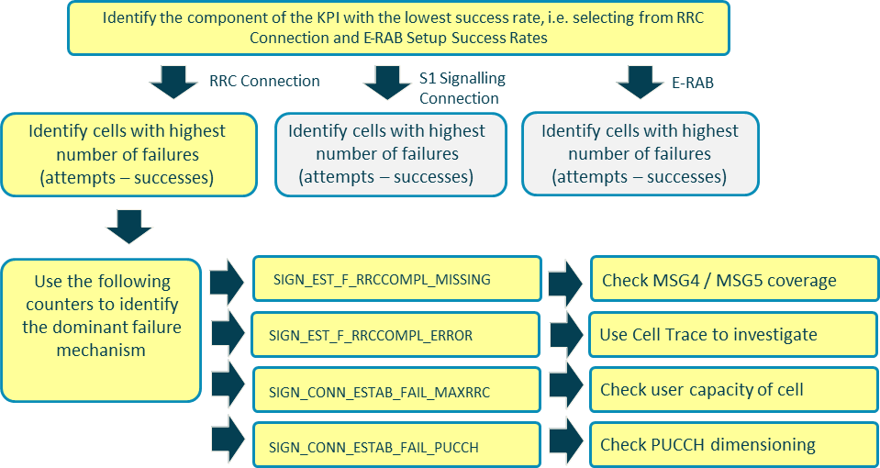
Figure 7: Process when RRC Connection Setup Success Rate degrades Accessibility
In this case, failure counters are used to help identify the root cause. Some root causes are simple to resolve while others require further investigation. For example, failures due to maximum RRC limitation can often be resolved by simple changes to the eNodeB databuild, i.e. increase the number of RRC connections allowed in the cell or reduce/prevent Scell connections in the cell. increasing RRC capacity may require a greater PUCCH PRB allocation. Failures due to PUCCH may be resolved by increasing PUCCH capacity to support the allowed number of RRC connections, offsetting the PRACH appropriately. This may be done through manual dimensioning or by using LTE1130 Dynamic PUCCH Allocation and optionally LTE2664 Load Based PUCCH Region. A cell may already be configured with the maximum supported number of connections. In this case, traffic management solutions should be studied to determine whether or not traffic can be offloaded. Alternatively, the potential for an additional RF carrier, increased sectorisation or microcell/small cell can be considered. Otherwise, the traffic captured by the cell can be reduced by decreasing the size of the dominance area with increased downtilt or Reference Signal de-boosting.
Failure counters which require further investigation can trigger the use of tools such as NetAct Cell Trace (Trace Viewer) or Emil depending upon availability. These investigations are typically time consuming and can be challenging when a small number of failures are sought within a large log file. However, issues can be common across the network so once the troubleshooting has been completed once, it may be possible to apply the learnings whenever the relevant failure counters are observed in the future.
Figure 8 illustrates a similar process for when the E-RAB Setup Success Ratio requires improvement. Failure counters are used to categorise the failures and provide focus for any subsequent investigation. It is likely that network logging will be required, at least initially, to identify the root causes.
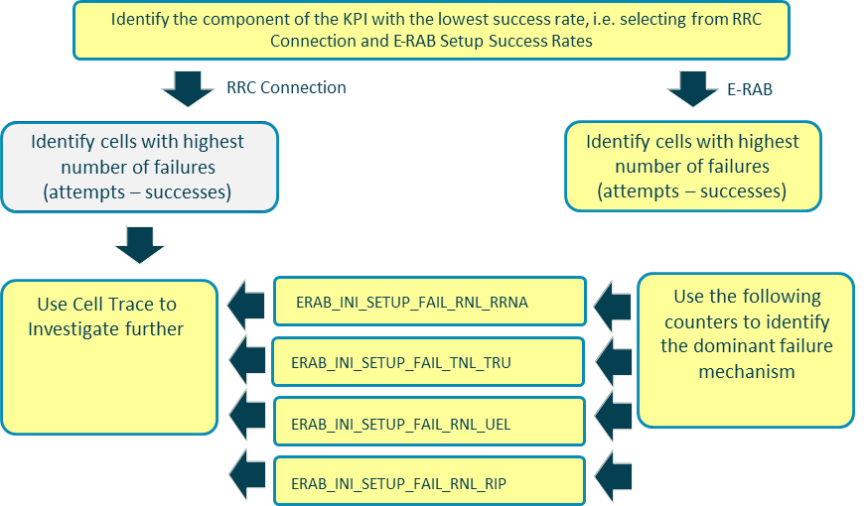
Figure 8: Process when E-RAB Setup Success Rate degrades Accessibility
It should be recognised that the Accessibility KPI does not account for the random-access procedure, i.e. an RRC Connection attempt is counted as the RRC Connection Request which assumes that MSG1 and MSG2 have already been successfully received. Although it can be argued that the random-access procedure should be included, it is normal practise to define Accessibility from the RRC Connection Request message. The performance of the random-access procedure should be studied separately to ensure that there are no significant issues.

Drop Ratio
A general Drop Ratio KPI can be defined using LTE_5119. This KPI has a range of versions depending upon the software release being used. The FDD-LTE19B version of the KPI is given by:

E-UTRAN E-RAB Drop Ratio (LTE_5119g) =
100 * (ERAB_REL_HO_PART + ERAB_REL_ENB - ERAB_REL_ENB_RNL_INA - ERAB_REL_ENB_RNL_RED + EPC_EPS_BEARER_REL_REQ_RNL + EPC_EPS_BEARER_REL_REQ_OTH + ERAB_REL_EPC_PATH_SWITCH - ERAB_REL_TEMP_QCI1 - ERAB_REL_DOUBLE_S1 + ERAB_REL_ENB_INI_S1_GLOB_RESET + ERAB_REL_MME_INI_S1_GLOB_RESET + ERAB_REL_ENB_INI_S1_PART_RESET + ERAB_REL_MME_INI_S1_PART_RESET + ERAB_REL_S1_OUTAGE)
/
(ERAB_REL_ENB + ERAB_REL_HO_PART + EPC_EPS_BEARER_REL_REQ_NORM + EPC_EPS_BEARER_REL_REQ_DETACH + EPC_EPS_BEARER_REL_REQ_RNL + EPC_EPS_BEARER_REL_REQ_OTH + ERAB_REL_EPC_PATH_SWITCH
- ERAB_REL_TEMP_QCI1 + ERAB_REL_SUCC_HO_UTRAN + ERAB_REL_SUCC_HO_GERAN + ERAB_REL_ENB_INI_S1_GLOB_RESET + ERAB_REL_MME_INI_S1_GLOB_RESET + ERAB_REL_ENB_INI_S1_PART_RESET + ERAB_REL_MME_INI_S1_PART_RESET + ERAB_REL_S1_OUTAGE
)

Changes in KPI definitions between software releases can make it challenging to maintain continuity of results between software releases. However, KPI definitions are modified to generate improved results so there should be a benefit associated with the changes.
In general, for this type of KPI the numerator counters should be studied to identify those which are linked to the highest number of drops. The counters may not indicate the precise source of the issue, but they should help to focus any subsequent investigations. An example high level process is illustrated in Figure 9.
Figure 9: Process to identify dominant source of dropped calls
This example uses the counters to identify the general area of focus while Cell Trace is used for detailed analysis. Emil could be used instead of Cell Trace if it is available. It is unlikely that detailed analysis is required for every site with poor performance. It is likely that issues are common across sites so resolving issues at one site should help to provide solutions for other sites.
In this example, the failure counters can be categorised into those initiated by the eNodeB and those initiated by the MME. This categorisation can help identify the failure scenarios in network logs, i.e. it helps to determine which messages to search. Figure 10 illustrates the messages associated with each of the counter categories.
Figure 10: Categorisation of failure counters

Throughputs
The optimization of uplink and downlink cell throughputs is discussed in sections 6.9 and 6.11. These sections also discuss uplink and downlink connection throughputs. The main KPI for Downlink Cell Throughput is LTE_5292. The ‘d’ version of this KPI has been valid since earlier releases and remains valid into LTE19B.
LTE_5292d E-UTRAN Average PDCP Layer Active Cell Throughput DL
8 * SUM(PDCP_SDU_VOL_DL) / SUM(ACTIVE_TTI_DL)

Similarly, the main KPI for Uplink Cell Throughput is LTE_5289d.
LTE_5289d E-UTRAN Average PDCP Layer Active Cell Throughput UL
8 * SUM(PDCP_SDU_VOL_UL) / SUM(ACTIVE_TTI_UL)

In terms of an optimization process, it may be decided that specific cells can be excluded from analysis. For example, cells serving an open area may have low volumes of traffic. Low volumes of traffic mean that KPI results tend to be relatively unstable and are more difficult to interpret. An example condition to exclude low traffic cells from analysis is shown in Figure 11. In this example, cells are excluded if the average number of RRC connections is less than 40. Exclusions should be dynamic so sites are included in the optimization process as their traffic increases over time.
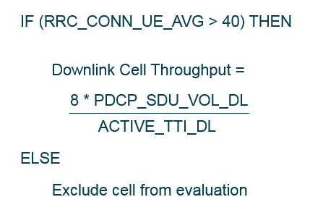
Figure 11: Exclusion of low traffic cells from analysis

Handovers
Handover performance can be optimized in a number of phases depending upon the types of handover used across the network. The majority of operators support X2 connectivity between eNodeB. In this case, the vast majority of inter-eNodeB handovers should be X2 based, while the number of S1 handovers should be small. A first optimization phase could target the requirement to minimize the percentage of S1 handovers. Subsequent optimization phases could then target the performance on X2 based Handovers. It is likely that intra-frequency and inter-frequency handovers will have different success rates and will benefit from separate optimization. Figure 12 illustrates an example phased approach to handover optimization.
Figure 12: Phased approach to the optimisation of Handover Success Rate

In general, S1 handovers are triggered when there is no X2 connection. The lack of an X2 connection could be caused by a fault across the transport network or could be caused by a lack of LNADJ. The latter is less likely with newer software releases but may still occur in dense urban environments. When there is a lack of LNADJ capacity, X2 connections may not be setup because one eNodeB had reached its maximum number of LNADJ. This type of scenario is illustrated in Figure 13.
Figure 13: S1 handovers caused by lack of LNADJ capacity
FL19B supports up to 256 LNADJ for release 3 Flexi system modules and AirScale system modules. It is possible for eNodeB to consume all of their LNADJ capacity if neighbor lists are not maintained/refreshed over time. Example networks using UE based ANR have been observed to consume the whole 256 LNADJ capacity belonging to an FSMF system module. Auto-deletion features can be used to help avoid the maximum limits being reached.
The number of S1 handovers can be monitored directly from raw counters. The number of S1 Handover Preparation Attempts is given by the counter shown below:

INTER_ENB_S1_HO_PREP
If this counter becomes high, then an audit should be completed to study the number and distribution of unavailable X2 connections. The eNodeB databuild can be interrogated for this purpose. Table 1 presents the x2LinkStatus parameter which is an output parameter populated by the system rather than by the operator. S1 handovers will be triggered if this parameter shows a value of ‘Unavailable’. Alarms can also be checked to identify a loss of X2 connectivity.
Parameter | Object | Range | Default
x2LinkStatus | LNADJ | Unavailable (0), Available (1) | -
Table 1: Output parameter used to indicate X2 availability per LNADJ
It may not be necessary to study the success rate of S1 based handovers if the primary objective is to minimize the number of S1 Handovers. However, there is some value in being aware of the success rate because it could impact other KPI results, e.g. failed S1 handover attempts could increase the connection drop ratio.
The FDD-LTE19B version of the S1 Handover Success Rate KPI is given by:

E-UTRAN Total HO Success Ratio, inter eNB S1 based (LTE_5084b) =
100 * (INTER_ENB_S1_HO_SUCC)
/
(INTER_ENB_S1_HO_PREP – INTER_S2_LB_PREP_FAIL_AC)

This KPI is a relatively simple ratio between the number of successful handover executions and the number of handover preparation attempts. Troubleshooting should involve separate analysis of the preparation and execution phases. The KPI excludes the number handover preparations triggered by load balancing which are blocked by admission control. These handover attempts are excluded because they can cause a rapid reduction in the handover success rate without reflecting the end-user experience, i.e. failed load based handover preparations do not impact the end-user because the end-user is left on the current carrier without being aware of the handover attempt (load based handover attempts are triggered internally within the eNodeB).
The X2 Handover Success Ratio is defined by LTE_5058c. The format of this KPI is the same as that for the S1 Handover Success Ratio:

E-UTRAN Total HO Success Ratio, inter eNB X2 based (LTE_5058c) =
100 * (SUCC_INTER_ENB_HO)
/
(INTER_ENB_HO_PREP – INTER_X2_LB_PREP_FAIL_AC)

When troubleshooting, the performance of the handover preparation phase can be quantified using LTE_5049. The definition of this KPI is given by:

E-UTRAN HO Preparation Success Ratio, inter eNB X2 based (LTE_5049c) =
100 * (ATT_INTER_ENB_HO)
/
(INTER_ENB_HO_PREP – INTER_X2_LB_PREP_FAIL_AC)

If the success rate is poor then the failure counters can be used to help direct further investigations, e.g. the counters FAIL_ENB_HO_PREP_TIME, FAIL_ENB_HO_PREP_AC and FAIL_ENB_HO_PREP_OTHER can be studied.
The performance of the handover execution phase can be quantified using LTE_5048b:

E-UTRAN HO Success Ratio, inter eNB X2 based (LTE_5048b) =
100 * (SUCC_INTER_ENB_HO)
/
(ATT_INTER_ENB_HO)

The success rate of intra-eNodeB handovers can be quantified using LTE_5043a:

E-UTRAN Total HO Success Ratio, intra eNB (LTE_5043a) =
100 * (SUCC_INTRA_ENB_HO)
/
(INTRA_ENB_HO_PREP)

Similar to the inter-eNodeB case, this KPI can be divided into preparation and execution phases:

E-UTRAN HO Preparation Success Ratio, intra eNB (LTE_5036a) =
100 * (ATT_INTRA_ENB_HO)
/
(INTRA_ENB_HO_PREP)

E-UTRAN HO Success Ratio, intra eNB (LTE_5035a) =
100 * (SUCC_INTRA_ENB_HO)
/
(ATT_INTRA_ENB_HO)

The KPI for Inter-Frequency Handover Success Rate does not differentiate between intra and inter-eNodeB scenarios. In addition, the KPI includes only the execution phase:

E-UTRAN Inter-Frequency HO Success Ratio (LTE_5114a) =
100 * (HO_INTFREQ_SUCC)
/
(HO_INTFREQ_ATT)

Similarly, the KPI for Intra-Frequency Handover Success Rate does not differentiate between intra and inter-eNodeB scenarios, and includes only the execution phase:

E-UTRAN Intra-Frequency HO Success Ratio (LTE_5568a) =
100 * (SUCC_INTRA_ENB_HO + SUCC_INTER_ENB_HO + INTER_ENB_S1_HO_SUCC - HO_INTFREQ_SUCC)
/
(ATT_INTRA_ENB_HO + ATT_INTER_ENB_HO +INTER_ENB_S1_HO_ATT - HO_INTFREQ_ATT)

RF Optimization
Physical RF Optimization is the first step to improve the performance of the network in order to get the maximum benefits from any subsequent parameter optimization. Checking the coverage footprint, aiming for good dominance areas, avoiding crossed feeders and looking for wrong/not optimized tilts and azimuths are fundamental areas covered in this section.
Performance in LTE is strongly impacted by interference. This is typical to any cellular technology working with a frequency re-use of 1. Thus, the SINR distribution is the main throughput limiting factor. Any interference reduction is reflected by an increase in cell range and user throughput.
A basic planning rule to avoid/reduce interference is to minimize cell overlapping by planning clear dominance areas and avoiding overshooting sites. The effect of parameter tuning is limited if a network is badly planned.
The effect of the interference on the network performance has been studied since the early days of LTE. Figure 14 shows the impact on throughput and SINR measured across the same drive route with 70% load and without load (0%). Case: 20MHz, OL MIMO, FTP download, 1 UE inside car. Load generated with feature: ‘DL Inter-cell Interference Generation, LTE819’.
The average throughput for this specific route was 58% better for the no interference case.
Figure 14: Throughput CDF (left) and SINR CDF (right) under different load conditions)
Antenna tilts and azimuths together with antenna placement are strong primary RF shaping factors.

Antenna Tilt
Antenna tilt is defined as the angle of the main beam of the antenna with respect to the horizontal plane. Positive and negative angles are referred to as downtilt and uptilt respectively. Antenna tilt can be adjusted mechanically and/or electrically as shown in Figure 15 and Figure 16 respectively.
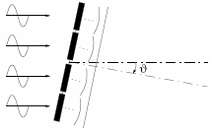
Figure 15: Mechanical tilt
There are different techniques for managing the electrical tilt such as remote electrical tilt (RET), variable electrical-tilt (VET) and fixed electrical tilt. Usage of RET antennas removes the need for tower climbing and base station site visits by controlling the tilt angle via network management system (OMS) so operational cost is saved. Hence, remote electrical tilt has become more popular for network operators e.g. adjusting tilt angle when eNodeB addition or removal occurs. On the other hand, mechanical tilt is also needed because electrical tilt range is limited compared to the mechanical tilt range.
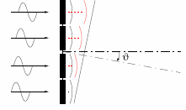
Figure 16: Electrical tilt
Electrical tilt poses an advantage over the mechanical as tilt is also applied on the back lobe and because the shape of the main radiation lobe is kept constant. Mechanical tilt results in the uptilting of the back lobe which might increase the interference in tower sites.
From Figure 17 the gain might be up to 40-50% for a flat hexagonal scenario comparing 0 degrees tilt versus an optimised tilt solution. Antenna tilt has an optimum value as high tilts decrease coverage which increases dominance.
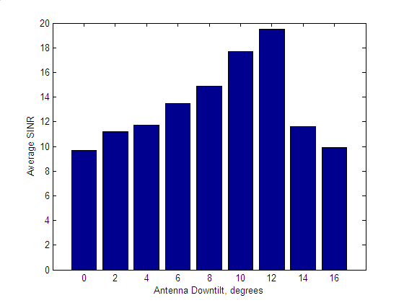
Figure 17: Example of average SINR as function of tilt -1 km site radius, 65-deg antenna, SNR measured at street level
As discussed, interference can have a significant impact upon throughput, so identification of the strongest interferers is important. From drive test data, an area of strong interference can be identified as an area with good RSRP but low SINR or RSRQ. However, SINR and RSRQ measurements are dependent upon network load and measurement methods. Studies have shown that absolute SINR measurement values cannot be used as a reliable performance indicator as SINR values change considerably depending on the scanner (if it is measuring RS SINR or S-SCH SINR) and the interference situation. Relative SINR changes, if the same measurement tool is used all the time, still can be used as performance indicators. In an unloaded network, SINR measured from Reference Signals reflects the PCI planning quality. RS SINR has also a random component depending on the radio frame synchronization state between neighbouring sites (no controlled synchronization by the network). Thus, it is possible to have locations with good RS SINR in unloaded network but suffering from heavy interference when there is traffic load in a neighbouring (interfering) cell.
Scanner RSRP measurements provide the most accurate method to identify interfering sites. Alternatively, the Minimisation of Drive Testing (MDT) solution described in section 9 can be used to obtain RSRP from both serving and neighbouring cells. The MDT solution avoids the requirement for drive testing. By looking at best N cells RSRP values, it is possible to identify places that don’t have dominant server or where there are many cells visible inside a small power window. Those locations could still have fairly good performance in unloaded network, but they would suffer from interference when traffic load increases in surrounding cells.
At a first stage, corrective actions to improve the situation are changes of antenna tilt, azimuth and eventually eNodeB power of the interfering cells. A second stage might be the change of antenna type and height.
During RF optimisation it is useful to understand the initial conditions. This helps to determine whether antenna should up-tilted or down-tilted. Example scenarios include:
- Overshooting cell:
A cell located in an area of continuous LTE coverage that, because of e.g. actual propagation being better than assumed in planning or an error in setting the tilt value provides coverage further than expected. It can be detected by looking at the average inter-site distance calculated over the target cells for outgoing handovers or by looking into drive test results plot marked with serving cells IDs along with handovers. The coverage area should be reduced to a certain degree by down tilting.
- Coverage gaps:
Independent of the cause, coverage gaps can be detected by looking at the inter-RAT handover statistics per each adjacency. More specifically, in case of a gap, a number of terminals served by a set of neighbouring LTE cells, will perform inter-RAT handover towards the same set of WCDMA (or CDMA or 2G) cells. Inter-RAT HO statistics may detect coverage gaps from various causes: UL limited cells, worse than expected propagation, blocking by a building or indoor penetration losses.
A coverage limitation due to UL power requires increasing (if possible) the antenna gain towards the cell edge. This can be done by the decrease of tilt, antenna azimuth manipulation, change of antenna or antenna height increase if possible. Another step could consider specific receiver features like higher order diversity.
- UL coverage limited cell:
The coverage of a functional network is given by the uplink and downlink coverage. However, uplink coverage will normally be the limiting factor. UL coverage limitation can result in radio link failures in case the RSRP levels are still good and do not trigger any intra or inter-RAT handover.

Crossed feeders
Crossed feeders are characterised by a mismatch between the cell information within the eNodeB databuild and the cell information radiated by an antenna. The issue is caused by incorrect connection of feeder cables between the eNodeB RF hardware and the antenna. Crossed feeders are caused by human error during the site build process. They are also known to occur on GSM and UMTS networks. Technologies may share feeder cables, so a single crossed feeder error could impact multiple technologies.
The LTE Physical-layer Cell ID (PCI) can be used in a similar way to scrambling codes in UMTS. All scanners and UE logging tools report the PCI of the cells they are measuring so drive testing can identify crossed feeders relatively easily. An initial drive test around a site after site integration provides a good solution for identifying crossed feeders. A dominance plot, showing the PCIs measured by the scanner or UE logging tool during the drive test allows crossed feeders to be identified.
Figure 18 shows an example of crossed feeders between two sectors. The upper part of the figure illustrates the best server plot when the feeders were crossed. The lower part of the figure illustrates the best server plot after correcting the crossed feeders. If there are crossed feeders then the PCI appear swapped between sectors.
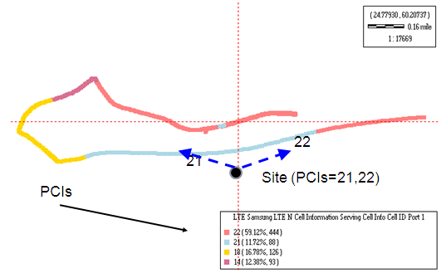
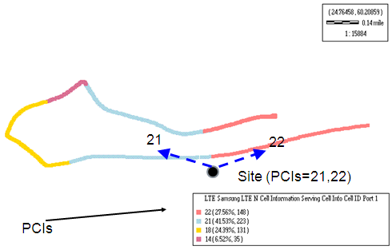
Figure 18: Crossed-feeders case (above) and corrected (below)

Crossed feeders should be identified by Network Integration engineers (or subcontractor company responsible for the site installation) when the site is put on air or after some work has been carried out in the site (e.g. Equipment swap and MHA changes) although this is not always the case so NPO engineers may need to identify them as part of the network optimization.
- Crossed feeders in case of MIMO Configuration
MIMO usage in LTE increases the probabilities of crossed feeders. Figure 19 shows an example of an incorrect MIMO configuration resulting in sectors overlapping with each other (and as result, bad throughput due to interference)
Figure 19: Incorrect MIMO configuration
One symptom of crossed feeders in case of MIMO can be that MIMO SM will not work (i.e. not possible to get expected peak throughputs) or it won’t be selected at all due to low Rank Indicator reported. The rank indicates how well the UE can decode the MIMO matrix (multipath). If one of the antennas is not transmitting the right data, the UE will report mostly rank1 and MIMO TxDiv will then be used even in very good radio conditions where the CQI (Channel Quality Indicator) is high but the rank is low.
If the two antenna ports of one cell are directed to different azimuth directions (i.e., physical sectors), it would cause high power imbalance in the MIMO channel matrix, effectively making it almost a SIMO transmission as the UE sees rank-1 channel.
A proposal for how to check for X-feeders with MIMO is:
- Leave only one cell on air (the one to be tested)
- Set the syncSigTxMode LNCEL parameter to Transmit Diversity (i.e. 1). This parameter defines if the Primary and Secondary Synchronization signals (PSS and SSS) are transmitted into the cell via one antenna port (SingleTx) or via the two antenna ports using Transmit diversity.
- Leave only one Power Amplifier (PA) on at each time and measure the RS signal with a scanner:
  - Set PA ‘ON’ for RF module1 and PA for RF module 2 ‘OFF’ and drive with the scanner to get the RSRP. PSS and SSS should be visible.
  - Set PA ‘OFF’ for RF module1 and PA for RF module2 ‘ON’ and drive with the scanner the same route
- Compare the Rx signal Coverage measured by the scanner. If one of the Tx is connected to a different antenna the discrepancy should be seen in the measurements. Figure 20 below shows the scanner measurement results in a cross-feeder case. Sectors 241 and 242 are almost equally strong in an area where 242 should dominate since 241 is pointing to the opposite direction.

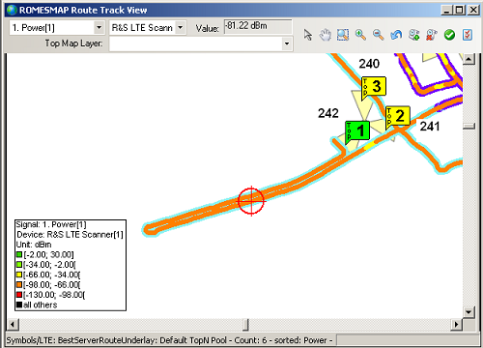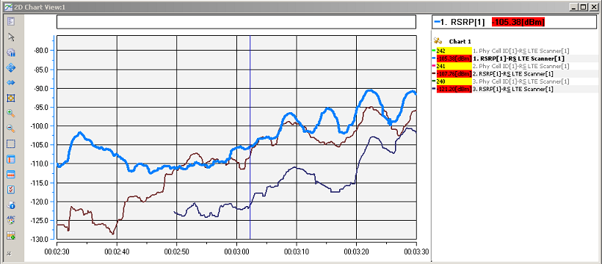
242
241
Figure 20: X-feeders case and scanner measurements

- Crossed feeders leading to Swapped Sectors
The Minimization of Drive Testing (MDT) capability within the NetAct Trace Viewer application can also be used to identify crossed sectors. MDT allows the collection of GPS data for the UE connected to specific cells. This allows the population of UE to be plotted on a map and checks made to verify that the UE are located across the expected area. Figure 21 illustrates an example of a L800/L1800/L2100 Based Station. The L800 layer uses a first set of antennae while the L1800 and L2100 layers use a second set of antenna. MDT has been used to plot the location of the traffic belonging to sector 2 (the sector pointing southwards). The L800 traffic appears across the expected area, while the L1800/L2100 traffic appears across a different area. This difference in traffic location indicates that the feeders for the L1800/L2100 layers have been swapped across sectors. This type of error leads to problems with both traffic balancing and Carrier Aggregation which have been configured to operate co-sector rather than across sectors.
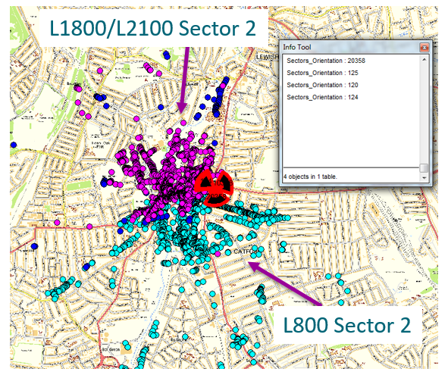

Figure 21: X-feeders visible in MDT analysis
The Flexible Secondary Cell Swap feature can also be used to identify this type of error if CAREL objects are configured across sectors. In this case, the Base Station would initially configure the Carrier Aggregation connection to use L800 sector 2 with L2100 sector 2 (for example). The UE would then recognize that it is unable to measure sector 2 because the feeders have been crosses and sector 2 is actually radiating across a different area. So, the UE triggers event A6 to swap the secondary cell to whichever sector is actually radiating above L800 sector 2. This pattern can be identified using the CA_SCELL_SWAP_A6 counter, i.e. high volumes of secondary cell swaps indicate that sectors are not aligned in the expected manner.

Feeder Loss Imbalance
Both uplink and downlink performance can be compromised if feeder losses are imbalanced. For example, if a cell is using 2-way Maximal Ratio Combining (MRC), or 2-way Interference Rejection Combining (IRC) then performance would be compromised if one receive-branch had more loss than the other receive branch. The receiver operates with optimal performance when both branches are received with equal average power.
Imbalances could be caused by the use of different feeder lengths. This should not normally be the case because the feeders should follow a similar path between the antenna and base station cabinet. Imbalances can also be caused by loose connectors. If a connector has not been fully tightened, then it can introduce additional loss.
The M8005 counter table, ‘LTE Power and Quality UL’ includes counters which can be used to identify feeder loss imbalances. These counters are activated using the LNBTS parameter, actL1PM. This corresponds to activating the feature, ‘LTE1491 – Additional Layer 1 Performance Counters’. It should be noted that enabling this feature activates a large quantity of additional counters. It is possible that these additional counters impact base station performance. It is recommended that these counters are only enabled during the period of investigation, i.e. they should be disabled after the analysis has been completed.
Figure 22 illustrates example results from the Received Total Wideband Power (RTWP) counters (AVG_RTWP_RX_ANT_x). These counters are recorded ‘per antenna element’ so they reflect the power received through each feeder path. In this example, there is about 1 dB imbalance between the 2 paths. This is not ideal but is not sufficient to trigger a site visit and further investigation. Larger differences, e.g. 3 dB, are more likely to require further investigation.
Figure 22: Example results from AVG_RTWP_RX_ANT_1 and AVG_RTWP_RX_ANT_2
The full set of RTWP counters is presented in Table 2, i.e. up to 8 antenna elements per cell are supported.
Counter Id | Counter Name | Comments
M8005C306 | AVG_RTWP_RX_ANT_1 | Counters are recorded ‘per antenna element’
M8005C307 | AVG_RTWP_RX_ANT_2 | Counters are recorded ‘per antenna element’
M8005C308 | AVG_RTWP_RX_ANT_3 | Counters are recorded ‘per antenna element’
M8005C309 | AVG_RTWP_RX_ANT_4 | Counters are recorded ‘per antenna element’
M8005C310 | AVG_RTWP_RX_ANT_5 | Counters are recorded ‘per antenna element’
M8005C311 | AVG_RTWP_RX_ANT_6 | Counters are recorded ‘per antenna element’
M8005C312 | AVG_RTWP_RX_ANT_7 | Counters are recorded ‘per antenna element’
M8005C313 | AVG_RTWP_RX_ANT_8 | Counters are recorded ‘per antenna element’
Table 2: Additional L1 counters for recording RTWP

Interference Checks
Background interference levels should be low and the noise floor should be dominated by thermal noise rather than interference. The M8005 counter table, ‘LTE Power and Quality UL’ includes counters which can be used to quantify Interference over Thermal (IoT) noise rise. These counters are activated using the LNBTS parameter, actL1PM. This corresponds to activating the feature, ‘LTE1491 – Additional Layer 1 Performance Counters’. It should be noted that enabling this feature activates a large quantity of additional counters. It is possible that these additional counters impact base station performance. It is recommended that these counters are only enabled during the period of investigation, i.e. they should be disabled after the analysis has been completed.
The relevant counters are shown in Table 3. These counters provide a distribution of IoT across the channel bandwidth, i.e. the channel bandwidth is divided into 9 sections and a counter result is generated for each section. The number of Resource Blocks within each section depends upon the channel bandwidth.
Counter Id | Counter Name | Comments
M8005C317 | UL_IOT_PUSCH_DIST_BIN_0 | Counters provide a distribution across the channel bandwidth, i.e. it is possible to quantify interference levels across different parts of the channel
M8005C318 | UL_IOT_PUSCH_DIST_BIN_1
M8005C319 | UL_IOT_PUSCH_DIST_BIN_2
M8005C320 | UL_IOT_PUSCH_DIST_BIN_3
M8005C321 | UL_IOT_PUSCH_DIST_BIN_4
M8005C322 | UL_IOT_PUSCH_DIST_BIN_5
M8005C323 | UL_IOT_PUSCH_DIST_BIN_6
M8005C324 | UL_IOT_PUSCH_DIST_BIN_7
M8005C325 | UL_IOT_PUSCH_DIST_BIN_8
Table 3: Additional L1 counters for recording Interference over Thermal (IoT)
Figure 23 presents an example set of results from these counters. The x-axis corresponds to the set of bins, i.e. the x-axis represents the channel bandwidth. In this example, there are separate lines for each hour within the day. The graph illustrates that IoT levels vary throughout the day as the levels of network traffic change. In this example, it is apparent that the upper side of the channel bandwidth is experiencing increased interference levels. This could be originating from an external interference source, or it could be originating from inter-cell interference if a neighbouring site was scheduling its traffic predominantly in the upper part of the channel. In this case, the interference rise is present during the night when traffic levels are low so it is unlikely to be caused by inter-cell interference.

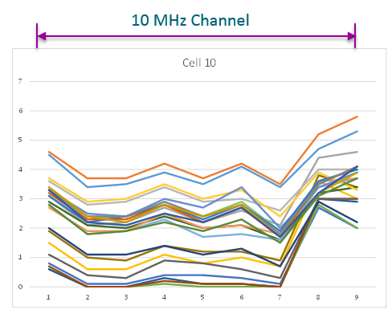
Figure 23: Example results for UL_IOT_PUSCH_DIST_BIN_x
The impact of this interference can be visualised using the Signal to Interference Ratio (SIR) counters presented in Table 4. These counters provide a distribution of SIR across the channel bandwidth. A low SIR can indicate higher interference levels and can also indicate that the packet scheduler is not allocating Resource Blocks in that part of the channel bandwidth very frequently. The channel aware scheduler should detect increased interference levels and try to avoid those when they are present in only part of the channel bandwidth.
Counter Id | Counter Name | Comments
M8005C326 | AVG_SIR_DIST_BIN_0 | Counters provide a distribution across the channel bandwidth, i.e. it is possible to quantify SIR levels across different parts of the channel
M8005C327 | AVG_SIR_DIST_BIN_1
M8005C328 | AVG_SIR_DIST_BIN_2
M8005C329 | AVG_SIR_DIST_BIN_3
M8005C330 | AVG_SIR_DIST_BIN_4
M8005C331 | AVG_SIR_DIST_BIN_5
M8005C332 | AVG_SIR_DIST_BIN_6
M8005C333 | AVG_SIR_DIST_BIN_7
M8005C334 | AVG_SIR_DIST_BIN_8
M8005C335 | AVG_SIR_DIST_BIN_9
Table 4: Additional L1 counters for recording Signal to Interference Ratio (SIR)

An example set of results for these counters is presented in Figure 24. These results correspond to the same cell used for the IoT results in Figure 23. It is apparent from this graph that the packet scheduler is avoiding the upper part of the channel bandwidth due to the increased interference levels. The SIR counters illustrate increased activity towards the centre and lower side of the channel bandwidth.

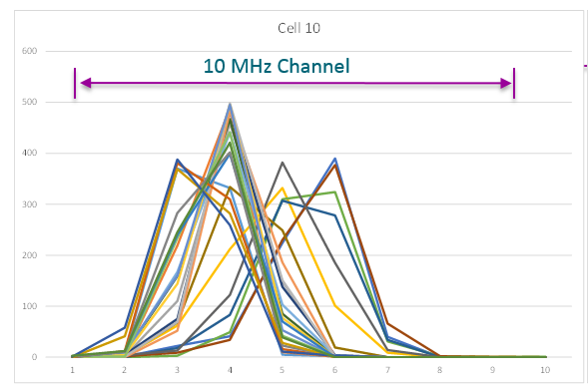
Figure 24: Example results for AVG_SIR_DIST_BIN_x

Furthermore, the feature LTE3702 User Plane Performance Monitoring Improvements introduces the LTE Received Interference Power measurement table. These counters provide the received uplink interference power per PRB and are activated using the PMRNL parameter mtRIP. Table 5 lists the counters provided by the M8056 table.
Counter Id | Counter Name | Comments
M8056C0 | MEAN_UL_RIP_PER_PRB0 | Counters provide a distribution across the channel bandwidth, i.e. it is possible to quantify received interference power per PRB across the channel
… | …
M8056C99 | MEAN_UL_RIP_PER_PRB99
M8056C100 | MAX_UL_RIP_PER_PRB0
… | …
M8056C199 | MAX_UL_RIP_PER_PRB99
Table 5: Additional counters for reporting Received Interference Power per PRB

An example set of results is presented in Figure 25. This example is for a 3 sector site utilising a 10MHz channel bandwidth. The chart illustrates generally higher interference levels in the PUCCH region at each side of the x-axis. PRBs 4-22 report relatively stable values, whilst PRBs 26-45 show a noisy profile, caused by co-channel interference from nearby GSM sites. Counters for PRBs numbering 50 upwards are not incremented due to the 10MHz bandwidth.
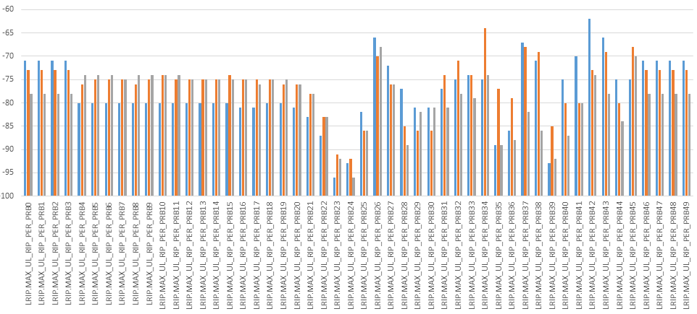
Figure 25: Example profile of RIP per PRB counters for a 3-sectored site

Automatic Cell Planning (ACP)
The best practice is to start optimization during the planning stage with the use of an Automatic Cell Planning (ACP) tool like ACP module in Atoll or Capesso tool in Planet. The main advantage of such tools is the possibility to check many configurations, much more than with manual optimization.
ACP tools are especially helpful in case of dense network designs where strong interference limitation exists. The design can become complicated as the interference is shared between many different cells.
An example of planning and automated optimization of dense network cluster can be found in LTE planning study for Sydney cluster. In that example, the optimization of the network was based on antenna azimuth and tilt changes along with changes in DL power of eNodeB. Figure below shows SINR results from proposed changes. The cluster consisted in 56 sites/165 sectors on 26.5 km2 of dense urban area. Proposed changes were as follows:
Changes | 20% (54) changes | 100% (270) changes
Azimuth | 10x | 87x
Tilt | 30x | 106x
Power | 14x | 77x
Table 6: Example of summary changes from study with ACP (Atoll)

Figure 26: Example DL Mean RLC Throughput comparison for initial configuration, and implemented changes proposed by ACP tool as optimization

Feature Summary
In general, features can be categorised into those which provide:
- new functionality alone
- new functionality to improve performance
For example, LTE1382 Cell Resource Groups, allows the subscribers belonging to multiple operators to share the resources within a cell. This feature aims to provide new functionality without targeting a specific performance improvement. In contrast, LTE2479 256QAM in Downlink, provides new functionality specifically to improve downlink throughputs.
Table 7 presents the set of features associated with improving downlink throughput performance. The majority of these features are linked to the downlink modulation scheme, the downlink transmission mode or downlink Carrier Aggregation. Some features can be enabled without additional hardware, e.g. 256QAM in Downlink, whereas other features may require additional hardware depending upon what is already available, e.g. DL Adaptive Closed Loop MIMO (4x2) is likely to require additional antenna, feeders and power amplifiers. FL18A introduces Massive MIMO for FDD deployments.
Id | Name | Software Release
LTE793 | Support of 16 QAM (DL) | RL10
LTE43 | Support of 64 QAM in DL | RL10
LTE70 | Downlink adaptive open loop MIMO for two antennas | RL10
LTE703 | DL adaptive closed loop MIMO for two antennas | RL20
LTE568 | DL Adaptive Closed Loop MIMO (4x2) | RL50
LTE1089 | Downlink Carrier Aggregation - 20 MHz | RL50
LTE1332 | Downlink carrier aggregation - 40 MHz | RL60
LTE1803 | Downlink carrier aggregation 3 CC - 40 MHz | RL70
LTE2149 | Supplemental Downlink Carrier | FL15A
LTE1804 | Downlink Carrier Aggregation 3 CC - 60 MHz | FL15A
LTE2316 | FDD-TDD downlink carrier aggregation 3CC | FL16
LTE2180 | FDD-TDD Downlink Carrier Aggregation 2CC | FL16
LTE1987 | Downlink Adaptive Closed Loop SU MIMO (4x4) | FL16
LTE1541 | Advanced SCell measurement handling | FL16
LTE2276 | Measurement-based SCell Selection | FL16A
LTE2531 | FDD Downlink Carrier Aggregation 4CC | FL16A
LTE2630 | Uplink Control Information Only Transmission | FL16A
LTE2479 | 256QAM in Downlink | FL16A
LTE3073 | 256QAM Extensions | FL17A
LTE2582 | DL 4x4 MIMO with Carrier Aggregation | FL17A
LTE2337 | FDD-TDD Downlink Carrier Aggregation 3CC | FL17A
LTE2623 | FDD-TDD Downlink Carrier Aggregation 4CC | FL17A
LTE3225 | FDD Downlink Carrier Aggregation 5CC | FL18
LTE3022 | Inter Site Carrier Aggregation | FL18
LTE3605 | DL 4x4 MIMO with Carrier Aggregation – 12 Layers | FL18
LTE4518 | Inter Site FDD-TDD Downlink Carrier Aggregation 4CC | FL18SP
LTE4536 | Inter Site FDD-TDD Downlink Carrier Aggregation 5CC | FL18SP
LTE4537 | Inter-site CA Extensions | FL18SP
LTE3881 | FDD-TDD Downlink Carrier Aggregation with MIMO – 12 Layers | FL18A
LTE4054 | Dynamic Power Backoff | FL18A
LTE4064 | 256QAM Enhancements | FL18A
LTE4166 | Inter Site FDD-TDD DL Carrier Aggregation with MIMO – 10 Layers | FL18A
LTE4203 | DL 4x4 MIMO with Carrier Aggregation - 20 Layers | FL18A
LTE4265 | Split L1 with Fixed Beam Sectorisation for 16TRX FDD mMIMO | FL18A
LTE4300 | 16TRX FDD mMIMO: DL USBF based on UE Feedback | FL18A
LTE4479 | FDD-TDD Downlink Carrier Aggregation with MIMO – 20 Layers | FL18A
LTE4482 | TDD Downlink Carrier Aggregation with MIMO – 16 Layers | FL18A
LTE4613 | TM9 in MBSFN Subframes | FL18A
LTE3775 | FDD Downlink Carrier Aggregation 6CC | LTE19
LTE4567 | TDD Massive MIMO Capacity Boost | LTE19
LTE4754 | UE CA Capability Signaling - Skip Fallback | LTE19
LTE5107 | TDD TM9 MU-MIMO Support for Massive MIMO | LTE19
LTE2735 | Intra Airscale eNB FDD-TDD DL Carrier Aggregation - 2/3CC | LTE19A
LTE3193 | Intra Airscale eNB FDD-TDD DL Carrier Aggregation - 5CC | LTE19A
LTE3352 | Intra Airscale eNB FDD-TDD DL Carrier Aggregation – 4CC | LTE19A
LTE4265 | Split L1 with Fixed Beam Sectorization for 16TRX FDD mMIMO | LTE19A
LTE4707 | Intra Airscale eNB FDD-TDD DL Carrier Aggregation - 6CC | LTE19A
LTE4961 | Flexible CA Management | LTE19A
LTE2500 | TDD Downlink Carrier Aggregation 5CC - 20 Layers | LTE19B
LTE4303 | 16TRX FDD mMIMO: DL USBF with MU-MIMO | LTE19B
LTE4671 | TDD Massive MIMO on ABIC | LTE19B
LTE5107 | TDD TM9 MU-MIMO Support for Massive MIMO | LTE19B
LTE5116 | TDD Massive MIMO 32TRX on ABIC | LTE19B
LTE5141 | TDD massive MIMO calibration enhancement | LTE19B
LTE5245 | TDD-FDD SDLC DL carrier aggregation 4CC | LTE19B
LTE5400 | TDD Massive MIMO ABIC Remaining Porting | LTE19B
LTE5426 | Flexible CA management - frequency layers increase | LTE19B
LTE5731 | TCP Service Differentiation | LTE19B
Table 7: Features aimed at improving downlink throughputs

Table 8 presents the set of features associated with improving uplink throughput performance. Similar to the downlink, there are features linked to the modulation scheme, transmission mode and Carrier Aggregation. The uplink also includes features which impact power control and the scheduler algorithm. In addition, the uplink can benefit from Co-ordinated Multipoint (CoMP), Centralised RAN (CRAN) and Interference Rejection Combining (IRC).
Id | Name | Software Release
LTE27 | Open loop UL power control and DL power setting | RL10
LTE28 | Closed loop UL power control | RL10
LTE788 | Support of 16 QAM (UL) | RL10
LTE619 | Interference aware UL scheduling | RL30
LTE829 | Increased uplink MCS range | RL30
LTE1034 | Extended UL Link Adaptation | RL30
LTE46 | Channel-aware Scheduler (UL) | RL40
LTE979 | IRC for 2 RX Paths | RL40
LTE980 | IRC for 4 RX Paths | RL50
LTE1336 | Interference aware UL power control | RL60
LTE1402 | Uplink Intra-eNB CoMP | RL60
LTE1495 | Fast uplink link adaptation | RL60
LTE1691 | Uplink intra-eNB CoMP 4Rx | RL70
LTE44 | 64QAM in UL | FL16
LTE2470 | Centralized RAN for FL16 | FL16
LTE2564 | Centralized RAN CL16A Release | FL16A
LTE1092 | Uplink Carrier Aggregation – 2CC | FL16A
LTE1130 | Dynamic PUCCH Allocation | FL16A
LTE2664 | Load Based PUCCH Region | FL17A
LTE3313 | FDD UL CA Extensions – Part 1 | FL18SP
LTE3933 | Flexible Inter eNB UL CoMP | FL18A
LTE4053 | Advanced UL CA SCell Handling | FL18A
LTE4581 | 256QAM in UL | LTE19B
Table 8: Features aimed at improving uplink throughputs

Table 9 presents the set of features associated with improving the performance CS Fallback and RRC Connection Release with Redirection. Some of these features involve trade-offs, e.g. Measurement based Redirect to UTRAN improves the reliability of the redirection but increases the delay. The RAN Information Management features require support on the target GSM/WCDMA technologies. Although not implied by the name, the CS Fallback to UTRAN feature allows CS Fallback to be combined with a packet switched inter-system handover. This means that the UE moves from LTE connected mode to UMTS connected mode, rather than LTE connected mode to UMTS idle mode.
Id | Name | Software Release
LTE736 | CS Fallback to UTRAN | RL40
LTE1073 | Measurement-based Redirect to UTRAN | RL40
LTE984 | GSM Redirect with System Information | RL40
LTE498 | RAN Information Management for GSM | RL60
LTE1196 | RAN Information Management for WCDMA | FL15A
LTE2410 | Roaming and Access Restrictions Removal for CSFB Emergency Calls | FL17A
Table 9: Features aimed at improving CS Fallback and Release with Redirection

Table 10 presents the set of features associated with improving the performance VoLTE. This represents a subset of the total VoLTE feature set. The full set of VoLTE features is presented in section 6.18. Note that the DRX parameters listed in Table 11 also impact VoLTE performance in terms of UE battery life, latency and drop ratio.
Id | Name | Software Release
LTE11 | Robust header compression | RL20
LTE571 | Controlled uplink packet segmentation | RL30
LTE907 | TTI Bundling | RL50
LTE1406 | Extended VoLTE talk time | RL70
LTE1127 | Service Based Mobility Trigger | RL70
LTE2112 | Dedicated Mobility Thresholds for SRVCC | RL70
LTE64 | Service-based Handover Thresholds | FL15A
LTE2430 | QCI1 Establishment Triggered Protection Timer | FL15A
LTE2098 | VoLTE uplink coverage boosting | FL16
LTE1569 | QCI 1 specific RLF and re-establishment control | FL16
LTE2832 | SRVCC Due to Admission Control Rejection | FL16A
LTE3290 | SRVCC Trigger Enhancement | FL17A
LTE3443 | VoLTE Triggered SRVCC to GSM | FL18
LTE3127 | SRVCC to GSM Measurement Optimisation | FL18
LTE3692 | VoLTE Robustness Enhancements | FL18
LTE3723 | VoLTE Quality Triggered Inter-Frequency Mobility | FL18A
LTE4244 | VoLTE Coverage Extension by Codec Rate Adaptation | LTE19
LTE5524 | Ongoing QCI1 Prevents EN-DC setup | LTE19A
Table 10: Features aimed at improving VoLTE performance

Table 11 presents the set of features associated with DRX. The features from RL30 allow long DRX cycles to be configured, whereas the RL50 feature allows short DRX cycles to be configured. DRX tends to increase UE battery life, increase latency and increase connection drop ratio.
Id | Name | Software Release
LTE42 | DRX in RRC connected mode | RL30
LTE473 | Extended DRX settings | RL30
LTE585 | Smart DRX | RL50
Table 11: Features associated with DRX

Table 12 presents the set of features associated with RRC connection re-establishment. These features are very important in terms of improving the drop call ratio for both data and VoLTE connections. RRC Connection Re-establishment feature allows re-establishment within the cell where the connection dropped, or within a cell where handover preparation has already completed. The RLF triggered handover feature allows re-establishment within any cell which has an X2 connection with the cell where the connection dropped. The Extended RLF Handling feature allows some of the radio link failure conditions to be operator configurable. The FL18A feature is an enhancement of the LTE1617 solution that gives priority to the RLF triggered HO over ongoing procedures. procedures.
Id | Name | Software Release
LTE735 | RRC Connection Re-establishment | RL30
LTE1617 | RLF Triggered Handover | RL70
LTE2206 | Extended RLF Handling | FL16
LTE3105 | RLF Triggered HO Enhancements | FL18A
Table 12: Features associated with RRC Connection Re-establishment

Table 13 presents the set of features associated with RSRQ mobility. These features can be important when levels of interference are high, i.e. these features allow mobility procedures to be triggered by degraded signal quality rather than weak signal strength. High interference levels are typical in urban environments where the site density is greater.
Id | Name | Software Release
LTE1036 | RSRQ Based Cell Reselection | RL50
LTE1407 | RSRQ Based Redirect | RL50
LTE1198 | RSRQ triggered mobility | RL60
LTE2551 | RSRQ-based A5 | FL16A
LTE2572 | RSRQ-based B2 | FL17A
LTE3462 | Support for Intra-Frequency A3 RSRQ Measurement | FL17A
Table 13: Features associated with RSRQ based mobility

Table 14 presents the set of features associated with traffic management. These features allow load balancing in either RRC Idle mode or RRC Connected mode. Idle Mode Load Balancing allows UE specific prioritisation of both LTE and inter-system network layers for cell reselection. This feature does not require any X2 signalling nor any signalling with inter-system technologies. With the exception of ‘LTE-UTRAN Load Balancing’, Connected Mode Load Balancing allows traffic distribution across LTE network layers. The feature can be enabled with or without X2 signalling. The option to enable without X2 signalling is useful for inter-vendor scenarios. There is also an intra-frequency load balancing feature which adjusts the distribution of traffic within a network layer by moving the cell boundary towards heavily loaded cells. The ‘Pcell Swap’ feature helps to balance uplink load by changing the Primary Cell when Carrier Aggregation is used. In the case of downlink Carrier Aggregation, the UE only transmits on the Primary Cell so balancing the Primary Cell load helps to balance the uplink load.
Id | Name | Software Release
LTE1387 | Intra-eNB Inter-frequency Load Balancing | RL40
LTE487 | Idle Mode Mobility Load Balancing | RL50
LTE1170 | Inter - frequency Load Balancing | RL50
LTE1531 | Inter-frequency Load Balancing Extension | RL60
LTE1677 | Idle Mode Mobility Balancing Extensions | RL60
LTE1894 | Reference Signal Power De-boosting | RL70
LTE1140 | Intra-Frequency Load Balancing | RL70
LTE1841 | Inter-Frequency Load Equalization | RL70
LTE2050 | Load triggered Idle Mode Load Balancing | RL70
LTE1357 | LTE-UTRAN Load Balancing | FL15A
LTE2051 | Measurement based Idle Mode Load Balancing | FL15A
LTE1536 | RRC connection rejection with deprioritisation | FL16
LTE2275 | PCell Swap | FL16
LTE2505 | Access Class Barring Skip | FL16
LTE2601 | CA-Aware Idle Mode Load Balancing | FL16A
LTE4154 | CA-Aware Idle Mode Load Balancing II | FL18
LTE1898 | UE Context Pre-emption | FL18
LTE2571 | Dedicated Target Frequency List for Load Balancing | FL18
LTE2617 | Increased Carrier Monitoring in Idle Mode | FL18A
LTE4259 | Increased Carrier Monitoring in Connected Mode | FL18A
LTE4631 | Load based Carrier Aggregation PCell and SCell Blocking | FL18A
LTE4668 | Enhanced UE CA Capability Signalling | FL18A
LTE4945 | TM9 Aware Idle Mode Load Balancing | LTE19B
LTE5266 | Configurable number of UEs for load balancing | LTE19B
Table 14: Features associated with Traffic Management

‘Reference Signal Power De-boosting’ is also included in Table 14 because it can be used to change the dominance area of a cell. De-boosting decreases dominance area and so reduces the volume of traffic capture by a cell. This can be useful at special event scenarios or in urban areas. This feature also allows unused power to be allocated to the PDSCH.
Table 15 presents the control plane and user plane overload control features which help to manage performance when the system module processing capability becomes heavily loaded. These features should not trigger under normal operating conditions but are more likely to trigger when using older system module hardware, e.g. FSME rather than FSMF.
Id | Name | Software Release
LTE1047 | Control plane overload handling | RL60
LTE2023 | User Plane Overload Handling | FL15A
LTE1788 | Automatic Access Class Barring | FL15A
LTE2460 | Automatic Access Class Barring with PLMN Disabling | FL16A
LTE2235 | RACH Load Triggered Access Class Barring | FL17A
LTE2823 | RRC Connection Triggered Access Class Barring | FL17A
LTE3099 | Overbooking for GBR Services | LTE19
Table 15: Features associated with Overload Management

Table 16 presents features which are specifically targeted at managing interference between cells. eICIC is aimed at managing interference between small cells and macrocells. Downlink interference shaping is aimed at managing interference between neighbouring macrocells. It should be recognised that other features also provide interference management. For example, LTE1336 Interference Aware UL Power Control (listed as a feature to improve uplink throughput), helps to manage inter-cell interference by controlling UE transmit powers towards cell edge.
Id | Name | Software Release
LTE1113 | eICIC - macro | RL70
LTE1496 | eICIC - micro | RL70
LTE1800 | Downlink interference shaping | RL70
Table 16: Features associated with Interference Management

Table 17 presents features associated with high speed mobility. These features provide support for a 3GPP capability which modifies the random-access procedure to make it more robust under high speed conditions. This feature should only be enabled when necessary because it increases the complexity of the PRACH root sequence planning process.
Id | Name | Software Release
LTE48 | Support of High-Speed Users | RL40
LTE3405 | Support of Extended Cell Range in High Speed | LTE19B
Table 17: Feature associated with high speed mobility

Table 18 presents a feature associated with tackling non-ideal ‘PCI mod 30’ planning. The ‘PCI mod 30’ planning rule aims to ensure that neighbouring cells use different uplink Reference Signal sequences. Sequence clashes occur when neighbouring cells have equal results from the ‘PCI mode 30’ calculation. The Group Hopping feature provides a hopping pattern to minimise the impact of clashes. This feature will have increased importance if neighbouring cells are time synchronised, i.e. clashes are less likely to be an issue when neighbouring cells are not time synchronised.
Id | Name | Software Release
LTE801 | Group Hopping for UL Reference Signal | RL60
Table 18: Feature associated with PCI mod 30 planning

Table 19 presents a feature associated with adjusting the management of a UE based upon its activity profile. The Data Session Profiling feature adjusts the RRC connection inactivity timer according to the short-term history of the UE. An increased inactivity timer is applied if the UE is making frequent transitions into RRC Connected mode.

Id | Name | Software Release
LTE1819 | Data Session Profiling | FL16
Table 19: Feature associated with user profiling

Table 20 presents a feature which is used to increase the robustness of the downlink SRB. This is achieved by decreasing the CQI for transmissions which include the downlink SRB. Decreasing the CQI means that link adaptation will be more conservative and will increase the number of Resource Blocks allocated to the transmission. The impact of the increased Resource Block load is expected to be small due to the SRB transmissions being infrequent.
Id | Name | Software Release
LTE2026 | RRC Signaling Robustness - downlink | FL16
Table 20: Feature associated with SRB robustness

Table 21 presents a feature which is used to improved non GBR traffic latency by proactively sending UL grants.
Id | Name | Software Release
LTE4066 | Low Latency Fast UL Grants | FL18A
Table 21: Feature associated with Low Latency

Table 21 presents a feature which allows the allocation of partial Resource Block Groups (RBG), thus increasing spectral efficiency.
Id | Name | Software Release
LTE1118 | Resource Allocation Type I | LTE19B
Table 22: Feature associated with spectral efficiency
Table 23 presents a feature that allows Msg2 to be retransmitted when the eNB detects DTX, thus improving the probability that the UE can correctly decode Msg2.
Id | Name | Software Release
LTE2369 | Message 3 DTX Robustness | LTE17A
Table 23: Feature associated with RACH accessibility improvement

Table 24 presents features related to inter-working between 4G and 5G. These features are described in more detail in [REF].
Id | Name | Software Release
LTE4087 | X2 interface with NR gNB | LTE18A
LTE4935 | 3GPP ASN.1 R15 June 2018 for EN-DC | LTE18A
LTE4088 | LTE-NR Dual Connectivity Option 3X | LTE19
LTE4193 | Dynamic Trigger for LTE-NR DC Option 3X | LTE19
LTE4575 | Blind Carrier Aggregation with LTE-NR DC Option 3X | LTE19
LTE4744 | gNB Initiated EN-DC Configuration Update | LTE19
LTE4824 | NR-LTE concurrent operation for TDD MAA radios with split mode | LTE19
LTE5176 | 3GPP R15 December 2018 for EN-DC | LTE19
LTE4461 | NR-LTE FDD concurrent operation for CPRI RUs | LTE19A
LTE4530 | Inter-SgNB Mobility for LTE-NR DC Option 3X | LTE19A
LTE4531 | LTE-NR DC Option 3X: Multiple non-GBR SCG split Bearers | LTE19A
LTE4873 | Secondary RAT Data Usage Report for EN-DC | LTE19A
LTE5335 | LTE-NR DC Option 3X Enhancements | LTE19A
LTE4281 | Intra-eNB handover for LTE-NR DC Option 3X | LTE19B
LTE4549 | Flexible LTE CA with EN-DC | LTE19B
LTE5115 | NR-LTE concurrent operation with 32TRx split mode on ABIC | LTE19B
LTE5150 | EN-DC capability based mobility trigger | LTE19B
LTE5190 | X2 partial reset with gNB | LTE19B
LTE5510 | Stepwise addition of multiple bearers for EN-DC | LTE19B
LTE5558 | S1 Handover for LTE-NR DC option 3X | LTE19B
Table 24: Features associated with 4G-5G interworking

Table 21 presents features related to License Assisted Access (LAA). LAA enables the allocation of supplemental carriers belonging to unlicensed spectrum to a UE, carrier aggregation combinations with licensed spectrum.
Id | Name | Software Release
LTE2860 | Licensed-Assisted Access | LTE18
LTE3635 | LAA Dynamic Channel Selection for AirScale | LTE18SP
LTE4224 | Licensed-Assisted Access 5CC | LTE18SP
LTE4278 | Additional LAA band combinations for Flexi Zone - I | LTE18SP
LTE4416 | In-Device Coexistence for LAA | LTE18SP
LTE4216 | DFS Support for LAA | LTE18A
LTE4603 | FDD-TDD LAA 5CC | LTE19
LTE4753 | Licensed-Assisted Access 7CC | LTE19
LTE4701 | FDD-TDD LAA 7CC | LTE19A
LTE4875 | LAA Dynamic Power Control | LTE19A
LTE5283 | Additional LAA band combinations | LTE19A
LTE5245 | Intra Airscale eNB FDD-TDD LAA 5CC | LTE19B
LTE5406 | Intra Airscale eNB FDD-TDD LAA 7CC | LTE19B
Table 25: Features associated with LAA

Parameter Optimization
Parameter optimization can be initiated after RF optimization has been completed. Parameter optimization can involve enabling new features or tuning the configuration of existing features. All radio network parameters are stored within the eNodeB. The structure of the relevant parameter objects is illustrated in Figure 27.

Figure 27: Structure of Radio Network parameter objects (FL19B)
This section addresses the most important areas of functionality requiring optimisation. The content has been developed based upon practical experience of live network trials and projects.

Idle Mode Mobility Management

Introduction
Idle mode mobility refers to cell reselection in RRC Idle mode. It determines the cell that a UE camps on. Cell reselection can be:
- intra-frequency
- inter-frequency
- inter-system
It is necessary to define an idle mode mobility strategy prior to configuring the associated parameter set. The strategy should be aligned across technologies to ensure smooth interworking. The strategy should account for network load on each layer and the penetration of devices supporting each layer. The strategy should include:
- the prioritisation of frequency layers, and whether that prioritisation should change with coverage conditions, e.g. LTE2600 layer prioritised in good coverage but LTE800 layer prioritised in poor coverage
- the preferred mobility path between layers, e.g. is a UE able to reselect LTE directly from GSM, or does the UE need to move via UMTS?
- selection between RSRP and RSRQ based mobility
- solutions to avoid ping-pong between layers
- whether or not parameters are configured differently at Tracking Area boundaries, or along high mobility routes
A UE receives cell reselection information from the set of System Information Blocks (SIB) scheduled on the PDSCH. The relevant SIB are:
- SIB 3: cell re-selection information, mainly related to the serving cell
- SIB 4: serving cell and intra-frequency neighboring cell information, including parameters which are frequency specific and parameters which are cell specific
- SIB 5: other LTE frequencies and inter-frequency neighboring cell information, including parameters which are frequency specific and parameters which are cell specific
- SIB6: UMTS frequencies and UMTS neighboring cell information, including parameters which are frequency specific and parameters which are cell specific
- SIB7: GERAN frequency information, including parameters for each frequency
- SIB8: CDMA2000 cell reselection parameters
Some SIB are optional and are only broadcast if necessary, e.g. SIB 5 will not be broadcast if there are not any inter-frequency LTE carriers.

Typical Issues
Issues with Cell Reselection can be caused by:
- Inadequate hysteresis to avoid ping-pong
Hysteresis should be used to avoid frequent cell reselections back and forth between a pair of cells. This is especially important when the cell reselection is across a tracking area boundary, or between technologies. In these cases, the UE will trigger mobility management registration procedures after each cell reselection. These cell reselections increase the probability of missed paging messages. Hysteresis should not be set too high otherwise UE will not necessarily camp on the cell which has the highest priority, or which offers the best RF conditions.
- Overload in a network layer
LTE network layers are likely to be allocated the highest priority for cell reselection. This does not cause an issue while the penetration of LTE devices remains relatively low. However, it may generate congestion once the penetration of LTE devices becomes high. Solutions for increased capacity or load balancing should then be sought.
- Not selecting the highest priority layer
The success of moving UE to a high priority layer can depend upon the operating bands being used. If the high priority band has a higher operating frequency, then it will have smaller idle mode coverage (unless compensated with changes to the transmit power). UE in weak coverage on the low priority layer will not be able to move to the high priority layer. This is often the case when UE are indoors and the high priority layer does not provide adequate indoor coverage.
- Triggering band scans
UE moving out of coverage without an appropriate target for cell reselection will trigger a band scan for cell selection rather than cell reselection. Band scans place the UE out-of-service for relatively long periods of time. This can result in missed paging messages or preventing the end-user from being able to initiate any activity. This can be avoided by ensuring the UE is always able to complete cell reselection rather than cell selection.

Performance Analysis
The performance of cell reselection is difficult to quantify from network counters because UE generally complete cell reselections autonomously without informing the network. The exception is when a UE changes tracking area or changes technology. In these cases, signalling procedures are triggered to allow the UE to register within the new tracking area or new technology. These signalling procedures are between the Non-Access Stratum (NAS) layers of the UE and core network so are not visible to the eNodeB, i.e. the eNodeB does not record statistics for Tracking Area Update attempts and successes. MME counters must be used for this purpose.
The eNodeB counter shown in Table 26 can be used to monitor trends in inter-system cell reselections towards LTE and cell reselections across tracking area boundaries. This counter quantifies the number of RRC Connection Request messages with cause ‘mobile originated signalling’. This counter is incremented for any signalling procedure but nevertheless can be used to identify trends in cell reselections.
Counter Id | Counter Name | Comments
M8013C17 | SIGN_CONN_ESTAB_ATT_MO_S | Mobile originated signalling connection
Table 26: Counter associated with signalling procedures following cell reselection
Cell reselection behaviour can be studied using drive and walk testing. UE log files can be used to identify the locations where cell reselections occur. They can also be used to determine whether or not the UE experiences ping-pong when moving slowly around cell boundaries. Example metrics which can be extracted from UE log files include:
- RSRP in source and target cells for intra-frequency and inter-frequency cell reselection
- RSRP in source cell for outgoing inter-system cell reselection
- RSRP in target cell for incoming inter-system cell reselection
- number of ping-pong occurrences
- technology selected when leaving LTE
- percentage time on each technology

Parameter Definition
The definition of a cell reselection strategy should start by allocating priorities to each layer. These priorities will determine the preferred layer for UE in RRC Idle mode. UE will always attempt to find a higher priority layer. UE will attempt access to an equal or lower priority layer if the coverage of the current layer becomes weak. Priorities can be allocated values from 0 (lowest priority) to 7 (highest priority). It is not permitted to allocate equal priorities to different radio access technologies, e.g. LTE and UMTS cannot be allocated equal priorities. Figure 28 illustrates an example allocation of absolute priorities.
Figure 28: Example allocation of absolute priorities from the perspective of LTE
In this example LTE2600 is allocated the highest priority so UE will always attempt access to that layer (assuming the UE supports LTE2600). The 2600 MHz operating band experiences higher path loss than the 800 MHz operating band so coverage belonging to LTE2600 will become weak prior to LTE800. Once LTE2600 coverage becomes weak, UE will seek equal or lower priority layers and will reselect towards the LTE800 layer.
In this example, only UMTS layers F1 and F3 have been defined within the LTE network. Keeping the number of layers to a minimum helps to reduce the requirement for measurements and helps to avoid issues with UE selecting GSM instead of UMTS (see Typical Issues section). UMTS layer F2 would have a priority defined within the UMTS network, i.e. within the RNC databuild.
The eNodeB parameters used to configure priorities for each layer are presented in Table 27.
Parameter | Object | Range | Default
cellReSelPrio | SIB | 0 to 7, step 1 | -
eutCelResPrio | IRFIM | 0 to 7, step 1 | -
uCelResPrio | UFFIM | 0 to 7, step 1 | -
gCelResPrio | GFIM | 0 to 7, step 1 | -
hrpdCResPrio | CDFIM | 0 to 7, step 1 | -
rttCResPrio | CDFIM | 0 to 7, step 1 | -
Table 27: Parameters used to define the absolute priority of each network layer
Target cells for cell reselection must always satisfy the S-criteria. The release 8 version of the 3GPP specifications based the S-criteria upon RSRP only. The release 9 version of the 3GPP specifications introduced the use of RSRQ. Nokia introduced RSRQ based cell selection and cell reselection in earlier releases. The use of RSRQ is optional and the majority of live networks continue to use only RSRP. The parameters associated with cell selection and the S-criteria are presented in Table 28.
 | Parameter | Object | Range | Default
RSRP based | qrxlevmin | SIB | -140 to -44 dBm | - 130 dBm
RSRP based | qRxLevMinOffset | SIB | 0 to 62 dB | 62 dBm
RSRQ based | qQualMinR9 | SIB | -34 to -3 dB | Not populated
RSRQ based | qQualMinOffsetR9 | SIB | 1 to 8 dB | Not populated
Table 28: Parameters associated with cell reselection
The RSRQ parameters can be left unpopulated within the databuild if cell selection is to be based upon only RSRP.

Intra-Frequency
Measurements must be triggered prior to the UE completing cell reselection. If RSRP based cell reselection is used then intra-frequency measurements are triggered when the following condition is satisfied:
Measured RSRP – qrxlevmin ≤ Sintrasearch
If RSRQ based cell reselection is used then intra-frequency measurements are triggered when either of the following conditions are satisfied:
Measured RSRP – qrxlevmin ≤ sIntraSearchPR9
Measured RSRQ – qQualMinR9 ≤ sIntraSearchQR9
In general, Sintrasearch is allocated a high value to trigger measurements as soon as possible. Some scenarios require cell reselection when the RSRP is high, e.g. changing sector in good coverage, or moving from macro to micro when the micro is located within good macro coverage. The parameters used to configure the thresholds for intra-frequency cell reselection measurements are presented in Table 29.
Parameter | Object | Range | Default
Sintrasearch | SIB | 0 to 62 dB | 62 dB
sIntraSearchPR9 | SIB | 0 to 62 dB | Not populated
sIntraSearchQR9 | SIB | 0 to 31 dB | Not populated
Table 29: Parameters used to trigger measurements for intra-frequency cell reselection
Once measurements have started, intra-frequency cell reselection is based upon ranking the serving cell against neighbouring cells using the following expressions:
Rs = Qmeas,s + Qhyst
Rn = Qmeas,n - Qoffset
Cell reselection towards a neighboring cell is triggered if Rn > Rs during the time-to-trigger, and if the UE has camped on the current serving cell for more than 1 second. Ranking the serving and neighboring intra-frequency cells is always based upon RSRP rather than RSRQ. The neighboring cell must also satisfy its S-criteria. The parameters associated with intra-frequency cell reselection are presented in Table 30.
Parameter | Object | Range | Default
qHyst | SIB | 0 to 24 dB | 2 dB
qOffsetCell | IAFIM | -24 to 24 dB | 0 dB
tReselEutr | SIB | 0 to 7 secs | 1 sec
qrxlevminintraF | SIB | -140 to -44 dBm | Not populated
qQualMinR9 | SIB | -34 to -3 dB | Not populated
Table 30: Parameters associated with intra-frequency cell reselection

Inter-Frequency
Inter-frequency measurements for cell reselection towards a higher priority layer are always triggered.
If RSRP based cell reselection is used then inter-frequency measurements to an equal or lower priority layer are triggered when the following condition is satisfied:
Measured RSRP – qrxlevmin ≤ sNonIntrsearch
If RSRQ based cell reselection is used then inter-frequency measurements to an equal or lower priority layer are triggered when either of the following conditions are satisfied:
Measured RSRP – qrxlevmin ≤ sNonIntraSearchPR9
Measured RSRQ – qQualMinR9 ≤ sNonIntraSearchQR9
The parameters used to configure the thresholds for inter-frequency cell reselection measurements for equal and lower priority layers are presented in Table 31.
Parameter | Object | Range | Default
sNonIntrsearch | SIB | 0 to 62 dB | 16 dB
sNonIntraSearchPR9 | SIB | 0 to 62 dB | Not populated
sNonIntraSearchQR9 | SIB | 0 to 31 dB | Not populated
Table 31: Parameters used to trigger measurements for inter-frequency cell reselection
Inter-frequency cell reselection towards an equal priority frequency layer is completed using the same type of ranking as intra-frequency cell reselection. In this case, the neighbor cell measurement offset is defined by the IRFIM parameter qOffCell.
If RSRP based cell reselection is used, inter-frequency cell reselection towards a higher priority layer is completed when the following condition is satisfied:
Measured RSRP (target cell) – qRxLevMinInterF > interFrqThrH
If RSRQ based cell reselection is used, inter-frequency cell reselection towards a higher priority layer is completed when the following condition is satisfied:
Measured RSRQ (target cell) – qQualMinR9 > interFrqQThrHighR9
If RSRP based cell reselection is used, inter-frequency cell reselection towards a lower priority layer is completed when the following condition is satisfied:
Measured RSRP (serving cell) – qrxlevmin < threshSrvLow AND
Measured RSRP (target cell) – qRxLevMinInterF > interFrqThrL
If RSRQ based cell reselection is used, inter-frequency cell reselection towards a lower priority layer is completed when the following condition is satisfied:
Measured RSRQ (serving cell) – qQualMinR9 < threshServingLowQR9 AND
Measured RSRQ (target cell) – qQualMinR9 > interFrqQThrLowR9
The time-to-trigger for inter-frequency cell reselection is defined by the interTResEut parameter. In all cases, cell reselection is only permitted after the UE has been camped on the current cell for at least 1 second.
The parameters associated with inter-frequency cell reselection are presented in Table 32.
Parameter | Object | Range | Default
qOffCell | IRFIM | -24 to 24 dB | Not populated
interFrqQThrHighR9 | IRFIM | 0 to 31 dB | Not populated
interFrqQThrLowR9 | IRFIM | 0 to 31 dB | Not populated
interFrqThrH | IRFIM | 0 to 62 dB | 10 dB
interFrqThrL | IRFIM | 0 to 62 dB | 6 dB
interTResEut | IRFIM | 0 to 7 secs | 1 sec
qQualMinR9 | IRFIM | -34 to -3 dB | Not populated
qRxLevMinInterF | IRFIM | -140 to -44 dBm | -130 dBm
threshSrvLow | SIB | 0 to 62 dB | 4 dB
threshServingLowQR9 | SIB | 0 to 31 dB | Not populated
Table 32: Parameters associated with inter-frequency cell reselection

Inter-System towards UMTS
Measurements for inter-system cell reselection are triggered using the same thresholds as inter-frequency cell reselection, i.e. measurements for higher priority layers are always triggered whereas measurements for lower priority layers are triggered based upon sNonIntrasearch, sNonIntraSearchPR9 and sNonIntraSearchQR9.
If RSRP based cell reselection is used, inter-system cell reselection towards a higher priority UMTS layer is completed when the following condition is satisfied:
Measured RSCP (target cell) – qRxLevMinUtra > utraFrqThrH
If RSRQ based cell reselection is used, inter-system cell reselection towards a higher priority UMTS layer is completed when the following condition is satisfied:
Measured Ec/Io (target cell) – qQualMinUtra > utraFrqQThrHighR9
If RSRP based cell reselection is used, inter-system cell reselection towards a lower priority UMTS layer is completed when the following condition is satisfied:
Measured RSRP (serving cell) – qrxlevmin < threshSrvLow AND
Measured RSCP (target cell) – qRxLevMinUtra > utraFrqThrL
If RSRQ based cell reselection is used, inter-system cell reselection towards a lower priority UMTS layer is completed when the following condition is satisfied:
Measured RSRQ (serving cell) – qQualMinR9 < threshServingLowQR9 AND
Measured Ec/Io (target cell) – qQualMinUtra > utraFrqQThrLowR9
The time-to-trigger for inter-system cell reselection towards UMTS is defined by the tResUtra parameter. In all cases, cell reselection is only permitted after the UE has been camped on the current cell for at least 1 second.
The parameters associated with inter-system cell reselection towards UMTS are presented in Table 33.
Parameter | Object | Range | Default
qRxLevMinUtra | UFFIM | -119 to -25 dBm | -115 dBm
qQualMinUtra | UFFIM | -24 to 0 dB | -18 dB
utraFrqThrH | UFFIM | 0 to 62 dB | 10 dB
utraFrqThrL | UFFIM | 0 to 62 dB | 6 dB
utraFrqQThrHighR9 | UFFIM | 0 to 31 dB | Not populated
utraFrqQThrLowR9 | UFFIM | 0 to 31 dB | Not populated
tResUtra | UFFIM | 0 to 7 secs | 1 sec
threshSrvLow | SIB | 0 to 62 dB | 4 dB
threshServingLowQR9 | SIB | 0 to 31 dB | Not populated
Table 33: Parameters associated with inter-system cell reselection towards UMTS

Inter-System towards GSM
Measurements for inter-system cell reselection are triggered using the same thresholds as inter-frequency cell reselection, i.e. measurements for higher priority layers are always triggered whereas measurements for lower priority layers are triggered based upon sNonIntrasearch, sNonIntraSearchPR9 and sNonIntraSearchQR9.
Cell reselection towards GSM is always based upon RSRP (LTE measurements) and RSSI (GSM measurements). There is no RSRQ based ranking for cell reselection towards GSM.
Inter-system cell reselection towards a higher priority GSM layer is completed when the following condition is satisfied:
Measured RSSI (target cell) – qRxLevMinGer > gerFrqThrH
Inter-system cell reselection towards a lower priority GSM layer is completed when the following conditions are satisfied:
Measured RSRP (serving cell) – qrxlevmin < threshSrvLow AND
Measured RSSI (target cell) – qRxLevMinGer > gerFrqThrL
The time-to-trigger for inter-system cell reselection towards GSM is defined by the tResGer parameter. In all cases, cell reselection is only permitted after the UE has been camped on the current cell for at least 1 second.
The parameters associated with inter-system cell reselection towards GSM are presented in Table 34.
Parameter | Object | Range | Default
qRxLevMinGer | GNFL | -115 to -25 dBm | -105 dBm
gerFrqThrH | GNFL | 0 to 62 dB | 10 dB
gerFrqThrL | GNFL | 0 to 62 dB | 6 dB
tResGer | GFIM | 0 to 7 secs | 1 sec
threshSrvLow | SIB | 0 to 62 dB | 4 dB
Table 34: Parameters associated with inter-system cell reselection towards GSM

Inter-System towards CDMA2000 RTT
Measurements for inter-system cell reselection are triggered using the same thresholds as inter-frequency cell reselection, i.e. measurements for higher priority layers are always triggered whereas measurements for lower priority layers are triggered based upon sNonIntrasearch, sNonIntraSearchPR9 and sNonIntraSearchQR9.
Cell reselection towards CDMA2000 RTT is always based upon RSRP (LTE measurements) and pilot Ec/Io (CDMA2000 measurements). There is no RSRQ based cell reselection towards CDMA2000.
Inter-system cell reselection towards a higher priority CDMA2000 RTT layer is completed when the following condition is satisfied:
Measured Srxlev (target cell) > rttFrqThrH
Inter-system cell reselection towards a lower priority CDMA2000 RTT layer is completed when the following conditions are satisfied:
Measured RSRP (serving cell) – qrxlevmin < threshSrvLow AND
Measured Srxlev (target cell) – qRxLevMinGer > rttFrqThrL
The time-to-trigger for inter-system cell reselection towards CDMA2000 RTT is defined by the tResRtt parameter. In all cases, cell reselection is only permitted after the UE has been camped on the current cell for at least 1 second.
The parameters associated with inter-system cell reselection towards CDMA2000 RTT are presented in Table 35.
Parameter | Object | Range | Default
rttFrqThrH | CDFIM | 0 to 31.5 dB | Not populated
rttFrqThrL | CDFIM | 0 to 31.5 dB | Not populated
tResRtt | CDFIM | 0 to 7 secs | Not populated
threshSrvLow | SIB | 0 to 62 dB | 4 dB
Table 35: Parameters associated with inter-system cell reselection towards CDMA2000 RTT

Inter-System towards CDMA2000 HRPD
Measurements for inter-system cell reselection are triggered using the same thresholds as inter-frequency cell reselection, i.e. measurements for higher priority layers are always triggered whereas measurements for lower priority layers are triggered based upon sNonIntrasearch, sNonIntraSearchPR9 and sNonIntraSearchQR9.
Cell reselection towards CDMA2000 HRPD is always based upon RSRP (LTE measurements) and pilot Ec/Io (CDMA2000 measurements). There is no RSRQ based cell reselection towards CDMA2000.
Inter-system cell reselection towards a higher priority CDMA2000 HRPD layer is completed when the following condition is satisfied:
Measured Srxlev (target cell) > hrpdFrqThrH
Inter-system cell reselection towards a lower priority CDMA2000 HRPD layer is completed when the following conditions are satisfied:
Measured RSRP (serving cell) – qrxlevmin < threshSrvLow AND
Measured Srxlev (target cell) – qRxLevMinGer > hrpdFrqThrL
The time-to-trigger for inter-system cell reselection towards CDMA2000 HRPD is defined by the tReshrpd parameter. In all cases, cell reselection is only permitted after the UE has been camped on the current cell for at least 1 second.
The parameters associated with inter-system cell reselection towards CDMA2000 HRPD are presented in Table 36.
Parameter | Object | Range | Default
hrpdFrqThrH | CDFIM | 0 to 31.5 dB | Not populated
hrpdFrqThrL | CDFIM | 0 to 31.5 dB | Not populated
tReshrpd | CDFIM | 0 to 7 secs | Not populated
threshSrvLow | SIB | 0 to 62 dB | 4 dB
Table 36: Parameters associated with inter-system cell reselection towards CDMA2000 HRPD

Optimization Procedures
LTE Network Layer is Congested
The optimization procedure illustrated in Figure 29 is applicable when an LTE network layer has become congested. This congestion may be caused by the idle mode cell reselection strategy if too much traffic is moved towards a specific network layer.
Figure 29: Optimisation procedure – LTE Network Layer is Congested
Step 1: Do other LTE network layers have capacity available?
A check should be completed to determine whether or not other LTE network layers have available capacity. If capacity is available on other LTE network layers then optimisation should target load balancing across LTE layers. Otherwise, optimisation should target either inter-system load balancing, or increasing the capacity of the LTE layer.
Step 2: Intra-System Load Balancing
Intra-system load balancing can be achieved using either cell reselection parameters or by enabling the Idle Mode Mobility Load Balancing feature.
Cell reselection parameters can be configured such that UE in good coverage are moved towards one network layer, while UE in poor coverage are moved towards another network layer. Adjusting the good/poor coverage thresholds allows the traffic balance to be adjusted. An example of this approach is LTE2600 configured with a high absolute priority and LTE800 configured with a lower absolute priority. UE will select LTE2600 when in good coverage but will select LTE800 when in relatively weak coverage, i.e. cell reselection towards a lower priority layer is permitted when the coverage becomes poor.
The Idle Mode Mobility Load Balancing feature was introduced in RL40 and has been enhanced in subsequent software releases:
- RL40: Load balancing across LTE carriers
- RL50: LTE487 introduced inter-system capability
- RL60: LTE1677 introduced absolute priority weights
- RL70: LTE2050 introduced load triggered functionality
- FDD-LTE15A: LTE2051 Measurement based Idle Mode Load Balancing
- FDD-LTE16: LTE2166 Support of Dedicated Idle Mode Mobility Priorities
- FDD-LTE16A: LTE2601: CA-aware Idle Mode Load Balancing
- FL18: LTE4154: CA-aware Idle Mode Load Balancing II
- LTE19B: LTE4945 TM9 Aware Idle Mode Load Balancing
This feature uses UE specific absolute priorities to move specific percentages of UE to each network layer. The RL70 version of the feature allows the functionality to be triggered by network load. FDD-LTE15A introduced measurement based Idle Mode Load Balancing which allows the coverage of the highest priority layer to be checked before the priorities are signalled to the UE. The FDD-LTE16 version of the feature introduced the ability to specify the absolute priorities which are included within the RRC Connection Release message, rather than basing those priorities upon the values within the SIB. The FDD-LTE16A version of the feature takes account of the UE capability in terms of Carrier Aggregation when redirecting. From LTE19A, it is possible to ensure TM9 capable UE are moved from a non-TM9 capable layer to a TM9 capable layer.
Step 3: Can Traffic be Offloaded to other Technologies?
A check should be completed to determine whether or not other network layers belonging to other technologies have available capacity. This should be checked using network counters, e.g. is the 3G network reaching its maximum number of HSPA users? If capacity is available on other network layers then optimisation should target load balancing across layers. Otherwise, optimisation should target either inter-system load balancing, or increasing the capacity of the LTE layer.
Step 4: Inter-System Load Balancing
Similar to the intra-system scenario, load balancing can be achieved using either cell reselection parameters or by enabling the Idle Mode Mobility Load Balancing feature.
Cell reselection parameters can be configured such that UE in good coverage are moved towards one network layer, while UE in poor coverage are moved towards another network layer. Adjusting the good/poor coverage thresholds allows the traffic balance to be adjusted.
The Idle Mode Mobility Load Balancing feature mentioned in step 2 can be configured to operate across technologies so allows inter-system load balancing.
Step 5: Apply Capacity Solutions Guidelines (link)
If load balancing has already been achieved, then it is necessary to increase the capacity of the network. This may be possible by enabling features or by optimisation. Alternatively, it may require additional LTE cells (new RF carrier, sectorisation, new site).
Ping-Pong between Cells
The optimization procedure illustrated in Figure 30 is applicable when UE experience ping pong between cells. This ping pong could be intra-frequency, inter-frequency or inter-system.
Figure 30: Optimisation procedure – Ping Pong is experienced

Step 1: Check Existing Databuild
The existing databuild should be checked to ensure that an error is not responsible for the ping-pong. If the ping-pong is across technologies, then the databuild check should be completed for both technologies.
Step 2: Increase Hysteresis
Ping pong can be reduced by increasing the quantity of hysteresis. The hysteresis should not be increased excessively otherwise UE are less likely to camp on the best target cell. Traffic volume counters should be monitored after any change to identify changes to the quantity of traffic on each cell.
UE Not Selecting the Highest Priority Layer
The optimization procedure illustrated in Figure 31 is applicable when UE do not select the highest priority layer during cell reselection, e.g. a UE selects a low priority GSM layer instead of a medium priority UMTS layer.
Figure 31: Optimisation procedure – UE selects GSM instead of UMTS
Step 1: Reduce Number of UMTS RF Carriers used as Cell Reselection Targets
Configuring a relatively large number of UMTS RF carriers as targets increases the measurement time requirement, and increases the probability that the UE will reselect GSM rather than UMTS. Thus, the number of target RF carriers should be kept to a minimum to maximise the probability of selecting UMTS rather than GSM.
Step 2: Reduce the Time-to-Trigger used for Cell Reselection towards UMTS
Reducing the time-to-trigger allows cell reselection to happen more rapidly. Thus, the time-to-trigger could be set to a lower value for higher priority layers to help encourage UE to select those layers. Reductions should be done in small steps to avoid cell reselections becoming too sensitive to short term changes in RF conditions.

Random Access

Introduction
Random Access procedures can be categorised as:
- Contention based
  - RRC connection establishment
  - RRC connection re-establishment
  - uplink data arrival while UE is out-of-sync
  - handovers (if dedicated preambles unavailable)
  - downlink data arrival while UE is out-of-sync (if dedicated preambles unavailable)
- Non-contention based
  - handovers
  - downlink data arrival while UE is out-of-sync
Contention based procedures allow the UE to select a PRACH preamble at random from the set available within the cell. Non-contention based procedures allow the eNodeB to allocate a dedicated preamble to the UE. Non-contention based procedures can use the contention based procedure if the set of dedicated preambles becomes exhausted, i.e. the eNodeB is unable to allocate a dedicated preamble. The non-contention based procedure is faster and more reliable so is preferred whenever possible. The two types of procedure are illustrated in Figure 32.
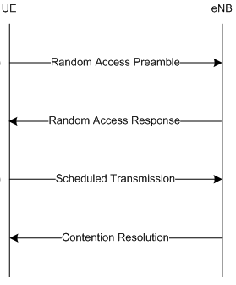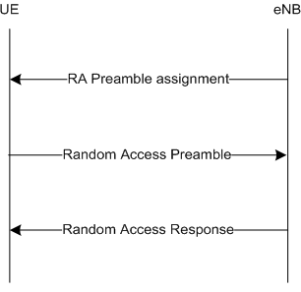
Figure 32: Contention based (left) and non-contention based (right) RACH procedures
Many of the parameters associated with the PRACH are configured during radio network planning, e.g. a re-use pattern is planned for the PRACH root sequences; cell ranges are planned using the PRACH configuration index and root sequence cyclic shift; PRACH capacity is planned using the PRACH configuration index. These planning activities are likely to require optimisation over time. Other parameters associated with the PRACH may also require optimisation, e.g. power control and resource allocation parameters.

Typical Issues
Issues with PRACH performance can be caused by:
- Antenna radiating beyond the planned maximum cell range
PRACH planning determines the maximum cell range. PRACH procedures will fail if UE are located outside the maximum cell range (causes PRACH preamble ambiguity). This can be caused by antennas radiating beyond the planned maximum cell range. The solution is to either re-plan the PRACH to support a larger cell range, down tilt antennas to avoid overshooting or modify parameters to reduce coverage.
- PRACH root sequence clashes and Ghost Calls
PRACH planning includes the allocation of root sequences to each cell. These root sequences should be allocated with a re-use pattern which avoids neighbouring cells using the same root sequences. If neighbouring cells are allocated the same root sequences then multiple cells can receive the same PRACH transmission from a UE. This can trigger multiple cells to initiate connections and thus create ‘ghost calls’. The risk is low when neighbouring cells are not time synchronised because each cell will generally listen for PRACH transmissions at different times. Cells belonging to the same eNodeB are time synchronised and complete networks may be time synchronised for features such as MBMS and time domain interference co-ordination.
- MSG1 to MSG2 Success Rate Degradation due to False Detections
The MSG1 to MSG2 Success Rate should normally be very close to 100%. This metric does not involve any transmission across the air-interface, i.e. the eNodeB receives MSG1 and pegs the attempt counter, then transmits MSG2 and pegs the success counter. So, this metric only involves processing within the eNodeB. However, the way in which the counters have been implemented mean that success rates less than 100 % are observed when there are false preamble detections. When the eNodeB detects a false preamble within the contention based preamble allocation then it does not know that the preamble is false. The eNodeB generates a MSG2 and transmits it across the air-interface. This keeps the metric at 100%. However, when the eNodeB detects a false preamble within the non-contention based preamble allocation then it does starts by pegging the attempt counter to record that a MSG1 has been received. But then the eNodeB recognises that it did not allocate that preamble to anyone and so does not generate MSG2 and the success counter does not get pegged. These false detections typically occur when there is high uplink interference.

- Unreliable reception of MSG3
MSG3 corresponds to the first PUSCH transmission. This means that it is transmitted before link adaptation and power control have had a chance to converge. MSG3 is transmitted using an initial Resource Block allocation, an initial MCS and an initial transmit power. If any of these are inaccurate then the eNodeB may struggle to receive MSG3. The drawback of allocating an increased number of Resource Blocks and a lower MCS is a negative impact upon cell capacity, i.e. each MSG3 transmission consumes more resources. It also reduces the transmit power per Resource Block for cell edge UE.
- Unreliable reception of MSG5
MSG5 corresponds to the second PUSCH transmission. Similar to MSG3, it is transmitted before link adaptation and power control have had a chance to converge. Thus, its reliability can also be impacted by the initial Resource Block, MCS and transmit power allocations.
- eNodeB processing capability
The eNodeB processing capability limits the number of Random-Access Responses (MSG2) which can be generated for each PRACH subframe. The eNodeB is specified to be capable of detecting all 64 PRACH preambles but only responding to 10 of them. The eNodeB also has a general limit upon the number of control plane actions which can be handled per second. This means that as cells become busier the success rate of the MSG1 -> MSG2 handshake will decrease.
- PDCCH congestion
PDCCH congestion can lead to blocking for the Random-Access Response (RAR) message. The RAR is transmitted on the PDSCH and requires its Resource Block Allocation to be signalled to the UE on the PDCCH. PDCCH transmissions for System Information and Paging resource allocations are prioritised over PDCCH transmissions for RAR. Blocking can occur if there is limited PDCCH capacity and transmissions for System Information, Paging and RAR coincide. This can occur when the number of PDCCH symbols is allocated dynamically because the algorithm waits for blocking to occur prior to upgrading the number of allocated symbols. Once blocking has occurred the eNodeB does not re-attempt transmission so the MSG1 to MGS2 handshake fails.

Performance Analysis
A thorough analysis of PRACH performance requires both network statistics and UE logging. Network statistics are not able to capture all aspects of PRACH performance. For example, if a UE is at the edge of coverage and is transmitting its PRACH preambles at maximum power but those preambles are not received by the eNodeB then network statistics will not capture the failed PRACH procedures.
UE logging tools capture each phase of the random-access procedure from the UE perspective. The information collected may include:
- the number of PRACH preambles (MSG1) and their transmit powers
- reception of resource allocations on the PDCCH for MSG2, MSG4 and MSG5
- reception of MSG2 (random access response) and MSG4 on the PDSCH
- transmission of MSG3 and MSG5 on the PUSCH
Network statistics collect information from the perspective of the eNodeB Table 37 Table 48 presents the set of eNodeB counters which are applicable to the PRACH procedure.
These counters can be used in combination with information from UE log files to help identify whether performance issues are caused by the uplink or downlink.
Counter Id | Counter Name | Comments
M8001C6 | RACH_STP_ATT_SMALL_MSG | MSG1 – contention based
M8001C7 | RACH_STP_ATT_LARGE_MSG | MSG1 – contention based
M8001C286 | RACH_STP_ATT_DEDICATED | MSG1 – non-contention based
M8001C8 | RACH_STP_COMPLETIONS | MSG2 – for all PRACH procedures
M8029C210 | RACH_STP_COMP_CONTENTION_BASED | MSG2 – contention based
M8029C209 | RACH_STP_COMP_CONTENTION_FREE | MSG2 – non-contention based
M8029C31 | RACH_MSG3_UL_DATA_NON_SYNC | MSG3 – when UE is out-of-sync
M8029C32 | RACH_MSG3_CONTENTION | MSG3 – contention based
M8013C17 | SIGN_CONN_ESTAB_ATT_MO_S | MSG3 – RRC Connection Request
M8013C18 | SIGN_CONN_ESTAB_ATT_MT | MSG3 – RRC Connection Request
M8013C19 | SIGN_CONN_ESTAB_ATT_MO_D | MSG3 – RRC Connection Request
M8013C91 | SIGN_CONN_ESTAB_ATT_OTHERS | MSG3 – RRC Connection Request
M8013C21 | SIGN_CONN_ESTAB_ATT_EMG | MSG3 – RRC Connection Request
M8013C31 | SIGN_CONN_ESTAB_ATT_HIPRIO | MSG3 – RRC Connection Request
M8013C34 | SIGN_CONN_ESTAB_ATT_DEL_TOL | MSG3 – RRC Connection Request
M8013C93 | SIGN_CONN_ESTAB_ATT_MO_VOICE | MSG3 – RRC Connection Request
M8008C4 | RRC_CON_RE_ESTAB_ATT | MSG3 – RRC Connection Re-est. Request
M8007C7 | SRB1_SETUP_ATT | MSG4 transmitted
M8007C8 | SRB1_SETUP_SUCC | MSG5 received
M8013C5 | SIGN_CONN_ESTAB_COMP | MSG5 received
M8013C6 | SIGN_EST_F_RRCCOMPL_MISSING | MSG5 not received
Table 37: Counters applicable to the PRACH procedure

The E-UTRAN RACH Setup Completion Success Rate KPI can be used to quantify the performance of the MSG1/MSG2 handshake:
LTE_5569a E-UTRAN RACH Setup Completion Success Rate
100 * SUM(RACH_STP_COMPLETIONS)
/ SUM (RACH_STP_ATT_SMALL_MSG + RACH_STP_ATT_LARGE_MSG + RACH_STP_ATT_DEDICATED)
This KPI assumes that MSG1 has been received successfully. The KPI includes the impact of all PRACH procedures. This KPI should generate high results even when there are issues with cell range or PRACH capacity. If there is an issue with cell range then PRACH preambles are misinterpreted by the eNodeB, i.e. the UE transmits preamble ‘x’ while the eNodeB thinks it receives preamble ‘y’. The eNodeB then generates a random access response for preamble ‘y’ and the handshake is recorded as a success (although the UE will not recognise the random access response). If there is an issue with PRACH capacity then the eNodeB can receive the same preamble from multiple UE. From the eNodeB perspective, these preambles appear as though they are multipath from the same transmission. The eNodeB generates a single random access response and records a single attempt and single success.
The performance of the E-UTRAN RACH Setup Completion Success Rate KPI can be degraded by PDCCH blocking. This can create a scenario where a PRACH preamble is received but a random access response is not transmitted. It can also be degraded by the eNodeB baseband processing capability, i.e. a maximum of 10 MSG2 can be generated for each PRACH occasion. However, it is more likely that the KPI is degraded by false PRACH preamble detections. These can become significant when uplink interference levels are high. Figure 33 illustrates an example set of cells with poor MSG1 to MSG2 Success Rate. This metric should normally be around 99%.
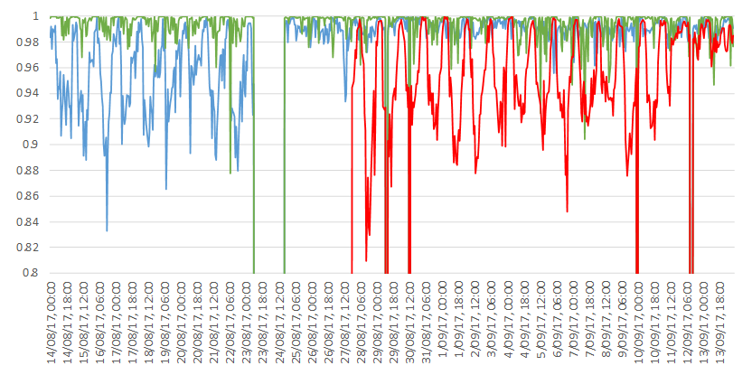
Figure 33: MSG1 to MSG2 Success Rate for cells on L800, L1800 and L1800
The performance degradation for these cells is believed to originate from false PRACH preamble detections. When the eNodeB detects a false preamble within the contention based preamble allocation then it does not know that the preamble is false. The eNodeB generates a MSG2 and transmits it across the air-interface. This keeps the metric at 100%. However, when the eNodeB detects a false preamble within the non-contention based preamble allocation then it does starts by pegging the attempt counter to record that a MSG1 has been received. But then the eNodeB recognises that it did not allocate that preamble to anyone and so does not generate MSG2 and the success counter does not get pegged. These false detections typically occur when there is high uplink interference
From LTE19A, it is possible to determine the MSG1 to MSG2 success rate separately for non-contention based preambles and for contention based preambles, using LTE_6986a and LTE_6987a respectively:
LTE_6986a E-UTRAN RACH Contention Free Setup Success Ratio
100 * SUM(RACH_STP_COMP_CONTENTION_FREE)
/ SUM(RACH_STP_ATT_DEDICATED)
LTE_6987a E-UTRAN RACH Contention Based Setup Success Ratio
100 * SUM(RACH_STP_COMP_CONTENTION_BASED)
/ SUM(RACH_STP_ATT_SMALL_MSG + RACH_STP_ATT_LARGE_MSG)
The E-UTRAN Complete Contention Based RACH Setup Success Rate KPI can be used to quantify the performance of the MSG1/MSG3 handshake for contention based procedures:
LTE_5670a E-UTRAN Complete Contention Based RACH Setup Success Rate
100 * SUM(RACH_MSG3_CONTENTION)
/ SUM(RACH_STP_ATT_SMALL_MSG + RACH_STP_ATT_LARGE_MSG)
The numerator of this KPI includes counters for RRC Connection Requests, RRC Connection Re-establishment Requests and MSG3transmission by UE which have uplink data to send while out-of-sync. The denominator captures the reception of all contention based preambles. The KPI definition assumes that handovers and downlink data arrival while the UE is out-of-sync use dedicated preambles.
This KPI is useful when determining whether or not the antenna is radiating beyond the planned maximum cell range. The performance will be relatively poor if UE attempt access at distances greater than the planned maximum cell range. This is caused by the eNodeB misinterpreting the PRACH preamble and then transmitting a random access response which is not recognised by the UE. The UE is then unable to proceed with MSG3 transmission. The KPI also includes the impact of the MSG2 and MSG3 link budgets. Poor reception in either the downlink or uplink directions will impact this KPI. This KPI also includes the impact of PDCCH blocking preventing MSG2 from being transmitted.
The Total E-UTRAN RRC Connection Setup Success Ratio KPI can be used to quantify the performance of the MSG3/MSG5 handshake for procedures associated with RRC connection establishment:
LTE_5218g Total E-UTRAN RRC Connection Setup Success Ratio
100 * SUM(sign_conn_estab_comp)
/ SUM(sign_conn_estab_att_mo_s + sign_conn_estab_att_mt + sign_conn_estab_att_mo_d + sign_conn_estab_att_del_tol + sign_conn_estab_att_hiprio + sign_conn_estab_att_emg + sign_conn_estab_att_mo_voice + sign_conn_estab_att_others)
The numerator of this KPI includes a counter for the RRC Connection Setup Complete message. The denominator captures the reception of all RRC Connection Request messages. The KPI assumes that MSG3 has been received successfully but captures any issues with MSG4 and MSG5.
The SRB1 Setup Success Ratio KPI can be used to quantify the performance of the MSG4/MSG5 handshake for RRC connection establishments. The numerator of this KPI includes a counter which is incremented when the RRC Connection Setup Complete message is received. The denominator includes a counter which is incremented when the RRC Connection Setup message is transmitted.
LTE_5a SRB1 Setup Success Ratio
100 * SUM(SRB1_SETUP_SUCC) / SUM(SRB1_SETUP_ATT)

Parameter Definition
The key parameters associated with PRACH planning are presented in Table 38.
Parameter | Object | Range | Default
prachConfIndex | LNCEL_FDD | 3 to 24 | Planning parameter
prachCS | LNCEL_FDD | 0 to 15 | Planning parameter
prachHsFlag | LNCEL_FDD | 0 (false), 1 (true) | Planning parameter
rootSeqIndex | LNCEL_FDD | 0 to 837, step 1 | Planning parameter
prachFreqOff | LNCEL_FDD | 0 to 94, step 1 | Planning parameter
Table 38: Key parameters associated with PRACH planning
PRACH planning should start by defining the target maximum cell range. It is important that the target maximum cell range is selected based upon a realistic expectation of cell range in the live network. PRACH procedures using both contention based preambles and dedicated preambles will fail if the live network cell range exceeds the planned maximum cell range.
The maximum target cell range determines the PRACH preamble format. The maximum cell range associated with each preamble format is presented in Table 39. Only the first 4 of these preamble formats are applicable to FDD. Preamble formats 0, 1 and 3 are supported by FL18.
Preamble Format | Application | Cyclic Prefix Duration | Sequence Duration | Guard Time | Total Duration | Typical Max. Cell Range
0 | FDD & TDD | 103.13 µs | 800 µs | 96.88 µs | 1 ms | 14.5 km
1 | FDD & TDD | 684.38 µs | 800 µs | 515.63 µs | 2 ms | 77.3 km
2 | FDD & TDD | 203.13 µs | 1600 µs | 196.88 µs | 2 ms | 29.5 km
3 | FDD & TDD | 684.38 µs | 1600 µs | 715.63 µs | 3 ms | 100.2 km
4 | TDD only | 14.58 µs | 133 µs | 9.38 µs | 0.16 ms | 1.4 km
Table 39: PRACH preamble formats
The maximum cell range associated with each preamble format is calculated as the minimum of the cell range associated with the cyclic prefix and the cell range associated with the guard time. Figure 34 illustrates the structure of the PRACH preamble with the position of the cyclic prefix and guard time.
Figure 34: Structure of a random access preamble
The choice of preamble format does not impact the capacity of the PRACH although it has some impact upon the overhead generated by the PRACH. The overhead generated by the PRACH impacts the capacity of the PUSCH. The overhead is more significant for the smaller channel bandwidths (the PRACH preamble always occupies 6 Resource Blocks in the frequency domain).
Preamble format 0 is the most commonly employed preamble format. When using format 0, it is important to ensure that live network coverage does not extend beyond 14.5 km.
The prachCS parameter also needs to be planned according to the maximum cell range. This parameter represents a pointer to a row within Table 40. The row has an impact upon the maximum supported cell range and the size of the PRACH root sequence re-use pattern. Supporting an increased cell range causes a reduction in the size of re-use pattern (making radio network planning more challenging).
The relationship between cell range and the root sequence re-use pattern size is caused by the increased propagation delay associated with larger cell ranges. 3GPP have specified a total of 838 PRACH root sequences from which the PRACH preamble sequences are generated. PRACH preamble sequences are generated from the root sequences by applying cyclic shifts. Larger cell ranges have larger propagation delays and so require larger cyclic shifts. This means that fewer PRACH preamble sequences can be generated from each root sequence. So, each cell requires more root sequences and the re-use pattern size decreases.
PrachCs | Size of Cyclic Shift | Preambles per Root Sequence | Root Sequences per Cell | Cell Range (km)
1 | 13 | 64 | 1 | 0.76
2 | 15 | 55 | 2 | 1.04
3 | 18 | 46 | 2 | 1.47
4 | 22 | 38 | 2 | 2.04
5 | 26 | 32 | 2 | 2.62
6 | 32 | 26 | 3 | 3.48
7 | 38 | 22 | 3 | 4.33
8 | 46 | 18 | 4 | 5.48
9 | 59 | 14 | 5 | 7.34
10 | 76 | 11 | 6 | 9.77
11 | 93 | 9 | 8 | 12.20
12 | 119 | 7 | 10 | 15.92
13 | 167 | 5 | 13 | 22.78
14 | 279 | 3 | 22 | 38.80
15 | 419 | 2 | 32 | 58.83
0 | 839 | 1 | 64 | 118.90
Table 40: Cell ranges vs. Preamble cyclic Shifts (PrachCS)
If PRACH preamble format 0 has been selected (14.5 km cell range) then prachCS should be configured with a value of 12, or less.
For high speed cells, the Doppler Effect has to be considered for preamble detection and for these cases there is a restricted set of preambles available. High speed is indicated by the prachHsFlag parameter. It is recommended to avoid enabling the high speed flag unless really necessary because it complicates the planning of PRACH root sequences.
The preamble format is used as an input when configuring the prachConfIndex parameter. prachConfIndex represents a pointer to a row within Table 41. This table is applicable to FDD and is divided into 4 sections (one section for each preamble format).
Selecting an appropriate row from Table 41 requires the PRACH capacity requirement to be considered. Higher capacities mean that PRACH transmissions can occur more frequently, i.e. the number of radio frames and subframes that include PRACH transmissions increase. PRACH capacity is discussed in greater detail within reference [2].
Selecting an appropriate row from Table 41 also requires the definition of a strategy in terms of either allocating the same prachConfIndex value to all cells at an eNodeB, or allocating different prachConfIndex values to each cell at an eNodeB. For example,
- prachConfIndex = 3 in all cells means that PRACH belonging to neighbouring sectors are time synchronised so there is PRACH->PRACH interference between sectors (viewed as less critical compared to PUSCH->PRACH interference), but each sector must be allocated a different root sequence so PRACH planning is more challenging.
- prachConfIndex = {3,4,5} across the three sectors of a site so there is PUSCH->PRACH interference between sectors but root sequence planning is simplified because each sector can be allocated the same root sequence
The current Nokia recommendation is to configure prachConfIndex with equal values in all cells at an eNodeB. This helps to minimise PUSCH->PRACH interference (inter-eNodeB PUSCH->PRACH interference will remain while the network is not time synchronised).

fig. Index | Preamble Format | SFN | Subframe Numbers |  | Config. Index | Preamble Format | SFN | Subframe Numbers
0 | 0 | Even | 1 |  | 32 | 2 | Even | 1
1 | 0 | Even | 4 |  | 33 | 2 | Even | 4
2 | 0 | Even | 7 |  | 34 | 2 | Even | 7
3 | 0 | Any | 1 |  | 35 | 2 | Any | 1
4 | 0 | Any | 4 |  | 36 | 2 | Any | 4
5 | 0 | Any | 7 |  | 37 | 2 | Any | 7
6 | 0 | Any | 1, 6 |  | 38 | 2 | Any | 1, 6
7 | 0 | Any | 2, 7 |  | 39 | 2 | Any | 2, 7
8 | 0 | Any | 3, 8 |  | 40 | 2 | Any | 3, 8
9 | 0 | Any | 1, 4, 7 |  | 41 | 2 | Any | 1, 4, 7
10 | 0 | Any | 2, 5, 8 |  | 42 | 2 | Any | 2, 5, 8
11 | 0 | Any | 3, 6, 9 |  | 43 | 2 | Any | 3, 6, 9
12 | 0 | Any | 0, 2 , 4, 6, 8 |  | 44 | 2 | Any | 0, 2 , 4, 6, 8
13 | 0 | Any | 1, 3, 5, 7, 9 |  | 45 | 2 | Any | 1, 3, 5, 7, 9
14 | 0 | Any | 0 to 9 |  | 46
15 | 0 | Even | 9 |  | 47 | 2 | Even | 9
16 | 1 | Even | 1 |  | 48 | 3 | Even | 1
17 | 1 | Even | 4 |  | 49 | 3 | Even | 4
18 | 1 | Even | 7 |  | 50 | 3 | Even | 7
19 | 1 | Any | 1 |  | 51 | 3 | Any | 1
20 | 1 | Any | 4 |  | 52 | 3 | Any | 4
21 | 1 | Any | 7 |  | 53 | 3 | Any | 7
22 | 1 | Any | 1, 6 |  | 54 | 3 | Any | 1, 6
23 | 1 | Any | 2, 7 |  | 55 | 3 | Any | 2, 7
24 | 1 | Any | 3, 8 |  | 56 | 3 | Any | 3, 8
25 | 1 | Any | 1, 4, 7 |  | 57 | 3 | Any | 1, 4, 7
26 | 1 | Any | 2, 5, 8 |  | 58 | 3 | Any | 2, 5, 8
27 | 1 | Any | 3, 6, 9 |  | 59 | 3 | Any | 3, 6, 9
28 | 1 | Any | 0, 2 , 4, 6, 8 |  | 60
29 | 1 | Any | 1, 3, 5, 7, 9 |  | 61
30 |  |  |  |  | 62
31 | 1 | Even | 9 |  | 63 | 3 | Even | 9
Table 41: PRACH Configuration Indices
Simulations have shown that PRACH->PRACH interference is preferred when compared to PUSCH->PRACH interference. This is because the PUSCH received power (SINR) can be very high compared to the PRACH SINR in the neighbour cell and so can effectively swamp the PRACH preambles and/or cause PRACH preamble misdetections (ghost PRACH).
Figure 35 presents a set of simulation results which illustrate the relationship between PUSCH SINR and the PRACH SINR required for a 1% probability of misdetection, i.e. the probability that a preamble is not detected by the eNodeB. There is a general trend towards increasing PRACH SINR requirement as the interfering PUSCH becomes stronger.
Figure 35: Simulation results for PUSCH SINR vs. PRACH SINR Requirement
Figure 36 shows simulation results which illustrate the relationship between PUSCH SINR and the PRACH false alarm rate, i.e. the probability that a preamble is falsely detected due to noise or interference when no such preamble was transmitted.
Up to an SNR of ~0 dB the degradation is acceptable, i.e. ~1% false alarm rate and PRACH SNR requirement increase of ~3dB. The degradation could be tolerable up to a PUSCH SNR of 4dB (switching point from QPSK to 16QAM on the PUSCH) with 5% false alarm rate and ~6 dB PRACH SNR requirement increase. In any case, higher PUSCH SNR has a strong (negative) impact upon PRACH detection.

Figure 36: Simulation Results for PUSCH SINR vs. PRACH False Alarm Rate

The prachFreqOff parameter determines the position of the PRACH in the frequency domain. The PRACH should always be positioned adjacent to the PUCCH to avoid segmentation of the PUSCH. This leads to only two possibilities for the position of the PRACH – at the lower or upper edge of the PUSCH region. In general, prachFreqOff is configured with an equal value across the network. However, site specific values can be introduced during capacity upgrades, i.e. if the PUCCH capacity is increased at a hotspot site then the capacity of the PUSCH will decrease and the PRACH will be moved inwards. Site specific values can also be introduced if there are issues with duplicate root sequence, i.e. the PRACH preambles can be isolated in the frequency domain to avoid ‘ghost calls’. Changes to prachFreqOff should be done at a site level rather than cell level if the impact of PUSCH->PRACH interference is to be minimized.

Table 37 presents the set of parameters to be considered during PRACH optimisation. These parameters are grouped according to their phase of the PRACH procedure, e.g. parameters associated with MSG1 transmission are grouped. These parameters are discussed in greater detail in the following sections.

 | Parameter | Object | Range | Default
MSG1 | ulpcIniPrePwr | SIB | -120 to -90 dBm | -96 dBm
MSG1 | prachPwrRamp | SIB | 0, 2, 4, 6 dB | 2 dB
MSG1 | preambTxMax | SIB | 3 to 20 | 10
MSG2 | pdcchAggRaresp | LNCEL | 4 to 8, step 4 | 4
MSG2 | maxCrRaDl | LNCEL | 0.05 to 0.5, step 0.01 | 0.12
MSG2 | raRespWinSize | LNCEL | 2 to 10 subframes | 10 subframes
MSG3 | raSmallVolUl | LNCEL | 56, 144, 208, 256 bits | 144 bits
MSG3 | deltaPreMsg3 | LNCEL | -1 to 6, step 1 | 1 (2 dB)
MSG3 | ulpcRarespTpc | LNCEL | -6 to 8, step 2 dB | 4 dB
MSG3 | harqMaxMsg3 | LNCEL | 1 to 8, step 1 | 5
MSG4 | pdcchAggMsg4 | LNCEL | 4 to 8, step 4 | 8
MSG4 | maxCrRa4Dl | LNCEL | 0.05 to 0.5, step 0.01 | 0.12
MSG4 | harqMaxTrDl | LNCEL | 1 to 16, step 1 | 5
MSG4 | raContResoT | LNCEL | 8 to 64 ms | 64 ms
MSG4 | T300 | SIB | 100 to 2000 ms | 400 ms
MSG4 | T301 | SIB | 100 to 2000 ms | 400 ms
MSG5 | iniMcsUl | LNCEL | 0 to 20, step 1 | 5
MSG5 | iniPrbsUl | LNCEL | 1 to 100, step | 10
MSG5 | ulsMinTbs | LNCEL | 32 to 1544, step 8 | 104
MSG5 | harqMaxTrUl | LNCEL | 1 to 7, step 1 | 5
Table 42: Parameters associated with PRACH optimisation

Optimization Procedure

MSG1
MSG1 corresponds to the PRACH preamble. Poor performance can be identified from UE log files if UE are transmitting large quantities of preambles without a response. Issues could be caused by:
- cell range
- power control
If a UE is located outside the maximum planned cell range then it will not receive a random access response because the eNodeB will misinterpret the transmitted preamble. This will lead to the UE continuing to transmit preambles until the maximum number of transmissions is reached. This scenario is illustrated in Figure 37.
Figure 37: PRACH preamble ambiguity outside the maximum planned cell range
If PRACH power control is not configured appropriately then the eNodeB may not receive PRACH preambles transmitted by the UE. Assuming a maximum UE transmit power of 23 dBm, the transmit power of a PRACH preamble is determined by the expression:
P_{PRACH} = Min{23, ulpcIniPrePwr + (Preamble_Tx_Cnt – 1) × prachPwrRamp + Path Loss}
This equation simplifies to Min{23, ulpcIniPrePwr + Path Loss} for the first preamble transmission. Assuming the default value for ulpcIniPrePwr (-96 dBm), the UE becomes power limited when the path loss equals 119 dB. Assuming a 20 W total downlink transmit power, this path loss can be converted to an equivalent RSRP for each channel bandwidth. This has been done in Table 43 while assuming that Reference Signal power boosting is disabled.
Channel Bandwidth | Resource Blocks | Resource Element Transmit Power | Power Limited RSRP
1.4 MHz | 6 | 24.4 dBm | -94.6 dBm
3 MHz | 15 | 20.4 dBm | -98.6 dBm
5 MHZ | 25 | 18.2 dBm | -100.8 dBm
10 MHz | 50 | 15.2 dBm | -103.8 dBm
15 MHz | 75 | 13.5 dBm | -105.5 dBm
20 MHz | 100 | 12.2 dBm | -106.8 dBm
Table 43: RSRP at which the UE becomes power limited for the first PRACH preamble

These results illustrate that the UE becomes power limited at relatively high RSRP, i.e. before the UE reaches cell edge. In the case of the 10 MHz channel bandwidth, the UE becomes power limited at an RSRP of -103.8 dBm. If the cell is configured with a Qrxlevmin = -124 dBm then a UE at cell edge will be received with 20 dB less power than a UE which has an RSRP greater than, or equal to -104 dBm. PRACH preambles are transmitted on shared Resource Blocks so there is a danger that the signal received from the UE at cell edge will become swamped by the signals received from UE in better coverage conditions. This scenario is illustrated in Figure 38.

Figure 38: PRACH preamble received power differences
This scenario corresponds to an aggressive PRACH power control strategy which tends to allocate a high PRACH preamble transmit power to help improve the probability of reception. This strategy sacrifices some cell edge performance for an improved average cell performance. Reducing the value of ulpcIniPrePwr means that preambles are transmitted with lower power and there will be a smaller received power difference between cell edge UE and UE in good coverage. This strategy will help to improve cell edge performance but may reduce the average cell performance because UE in good coverage will be received with less power.
The capability of network statistics to monitor the performance of MSG1 is limited. If the eNodeB fails to receive a preamble then network statistics will be unable to record an attempt. However, network statistics are able to reflect the performance impact of a cell range which exceeds the planned maximum cell range. This can be studied using the following KPI:
LTE_5670a E-UTRAN Complete Contention Based RACH Setup Success Rate
This KPI will become poor if UE are located outside the maximum planned cell range. Figure 39 illustrates an example of the Complete RACH Setup Success Rate for a cell which was initially configured with a maximum cell range of 15 km. In reality the coverage provided by the cell exceeded 15 km and UE were attempting access at larger cell ranges. This led to a very poor Setup Success Rate. Reconfiguring the PRACH parameters to support a cell range of 22 km provided a significant gain in performance.
Figure 39: Complete RACH Setup Success Rate as a function of cell range
It should be noted that a poor Complete RACH Setup Success Rate isn’t always caused by cell range but could also be caused by other issues, e.g. poor reliability of MSG3.
PRACH root sequence clashes which allow neighboring cells to receive the same PRACH preamble transmission also result in a degraded Complete RACH Setup Success Rate (when neighboring cells are time synchronized and are listening for PRACH preambles at the same time).When neighboring cells are unsynchronized then the impact of root sequence clashes is likely to be small.

MSG2
MSG2 corresponds to the Random Access Response (RAR). Areas of optimization include:
- PDCCH aggregation level
- coding rate
- waiting time
- PDCCH capacity
PDCCH Aggregation Level
The PDCCH is used to allocate PDSCH resources for the transfer of the RAR. It is transmitted using the common search space which supports aggregation levels of 4 and 8. 3GPP has not specified support for aggregation levels 1 and 2 because it must be possible to receive transmissions associated with the common search space at cell edge. The PDCCH aggregation level for the RAR can be configured using the pdcchAggRaresp parameter. The default value of 4 provides reliability without placing excessive load upon the PDCCH. Configuring a value of 8 will increase reliability but will also increase the PDCCH load and increase the probability of PDCCH blocking. Downlink Control Information (DCI) format 1C is used to allocate RAR resources. This DCI has a low payload size to help maximize the quantity of redundancy which can be included on the PDCCH.
Coding Rate
The maxCrRaDl parameter defines the maximum coding rate for the RAR on the PDSCH. This parameter is used by the downlink packet scheduler when identifying the Resource Block Requirement. A single RAR has a size of 56 bits (1 byte header + 6 bytes payload). DCI format 1C supports a limited range of transport block sizes but 56 bits is a supported transport block size. The physical layer adds a 24 bit CRC before applying channel coding. The default value for maxCrRaDl is 0.12 so the (56 + 24) bits would be increased to 667 bits. Random Access Responses are always transmitted using QPSK so this corresponds to 334 Resource Elements which requires 3 Resource Blocks to be allocated for transmission.
The default value for maxCrRaDl (0.12) is already a low coding rate which implies large quantities of redundancy to help protect the information bits as they are transferred across the air-interface. Decreasing the value of this parameter will increase redundancy further but will also increase the number of Resource Blocks required by each RAR transmission.
Waiting Time
The raRespWinSize parameter defines the waiting time for the RAR. The default value of 10 subframes is the maximum permitted value. The timing for the RAR isn’t completely fixed because it relies upon the uplink packet scheduler allocating resources for MSG3. These resources are signaled within the RAR. The RAR is also transmitted 6 subframes in advance of MSG3 transmission. The downlink packet scheduler must be able to allocate both PDCCH and PDSCH resources during that subframe otherwise the RAR will be blocked.
PDCCH Capacity
PDCCH transmissions for System Information Blocks (SIB) and paging messages are prioritized over PDCCH transmissions for Random Access Responses (RAR). All 3 of these PDCCH transmissions use an aggregation level of 4 (assuming the default Nokia parameter set). Thus, there should always be PDCCH capacity available for the RAR if there are at least 3 x 4 = 12 CCE. The 10 MHz channel bandwidth has only 10 CCE when a single symbol is allocated to the PDCCH. This means that PDCCH blocking for the RAR will occur if the eNodeB needs to transmit the PDCCH for the SIB, paging and RAR during the same subframe. Paging messages are only broadcast during subframe 9 so all other subframes are always able to transmit the PDCCH for SIB and RAR. The dynamic allocation of PDCCH symbols allows blocking to occur prior to triggering an upgrade. This means that blocking can occur even when a maximum of 3 symbols are permitted for the PDCCH. Increasing the number of PRACH subframes per radio frame increases the probability of PDCCH blocking because it can become necessary to transmit multiple RAR PDCCH during a single subframe.

MSG3
MSG3 typically corresponds to the first RRC message, e.g. RRC Connection Request, RRC Re-establishment Request or RRC Reconfiguration Complete. Areas of optimization include:
- short vs. long MSG3
- power control
- re-transmission count
Short vs. Long Msg3
MSG3 can be allocated resources for either a short payload size or a long payload size. The eNodeB always allocates resources for a long payload size when using the non-contention based procedure. The eNodeB selects between a short or long payload size when using the contention based procedure. Selection is done according to the type of PRACH preamble transmitted by the UE. If the UE transmits a Group A preamble then the eNodeB selects a short payload size, whereas if the UE transmits a Group B preamble then the eNodeB selects a long payload size.
The UE transmits a Group B preamble if both of the following conditions are satisfied:
Message Size > raSmallVolUl AND
Path Loss < P_{MAX} – ulpcIniPrePwr – deltaPreMsg3 – raMsgPoffGrB
Otherwise, the UE transmits a Group A preamble. This means that UE tend to be allocated more Resource Blocks for MSG3 when the UE is in good coverage and has larger volumes of data in its buffer. UE can be forced to always select a Group A preamble if the raPreGrASize parameter is set equal to the raNondedPreamb parameter, i.e. the size of Group B is set to 0.
The parameters shown in Table 44 are used to determine the number of Resource Blocks allocated for MSG3.
Parameter | Object | Range | Default
raSmallVolUl | LNCEL | 56, 144, 208, 256 bits | 144 bits
raLargeVolUl | LNBTS | not configurable | 512 bits
raSmallMcsUl | LNCEL | not configurable | 5
raLargeMcsUl | LNCEL | not configurable | 5
Table 44: Parameters used to determine the number of Resource Blocks allocated for MSG3
If the eNodeB selects a short payload size then it allocates the number of Resource Blocks which are able to accommodate a transport block size equal to raSmallVolUl while using an MCS = 5 (QPSK). The number of Resource Blocks is identified using the 3GPP look-up table presented in Table 45. This results in 2 Resource Blocks being allocated.
If the eNodeB selects a long payload size then it allocates the number of Resource Blocks which are able to accommodate a transport block size equal to raLargeVolUl while using an MCS = 5 (QPSK). The number of Resource Blocks is identified in the same way as for the short payload. This results in 8 Resource Blocks being allocated. Note that 7 Resource Blocks are sufficient according to the 3GPP look-up table but 3GPP does not permit an uplink allocation of 7 Resource Blocks. It must always be possible to calculate Resource Block allocation from the expression: 2^{x} × 3^{y} × 5^{z}.
 | 1 | 2 | 3 | 4 | 5 | 6 | 7 | 8 | 9 | 10
0 | 16 | 32 | 56 | 88 | 120 | 152 | 176 | 208 | 224 | 256
1 | 24 | 56 | 88 | 144 | 176 | 208 | 224 | 256 | 328 | 344
2 | 32 | 72 | 144 | 176 | 208 | 256 | 296 | 328 | 376 | 424
3 | 40 | 104 | 176 | 208 | 256 | 328 | 392 | 440 | 504 | 568
4 | 56 | 120 | 208 | 256 | 328 | 408 | 488 | 552 | 632 | 696
5 | 72 | 144 | 224 | 328 | 424 | 504 | 600 | 680 | 776 | 872
Table 45: Transport Block Size Table. Extract (3GPP TS36.213 v9.3.0 Table 7.1.7.2.1-1)
The results indicate that MSG3 has 10×LOG(8/2) = 6 dB greater power headroom when using the short payload size, i.e. coverage will be 6 dB better because the UE spreads its transmit power capability across fewer Resource Blocks.
An RRC Connection Request message has a size of 48 bits. Padding is used to increase the payload to 144 bits when allocating 2 Resource Blocks. This padding represents an overhead which requires additional UE transmit power and degrades the uplink link budget. The link budget can be improved if the UE is allocated a transport block size of 72 bits with 1 Resource Block. The UE can double its transmit power per Resource Block when allocated 1 Resource Block rather than 2 Resource Blocks. The coding rate remains the same in both cases because the payload halves from 144 bits to 72 bits while the physical capacity also halves from 2 Resource Blocks to 1 Resource Block. This change can be implemented by reconfiguring raSmallVolUl from 144 bits to 56 bits.
MSG3 Power Control
MSG3 is transmitted on the PUSCH using a power which is calculated from:
P_{PUSCH} = Min{23, 10×LOG(M_{PUSCH}) + ulpcIniPrePwr + deltaPreMsg3 + Path Loss + Δ_{TF} + f(i)}
where,
M_{PUSCH} is the number of allocated Resource Blocks
ulpcIniPrePwr is the same parameter as used for MSG1 transmission
deltaPreMsg3 is a parameter which can be configured with values ranging from -2 to 12 dB. It has a default value of 2 dB.
Δ_{TF} is dependent upon the deltaTfEnable parameter (disabled by default)
f(i) is the closed loop power control command configured using the ulpcRarespTpc parameter and provided within the Random Access Response. Note that closed loop power control is not fully operational at this point so ulpcRarespTpc provides a static power offset for all UE.
It should be noted that adjusting the parameters in the power control equation above in an attempt to improve PRACH performance may have little impact. The UE is likely to be already transmitting at 23 dBm at locations where MSG3 reliability is poor. It is not possible to increase the total transmit power above the UE capability. The ‘Short vs. Long MSG3’ section achieved a link budget gain by increasing the transmit power per Resource Block rather than increasing the total transmit power.
Increasing the total UE transmit power at locations where the UE is not already transmitting at maximum power may improve performance at those locations but will also increase levels of uplink inter-cell interference generated by the PUSCH. This is likely to be observed as short term interference spikes which reduce as transmissions continue and closed loop power control becomes active.
MSG3 Re-transmissions
When establishing a new connection, the reliability of MSG3 can be modified using the harqMaxMsg3 parameter. This parameter defines the maximum permitted number of re-transmissions for MSG3. It has a default value of 5, and a range from 1 to 8. Random access procedures during an existing connection, e.g. handovers, use the more general harqMaxTrUl parameter to specify the maximum number of re-transmissions. UE in good coverage should not require an increased number of re-transmissions but UE in weaker coverage may benefit from them.
Increasing the value allocated to harqMaxMsg3 can have the following impact:
- improved accessibility due to the additional reliability provided by the extra re-transmissions. The average call setup time may increase due to the connections which previously failed but now establish with an increased number of re-transmissions. This impact upon average call setup time is likely to be very small
- each MSG3 re-transmission consumes PUSCH resources so there would be a small impact upon PUSCH capacity and uplink throughputs (likely to be a very small impact)
- as noted within the MSG3 Power Control section, MSG3 is transmitted prior to closed loop power control becoming properly active. This means that each MSG3 transmission may generate an uplink interference spike. These spikes would become more frequent if the number of re-transmissions is increased
From LTE17A, the feature LTE2369: Message 3 DTX Robustness can improve the reliability of the Msg1 to Msg 3 success rate. When this feature is enabled:
- If the eNB does not receive Msg3, i.e. it detects Msg3 DTX, instead of indicating DTX to L2, it initiates a Msg3 retransmission by sending a NACK on the PHICH
- An offset set by msg3DtxOffset is applied to the normal SINR threshold for DTX detection
- The eNB will c006Fntinue to initiate Msg3 retransmission until
  - Msg3 has been successfully received
  - There have been msg3ConsecutiveDtx retransmissions initiated
  - The maximum allowed number of retransmissions set by harqMaxMsg3 or harqMaxTxUl have been reached

MSG4
MSG4 corresponds to the RRC Connection Setup message during connection establishment. Areas of optimization include:
- PDCCH aggregation level
- coding rate
- re-transmission count
- waiting times
PDCCH Aggregation Level
The PDCCH is used to allocate PDSCH resources for the transfer of MSG4. PDCCH link adaptation and power control have not started to operate at this stage. Downlink Control Information (DCI) format 1A is used to allocate MSG4 resources. This DCI is larger than format 1C used for the Random Access Response (MSG2). A static PDCCH aggregation level can be configured using the pdcchAggMsg4 parameter. An aggregation level of 4 or 8 is permitted. Aggregation levels 1 and 2 are not permitted because the value needs to be applicable to UE across the entire cell area, i.e. including those at cell edge. The default value of 8 provides reliability at the cost of additional PDCCH load. Configuring a value of 4 will reduce the PDCCH load but will also reduce reliability.
Coding Rate
The maxCrRa4Dl parameter defines the maximum coding rate for MSG4 on the PDSCH. This parameter is used by the downlink packet scheduler when identifying the Resource Block Requirement. The size of MSG4 is variable but MSG4 is always transmitted using QPSK.
The default value for maxCrRa4Dl (0.12) is already a low coding rate which implies large quantities of redundancy to help protect the information bits as they are transferred across the air-interface. Decreasing the value of this parameter will increase redundancy further but will also increase the number of Resource Blocks required by each MSG4 transmission.
MSG4 Re-transmissions
The reliability of MSG4 can be modified using the harqMaxTrDl parameter. This parameter defines the maximum permitted number of transmissions (original transmission + re-transmissions). It is generally applicable to the downlink and is not just applicable to MSG4. Thus, modifying this parameter will impact the downlink throughout the lifetime of the connection. The parameter has a default value of 5 (allowing up to 4 re-transmissions), and a range from 1 to 16.
Waiting Time
The raContResoT parameter defines the waiting time for MSG4. This parameter is named after contention resolution because the UE Contention Resolution Identity MAC Control Element is included within the MSG4 header information. The parameter has a default value of 64 ms which is already the maximum permitted value.
T300 defines the waiting time for the RRC Connection Setup message after transmitting the RRC Connection Request message, i.e. it corresponds to the waiting time for MSG4 after transmitting MSG3. Similarly, T301 defines the waiting time for the RRC Connection Re-establishment message after transmitting the RRC Connection Re-establishment Request message. Both of these parameters have default values of 400 ms and maximum values of 2000 ms. Increasing the values of T300 and T301 is unlikely to have much impact upon the reliability of MSG4 reception.

MSG5
MSG5 corresponds to the RRC Connection Setup Complete message during connection establishment. Areas of optimization include:
- resource allocation (MCS and Resource Blocks)
- re-transmission count
Resource Allocation
The iniMcsUl parameter defines the MCS applicable to MSG5. The default value of 5 corresponds to QPSK. The iniPrbsUl parameter defines the maximum number of Resource Blocks which can be allocated for MSG5, whereas the ulsMinTbs parameter defines the minimum Transport Block Size which can be allocated for MSG5. The combination of ulsMinTbs and iniMcsUl defines the minimum number of Resource Blocks which can be allocated for MSG5. The default parameter set means that the UE is allocated between 2 and 10 Resource Blocks.
MSG5 Re-transmissions
The reliability of MSG5 can be modified using the harqMaxTrUl parameter. This parameter defines the maximum permitted number of transmissions (original transmission + re-transmissions). It is generally applicable to the uplink and is not just applicable to MSG5. Thus, modifying this parameter will impact the uplink throughout the lifetime of the connection. The parameter has a default value of 5 (allowing up to 4 re-transmissions), and a range from 1 to 7.
Once msg5 detection has been improved, further optimization can be used to target the subsequent signaling procedures, i.e. security mode procedure and RRC Connection Reconfigurations. The iniPrbsUl parameter can be decreased to match the number of Resource Blocks allocated to MSG5. The ramp-up of allocated Resource Blocks can then be made more rapid by enabling Fast Uplink Link Adaptation or by reducing the value of eUlLaPrbIncDecFactor (from 0.8 to 0.7).

Procedures
Poor Performance Observed from UE Log File
The optimization procedure illustrated in Figure 40 is applicable when UE log files indicate that the UE is transmitting the maximum number of PRACH preambles without receiving a response from the eNodeB.
Figure 40: Optimisation procedure –
UE log file indicates maximum preamble transmissions without a response

Step 1: Check that MSG1 and MSG2 parameters are configured correctly
The procedure starts with a databuild check to ensure that parameter discrepancies are not causing the performance issue. The parameters to check are:
- ulpcIniPrePwr
- prachPwrRamp
- preambTxMax
- pdcchAggRaresp
- maxCrRaDl
- raRespWinSize

Step 2: Root Cause selection
Root Cause 1: UE is outside the maximum cell range
If the UE log file includes GPS data then the distance from the UE to serving cell can be calculated. If this distance is greater than the planned maximum cell range then Root Cause 1 should be selected. If GPS data is not available then BTS logging with Emil can be used to determine whether or not the PRACH preamble transmitted by the UE was detected correctly. If the UE is outside the planned maximum cell range then the eNodeB will detect an incorrect cyclic shift for the received preamble.
Root Cause 2: eNodeB is not receiving MSG1
BTS logging can be used to determine whether or not the eNodeB is receiving MSG1. Analysis will be simplified if testing is completed during a period with less traffic, i.e. it will be easier to separate the test mobile transmissions from the background traffic transmissions.
Root Cause 3: UE is not receiving MSG2
BTS logging can be used to determine whether or not the eNodeB transmitted MSG2 (random access response). The UE log file can then be used to verify whether or not the UE received MSG2.
Step 3: Cell Range Optimisation
There are two options for cell range optimization:
- increase the planned maximum cell range
- reduce the coverage footprint of the cell
Increasing the planned maximum cell range requires consideration of the PRACH preamble format (configured using prachConfIndex). If the new cell range requirement is greater than 14.5 km then it will be necessary to use PRACH preamble format 1. Increasing the planned maximum cell range also requires consideration of the PRACH cyclic shift (configured using prachCS). A larger cyclic shift will be required to increase the cell range. This has an impact upon root sequence planning and it may be necessary to re-allocate a root sequence to the cell (using the rootSeqIndex parameter). Re-allocation of the root sequence should account for the number of root sequences required by the cell and those used by all neighbouring cells.
Reducing the coverage footprint of the cell can be achieved by parameter changes, or by physical changes. Increasing the value of qrxlevmin will reduce the idle mode coverage area. PRACH procedures associated with handovers will also fail if the planned maximum cell range is exceeded so it will also be necessary to adjust handover parameters to ensure that handovers are only triggered within the target cell range. If Reference Signal power boosting is enabled then disabling the boosting will help to reduce the cell range. Antenna downtilts can be applied to reduce the cell range without changing any parameters.
Step 4: MSG1 Power Control Optimisation
Optimisation of MSG1 power control requires consideration of whether or not PRACH preambles are failing to be received because:
- the UE is transmitting with insufficient power
- the preamble received power is being swamped by preambles received by other UE
The first scenario could be solved by increasing the value of ulpcIniPrePwr, prachPwrRamp or preambTxMax. However, it is likely that UE are already transmitting at their maximum power (check from UE log file) so these changes would not help. In that case it is necessary to improve the uplink link budget in some other way. Checks should be made upon uplink interference levels. If there is PUSCH to PRACH interference then it is possible that the relatively high powers associated with the PUSCH are preventing the PRACH preambles from being received. Ultimately, reducing the cell range will help to improve the PRACH preamble link budget. The value of qrxlevmin should be checked to verify that a sensible value is configured.
The second scenario could be solved by reducing the value allocated to ulpcIniPrePwr. This will cause all UE in the cell to use less transmit power for their PRACH preambles and will reduce levels of uplink interference. Checks should be made to ensure that the average cell performance is not compromised.
Step 5: MSG2 PDCCH Optimisation
It is necessary for the UE to receive the PDCCH prior to receiving MSG2 on the PDSCH. The PDCCH is used to signal the PDSCH resource allocation to the UE. The reliability of the PDCCH is dependent upon its aggregation level which is configured using the pdcchAggRaresp parameter. This parameter has a default value of 4 but can also be configured with a value of 8. The value of 8 will increase reliability but will have an impact upon PDCCH load. The PDCCH load should be carefully monitored if the aggregation level is increased to 8.
It is also possible that PDCCH blocking is preventing the Random Access Response (RAR) from being transmitted. This can occur even when the cell load is low because the dynamic allocation of symbols for the PDCCH allows blocking to occur prior to triggering an upgrade. PDCCH transmissions for System Information and Paging messages are prioritized over PDCCH transmissions for the RAR. A static allocation of 2 or 3 symbols for the PDCCH can help to prevent PDCCH blocking for the RAR.
Step 6: MSG2 Optimisation
The transmission of MSG2 on the PDSCH can be optimized in terms of its coding rate using the maxCrRaDl parameter. The default value of 0.12 is already relatively low which means that high quantities of redundancy are included prior to transmitting the RAR across the air-interface. Decreasing the coding rate further will mean that additional redundancy is included, e.g. a value of 0.05 could be trialed. The drawback of decreasing the coding rate is an increased Resource Block requirement.
The waiting time for the RAR is defined by the raRespWinSize parameter. The default value of 10 subframes is already the maximum allowed value.
Poor Performance Observed from Network Statistics
The optimization procedure illustrated in Figure 41 is applicable when the KPI: LTE_5569 E-UTRAN RACH Setup Completion Success Rate, demonstrates poor performance. This KPI should generate a result close to 100% because it only relies upon BTS internal procedures. It relies upon the eNodeB having sufficient control planning processing capacity to generate Random Access Responses (RAR). It also relies upon the eNodeB completing successful PDCCH, PDSCH and PUSCH scheduling. The PDCCH is scheduled to allocate the PDSCH resources. The PDSCH is scheduled to transfer the RAR. The PUSCH is scheduled to transfer MSG3 (the resource allocation for MSG3 is included within the RAR).
Figure 41: Optimisation procedure –
Network Statistics show poor performance for E-UTRAN RACH Setup Completion Success Rate

Step 1: Verify KPI Definition
The KPI definition should be checked to ensure that the expected counters are included. The numerator should include a single counter which captures the transmission of all Random Access Responses (RAR). The denominator should include 3 counters which capture the reception of contention based preambles (small and large) and non-contention based preambles (dedicated preambles).
Step 2: Check that MSG1 and MSG2 parameters are configured correctly
A databuild check should be completed to ensure that parameter discrepancies are not causing the performance issue. The main parameters to check are:
- pdcchAggRaresp
- actLdPdcch
- maxNrSymPdcch
The pdcchAggRaresp parameter can be configured with a value of 4 or 8. A value of 8 helps to improve PDCCH coverage but also increases the probability of PDCCH blocking. PDCCH capacity should be considered when selecting an appropriate value. Smaller channel bandwidths have lower PDCCH capacity. PDCCH blocking can degrade the performance of the LTE_5569 KPI.
The actLdPdcch parameter enables the dynamic allocation of symbols for the PDCCH. The PDCCH can experience blocking when this feature is enabled because blocking is used to trigger an upgrade to the number of allocated symbols. If PDCCH blocking is suspected as being the cause for degraded KPI performance, then dynamic allocation can be disabled and a static allocation of 2 or 3 symbols can be configured using the maxNrSymPdcch parameter. It is possible to improve the responsiveness of the eNB to necessary aggregation levels downgrades by allocating a low value to the parameter adaptPdcchDwellTime.
Step 3: Root Cause selection
Root Cause 1: PDCCH Blocking
Only a single root cause is specified although successful transmission of the Random Access Response (RAR) relies upon PDCCH, PDSCH and PUSCH scheduling. PDSCH and PUSCH scheduling are less likely to cause blocking of the RAR. The PDCCH is most likely to cause blocking for smaller channel bandwidths and when only a single symbol is allocated to the PDCCH (dynamic allocation of symbols is likely to allocate a single symbol during periods of low traffic).
Step 4: PDCCH Capacity Optimisation
The PDCCH capacity should be evaluated considering that PDCCH transmissions for System Information Blocks (SIB) and Paging are prioritised over PDCCH transmissions for Random Access Responses (RAR). The default eNodeB databuild defines a PDCCH aggregation level of 4 for all of these transmissions. Thus at least 12 CCE must be available to allow all 3 of these transmissions during a single subframe. Depending upon the PRACH configuration, it may be necessary to transmit multiple PDCCH for RAR during a single subframe. This increases the probability of RAR blocking. The probability of blocking can be minimised by configuring a static allocation of symbols > 1. The drawback of a static allocation is a decreased PDSCH capacity during periods of low traffic during which the dynamic allocation algorithm would normally allocate only a single symbol.
The optimization procedure illustrated in Figure 42 is applicable when network statistics show poor performance for the LTE_5670a E-UTRAN Complete Contention Based RACH Setup Success Rate.
Figure 42: Optimisation procedure –
Network Statistics show poor performance for Complete RACH Setup Success Rate
Step 1: Verify KPI Definition
It is necessary to verify the KPI definition in case an old definition is being used. KPI definitions often change with software releases so they should be updated to maintain the latest definition. It is also important to understand the counters included within the KPI definition and to understand how the KPI results should be interpreted.
Step 2: Check that MSG1, MSG2 and MSG3 parameters are configured correctly
A databuild check should be completed to ensure that parameter discrepancies are not causing the performance issue. The parameters to check are:
- ulpcIniPrePwr
- prachPwrRamp
- preambTxMax
- pdcchAggRaresp
- maxCrRaDl
- raRespWinSize
- raSmallVolUl
- deltaPreMsg3
- ulpcRarespTpc
- harqMaxMsg3
Step 3: Root Cause selection
Root Cause 1: UE is outside the maximum cell range
If UE are located outside the maximum planned cell range, then the eNodeB will misinterpret the PRACH preamble. Random Access Responses (RAR) are addressed using the PRACH preamble so misinterpreting the preamble means the UE will not receive the RAR.
Root Cause 2: UE is not receiving MSG2
The UE will not receive MSG2 if it is not transmitted (potentially caused by PDCCH blocking). The UE may not receive MSG2 if the PDCCH or PDSCH link budgets are not satisfied.

Root Cause 3: eNodeB is not receiving MSG3
The eNodeB may not receive MSG3 if the PUSCH link budget is not satisfied.

Root Cause 4: eNodeB is misdetecting MSG1
If the eNodeB is receiving high levels of interference power during PRACH subframes then its PRACH detection algorithm may trigger false detections, i.e. it may falsely detect PRACH preambles in the noise which were not transmitted.
Step 4: Cell Range Optimisation
There are two options for cell range optimization:
- increase the planned maximum cell range
- reduce the coverage footprint of the cell
Increasing the planned maximum cell range requires consideration of the PRACH preamble format (configured using prachConfIndex). If the new cell range requirement is greater than 14.5 km then it will be necessary to use PRACH preamble format 1. Increasing the planned maximum cell range also requires consideration of the PRACH cyclic shift (configured using prachCS). A larger cyclic shift will be required to increase the cell range. This has an impact upon root sequence planning and it may be necessary to re-allocate a root sequence to the cell (using the rootSeqIndex parameter). Re-allocation of the root sequence should account for the number of root sequences required by the cell and those used by all neighbouring cells.
Reducing the coverage footprint of the cell can be achieved by parameter changes, or by physical changes. Increasing the value of qrxlevmin will reduce the idle mode coverage area. PRACH procedures associated with handovers will also fail if the planned maximum cell range is exceeded so it will also be necessary to adjust handover parameters to ensure that handovers are only triggered within the target cell range. If Reference Signal power boosting is enabled then disabling the boosting will help to reduce the cell range. Antenna downtilts can be applied to reduce the cell range without changing any parameters.
Step 5: MSG2 PDCCH Optimisation
The PDCCH capacity should be evaluated considering that PDCCH transmissions for System Information Blocks (SIB) and Paging are prioritised over PDCCH transmissions for Random Access Responses (RAR). The default eNodeB databuild defines a PDCCH aggregation level of 4 for all of these transmissions. Thus at least 12 CCE must be available to allow all 3 of these transmissions during a single subframe. Depending upon the PRACH configuration, it may be necessary to transmit multiple PDCCH for RAR during a single subframe. This increases the probability of RAR blocking. The probability of blocking can be minimised by configuring a static allocation of symbols > 1. The drawback of a static allocation is a decreased PDSCH capacity during periods of low traffic during which the dynamic allocation algorithm would normally allocate only a single symbol.
Step 6: MSG2 Optimisation
The transmission of MSG2 on the PDSCH can be optimized in terms of its coding rate using the maxCrRaDl parameter. The default value of 0.12 is already relatively low which means that high quantities of redundancy are included prior to transmitting the RAR across the air-interface. Decreasing the coding rate further will mean that additional redundancy is included, e.g. a value of 0.05 could be trialed. The drawback of decreasing the coding rate is an increased Resource Block requirement.
The waiting time for the RAR is defined by the raRespWinSize parameter. The default value of 10 subframes is already the maximum allowed value.
Step 7: MSG3 Optimisation
MSG3 typically corresponds to the first RRC message, e.g. RRC Connection Request, RRC Re-establishment Request or RRC Reconfiguration Complete. Areas of optimization include:
- Resource Blocks
- power control
- re-transmission count
The majority of MSG3 transmissions trigger the use of a ‘short’ PRACH preamble rather than a ‘long’ PRACH preamble. The number of Resource Blocks allocated for ‘short’ PRACH preambles can be controlled using the raSmallVolUl parameter. By default, this parameter is configured with a value of 144 bits which results in 2 Resource Blocks being allocated for MSG3. Reducing the value to 56 bits results in 1 Resource Block being allocated. Reducing the number of allocated Resource Blocks by a factor of 2 increases the UE transmit power per Resource Block by a factor of 2. This improves the link budget by 3 dB. The reduction in Resource Blocks does not change the coding rate because the allocated transport block size also reduces. This is illustrated by the following:
raSmallVolUl = 144 bits
Allocated Resource Blocks = 2
Transport Block Size = 144 bits
MSG3 Size (RRC Connection Request example) = 48 bits
Padding = 96 bits
raSmallVolUl = 56 bits
Allocated Resource Blocks = 1
Transport Block Size = 72 bits
MSG3 Size (RRC Connection Request example) = 48 bits
Padding = 24 bits
The default configuration which allocates 2 Resource Blocks leads to an increased quantity of padding which provides no benefit and does not increase air-interface redundancy.
The transmit power of MSG3 is primarily defined by the transmit power of the previous PRACH preamble. A transmit power offset can be configured using the deltaPreMsg3 parameter. This parameter can be used to increase the transmit power of MSG3 without impacting the transmit power of the PRACH preambles. The main limitation is the UE transmit power capability. Failed MSG3 transmissions are likely to be associated with locations with poor coverage where the UE is already transmitting at its maximum power capability. In these cases, increasing the value of deltaPreMsg3 will not have any impact.
The maximum number of MSG3 re-transmissions for new connections can be controlled using harqMaxMsg3 parameter. This parameter has a default value of 5, and a range from 1 to 8. Random access procedures for an existing connection, e.g. handovers, use the more general harqMaxTrUl parameter to specify the maximum number of re-transmissions. UE in good coverage should not require an increased number of re-transmissions but UE in weaker coverage may benefit from them.
During time-critical procedures, i.e. handovers between cells, it is desirable to not have to perform a contention based procedure. The pdcchAggRarespHo can be used to apply a power boost to Msg3 retransmissions in the scenario that initial transmission was unsuccessful and the PDCCH aggregation level for MSG2 is already set to 8.
Step 8: Interference Optimisation
High levels of inter-cell interference could trigger false detections of PRACH preambles, i.e. the eNodeB thinks that it has detected a PRACH preamble, although that PRACH preamble was not transmitted. Reducing high levels of inter-cell interference can be achieved by RF optimisation

Use of SON
The eNodeB feature LTE1235 Optimization of PRACH Power can be used to automatically tune the UE transmit power used for the first PRACH preamble. The databuild associated with this feature is presented in Table 46.
Parameter | Object | Range | Default
actUlpcRachPwrCtrl | LNCEL | False, True | False
sibUpdateRateThreshold | LNBTS | 5 to 31, step 1 | 25
ulpcRachTgtPwrDelta | LNBTS | 0 to 29, step 1 dB | 3 dB
ulpcRachPwrRipOffset | LNBTS | 0 to 20, step 1 dB | 10 dB
Table 46: Parameters associated with LTE1235 Optimisation of PRACH Power
The eNodeB measures the uplink interference levels across the set of Resource Blocks allocated to the PRACH. It then decides if the UE transmit power needs to be adjusted. Decreasing the value of ulpcRachTgtPwrDelta will make the algorithm more sensitive and will increase the number of changes. However, the PRACH parameters are broadcast in the SIB and there is a 3GPP limit upon the number of times that the SIB can be updated per hour (otherwise UE may not detect that the SIB have changed, i.e. the SIB value tag cycles through its complete range).
Figure 43 illustrates an example of LTE1235 automatically changing the PRACH power during a period of 3 days. The feature increases the power during the busy hours when the levels of interference are relatively high.
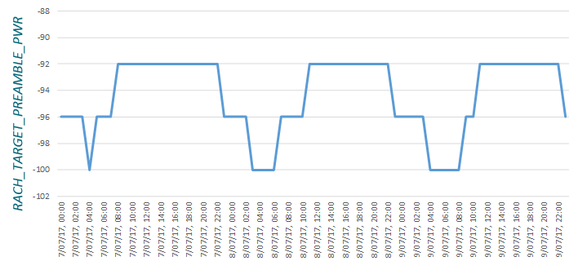
Figure 43: Automatic changes to the PRACH power using LTE1235
The counters belonging to LTE1235 are presented inTable 47. The majority of these are based upon information received from the UE. The eNodeB does not have direct visibility of PRACH preamble attempts and contention. The eNodeB requests this information from the population of UE using the Information Request procedure. The UE reports the number of preambles used for the most recent PRACH procedure and whether or not contention was detected. Some of the counters in Table 47 are pegged when the UE was power limited for the PRACH procedure. This information is not reported by the UE so the eNodeB has to estimate whether or not the UE was power limited.
Counter Id | Counter Name | Comments
M8005C340 | RACH_ONE_PREAMBLE_SUCC | These counters are based upon data received from UE RACH Reports within UE Information Response message
M8005C341 | RACH_RETX_PREAMBLE_SUCC
M8005C342 | RACH_ALL_ONE_PREAMBLE_SUCC
M8005C343 | RACH_ALL_RETX_PREAMBLE_SUCC
M8005C344 | RACH_PREAMBLE_COLLISIONS
M8005C345 | RACH_TARGET_PREAMBLE_PWR | Reflects the parameter value
Table 47: Counters associated with LTE1235 Optimisation of PRACH Power
Figure 44 illustrates an example UE Information Response message where the UE indicates that contention has been experienced. Interpretation of this message is not completely clear because the UE reports only a single preamble has been used, while the UE must have used more than a single preamble if contention was experienced. Thus, some care is required when interpreting the counters associated with LTE1235.
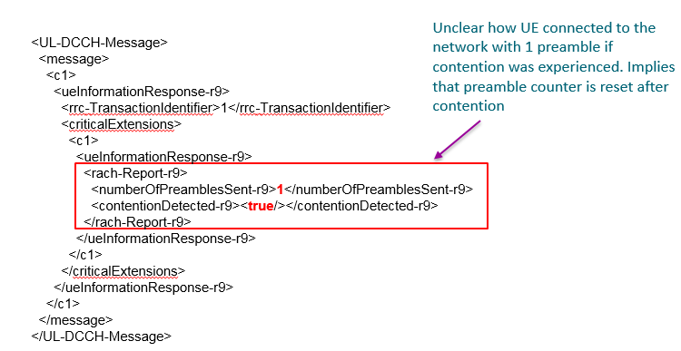
Figure 44: Example of UE reporting PRACH contention
The LTE581: PRACH Management feature runs as part of EdenNET within the OSS. It represents an Auto Configuration function and operates similar to a planning tool. It uses site location information and expected cell range information to plan values for the prachCS, prachConfIndex, prachFreqOff and rootSeqIndex parameter set. The allocation of parameters is done only for planned LNCELs and the combination of assigned values must be unique within the PRACH reuse distance. Screenshot below shows the preference settings for the PRACH management feature.
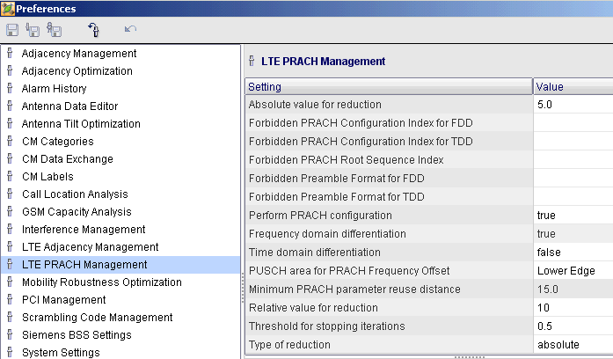
Figure 45: LTE581 PRACH Management feature

Radio Admission Control

Introduction
Radio Admission Control (RAC) is responsible for admitting or rejecting requests for new RRC connections and new radio bearers. These requests occur during:
- RRC connection establishment
- RRC connection re-establishment
- default bearer establishment
- dedicated bearer establishment
- incoming handover
- configuring a secondary cell for Carrier Aggregation
RAC has cell level scope so decisions are based upon the load within a specific cell.
Increasing admission control thresholds for the number of RRC connections requires an increased resource allocation for the PUCCH (and a corresponding resource reduction for the PUSCH). Thus, admission control thresholds should not be set unnecessarily high. There should be a balance which keeps the PUCCH overhead to a reasonable level while also avoiding blocking. The capacity upgrade process should involve increasing the admission thresholds and the corresponding PUCCH resource allocation as the quantity of traffic increases.
RAC for RRC connections (establishment, re-establishment, incoming handovers, secondary cell addition) is counter based. The number of connections can be limited by parameter controlled admission thresholds, e.g. a cell is configured to admit a maximum of 300 RRC connections. Additional margins can be included for incoming handovers and emergency call sessions. In all cases, the PUCCH must be dimensioned to support the appropriate number of RRC connections.
RAC for data radio bearers can be divided into:
Smart Admission Control disabled
- number of active UE
- number of data radio bearers
- number of QCI 1 data radio bearers
Smart Admission Control enabled
- number of active UE
- number data radio bearers
- resource block utilisation for GBR (QCI 1,2,3,4) data radio bearers
An ‘active UE’ is a UE with one or more data radio bearers. In general, the number of active UE is similar to the number of RRC connections because there are relatively few UE with only signalling radio bearers. The parameter used to enable smart admission control (LNBTS-actEnhAcAndGbrServices) also enables bearers with QCI 2, 3 and 4. In addition, it enables pre-emption based upon the Allocation and Retention Priority (ARP).

Typical Issues
Issues with Radio Admission Control can be caused by:
- Inadequate PUCCH dimensioning
Admission Control will check the availability of PUCCH resources when admitting a new RRC connection. The connection will be rejected if the PUCCH resources are already fully utilised. The allocation of PUCCH resources should be aligned with the maximum number of RRC connections permitted within a cell (accounting for any headroom provided for emergency calls). PUCCH dimensioning is described in [2].
- Admission thresholds set too low
The parameterised admission thresholds may be set too low for the quantity of traffic within a cell. Admission thresholds may be configured with a relatively low value for commercial reasons if the operator has an agreement for a specific number of connections.
- Inactivity timer set too long
Increasing the RRC connected -> RRC idle inactivity timer increases the number of connections kept in the RRC connected state. This may be done to reduce ping-pong between idle and connected states, or to reduce end-user delays. Configuring an inactivity timer which is relatively long increases the probability of reaching the admission control thresholds for RRC connections, active UE and data radio bearers.
- Aggressive Traffic Management
Operators may adopt a strategy to push as much traffic as possible towards a specific RF carrier. This is often appropriate while the penetration of LTE devices is relative low. As the penetration of devices increases then it can lead to congestion and admission control blocking.

Performance Analysis
Table 48 presents the set of counters which are applicable to admission control blocking. These counters can be studied to quantify the absolute number of admission control blocks. Otherwise, they can be included within KPI to quantify the blocking percentage.

Counter Id | Counter Name | Comments
M8013C65 | SIGN_CONN_ESTAB_FAIL_OVLCP | RRC connection establishment
M8013C66 | SIGN_CONN_ESTAB_FAIL_OVLUP | RRC connection establishment
M8013C67 | SIGN_CONN_ESTAB_FAIL_PUCCH | RRC connection establishment
M8013C68 | SIGN_CONN_ESTAB_FAIL_MAXRRC | RRC connection establishment
M8013C69 | SIGN_CONN_ESTAB_FAIL_OVLMME | RRC connection establishment
M8013C97 | SIGN_CONN_ESTAB_FAIL_DEPR_AC | RRC connection establishment
M8009C3 | FAIL_ENB_HO_PREP_AC | Intra-eNodeB handovers
M8014C3 | FAIL_ENB_HO_PREP_AC | X2 based inter-eNodeB handovers
M8014C16 | INTER_S1_HO_PRPE_FAIL_NORR | S1 based inter-eNodeB handovers
M8015C7 | INTER_HO_PREP_FAIL_AC_NB | X2 & S1 based handovers per Neigh.
M8006C4 | EPS_BEARER_SETUP_FAIL_RESOUR | Bearer setup failure due to radio resource
Table 48: Counters applicable to admission control blocking
The following KPI is applicable to admission control blocking during RRC connection establishment:
LTE_5707b E-UTRAN RRC Connection Setup Failure Ratio per Cause Rejection from eNB due to Overload and Lack of Resources
100 * SUM(SIGN_CONN_ESTAB_FAIL_OVLCP + SIGN_CONN_ESTAB_FAIL_OVLUP +SIGN_CONN_ESTAB_FAIL_PUCCH + SIGN_CONN_ESTAB_FAIL_MAXRRC + SIGN_CONN_ESTAB_FAIL_OVLMME +SIGN_CONN_ESTAB_FAIL_DEPR_AC)
/
SUM(SIGN_CONN_ESTAB_ATT_MO_S + SIGN_CONN_ESTAB_ATT_MT +SIGN_CONN_ESTAB_ATT_MO_D + SIGN_CONN_ESTAB_ATT_DEL_TOL + SIGN_CONN_ESTAB_ATT_HIPRIO +SIGN_CONN_ESTAB_ATT_EMG + SIGN_CONN_ESTAB_ATT_MO_VOICE + SIGN_CONN_ESTAB_ATT_OTHERS)

If admission control is blocking RRC connection requests, then the following KPI will be also be degraded:
LTE_5218g Total E-UTRAN RRC Connection Setup Success Ratio
100 * SUM(SIGN_CONN_ESTAB_COMP)
/
SUM(SIGN_CONN_ESTAB_ATT_MO_S + SIGN_CONN_ESTAB_ATT_MT +SIGN_CONN_ESTAB_ATT_MO_D + SIGN_CONN_ESTAB_ATT_DEL_TOL + SIGN_CONN_ESTAB_ATT_HIPRIO +SIGN_CONN_ESTAB_ATT_EMG + SIGN_CONN_ESTAB_ATT_MO_VOICE + SIGN_CONN_ESTAB_ATT_OTHERS)

The following KPI are applicable to admission control blocking during handover procedures. Admission control is applied during handover preparation rather than handover execution.
LTE_742a Inter eNB Handover Preparation Failure Ratio due to AC
100 * SUM(FAIL_ENB_HO_PREP_AC) / SUM(INTRA_ENB_HO_PREP)

LTE_5107b E-UTRAN HO Preparation Failure Ratio per Cause, inter eNB X2 based AC
100 * SUM(FAIL_ENB_HO_PREP_AC - INTER_X2_LB_PREP_FAIL_AC)
/
SUM(INTER_ENB_HO_PREP -INTER_X2_LB_PREP_FAIL_AC)

LTE_5080b E-UTRAN HO Preparation Failure Ratio per Cause, inter eNB S1 based, due to ‘lack or resources’
100 * SUM(INTER_S1_HO_PREP_FAIL_NORR - INTER_S1_LB_PREP_FAIL_AC)
/
SUM(INTER_ENB_S1_HO_PREP- INTER_S1_LB_PREP_FAIL_AC)

LTE_12c Inter eNB Neighbour Handover Preparation Success Ratio
100 * SUM(INTER_HO_ATT_NB)
/
SUM(INTER_HO_PREP_FAIL_AC_NB + INTER_HO_PREP_FAIL_OTH_NB + INTER_HO_PREP_FAIL_TIME_NB + INTER_HO_PREP_FAIL_QCI_NB + INTER_HO_ATT_NB)

The following KPI are applicable to admission control blocking radio bearers during E-RAB establishment. The second of these KPI does not explicitly quantify failures due to admission control but a low setup success rate could be caused by admission control failures.
LTE_5088c E-UTRAN E-RAB Setup Failure Ratio per Cause resource failure (RESOUR)
100 * SUM(ERAB_INI_SETUP_FAIL_RNL_RRNA + ERAB_ADD_SETUP_FAIL_RNL_RRNA + ERAB_REL_TEMP_QCI1)
/
SUM(EPS_BEARER_SETUP_ATTEMPTS)

LTE_5017a E-UTRAN E-RAB Setup Success Ratio
100 * SUM(EPS_BEARER_SETUP_COMPLETIONS) / SUM(EPS_BEARER_SETUP_ATTEMPTS)

In addition, it is useful to monitor the average and maximum connection counts to help predict when admission control blocking is likely occur, as levels of traffic increase over time. The counters presented in Table 49 quantify the average and maximum number of RRC connections and active UE.

Counter Id | Counter Name | Comments
M8051C56 | RRC_CONNECTED_UE_MAX | Maximum RRC connections per cell
M8051C55 | RRC_CONNECTED_UE_AVG | Average RRC connections per cell
M8051C58 | CELL_LOAD_ACTIVE_UE_MAX | Maximum active UE per cell
M8051C57 | CELL_LOAD_ACTIVE_UE_AVG | Average active UE per cell
Table 49: Counters applicable to monitoring the number of connections
It should be noted that the above counters only consider Pcell connections, therefore a cell having high Scell use could still trigger blocking even if M8051C56 records lower values than the configured number of RRC connections.
The counter shown in Table 50 provides the maximum recorded number of RRC connected UE plus Scell connections in a cell.
Counter Id | Counter Name | Comments
M8051C165 | RRC_CONNECTED_UE_SCELL_MAX | Maximum RRC connections plus Scell connections per cell
Table 50: Counter indicating maximum of summed Pcell and Scell connections

Parameter Definition
Parameters associated with the admission of RRC connections are presented in Table 51.
Parameter | Range | Default
maxNumRRC | 1.4 MHz: 0 to 40  3 MHz: 0 to 120  5 MHz: 0 to 840  10 MHz: 0 to 1000  15 MHz: 0 to 1250  20 MHz: 0 to 1500 | 1.4 MHz: 20  3 MHz: 80  5 MHz: 300  10 MHz: 300  15 MHz: 600  20 MHz: 600
addAUeRrHo | 1.4 MHz: 0 to 40  3 MHz: 0 to 120  5 MHz: 0 to 840  10 MHz: 0 to 1000  15 MHz: 0 to 1250  20 MHz: 0 to 1500 | 1.4 MHz: 2  3 MHz: 15  5 MHz: 15  10 MHz: 15  15 MHz: 30  20 MHz: 45
addAUeTcHo | 1.4 MHz: 0 to 40  3 MHz: 0 to 120  5 MHz: 0 to 840  10 MHz: 0 to 1000  15 MHz: 0 to 1250  20 MHz: 0 to 1500 | 1.4 MHz: 4  3 MHz: 20  5 MHz: 20  10 MHz: 20  15 MHz: 40  20 MHz: 50
maxNumRrcEmergency | 1.4 MHz: 0 to 40  3 MHz: 0 to 120  5 MHz: 0 to 840  10 MHz: 0 to 1000  15 MHz: 0 to 1250  20 MHz: 0 to 1500 | 1.4 MHz: 35  3 MHz: 100  5 MHz: 440  10 MHz: 560  15 MHz: 800  20 MHz: 800
Table 51: Parameters applicable to the admission of RRC connections
These 4 parameters are illustrated in Figure 46. The maxNumRRC parameter defines the admission control threshold for RRC connections within a cell. New connection establishments will be blocked if this threshold is reached. The addAUERrHo and addAUeTcHo parameters provide additional margin for incoming handovers. Incoming handovers are provided with a higher admission control threshold to help avoid dropped calls. The addAUERrHo parameter is applicable to incoming handovers triggered by event A3 (radio reason handover), whereas the addAUeTcHo parameter is applicable to incoming handovers triggered by event A5 (time critical handover). The maxNumRrcEmergency parameter defines the admission control threshold for emergency call related RRC connections. There is no pre-emption during the RRC setup phase so it is normal to configure maxNumRrcEmergency > maxNumRRC + MAX(addAUERrHo, addAUeTcHo).
The impact of enabling Carrier Aggregation should be considered. Carrier Aggregation causes RRC Connections to be double counted across both the primary serving cell and all secondary serving cells. Thus, a single UE is counted across multiple cells, effectively decreasing RRC Connection capacity.
It is important that the PUCCH is dimensioned to support the maximum configured number of RRC connections. For example, if maxNumRrcEmergency = 250, while maxNumRRC + MAX(addAUERrHo, addAUeTcHo) = 230, then the PUCCH should be dimensioned to support 250 connections. If the PUCCH is dimensioned for only 230 connections, then emergency connections could be blocked by existing non-emergency connections.
Figure 46: Admission control thresholds for RRC Connections, Active UE and Data Radio Bearers
Parameters associated with the admission of active UE are presented in Table 52. These parameters are also illustrated in Figure 46.
Parameter | Range | Default
maxNumActUE | 1.4 MHz: 0 to 40  3 MHz: 0 to 120  5 MHz: 0 to 840  10 MHz: 0 to 1000  15 MHz: 0 to 1250  20 MHz: 0 to 1500 | 1.4 MHz: 20  3 MHz: 80  5 MHz: 300  10 MHz: 300  15 MHz: 600  20 MHz: 600
addEmergencySessions | 1.4 MHz: 0 to 10  3 MHz: 0 to 60  5 MHz: 0 to 480  10 MHz: 0 to 480  15 MHz: 0 to 840  20 MHz: 0 to 840 | 1.4 MHz: 3  3 MHz: 4  5 MHz: 50  10 MHz: 70  15 MHz: 70  20 MHz: 90
Table 52: Parameters applicable to the admission of Active UE
The eNodeB includes a consistency check to ensure that maxNumRRC >= maxNumActUE. In general, the maximum number of active UE is configured to equal the maximum number of RRC connections. This allows each RRC connection to be allocated one or more data radio bearers. The incoming handover margins are based upon the same parameters as for the number of RRC connections, i.e. addAUERrHo and addAUeTcHo. The admission threshold for emergency active UE is defined differently to that for RRC connections. In the case of active UE, the emergency threshold is defined as a margin above the non-emergency threshold.
Parameters associated with the admission of Data Radio Bearers (DRB) are presented in Table 52. These parameters are also illustrated in Figure 46.
Parameter | Range | Default
maxNumActDrb | 1.4 MHz: 0 to 200  3 MHz: 0 to 600  5 MHz: 0 to 2520  10 MHz: 0 to 3000  15 MHz: 0 to 3750  20 MHz: 0 to 4500 | 1.4 MHz: 60  3 MHz: 200  5 MHz: 480  10 MHz: 600  15 MHz: 1200  20 MHz: 1200
addNumDrbTimeCriticalHo | 5 MHz: 0 to 2520  10 MHz: 0 to 3000  15 MHz: 0 to 3750  20 MHz: 0 to 4500 | 1.4 MHz: 12  3 MHz: 60  5 MHz: 60  10 MHz: 60  15 MHz: 120  20 MHz: 150
addNumDrbRadioReasHo | 1.4 MHz: 0 to 200  3 MHz: 0 to 600  5 MHz: 0 to 2520  10 MHz: 0 to 3000  15 MHz: 0 to 3750  20 MHz: 0 to 4500 | 1.4 MHz: 6  3 MHz: 35  5 MHz: 35  10 MHz: 35  15 MHz: 90  20 MHz: 135
Table 53: Parameters applicable to the admission of Data Radio Bearers
The concepts are the same as for the number of active UE. The margin used for emergency DRB is based upon the same parameter as that used for emergency active UE. The admission control thresholds for the number of DRB should be configured relatively high to allow for multiple DRB per active UE.
The procedure applied to the admission of GBR bearers depends upon the feature set enabled. The following set of features are enabled using the actEnhAcAndGbrServices parameter:
- LTE496 Support of QCI 2, 3 and 4
- LTE497 Smart Admission Control
- LTE534 ARP based Admission Control for E-RAB
If the actEnhAcAndGbrServices parameter is set to ‘disabled’ then only QCI 1 can be used for GBR bearers (assuming actConvVoice is set to ‘enabled’ to enable the use of QCI 1). In this case, the admission of QCI 1 bearers is based upon simple counters, similar to those used for RRC connections, active UE and DRB. The parameters used to define the corresponding admission thresholds are presented in Table 54. Values for AirScale (FSMr3 in brackets)
Parameter | Range | Default
maxNumQci1Drb | 1.4 MHz: 0 to 10 (10)  3 MHz: 0 to 60 (60)  5 MHz: 0 to 200 (200)  10 MHz: 0 to 200 (400)  15 MHz: 0 to 300 (500)  20 MHz: 0 to 300 (600) | 1.4 MHz: 5  3 MHz: 25  5 MHz: 75  10 MHz: 100  15 MHz: 100  20 MHz: 100
addNumQci1DrbTimeCriticalHo | 1.4 MHz: 0 to 10 (10)  3 MHz: 0 to 60 (60)  5 MHz: 0 to 200 (200)  10 MHz: 0... 200 (400)  15 MHz: 0 … 300 (500)  20 MHz:0 ...300 (600) | 1.4 MHz: 3  3 MHz: 8  5 MHz: 15  10 MHz: 20  15 MHz: 30  20 MHz: 40
addNumQci1DrbRadioReasHo | 1.4 MHz: 0 to 10 (10)  3 MHz: 0 to 60 (60)  5 MHz: 0 to 200 (200)  10 MHz: 0... 200 (400)  15 MHz: 0 … 300 (500)  20 MHz:0 ...300 (600) | 1.4 MHz: 2  3 MHz: 5  5 MHz: 15  10 MHz: 15  15 MHz: 30  20 MHz: 40
Table 54: Parameters applicable to the admission of QCI 1 Bearers (actEnhAcAndGbrServices = disabled)
Use of these parameters is illustrated in the left hand section of Figure 47. The addEmergencySessions parameter is the same as that used for active UE and DRB.
If the actEnhAcAndGbrServices parameter is set to ‘enabled’ then QCI 1, 2, 3 and 4 can be used for GBR bearers. In this case, the admission of GBR bearers is based upon resource block utilization. The maxGbrTrafficLimit parameter shown in Table 55 defines the percentage of uplink and downlink Resource Blocks which can be allocated to GBR bearers. Similar to counter based admission control, additional margins are defined for incoming handovers. Configuring actEnhAcAndGbrServices to ‘enabled’, enables ARB based pre-emption so connections are not necessarily blocked after the admission control threshold has been reached.
Parameter | Range | Default
maxGbrTrafficLimit | 30 to 90 %, step 5 % | 75 %
addGbrTrafficRrHo | 0 to 30 %, step 5 % | 5 %
addGbrTrafficTcHo | 0 to 30 %, step 5 % | 10 %
Table 55: Parameters applicable to the admission of GBR Bearers (actEnhAcAndGbrServices = enabled)
Figure 47: Admission control thresholds for GBR Bearers
When actEnhAcAndGbrServices is set to ‘enabled’, there is no additional margin for emergency calls (when admitting the GBR bearers). It is assumed that emergency calls will be allocated a high ARP priority so will be able to pre-empt any existing non-emergency calls.
The feature LTE1898: UE Context Pre-Emption allows an ARP-based strategy to be defined for incoming RRC connection requests, allowing the pre-emption of existing lower priority Pcell and Scell connections. This feature can improve RRC accessibility, notably in heavily loaded cells, such as those covering mass events or traffic hotspots. It is enabled at LNBTS level using the parameter actContextPreemption.

Optimization Procedure
The optimisation of Admission Control should ensure that RRC connections and data radio bearers are always admitted. A suggested optimisation procedure for the number of RRC connections is presented in Figure 48. The procedure is triggered when either Admission Control blocking is experienced, or the counters quantifying the maximum number of RRC connections indicates that the cell load is approaching its upper limit.
Step 1: Is Capacity Limited by admission thresholds or by PUCCH dimensioning?
Counters should be checked to determine whether or not the maximum number of RRC connections within the cell is reaching the Admission Control threshold defined by the eNodeB databuild. In addition, the number of resource blocks allocated to the PUCCH should be checked to ensure there are sufficient resources to support the maximum number of RRC connections.
Step 2: Can thresholds be increased?
The thresholds may already be configured with their maximum values. Otherwise, cell capacity can be increased by increasing the values configured for the Admission Control thresholds.
Figure 48: Optimisation of admission control (RRC connections)

Step 3: Increase Thresholds?
The Admission Control thresholds should be increased after considering the impact upon the PUCCH resource allocation. The thresholds should be increased sufficiently to avoid re-triggering the optimisation procedure after only a short period of time. The thresholds should not be increased to unnecessarily high levels to help minimise the PUCCH resource block requirement.
Step 4: Does the PUCCH need to be re-dimensioned?
The existing PUCCH resource block allocation should be checked to determine whether or not it is sufficient to support the increased number of RRC connections.
Step 5: Can actHighRrc be enabled?
The actHighRrc parameter can be enabled when using the 15 or 20 MHz channel bandwidth. It increases the maximum number of RRC connections from 840 to 1500 when using the 15 MHz channel bandwidth, and from 840 to 1200 when using the 20 MHz channel bandwidth. The actHighRrc parameter cannot be set to enabled when the actFlexBbUsage parameter is set to enabled.
Step 6: Enable actHighRrc?
The actHighRrc parameter should be set to ‘enabled’
Step 7: Evaluate parameter changes
Reaching this step indicates that the cell has reached its maximum capacity. Whenever possible, solutions to avoid Admission Control blocking should be based upon parameter changes rather than the introduction of new hardware. The traffic management strategy should be reviewed to determine whether or not too much traffic is being pushed towards the LTE cell. It may be necessary to enable traffic balancing features or to change the prioritisation of network layers. The RRC inactivity timer should also be reviewed. Configuring this timer with a high value means that connections will be maintained for relatively long periods of time. This will have a significant impact upon cell load. Configuring this timer with a low value could result in ping-pong between RRC Idle and RRC Connected. Disabling Carrier Aggregation can also be considered to avoid the double counting of connections. This option should be discussed with the operator to understand the strategic impact.
Step 8: Evaluate hardware changes
Reaching this step indicates that it has not been possible to reduce load using parameter changes. It is necessary to increase network capacity by introducing new cells. These new cells are likely to require new hardware. They could be introduced using a new RF carrier, by sectorisation or by adding a new site.
Step 9: Will the PUCCH overhead become unacceptable if increased?
The number of resource blocks allocated to the PUCCH should be evaluated. Larger channel bandwidths are able to accommodate large PUCCH resource block allocations. Even if it is decided that the PUCCH resource allocation can be increased, the parameter set associated with PUCCH dimensioning should be checked to determine whether or not the PUCCH can reconfigured to require fewer resource blocks.
Step 10: Re-dimension the PUCCH with existing parameter set
A PUCCH dimensioning exercise should be completed to ensure that the PUCCH is allocated sufficient resource blocks to support the maximum configured number of RRC connections.
Step 11: Re-dimension the PUCCH with updated parameter set
It may be possible to change some of the PUCCH parameters to reduce the PUCCH resource block requirement. For example, increasing the CQI reporting period (cqiPerNp) from 20 ms to 40 ms can reduce the PUCCH resource block requirement without having an impact upon network performance.
The optimisation of Admission Control should also ensure that the number of active users do not cause blocking. An active user is a user with one or more Data Radio Bearers (DRB). A suggested optimisation procedure for the number of active users is presented in Figure 49. The procedure is triggered when either Admission Control blocking is experienced, or the counters quantifying the maximum number of active users indicates that the cell load is approaching its upper limit.
Figure 49: Optimisation of admission control (Active UE)
Step 1: Has the maximum number of active UE been set equal to the maximum number of RRC connections?
A comparison of the maxNumRRC and maxNumActUE parameters should be completed.
Step 2: Set the maximum number of active UE equal to the maximum number of RRC connections
The value allocated to the maxNumActUE parameter should be increased to equal the value allocated to the maxNumRRC parameter.
Step 3: Trigger the RRC connection optimisation procedure
Follow the procedure illustrated in Figure 48 and then set the maxNumActUE parameter to equal the maxNumRRC parameter.

Physical Downlink Control Channel (PDCCH)

Introduction
The Physical Downlink Control Channel (PDCCH) is used to transfer Downlink Control Information (DCI). DCI is used to signal:
- uplink resource allocations
- downlink resource allocations
- Transmit Power Control (TPC) commands
PDCCH capacity can be quantified using units of Control Channel Elements (CCE). A CCE is equal to 36 Resource Elements. A single PDCCH transmission requires 1, 2, 4 or 8 CCE. A UE in good coverage conditions with a small PDCCH payload may only require 1 CCE, whereas a UE in poor coverage conditions with a large PDCCH payload may require 8 CCE. The use of 1, 2, 4 or 8 CCE is also referred to as the use of aggregation levels 1, 2, 4 or 8. These aggregation levels are summarised in Table 56.
Aggregation Level | Number of CCE | Number of Resource Elements | Number of Bits
1 | 1 | 36 | 72
2 | 2 | 72 | 144
4 | 4 | 144 | 288
8 | 8 | 288 | 576
Table 56: PDCCH aggregation levels
The capacity of the PDCCH is determined by the channel bandwidth, the number of OFDMA symbols allocated to the downlink control channels and the radio conditions. The channel bandwidth determines the number of Resource Elements in the frequency domain, while the number of OFDMA symbols determines the number of Resource Elements in the time domain. The radio conditions determine the quantity of redundancy required for reliable transmission.
The CCE capacity for a specific channel bandwidth and a specific number of allocated OFDMA symbols also depends upon the overheads generated by the Cell Specific Reference Signal, the PCFICH and the PHICH. Assuming the use of either 1 or 2 transmit antenna, the Cell Specific Reference Signal is always assumed to occupy 4 Resource Elements per Resource Block within the first column of Resource Elements belonging to each subframe, i.e. this leaves 8 Resource Elements per Resource Block during the first OFDMA symbol and 12 Resource Elements per Resource Block during the second and third OFDMA symbols. LTE568 Downlink Adaptive Closed Loop MIMO (4x2) uses 4 transmit antenna ports. This increases the number of Resource Elements used by the Cell Specific Reference Signal and decreases the PDCCH capacity.
The PCFICH always occupies 16 Resource Elements within the first column of Resource Elements belonging to each subframe. The number of Resource Elements used by the PHICH depends upon the number of allocated PHICH groups. Each PHICH group occupies 12 Resource Elements.
Table 57 presents the PDCCH capacity when assuming 1 or 2 transmit antenna and a phichRes value of 1/6. The phichRes parameter determines the number of allocated PHICH groups.
 |  | 1.4 MHz | 3 MHz | 5 MHz | 10 MHz | 15 MHz | 20 MHz
 |  | 6 Resource Blocks | 15 Resource Blocks | 25 Resource Blocks | 50 Resource Blocks | 75 Resource Blocks | 100 Resource Blocks
 |  | 1 PHICH Group | 1 PHICH Group | 1 PHICH Group | 2 PHICH Groups | 2 PHICH Groups | 3 PHICH Groups
PDCCH Symbols | 1 | - | 2 | 4 | 10 | 15 | 20
PDCCH Symbols | 2 | 2 | 7 | 13 | 26 | 40 | 54
PDCCH Symbols | 3 | 4 | 12 | 21 | 43 | 65 | 87
PDCCH Symbols | 4 | 6 | - | - | - | - | -
Table 57: PDCCH Capacity (phichRes = 1/6 and 1 or 2 transmit antenna)
UE receiving the PDCCH do not need to decode the full set of CCE. Instead, UE only decode CCE within the Common Search Space and their UE Specific Search Space. The UE Specific Search Space is determined by the RNTI allocated to the UE. PDCCH transmissions within the Common Search Space can use aggregation levels 4 or 8. PDCCH transmissions within the UE Specific Search Space can use aggregation levels 1, 2, 4 or 8.
The following PDCCH transmissions use the common search space so are only able to use aggregation levels 4 or 8:
- system information resource allocations
- paging message resource allocations
- random access response resource allocations
- dedicated PRACH preamble allocation (DL data arrival while UE is out-of-sync)
- random access MSG4 resource allocations
Transmissions using the Common Search Space use the larger aggregation levels because they need to provide coverage across the complete cell area. Figure 50 illustrates the general use of each PDCCH aggregation level for the UE specific and Common Search Spaces. The aggregation level for the Common Search Space is configured using a parameter within the eNodeB databuild. The aggregation level for the UE Specific Search Space is allocated dynamically by the eNodeB (assuming the PDCCH AMC feature is enabled).
Figure 50: PDCCH Aggregation levels
Increasing the resources allocated to the PDCCH decreases the resources available to the PDSCH, i.e. downlink capacity decreases. Table 58 shows the PDSCH coding rate as a function of the number of PDCCH symbols, the number of antenna and the transport block size, for the 10MHz channel bandwidth (assuming all 50 Resource Blocks are allocated to a UE).
 | Transport Block Size (bits) | 3 PDCCH Symbols |  | 2 PDCCH Symbols |  | 1 PDCCH Symbol
 | Transport Block Size (bits) | 2 antenna | 1 antenna | 2 antenna | 1 antenna | 2 antenna | 1 antenna
QPSK | 1384 | 0.115 | 0.110 | 0.105 | 0.100 | 0.096 | 0.092
QPSK | 1800 | 0.150 | 0.143 | 0.136 | 0.130 | 0.125 | 0.120
QPSK | 2216 | 0.185 | 0.176 | 0.168 | 0.161 | 0.154 | 0.148
QPSK | 2856 | 0.238 | 0.227 | 0.216 | 0.207 | 0.198 | 0.190
QPSK | 3624 | 0.302 | 0.288 | 0.275 | 0.263 | 0.252 | 0.242
QPSK | 4392 | 0.366 | 0.349 | 0.333 | 0.318 | 0.305 | 0.293
QPSK | 5160 | 0.430 | 0.410 | 0.391 | 0.374 | 0.358 | 0.344
QPSK | 6200 | 0.517 | 0.492 | 0.470 | 0.449 | 0.431 | 0.413
QPSK | 6968 | 0.581 | 0.553 | 0.528 | 0.505 | 0.484 | 0.465
QPSK | 7992 | 0.666 | 0.634 | 0.605 | 0.579 | 0.555 | 0.533
16QAM | 7992 | 0.333 | 0.317 | 0.303 | 0.290 | 0.278 | 0.266
16QAM | 8760 | 0.365 | 0.348 | 0.332 | 0.317 | 0.304 | 0.292
16QAM | 9912 | 0.413 | 0.393 | 0.375 | 0.359 | 0.344 | 0.330
16QAM | 11448 | 0.477 | 0.454 | 0.434 | 0.415 | 0.398 | 0.382
16QAM | 12960 | 0.540 | 0.514 | 0.491 | 0.470 | 0.450 | 0.432
16QAM | 14112 | 0.588 | 0.560 | 0.535 | 0.511 | 0.490 | 0.470
16QAM | 15264 | 0.636 | 0.606 | 0.578 | 0.553 | 0.530 | 0.509
64QAM | 15264 | 0.424 | 0.404 | 0.385 | 0.369 | 0.353 | 0.339
64QAM | 16416 | 0.456 | 0.434 | 0.415 | 0.397 | 0.380 | 0.365
64QAM | 18336 | 0.509 | 0.485 | 0.463 | 0.443 | 0.424 | 0.407
64QAM | 19848 | 0.551 | 0.525 | 0.501 | 0.479 | 0.459 | 0.441
64QAM | 21384 | 0.594 | 0.566 | 0.540 | 0.517 | 0.495 | 0.475
64QAM | 22920 | 0.637 | 0.606 | 0.579 | 0.554 | 0.531 | 0.509
64QAM | 25456 | 0.707 | 0.673 | 0.643 | 0.615 | 0.589 | 0.566
64QAM | 27376 | 0.760 | 0.724 | 0.691 | 0.661 | 0.634 | 0.608
64QAM | 28336 | 0.787 | 0.750 | 0.716 | 0.684 | 0.656 | 0.630
64QAM | 30576 | 0.849 | 0.809 | 0.772 | 0.739 | 0.708 | 0.679
64QAM | 31704 | 0.881 | 0.839 | 0.801 | 0.766 | 0.734 | 0.705
64QAM | 36696 | 1.019 | 0.971 | 0.927 | 0.886 | 0.849 | 0.815
256QAM | 36696 | 0.765 | 0.728 | 0.695 | 0.665 | 0.637 | 0.612
256QAM | 39232 | 0.817 | 0.778 | 0.743 | 0.711 | 0.681 | 0.654
256QAM | 40576 | 0.845 | 0.805 | 0.768 | 0.735 | 0.704 | 0.676
256QAM | 42368 | 0.883 | 0.841 | 0.802 | 0.768 | 0.736 | 0.706
256QAM | 48936 | 1.020 | 0.971 | 0.927 | 0.887 | 0.850 | 0.816
256QAM | 43816 | 0.913 | 0.869 | 0.830 | 0.794 | 0.761 | 0.730
Table 58: Coding rate as a function of the number of PDCCH symbols, the number of antenna and the transport block size, for 10MHz bandwidth
These figures illustrate that the maximum transport block size of 36696 cannot be used when 3 symbols are allocated to the PDCCH, i.e. the coding rate is greater than 1. The maximum target coding rate is 0.93 and this is only allowed when the radio conditions are very good. Based upon this, the maximum transport block size is possible when the radio conditions are very good, and 1 or 2 symbols are used by the PDCCH. For demonstrating maximum user bit rates (e.g. UL Peak Data throughputs for 10MHz and 48PRBs for PUSCH), it is recommended to use 2 symbols for PDCCH.

Typical Issues
Issues associated with PDCCH performance include:
- Dynamic Allocation Triggering based upon Blocking
The dynamic allocation of symbols to the PDCCH uses blocking as a triggering mechanism to increase the number of allocated symbols. This means that counters record PDCCH blocking while the PDCCH capacity is not necessarily fully utilised, e.g. blocking may be recorded while the number of allocated symbols is increased from 1 to 2, while up to 3 symbols are available. Thus, interpretation of the blocking counters requires care and should be studied with the counters recording the utilisation of symbols for the PDCCH.
- General lack of Capacity
The PDCCH is a potential capacity bottleneck. The PDCCH is most likely to limit capacity when the population of UE is located in poor coverage and an increased percentage of transmissions use aggregation 8. This may occur if an outdoor macrocell is serving a large number of indoor subscribers. PDCCH capacity cannot be increased once the maximum number of symbols have been allocated. It may be possible to improve the utilisation of PDCCH capacity by enabling power control and link adaptation if not already enabled. Ultimately additional cells must be introduced to increase PDCCH capacity.
- Dependence upon Traffic Profile
PDCCH load is dependent upon the traffic profile. A large number of low bit rate VoLTE users will load the PDCCH more than a moderate number of high bit rate data users. The PDCCH is used for both uplink and downlink resource allocations so applications requiring frequent uplink and downlink resource allocations tend to increase PDCCH load.
- Blocks causing other procedures to fail
The PDCCH is used to signal resource allocations so PDCCH blocking can potentially cause procedures to fail. The Nokia implementation prioritises PDCCH allocations for System Information and Paging above PDCCH allocations for Random Access Responses. If only a single symbol is allocated for the PDCCH then it is possible that the PDCCH for Random Access Responses is blocked (depending upon the number of CCE available within the single symbol). Blocked Random Access Responses are not re-attempted in the following subframe so cause failures.

Performance Analysis
The counter shown in Table 59 records the total aggregated number of CCE which are available during the measurement period.
Counter Id | Counter
M8011C38 | CCE_AVAIL_ACT_TTI
Table 59: Counter recording availability of CCE
This counter should be interpreted with care when using ‘Usage based PDCCH Adaptation’ because it reflects the number of CCE which are available based upon the current allocation of OFDMA symbols to the PDCCH. For example, if the ‘Usage based PDCCH Adaptation’ algorithm allocates a single OFDMA symbol to the PDCCH then the counter will reflect the capacity of the single OFDMA symbol, rather than the capacity which would be available if the algorithm were to allocate 3 OFDMA symbols.
As an example, consider a 10 MHz channel bandwidth with 1 OFDMA symbol allocated to the PDCCH throughout a 60 minute measurement interval. Assume 2 PHICH groups have been allocated which occupy 24 Resource Elements. The counter will generate a result of [(50 × 8) – 16 – 24 / 36 ] × 60 × 60 × 1000 = 36 000 000. Some typical results are illustrated in Figure 51. Some samples exceed the value of 36 000 000. These samples correspond to measurement periods during which the eNodeB has allocated more than a single OFDMA symbol for at least some subframes. There are also some samples which fall below the value of 36 000 000. These samples correspond to measurement periods during which the eNodeB was not on air for the complete period. These dips typically have good correlation with the cell availability counters.
Figure 51: Example results for the CCE_AVAIL_ACT_TTI counter
The counters in Table 60 record the utilisation of each PDCCH aggregation level. Cells with poor RF conditions are likely to have a higher proportion of aggregation levels 4 and 8.

Counter Id | Counter
M8011C39 | AGG1_USED_PDCCH
M8011C40 | AGG2_USED_PDCCH
M8011C41 | AGG4_USED_PDCCH
M8011C42 | AGG8_USED_PDCCH
Table 60: Counters recording PDCCH aggregation levels
Some example results from each counter are presented in Figure 52. These results illustrate that aggregation level 1 is used very rarely so in general, at least 2 CCE are used for each PDCCH transmission.
These counters are incremented for each PDCCH transmission, so they can be used to calculate an average PDCCH load. The equation below defines the total number of CCE which have been used during the measurement period.
Number of Used CCE per Subframe =
[(AGG1_USED_PDCCH × 1) + (AGG2_USED_PDCCH × 2) + (AGG4_USED_PDCCH × 4) + (AGG8_USED_PDCCH × 8)] / (Measurement Period in Minutes × 60 × 1000)
An example result for a cell with a 10 MHz channel bandwidth and a 15 minute measurement period is, (0 × 1) + (160233 × 2) + (59074 × 4) + (20 × 8) = 556 922. Within the 15-minute measurement period there are 15 × 60 × 1000 = 900 000 TTI, so the average number of CCE used per TTI is only 0.6. This result can be compared against the CCE capacity of 1, 2 or 3 OFDMA symbols, i.e. compared against a value of 10 CCE when assuming a single OFDMA symbol for the 10 MHz channel bandwidth.
Figure 52: Example results for the PDCCH aggregation level counters
The counters shown in Table 61 record occurrences of PDCCH blocking. Ideally, these counters would return zero results indicating that blocking is not occurring for any of the PDCCH aggregation levels. In practice, it is observed that even networks with relatively low levels of traffic start incrementing these counters. This can be caused by the Usage based PDCCH Adaptation (LTE616) feature because this feature triggers the allocation of additional PDCCH symbols when blocks occur, i.e. upgrades are reactive rather than proactive. Some example results are illustrated in Figure 53. These results illustrate that the quantity of blocking tends to increase for the larger aggregation levels. This is expected because the larger aggregation levels require more resources so are more likely to be blocked.
Counter Id | Counter
M8011C43 | AGG1_BLOCKED_PDCCH
M8011C44 | AGG2_BLOCKED_PDCCH
M8011C42 | AGG4_BLOCKED_PDCCH
M8011C46 | AGG8_BLOCKED_PDCCH
Table 61: Counters recording PDCCH blocking
PDCCH blocking represents a form of soft blocking from the end-user perspective. It is unlikely that end-users will be aware that PDCCH blocking is occurring within the eNodeB. A blocked PDCCH means that the resource allocation will be delayed until a later subframe, i.e. the end-user’s connection is maintained but there is an increased delay in the resource allocation.
There are only a few options for reducing the quantity of blocking once the PDCCH has been allocated its maximum of 3 OFDMA symbols. A check should be completed to ensure that the appropriate number of PHICH groups has been allocated. If the number of PHICH groups can be reduced, then the resources available to the PDCCH will increase. A check should also be made regarding the set of PDCCH features which have been enabled (described within section 6.4.4). For example, enabling power control for the PDCCH allows the eNodeB to balance the allocation of power with the allocation of CCE. Allocating an increased quantity of power allows a reduced aggregation level to be used and consequently would reduce the probability of blocking.
Figure 53: Example results for the PDCCH aggregation level blocking
The counters shown in Table 62 record the number of OFDMA symbols allocated to the PDCCH. The sum of these counters should approximately equal the number of subframes within the measurement period.
Counter Id | Counter
M8011C59 | PDCCH_1_OFDM_SYMBOL
M8011C60 | PDCCH_2_OFDM_SYMBOLS
M8011C61 | PDCCH_3_OFDM_SYMBOLS
Table 62: Counters recording the number of OFDMA symbols allocated to the PDCCH
Some example results for these counters are presented in Figure 54. Note that the vertical axis belonging to the first chart uses a different scale to that used for the second and third charts. This illustrates that subframes using only 1 OFDMA symbol for the PDCCH occur ~1000 times more frequently than subframes using 2 or 3 OFDMA symbols. These results have been extracted from a network with relatively low quantities of traffic. It is expected that the utilisation of 2 and 3 symbols will increase over time.
Figure 54: Example results for the number of OFDMA symbols used for the PDCCH

Parameter Definition
The key parameters associated with the PDCCH are presented in Table 63.

Parameter | Object | Range | Default
maxNrSymPdcch | LNCEL_FDD | 1 to 4 | 3
actLdPdcch | LNCEL | False (0), True (1) | False (0)
actOlLaPdcch | LNCEL | False (0), True (1) | False (0)
pdcchCqiShift | LNCEL | -10 to 10 | -5
pdcchHarqTargetBler | LNCEL | 0.1 to 3 % | 1 %
enablePcPdcch | LNCEL | False (0), True (1) | True (1)
enableAmcPdcch | LNCEL | False (0), True (1) | True (1)
pdcchAggDefUe | LNCEL | 1, 2, 4, 8 | 4
pdcchAggMsg4 | LNCEL | 4, 8 | 8
pdcchAggPaging | LNCEL | 4, 8 | 4
pdcchAggPreamb | LNCEL | 4, 8 | 4
pdcchAggRaresp | LNCEL | 4, 8 | 4
pdcchAggSib | LNCEL | 4, 8 | 4
pdcchAlpha | LNCEL | 0.5 to 2.0 | 0.8
pdcchUlDlBal | LNCEL | 0.1 to 0.9 | 0.5
phichDur | MPUCCH | Normal (0), Extended (1) | Normal (0)
Table 63: Key parameters associated with the PDCCH
In early software releases, it was only possible to configure a static PDCCH resource allocation. The static resource allocation was configured using the maxNrSymPdcch parameter. This parameter has a range from 1 to 4 but the value of 4 is only applicable to the 1.4 MHz channel bandwidth. The LTE616 Usage based PDCCH Adaptation feature dynamically allocates symbols for the PDDCH according to the level of traffic. It should be noted that this feature uses PDCCH blocking as a trigger to upgrade the number of allocated symbols. Thus, the quantity of PDCCH blocking will be greater with this feature enabled when compared to a static allocation of PDCCH symbols set to the maximum. The Usage based PDCCH Adaptation feature is enabled using the actLdPdcch parameter.
The LTE1035: Outer Loop Link Adaptation (OLLA) for PDCCH feature is enabled using the actOlLaPdcch parameter. OLLA dynamically adjusts the reported CQI for the purposes of PDDCH Adaptive Modulation and Coding (AMC). The initial offset applied to the reported CQI is defined by the pdcchCqiShift parameter. The CQI offset is then adjusted according to the target BLER defined by the pdcchHarqTargetBler parameter and the achieved BLER.
Power Control (PC) for the PDCCH is enabled using the enablePcPdcch parameter. Power control helps to ensure that the downlink transmit power capability is fully utilised during the symbols allocated to the PDCCH. It can also reduce the PDCCH aggregation level and thus help to reduce blocking.
The LTE749: Link Adaptation for PDCCH feature is enabled using the enableAmcPdcch parameter. If this feature is disabled then the PDCCH applies a fixed aggregation level defined by the pdcchAggDefUe parameter. If the feature is enabled then the eNodeB applies Adaptive Modulation and Coding (AMC) to dynamically adjust the aggregation level used by the PDCCH.
The set of parameters pdcchAggMsg4, pdcchAggPaging, pdcchAggPreamb, pdcchAggRaresp and pdcchAggSib define fixed aggregation levels for when the PDCCH is used for specific purposes, i.e. resource allocation for random access MSG4, paging, dedicated preamble allocation, Random Access Response and System Information.
The pdcchAlpha parameter defines the percentage of CCE which the packet scheduler targets for use. The default value of 0.8 means that 80 % of CCE are targeted. Configuring a value less than 100 % means that additional power is made available for the CCE which are used. This means that lower aggregations can be applied and the number of served users increased (effectively compensating for the 20 % of CCE which are unused).
The pdcchUlDlBal parameter defines a balance between the PDCCH within the UE specific Search Space used for uplink and downlink purposes. This static value is applied if the actLdPdcch parameter is set to ‘false’. Otherwise, the Usage based PDCCH Adaptation feature dynamically adjusts the PDCCH utilisation for uplink and downlink purposes.
If the phichDur parameter is set to ‘extended’ then 3 symbols are always allocated to the PDCCH. This is because the PHICH is transmitted across 3 symbols.

Optimization Procedure
PDCCH optimization involves a trade-off between performance and capacity. Improving performance tends to require the allocation of higher PDCCH aggregation levels, i.e. PDCCH reception becomes more reliable. However, the use of higher aggregation levels consumes increased capacity and consequently increases the probability of PDCCH blocking.

Optimizing Performance
The optimization procedure illustrated in Figure 55 is applicable to optimizing the performance of the PDCCH.
Figure 55: Optimisation of PDCCH performance
Step 1: Verify that Adaptive Modulation and Coding (AMC), Outer Loop Link Adaptation (OLLA), Power Control (PC) and Load based Symbol Allocation are enabled for the PDCCH.
AMC, OLLA and PC help to adapt the PDCCH transmissions to suite the radio conditions experienced by each individual UE. They help to optimise the balance between allocated aggregation level and allocated downlink transmit power. Load based Symbol allocation helps to ensure that the PDCCH has sufficient capacity. The maxNrSymPdcch parameter should also be checked to gain an understanding of the maximum number of symbols allocated to the PDCCH.
OLLA for the PDCCH (feature LTE1035) allows for a separate correction to the CQI employed in the PDCCH scheduling in order to employ the PDCCH resources efficiently and target a 1% BLER for this channel. In order to verify the functionality of this feature drive test data from a cluster drive was employed.
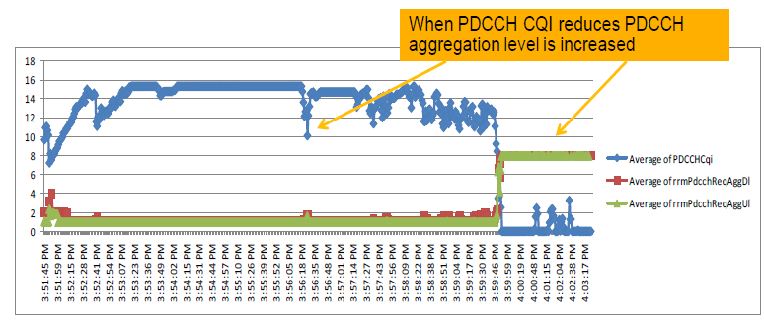
Figure 56: PDCCH CQI and UL & DL PDDCH aggregation levels vs. Time
Figure 56 shows average PDCCH CQI variation along the drive. As shown, the PDCCH CQI decreases, PDCCH LA and PC increase the aggregation level for the UL and DL allocations.
Figure 57: PDCCH CQI and CW1 DTX vs. Time
The purpose of feature LTE1035 is to obtain a 1% BLER for the PDCCH channel. In order to evaluate the feature, the discontinuous transmission (DTX) for codeword1 was measured at the eNodeB (Figure 57). In case of MIMO, at least Codeword1 (CW1) should be sent every time the UE is granted a turn. The reason to control the DTX is as follows:
The eNodeB sends the PDCCH and DL data (on PDSCH) and then waits for ACK/NACK on the UL. If nothing is detected on the UL (DTX) it can be either due to an UL power issue or to the fact that the UE didn’t get the DL data in the first place (i.e. not decoding PDCCH). With throughput tests it is possible to detect if there are UL issues. In the test, there were no UL power issues, so whenever the UE did not send ACK/NACK it meant it couldn’t decode the PDCCH.
The PDCCH outer loop algorithm is based on the UL HARQ feedback. As it can be observed in Figure 58 the average PDCCH BLER target was maintained for most of the drive. Some samples of high DTX can be observed during the drive as radio conditions deteriorate. These cause the PDDCH CQI to be significantly reduced leading to aggregation levels of 8 for the UL and the DL. Once the PDCCH CQI is reduced to 0, there is no further correction that can be done, even though the DTX for CW1 is high. This is caused by extremely bad radio conditions of approximately -12 dB DL SINR.
Figure 58 compares the eNodeB internal metrics for the PDCCH CQI and the PDSCH CQI. The PDCCH CQI is now independent of the PDSCH BLER and will not lead to changes in the PDSCH CQI and as a consequence in the DL MCS.
Figure 58: PDCCH CQ vs. PDSCH CQI and PDSCH BLER
Usage based load Adaptation of the PDCCH (LTE 616), adapts the number of OFDM symbols for PDCCH based on the CCE (control channel elements) load. Additionally, as a second part of the feature, the balance between the DL and the UL PDCCH space may be adapted depending on the current load split. The PDCCH usage will vary depending on the number of users in the cell, radio conditions of the users and amount of UL/DL traffic they generate. The information about number of symbols to be used is broadcasted every TTI via PCFICH. The benefit is that subscribers may experience better downlink throughput in scenarios with low PDCCH but high PDSCH usage.
The functionality of this feature has been verified during single UE cluster drives in which the UE performed simultaneous UL and DL UDP sessions. Figure 59 shows the number of PDCCH symbols used in the different cells vs. the DL SINR conditions measured by the UE. As expected, under good radio conditions, low aggregation levels are employed for UL and DL. As radio conditions worsen the aggregation levels will tend to increase and so will the average number of required PDCCH symbols. In extremely low DL SINR the average PDDCH symbols is just beneath 2, since drives were performed with a single user and 10MHz Bandwidth configurations for all the cells.
Figure 59: Number of PDCCH Symbols (CFI: Control Format Indicator) vs. DL SINR

Step 2: Evaluate Reductions to CQI Shift and BLER Target
Reducing the CQI shift parameter will tend to increase the allocated PDCCH aggregation level. Similarly, decreasing the BLER target will also tend to increase the allocated PDCCH aggregation level. Increasing the aggregation level will help to improve performance at the cost of PDCCH capacity, i.e. the number of connections served by the PDCCH may become limited.
Note: the default value of pdcchCqiShift is -5. Field/lab results have shown that this parameter can have an impact upon the intra eNodeB handover success rate. In good radio conditions, the intra eNodeB HO Success Rate was poor if the parameter was between 0 and -2 so the original recommendation changed to use the lower value of -5. In good radio conditions, the UE reported relatively high CQI values which led to lower aggregation that in turn decreased the probability of successful HO. Decreasing the value of this parameter decreases the reported CQI which increases the aggregation level, i.e. more CCEs are assigned for UE. On the contrary, it also decreases the PDCCH block error rate. The impact of this parameter for inter system handover is minimal as CQI values reported are lower and the aggregation is already higher.
Reducing the PDCCH block error rate also contributes to more stable throughput as seen in the example of Figure 60. Average application throughput goes from 32Mbps in case of pdcchCqiShift =0 to 38Mbps when pdcchCqiShift =-5.
From LTE19, it is possible to apply a separate parameter for 4Tx transmission by using the LNCEL parameter pdcchCqiShift4Tx. This allows link adaptation to be less aggressive in allocating PDCCH aggregation levels where 4x2 or 4x4 closed-loop MIMO is used.
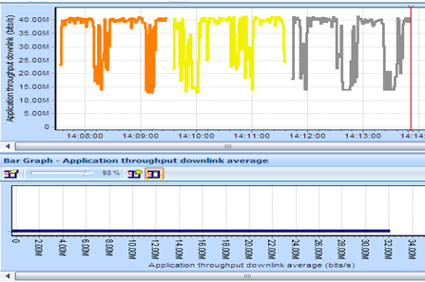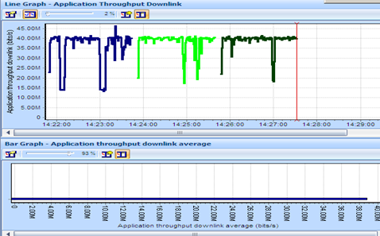
Figure 60: Throughput comparison with pdcchCqiShift =0 (left) vs. pdcchCqiShift =-5 (right)

Optimizing Capacity
The optimization procedure illustrated in Figure 61 is applicable to optimizing the capacity of the PDCCH.
Figure 61: Optimisation of PDCCH capacity

Step 1: Verify maxNrSymPdcch is set to maximum for the channel bandwidth
The 1.4 MHz channel bandwidth can allocate up to 4 symbols for the PDCCH, whereas the larger channel bandwidths can allocate up to 3 symbols. The maximum number of symbols should be allocated to maximize the PDCCH capacity.
Step 2: Verify that Adaptive Modulation and Coding (AMC), Outer Loop Link Adaptation (OLLA), Power Control (PC) and Load based Symbol Allocation are enabled for the PDCCH.
This step is the same as that applied when optimizing PDCCH performance (see previous section). Enabling these features helps to dynamically optimize the balance between performance and capacity.
Step 3: Check Scope for decreasing Default Aggregations
The default PDCCH aggregations for MSG4, paging, PDCCH orders, random access responses and system information can be configured to be either 4 or 8. An aggregation level of 8 improves performance at the cost of capacity. The default values specify an aggregation level of 4 so it may not be possible to reduce further to increase capacity. Any reductions should be accompanied with careful monitoring of performance.
Step 4: Evaluate Optimisation of pdcchAlpha
The pdcchAlpha parameter defines the percentage of CCE which the packet scheduler targets for use. The default value of 0.8 means that 80 % of CCE are targeted. Configuring a value less than 100 % means that additional power is made available for the CCE which are used. This means that lower aggregations can be applied and the number of served users increased (effectively compensating for the 20 % of CCE which are unused). Care should be taken with increasing the value of this parameter. Increasing its value means that the eNodeB will attempt to allocate an increased percentage of the total CCE, but the transmit power per CCE will decrease. Thus, aggregation levels may increase and the number of served connections may decrease.
Step 5: Do other Network Layers have Capacity?
If multiple LTE RF carriers are available, the traffic management strategy may be loading one RF carrier more than the other. This could mean that there is PDCCH capacity available on a different RF carrier.
Step 6: Improve Traffic Balancing
If capacity is available on another LTE carrier then the traffic management solution can be updated to adjust the balance of traffic. Care should be taken to account for differences in channel bandwidths and the load of the other physical channels.
Step 7: Can Traffic be Offloaded to Other Technologies?
Offloading to another technology is generally viewed as a last resort but can be necessary if the LTE network is congested. As the penetration of LTE devices increases, it is more likely that the LTE network becomes congested while other technologies may have spare capacity. Fully utilising the operator’s network resources requires traffic to be balanced across technologies.
Step 8: Offload Traffic
If capacity is available on another technology, then the traffic management solution can be updated to adjust the balance of traffic.

Non-Adaptive HARQ
It is possible to dynamically use non-adaptive HARQ retransmissions during high load.
Adaptive HARQ retransmissions are triggered by the eNB sending PDCCH DCI format 0 when it needs to indicate a NACK to the UE. If the New Data Indicator flag of the DCI format 0 is not toggled, then the UE will retransmit the previous retransmission. This consumes PDCCH capacity. PDCCH transmissions for adaptive HARQ are considered higher priority than other PDCCH transmissions, including QCI-1 grants.
Non-adaptive HARQ retransmissions are triggered when the UE receives DTX, i.e. the PDCCH DCI format 0 is not sent by the eNB. Therefore the UE still retransmits the previous data and PDCCH capacity is not consumed. Non-adaptive HARQ can be enabled using the LNCEL parameter ulamcAllTbEn.
The use of non-adaptive HARQ retransmissions is limited to periods when the PDCCH utilisation is >80%. This threshold is in place since adaptive HARQ retransmissions are preferable when capacity is sufficient. Non-adaptive HARQ retransmissions do not allow the resource blocks or incremental redundancy puncturing pattern to vary, thus an element of frequency and redundancy diversity is lost, when compared to adaptive HARQ. Determining the PDCCH utilisation should consider the number of OFDM symbols available to the PDCCH and the utilisation of these symbols as described in section Error! Reference source not found..

Physical Uplink Control Channel (PUCCH)

Introduction
The Physical Uplink Control Channel (PUCCH) is used to signal physical layer control information. The PUCCH uses a range of transmission formats to signal different types of information:
PUCCH format 1: Scheduling Request
PUCCH format 1a: 1 HARQ ACK or 1 HARQ ACK + Scheduling Request
PUCCH format 1b: 2 HARQ ACK or 2 HARQ ACK + Scheduling Request
PUCCH format 1b with Channel Selection: 4 HARQ ACK
PUCCH format 2: Periodic CSI report
PUCCH format 2a: Periodic CSI report + 1 HARQ ACK
PUCCH format 2b: Periodic CSI report + 2 HARQ ACK
PUCCH format 3: 10 HARQ ACK or 10 HARQ ACK + Scheduling Request
PUCCH format 1b with Channel Selection was introduced for the purposes of Carrier Aggregation with 2 Component Carriers. PUCCH format 3 was introduced for the purposes of Carrier Aggregation with 3 and 4 Component Carriers.
The capacity of the PUCCH must be dimensioned according to the maximum number of RRC connections within a cell, and also according to whether or not Carrier Aggregation will be enabled. This dimensioning procedure is part of the planning process and is documented within [2]. Admission Control will block connection requests (either from RRC Idle mode or from incoming handovers) if the PUCCH is under dimensioned. Over dimensioning the PUCCH will unnecessarily reduce the quantity of Resource Blocks available to the PUSCH.
The PUCCH is typically incorporated within capacity upgrade procedures. An initial network design may be based upon a relatively low number of RRC connections. As traffic levels increase, the capacity upgrade procedure should be triggered at specific sites. These sites should then be reconfigured for an increased number of connections and a correspondingly increased quantity of PUCCH resources.
The PUCCH is allocated Resource Blocks at the upper and lower edges of the channel bandwidth, while the PUSCH and PRACH occupy the central section of Resource Blocks. A single PUCCH transmission uses 2 Resource Blocks within a single subframe. The first Resource Block can be at either the upper or lower edge of the channel bandwidth. The second Resource Block is at the opposite edge to the first Resource Block. Switching between the two edges provides frequency diversity and helps to improve reception.

Typical Issues
The following are typical issues associated with the PUCCH. These issues are associated with dimensioning the appropriate quantity of resources for the PUCCH. The features: LTE1130 Dynamic PUCCH Allocation and LTE2664 Load based PUCCH Region, are available. These features help to improve the efficiency of PUCCH resource allocation.
- PUCCH is under dimensioned
Admission Control will check the availability of PUCCH resources when admitting a new RRC connection. The connection will be rejected if the PUCCH resources are already fully utilised. The allocation of PUCCH resources should be aligned with the maximum number of RRC connections permitted within a cell (accounting for any headroom provided for emergency calls).
- PUCCH is over dimensioned
Over dimensioning the PUCCH will reduce the Resource Blocks available to the PUSCH and so will reduce uplink throughputs and uplink cell capacity. Over dimensioning can be caused by 2 main reasons:
- Assumed number of RRC connections is significantly greater than the actual number of RRC connections. Some level of over dimensioning is desirable to avoid having to continuously trigger the upgrade procedure as levels of traffic increase over time. However, the assumed number of RRC connections should not be significantly greater than the expected levels of traffic.
- Reporting rates of physical layer control information are greater than necessary. The periodic CQI reporting rate has an impact upon PUCCH dimensioning. Configuring a higher than necessary reporting rate will unnecessarily increase the PUCCH resource allocation. Periodic CQI reports are primarily transferred during periods of inactivity while the UE is using DRX. If DRX is using a 40 ms cycle then there is little reason to configure a CQI reporting rate of 20 ms. This would require the PUCCH to be dimensioned based upon a 20 ms period while in reality UE would send reports using a 40 ms period.

Performance Analysis
The number of RRC connections within a cell should be periodically monitored to ensure that the upper limit is not causing high volumes of blocking. The maximum number of RRC connections within a cell can be monitored using the counter shown in Table 64. This counter can be used to trigger a capacity upgrade procedure.

Counter Id | Counter Name | Comments
M8051C56 | RRC_CONNECTED_UE_MAX | Maximum RRC connections per cell
Table 64: Counter which records the maximum number of RRC connections within a cell
This counter can also be used to determine whether or not the PUCCH is over dimensioned within a cell, i.e. the number of Resource Blocks allocated to the PUCCH is significantly more than what is required by the number of connections within the cell.
Admission Control will increment the counters shown in Table 65 if the PUCCH is under dimensioned and the number of RRC connections reaches its upper limit.
Counter Id | Counter Name | Comments
M8013C67 | SIGN_CONN_ESTAB_FAIL_PUCCH | RRC connection establishment
M8009C3 | FAIL_ENB_HO_PREP_AC | Intra-eNodeB handovers
M8014C3 | FAIL_ENB_HO_PREP_AC | X2 based handovers
M8014C16 | INTER_S1_HO_PREP_FAIL_NORR | S1 based handovers
M8015C7 | INTER_HO_PREP_FAIL_AC_NB | X2 & S1 based handovers per Neigh.
Table 65: Counters applicable to admission control blocking
The PUCCH also has counters for RSSI and SINR. These counters are divided into those which are measured across active PUCCH Resource Blocks and those which are measured across all PUCCH Resource Blocks.
The counters shown in Table 66 record the RSSI across active PUCCH Resource Blocks. There are minimum, maximum and average counters, as well as a set of counters recording the distribution of RSSI values. These counters can be used to identify cells which are receiving the PUCCH with relatively low powers, i.e. cells which are likely to have poor coverage.
Counter Id | Counter Name | Comments
M8005C0 | RSSI_PUCCH_MIN | Minimum, maximum and average RSSI values measured across active PUCCH Resource Blocks
M8005C1 | RSSI_PUCCH_MAX
M8005C2 | RSSI_PUCCH_AVG
M8005C6 | RSSI_PUCCH_LEVEL_01 | Distribution of RSSI values measured across active PUCCH Resource Blocks
M8005C7 | RSSI_PUCCH_LEVEL_02
-- | --
M8005C26 | RSSI_PUCCH_LEVEL_21
M8005C27 | RSSI_PUCCH_LEVEL_22
Table 66: Counters recording RSSI across active PUCCH Resource Blocks
The counters shown in Table 67 record the RSSI across all PUCCH Resource Blocks. There are minimum, maximum and average counters, as well as a set of counters recording the distribution of RSSI values. These counters reflect a combination of PUCCH RSSI and the number of connections within a cell. Low numbers of connections will result in low counter results because the counter results are averaged across both active and inactive Resource Blocks.
Counter Id | Counter Name | Comments
M8005C206 | RSSI_CELL_PUCCH_MIN | Minimum, maximum and average RSSI values measured across all PUCCH Resource Blocks
M8005C207 | RSSI_CELL_PUCCH_MAX
M8005C208 | RSSI_CELL_PUCCH_MEAN
M8005C209 | RSSI_CELL_PUCCH_LEVEL_1 | Distribution of RSSI values measured across all PUCCH Resource Blocks
M8005C210 | RSSI_CELL_PUCCH_LEVEL_2
-- | --
M8005C229 | RSSI_CELL_PUCCH_LEVEL_21
M8005C230 | RSSI_CELL_PUCCH_LEVEL_22
Table 67: Counters recording RSSI across all PUCCH Resource Blocks

The counters shown in Table 68 record the SINR across active PUCCH Resource Blocks. These counters can be used to identify cells which are receiving the PUCCH with relatively low powers, i.e. cells which are likely to have poor coverage.
Counter Id | Counter Name | Comments
M8005C90 | SINR_PUCCH_MIN | Minimum, maximum and average SINR values measured across active PUCCH Resource Blocks
M8005C91 | SINR_PUCCH_MAX
M8005C92 | SINR_PUCCH_AVG
M8005C96 | SINR_PUCCH_LEVEL_1 | Distribution of RSSI values measured across active PUCCH Resource Blocks
M8005C97 | SINR_PUCCH_LEVEL_2
-- | --
M8005C116 | SINR_PUCCH_LEVEL_21
M8005C117 | SINR_PUCCH_LEVEL_22
Table 68: Counters recording SINR across active PUCCH Resource Blocks

The counters shown in Table 69 record the SINR across all PUCCH Resource Blocks. These counters reflect a combination of PUCCH SINR and the number of connections within a cell. Low numbers of connections will result in low counter results because the counter results are averaged across both active and inactive Resource Blocks.

Counter Id | Counter Name | Comments
M8005C256 | SINR_CELL_PUCCH_MIN | Minimum, maximum and average SINR values measured across all PUCCH Resource Blocks
M8005C257 | SINR_CELL_PUCCH_MAX
M8005C258 | SINR_CELL_PUCCH_MEAN
M8005C259 | SINR_CELL_PUCCH_LEVEL_1 | Distribution of RSSI values measured across all PUCCH Resource Blocks
M8005C260 | SINR_CELL_PUCCH_LEVEL_2
-- | --
M8005C279 | SINR_CELL_PUCCH_LEVEL_21
M8005C280 | SINR_CELL_PUCCH_LEVEL_22
Table 69: Counters recording SINR across all PUCCH Resource Blocks

Parameter Definition
PUCCH parameter planning is described in detail within [2].
The key parameters associated with the PUCCH are presented in Table 70.
Parameter | Object | Range | Default
cqiPerNp | MPUCCH_FDD/TDD | 2, 5, 10, 20, 40, 80 ms | 40 ms
riPerM | MPUCCH_FDD/TDD | 1, 2 | 2
riPerOffset | MPUCCH_FDD/TDD | -1, 0 | 0
actDrx | LNCEL | 0 (false), 1 (true) | 0 (false)
nCqiRb | MPUCCH_FDD/TDD | 1 to 98 | 2
cellSrPeriod | MPUCCH_FDD/TDD | 5, 10, 20, 40, 80 ms | 20 ms
deltaPucchShift | MPUCCH_FDD/TDD | 1, 2, 3 | 2
n1PucchAn | MPUCCH_FDD/TDD | 10 to 2047 | 36
pucchNAnCS | LNCEL_FDD | 0 | 0
nPucchF3Prbs | MPUCCH_FDD/TDD | 0 to 1, step 1 | 0
Table 70: Key parameters associated with the PUCCH

The cqiPerNp, riPerM, riPerOffset and actDrx parameters impact the number of Resource Blocks required for PUCCH formats 2, 2a and 2b. If DRX is enabled then it is mandatory to set riPerM = 1 and riPerOffset = -1. This means that when DRX is enabled, the UE is requested to send RI and CQI reports in every reporting interval, i.e. 2 PUCCH transmissions per reporting interval, where the reporting interval is defined by cqiPerNp. If DRX is disabled then it is mandatory to set riPerM = 2 and riPerOffset = 0. This means that when DRX is disabled, the UE is requested to send RI and CQI reports in alternating reporting intervals, i.e. 1 PUCCH transmission per reporting interval. The nCqiRb parameter defines the resultant number of Resource Blocks allocated to PUCCH formats 2, 2a and 2b.
The cellSrPeriod and deltaPucchShift parameters impact the Resource Blocks required for PUCCH format 1. The cellSrPeriod parameter defines the rate at which an individual UE can transmit Scheduling Requests. The deltaPucchShift parameter defines the multiplexing capacity of the Resource Blocks used by PUCCH format 1 (multiplexing capacity = 36 / deltaPucchShift). The n1PucchAn parameter defines the number of resources reserved for PUCCH format 1 (which indirectly defines the number of Resource Blocks reserved for PUCCH format 1). The number of Resource Blocks is given by n1PucchAn / (36 / deltaPucchShift).
The number of Resource Blocks required by PUCCH formats 1a and 1b is determined by the channel bandwidth (dlChBw), the number of symbols available to the PDCCH (maxNrSymPdcch) and the quantity of resources allocated to the PHICH (phichRes). There is not a parameter to explicitly indicate the number of Resource Blocks allocated to PUCCH formats 1a and 1b but the PRACH must be positioned (PrachFreqOffset) after accounting for the Resource Block allocations for all PUCCH formats.
The pucchNAnCS parameter defines the number of resources available to PUCCH formats 1, 1a and 1b within a Resource Block which is shared with PUCCH formats 2, 2a and 2b. The current Nokia implementation does not allow shared Resource Blocks so this parameter is always 0.
The nPucchF3Prbs parameter is applicable when Carrier Aggregation is enabled with more than 2 component carriers. Carrier Aggregation with 3 component carriers is supported by LTE1803 and LTE2531. The nPucchF3Prbs parameter defines the number of Resource Blocks allocated to PUCCH format 3, which is able to signal 6 HARQ acknowledgements to the eNodeB. FDD-LTE17A supports the allocation of 1 or 2 Resource Blocks for PUCCH format 3. Thus, nPucchF3Prbs must be set to 1 or 2 when LTE1803 or LTE2531 is enabled.

Optimization Procedure

Procedures
Admission control blocking can result from a PUCCH allocation which is too small for the quantity of traffic loading the cell. The optimisation procedure for this scenario is presented in Figure 48 of section 6.3.

Use of SON
FL16A introduced the Dynamic PUCCH Allocation feature (LTE1130). The feature Dynamic PUCCH Allocation feature (LTE1130) does not change the number of Resource Blocks allocated to the PUCCH, but dynamically changes the allocated Scheduling Request period and the allocated CSI Reporting period. The number of connections supported by the PUCCH can be increased by increasing these periods. The feature uses the APUCCH parameter object which includes the parameters listed in Table 71. The parameters within the shaded rows are outputs rather than inputs. These parameters allow the output from the eNodeB calculations to be viewed.
Parameter | Object | Range | Default
aPucchId | APUCCH_FDD/TDD | 0 | 0
aPucchAddAUeRrHo | APUCCH_FDD/TDD | 0 to 1500, step 1 | 10
aPucchAddAUeTcHo | APUCCH_FDD/TDD | 0 to 1500, step 1 | 15
aPucchMinNumEmergencySessions | APUCCH_FDD/TDD | 0 to 100, step 5 | 10
aPucchMinNumRrc | APUCCH_FDD/TDD | 0 to 100, step 5 | 10
aPucchMinNumRrcNoDrb | APUCCH_FDD/TDD | 0 to 20, step 5 | 5
aPucchSrPeriodUpperLimit | APUCCH_FDD/TDD | 20, 40 | -
selectPrachRegion | APUCCH_FDD/TDD | None, OuterUpper, OuterLower, InnerUpper, InnerLower | None
assignedDeltaPucchShift | APUCCH_FDD/TDD | 1, 2, 3 | 2
assignedN1PucchAn | APUCCH_FDD/TDD | 10 to 2047, step 1 | 36
assignedNCqiRb | APUCCH_FDD/TDD | 1 to 98, step 1 | -
assignedNPucchF3Prbs | APUCCH_FDD/TDD | 0, 1, 2 | 0
assignedPhichDur | APUCCH_FDD/TDD | Normal, Extended | Normal
assignedPhichRes | APUCCH_FDD/TDD | 1/6, 1/2, 1, 2 | 1/6
assignedPrachFreqOff | APUCCH_FDD/TDD | 0 to 94, step 1 | -
assignedR10CsiConfIndex2Ri | APUCCH_FDD/TDD | 1 | -
assignedRiConfigIndex | APUCCH_FDD/TDD | 1 | -
Table 71: Parameters belonging to the APUCCH object
The feature starts by calculating the number of Resource Blocks which will be allocated to the PUCCH. This calculation is completed once when the feature is enabled. The number of allocated Resource Blocks does not subsequently change. The feature also calculates the position of the PRACH based upon the resultant number of PUCCH Resource Blocks. The feature then dynamically allocates appropriate Scheduling Request and CSI Reporting periods according to cell load. Short periods are allocated at low loads while longer periods are allocated at higher loads.
FL17A introduced the Load based PUCCH Region feature (LTE2664). This feature dynamically adjusts the number of Resource Blocks allocated to the PUCCH according to cell load. The Dynamic PUCCH Allocation feature is a prerequisite. This feature uses parameters within the LBPUCCHRDPR object to expand or compress the existing PUCCH region. These parameters are shown in Table 72.

Parameter | Object | Range | Default
lbPucchRPrId | LBPUCCHRDPR | 0 to 4, step 1 | -
rrcConnectedLowerThresh | LBPUCCHRDPR | 10 to 40, step 1% | 10 %
rrcConnectedUpperThresh | LBPUCCHRDPR | 60 to 90, step 1% | 80 %
countdownPucchCompr | LBPUCCHRDPR | 15, 30, 45, 60 min | 60 min
countdownPucchExp | LBPUCCHRDPR | 1, 2, 5, 10 min | 1 min
Table 72: Parameters belonging to the LBPUCCHRDPR object
The feature identifies a set of PUCCH resource allocation steps and subsequently moves between these steps as the cell load changes. Changes to the PUCCH resource allocation involves changes to the SIB content. This means there is a limit upon the maximum rate at which the PUCCH can be adjusted.
Figure 62 illustrates an example of the reduction in PUCCH Resource Blocks which can be achieved. The busy hour PUCCH resource allocation is reduced by 2 PRB during the busy hour after enabling the Load Based PUCCH feature. This will vary from site-to-site depending upon the cell load. These features provide clear benefits in terms of reduced planning and dimensioning work. The benefits in terms of reduced PUCCH overhead are less clear. Busy sites which would benefit from increased PUSCH Resource Blocks are likely to be the sites which also require a larger quantity of PUCCH PRB. The less busy sites will have a smaller PUCCH resource allocation but the additional available PRB may not be used by the PUSCH because the cell load is relatively low
Load based PUCCH enabled
Dynamic PUCCH enabled
Figure 62: Reduction of PUCCH PRB after enabling the Load based PUCCH Region feature
A potential drawback associated with enabling these features is the reduced control over the Scheduling Request period. An operator may have already optimised the Scheduling Request period to minimise latency, e.g. a Scheduling Request period of 10 ms may have been selected. After enabling the dynamic PUCCH feature, a relatively large percentage of connections will be allocated a 20 ms or 40 ms Scheduling Request period. This will increase latency for those connections. Figure 63 illustrates an example of the feature allocating a combination of 10 ms and 20 ms Scheduling Request periods. In this example, the allocation of 40 ms was prevented using the parameter design (aPucchSrPeriodUpperLimit) but the allocation of 20 ms cannot be prevented.
Figure 63: Allocation of different Scheduling Request periods when using Dynamic PUCCH

For TDD eNodeB, LTE18SP introduces LTE2615: Extended CQI Period for High Capacity Cells. This feature extends the range of CQI periodicity to 160ms, where dynamic PUCCH allocation is also in use. The reduced CQI reporting periodicity can lower the PUCCH resource block overhead whilst also increasing the maximum RRC connection capacity.
Furthermore, with LTE4466: Support TDD LTE Cell Capacity of 1200 Users, the peak RRC connection capacity using AirScale hardware can approach 1200 when combined with an extended SRS periodicity.
Care should be taken when enabling these two features, particularly when combined with an increase to maximum RRC connections. Longer CQI reporting periodicities may impact accuracy of timing advance estimations and longer SRS periodicities may impact beamforming accuracy. End user throughput in both the uplink, where transmission opportunities may be limited in a TDD cell, and the downlink may be impacted by higher contention for resources.
Figure 64 demonstrates that the enabling of LTE2615 allows the 160ms CQI reporting periodicity to be used (green area), whilst lowering PUCCH PRB allocation in the example cell during daytime hours by 2 PRBs (black line).
Figure 64: Example cell where LTE2615 enabled longer CQI reporting periodicities and reduced PUCCH PRB allocation

Downlink Power Control

Introduction
Downlink power control is responsible for setting the transmit power for each downlink signal and each downlink physical channel:
- Synchronisation Signals
- Cell Specific Reference Signal
- Positioning Reference Signal
- PCFICH
- PHICH
- PDCCH
- PBCH
- PDSCH
Power control is important because the downlink transmit power capability is a limited resource. Allocating excessive power to one signal or physical channel unnecessarily compromises the performance of other signals and physical channels.
The majority of downlink signals and physical channels have static power allocations which do not change dynamically over time. The PDCCH is the exception which has dynamic power control which combines with link adaptation according to the UE specific radio conditions.
The average downlink transmit power capability will be under-utilized if downlink Resource Blocks are not fully allocated, i.e. if the eNodeB is commissioned with 20 W then the average downlink transmit power will be less than 20 W if Resource Blocks are not fully allocated. The average downlink transmit power will tend to increase as traffic volumes increase.
The fundamental starting point for downlink power control is the transmit power per Resource Element assuming that the downlink transmit power is evenly distributed across all Resource Elements. This result is often referred to as the Power Spectral Density (PSD). The most basic calculation for PSD is:
PSD = pMax – 10 × LOG (Number of Resource Blocks × 12)
Where 12 is the number of Resource Elements per Resource Block in the frequency domain, i.e. a Resource Block has dimensions of 12 × 7 Resource Elements when using the normal cyclic prefix.
The eNodeB data build allows this result to be modified to generate a number of variables which are used within power control calculations. The dlCellPwrRed parameter allows the downlink transmit power to be reduced according to:
PSD_0 = pMax – dlCellPwrRed – 10 × LOG (Number of Resource Blocks × 12)
The dlpcMimoComp parameter can further reduce downlink transmit powers when MIMO is used:
PSD_MIMO = PSD_0 - dlpcMimoComp
The PSD_0 and PSD_MIMO variables are used throughout the remainder of this section.

Typical Issues
Issues with downlink power control include:
- Reference Signal Power Boosting causes excessive neighbour addition
The Cell specific Reference Signal is used by the UE to detect neighboring cells. If the transmit power is increased, then neighboring cells are more readily detected as the downlink signal radiates further. This means that neighbor lists are likely to increase in length which increases the probability of PCI clashes. It may also cause the maximum neighbor list length to be reached and prevent new important neighbours from being added. This is likely in urban areas with high site densities.
- Reference Signal Power Boosting causes maximum planned cell range to be exceeded
Cell selection and cell reselection are based upon RSRP measurements (and optionally RSRQ measurements). Increasing the Reference Signal transmit power tends to increase the distance at which the RSRP remains satisfactory. PRACH planning defines a maximum cell range and PRACH procedures will fail if UE attempt access at distances greater than that maximum cell range. Thus, increasing the Reference Signal transmit power increases the probability of failed random access attempts due to cell range restrictions.
- Reference Signal Power Boosting causes increased downlink inter-cell interference
Increases to the reference signal transmit power can increase levels of inter-cell interference. Increased inter-cell interference is likely to have a negative impact upon downlink throughputs. The increase may also reduce the quantity of power available to the PDSCH and so reduce the SINR achieved for downlink data transfer.

Performance Analysis
The counters shown in Table 73 quantify downlink transmit power. The PDCCH_POWER_AVG counter quantifies the PDCCH transmit power per Resource Element. The AVG_TRANS_PWR and MAX_TRANS_PWR counters quantify the average and maximum total downlink transmit powers.

Counter Id | Counter Name | Comments
M8010C67 | PDCCH_POWER_AVG | Power per Resource Element
M8010C74 | AVG_TRANS_PWR | Average and maximum total downlink transmit powers
M8010C75 | MAX_TRANS_PWR | Average and maximum total downlink transmit powers
Table 73: Counters used to quantify downlink transmit powers

Parameter Definition
The parameters associated with downlink power control are presented in Table 74.
Parameter | Object | Range | Default
pMax | LNCEL | 10 to 49 dBm | -
dlCellPwrRed | LNCEL | 0 to 20 dB | 0 dB
dlpcMimoComp | LNCEL_FDD/TDD | 0 to 10 dB | 0 dB
dlPcfichBoost | LNCEL | 0 to 6 dB | 0 dB
dlPhichBoost | LNCEL | 0 to 6 dB | 0 dB
dlRsBoost | LNCEL_FDD/TDD | -3, 0, 1.77, 3, 4.77, 6 dB | 0 dB
allowPbIndexZero | LNCEL_FDD/TDD | 0 (false), 1 (true) | 0 (false)
prsPowerBoost | LNCEL | -12 to 7.78 dB | 0 dB
enablePcPdcch | LNCEL | 0 (false), 1 (true) | 1 (true)
Table 74: Parameters associated with downlink power control

Synchronization Signals
The primary and secondary synchronization signals are used to achieve radio frame, subframe, slot and symbol synchronization in the time domain. They are also used to identify the center of the channel bandwidth in the frequency domain. In addition, they allow the UE to deduce the Physical Layer Cell Identity (PCI).
The transmit powers of the primary and secondary synchronizations are given by:
- 1 TX Mode: PSD_PHICH = PSD_0
- MIMO Mode: PSD_PHICH = PSD_MIMO
In principle, the transmit power of the synchronization signals could be boosted because there are 5 DTX Resource Elements above the synchronization signals and 5 DTX Resource Elements below the synchronization signals. This unused transmit power could be allocated to the synchronization signals. The boost achieved would be 10 × LOG (72/62) = 0.65 dB. The Nokia implementation includes the non-configurable dlSynchBoost parameter to enable boosting but this parameter is currently hard coded to ‘disabled’.

PHICH Power Boosting
The PHICH provides ACK/NACK feedback for uplink transmissions on the PUSCH. Boosting this physical channel improves the decoding reliability of HARQ feedback. Successful decoding of the PHICH prevents the UE from unnecessarily triggering non-adaptive re-transmissions.
A fixed increase in PHICH transmit power can be configured using the dlPhichBoost parameter. Link budget analysis and practical experience indicate that the PHICH usually has adequate coverage without power boosting. It is therefore recommended to avoid boosting the PHICH transmit power unless specific issues have been observed, e.g. UE detecting DTX when the PHICH is transmitted, or decoding the PHICH in error.
The transmit power of the PHICH is given by:
- 1 TX Mode: PSD_PHICH = PSD_0 + dlPhichBoost
- MIMO Mode: PSD_PHICH = PSD_MIMO + dlPhichBoost
When dlPhichBoost is configured with a non-zero value then the downlink transmit power available to the PDCCH decreases.

PCFICH Power Boosting
The PCFICH signals the number of symbols allocated to the PDCCH. Reliability of this physical channel is essential for successful PDCCH decoding. Poor PDCCH decoding performance leads to the requirement for PDCCH re-transmissions. PDCCH capacity is limited so unnecessary re-transmissions should be avoided. The UE which are most likely to experience poor decoding performance are those at cell edge which are also the UE which are most likely to be using the larger PDCCH aggregation levels, i.e. consuming the greatest PDCCH capacity.
A fixed increase in PCFICH transmit power can be configured using the dlPcfichBoost parameter. Simulations and practical experience indicate that in most cases the PCFICH has adequate coverage without power boosting. It is therefore generally recommended to avoid boosting the PCFICH transmit power unless specific issues have been observed, e.g. poor PDCCH decoding performance. However, simulations have also concluded that the PCFICH transmit power should be boosted by 0.5 dB for coverage limited scenarios. Some live networks have adopted this suggestion.
The transmit power of the PCFICH is given by:
- 1 TX Mode: PSD_PCFICH = PSD_0 + dlPcfichBoost
- MIMO Mode: PSD_PCFICH = PSD_MIMO + dlPcfichBoost
When dlPcfichBoost is configured with a non-zero value then the downlink transmit power available to the PDCCH decreases.

Cell specific Reference Signal
The Cell specific Reference Signal is used to support CQI reporting, demodulation, cell selection, cell reselection and handover. The Cell specific Reference Signal has equal transmit power in all symbols. The transmit power of the PDSCH can vary between symbols so the power offset between Reference Signal and PDSCH can also vary between symbols.
The dlRsBoost parameter allows the Reference Signal transmit power to be boosted. The benefits of boosting are an increased RSRP and increased coverage, whereas the drawbacks are increased intercell interference and increased neighbor list lengths. Boosting the Cell specific Reference Signal may also reduce the transmit power available to the PDSCH.
The transmit power of the Cell specific Reference Signal is given by:
- PSD_Ref_Signal = PSD_0 + dlRsBoost
Configuration of the dlRsBoost parameter can have an impact upon the PDSCH transmit power.

PDSCH
The PDSCH transmit power has a direct impact upon downlink throughput performance. It will also have some impact upon levels of inter-cell interference. With the exception of allowPbIndexZero, there are no parameters to directly adjust the transmit power of the PDSCH (after the cell transmit power capability has been defined). Instead, the PDSCH transmit power is affected by the Reference Signal transmit power allocation.
Symbols which exclude the cell specific Reference Signal have a PDSCH transmit power given by:
- 1 TX Mode: PSD_PDSCH(without Ref Sig) = PSD_0
- 4-way Tx Diversity: PSD_PDSCH(without Ref Sig) = PSD_MIMO + 10 × LOG (2)
- Else: PSD_PDSCH(without Ref Sig) = PSD_MIMO
Symbols which include the cell specific Reference Signal have a PDSCH transmit power given by:
- PSD_PDSCH(with Ref Sig) = PSD_PDSCH(no Ref Sig) + 10 × LOG (ρB / ρA)
where,
- 1 TX Mode: ρB / ρA = 6/5 – 1/5 × dlRsBoost (linear)
- Else: ρB / ρA = 6/4 – 1/4 × dlRsBoost (linear)
The 6/5 and 1/5 factors for the 1 TX Mode scenario originate from the allocation of 5 Resource Elements for the PDSCH and 1 Resource Element for the Reference Signal. If the Reference Signal power is not boosted then ρB / ρA = 1 and PSD_PDSCH(with Ref Sig) = PSD_PDSCH(no Ref Sig). If the Reference Signal is boosted by 3 dB then ρB / ρA = 4/5 and the PDSCH transmit power during symbols which include the Reference Signal will reduce.
The 6/4 and 1/4 factors for the remaining scenarios originate from the allocation of 4 Resource Elements for the PDSCH, 1 Resource Element for the Reference Signal and 1 DTX Resource Element. If the Reference Signal power is not boosted then ρB / ρA = 5/4 and PSD_PDSCH(with Ref Sig) = PSD_PDSCH(no Ref Sig) × 1.25. This assumes that the power from the 1 DTX Resource Element is shared between the 4 PDSCH Resource Elements. Without the downlink power re-use, this allocation of DTX power to the PDSCH is not done and the power remains unused if Reference Signal power boosting is not applied. The DTX power can be shared across the PDSCH Resource Elements if the allowPbIndexZero parameter is set to true.
The following calculations illustrate the principle:
With re-use of power – 2x2 MIMO, dlRsBoost = 0 dB (allowPbIndexZero = true)
- PSD_PDSCH(with Ref Sig) = PSD_PDSCH(no Ref Sig) + 10 × LOG (5/4)
- PSD_PDSCH(with Ref Sig) = PSD_PDSCH(no Ref Sig) + 0.97 dB
Without re-use of power – 2x2 MIMO, dlRsBoost = 0 dB
- PSD_PDSCH(with Ref Sig) = PSD_PDSCH(no Ref Sig) + 0 dB
- exception made to normal calculation rules
The downlink power re-use provides 0.97 dB of PDSCH transmit power gain relative to earlier software releases (assuming Reference Signal power boosting is not used). When a 3 dB Reference Signal power boost is applied then the result becomes:
2x2 MIMO, dlRsBoost = 3 dB
- PSD_PDSCH(with Ref Sig) = PSD_PDSCH(no Ref Sig) + 10 × LOG (1)
- PSD_PDSCH(with Ref Sig) = PSD_PDSCH(no Ref Sig)
Thus, a 3 dB Reference Signal transmit power boost does not impact the PDSCH transmit power when the DTX power is available to use, i.e. it has not already been allocated to the PDSCH. However, if the DTX power has been used for the PDSCH (when allowPbIndexZero = true) then boosting the Reference Signal has a negative impact upon the PDSCH transmit power.

PBCH
The PBCH is used to transfer the Master Information Block (MIB). Its transmit power uses the same calculations as the PDSCH, i.e. there can be a difference between symbols which includes the Reference Signal and symbols which exclude the Reference Signal.

Positioning Reference Signals
The Positioning Reference Signal is used for Location based Services. It does not occupy the same symbols as the Cell specific Reference Signal, nor does it occupy the same symbols as the PCFICH, PHICH and PDCCH. Instead, it shares symbols with the PDSCH.
The transmit power of the Positioning Reference Signal is given by:
- PSD_PRS = PSD_0 + prsPowerBoost
Boosting the Positioning Reference Signal transmit power will have a negative impact upon the transmit power available for the PDSCH.

PDCCH
The PDCCH is used to signal uplink and downlink resource allocations. It can also be used to signal inner loop power control commands. It shares downlink transmit power with the PCFICH, PHICH and Cell specific Reference Signal.
PDCCH power control can be enabled using the enablePcPdcch parameter. This allows the eNodeB to dynamically allocate PDCCH transmit power individually for each UE. The total PDCCH transmit power to be shared between all UE is equal to the total downlink power minus the power which has been allocated to the PCFICH, PHICH and Cell specific Reference Signal. The PCFICH and Cell specific Reference Signal only occupy the first symbol used by the PDCCH. The PHICH duration determines whether the PHICH occupies just the first symbol or is distributed across the first 3 symbols. This leads to the following total PDCCH transmit powers for each symbol:
PHICH normal or extended duration
PDCCH_Total_Power (symbol 0) = #PRB × 12 × 10^( PSD_0 / 10 )
- #PRB × 2 × 10^(( PSD_0 + dlRsBoost ) / 10)
- 16 × 10^(( PSD_0 + dlPcfichBoost ) / 10)
- #PHICH_RE × 10^(( PSD_0 + dlPhichBoost ) / 10)
PHICH normal duration
PDCCH_Total_Power (symbol 1, 2) = #PRB × 12 × 10^( PSD_0 / 10 )
PHICH extended duration
PDCCH_Total_Power (symbol 1, 2) = #PRB × 12 × 10^( PSD_0 / 10 )
- #PHICH_RE × 10^(( PSD_0 + dlPhichBoost ) / 10)
Once the total PDCCH transmit power has been determined the power control algorithm works in combination with link adaptation to allocate power to each PDCCH transmission. This is done using the following steps:
- the CQI belonging to each UE is translated into a downlink SINR when assuming an equal distribution of downlink transmit power across all PDCCH
- a hard coded look-up table generated from simulations is used to associate each PDCCH transmission with a PDCCH aggregation level. The look-up table defines a relationship between SINR and PDCCH BLER for each PDCCH aggregation level. PDCCH aggregation levels are selected based upon a 1% target BLER
- Some SINR values will be able to achieve < 1% PDCCH BLER with the allocated aggregation level, whereas other SINR values will achieve > 1% PDCCH BLER with the allocated aggregation level. The PDCCH transmissions which are able to achieve < 1% BLER have their transmit power reduced until the SINR equals the value which is expected to provide 1% BLER. This excess transmit power is then allocated to the PDCCH transmissions whose SINR values will achieve > 1% BLER. Power is allocated until the SINR equals the value which is expected to provide 1% BLER
- If any excess downlink transmit power remains after step 3 then it is equally distributed across all PDCCH transmissions

Optimization Procedure
Figure 65 presents a set of checks which can be used to verify that the PDSCH transmit power is optimized. RF optimization should also be completed to ensure that the downlink transmit power is used efficiently.
Figure 65: Checks for PDSCH transmit power
Figure 66 presents a set of checks which can be used to verify that the PDCCH transmit power is optimized. Outer Loop Link Adaptation (OLLA) should also be enabled for the PDCCH.
Figure 66: Checks for PDCCH transmit power
Figure 67 presents a set of checks associated with enabling Reference Signal transmit power boosting. It is generally recommended to avoid boosting the Reference Signal transmit power but it may be necessary if the operator is keen to increase RSRP or to align with other parts of the network (potentially provided by other network vendors).
Figure 67: Checks for Reference Signal transmit power boosting
The benefits and drawbacks associated with Reference Signal power boosting should be carefully considered before applying any boost. The main benefit is an increased RSRP. The drawbacks include increased downlink intercell interference and increased neighbor list lengths. There could also be a negative impact upon the transmit power of other physical channels and signals.
If power boosting is applied, then it is recommended to increase idle and connected mode RSRP thresholds by the same amount as the boost. This is necessary because power boosting improves the downlink Reference Signal link budget without improving the link budget of any physical channels. If RSRP thresholds are left unchanged then UE will attempt access to the cell at greater distances. This could lead to PRACH attempts outside the maximum planned cell range. It could also lead to connection establishment failures due to UE being power limited. Drops may also occur because UE will drag their connections further from the eNodeB. The main idle mode parameter to increase is Qrxlevmin. Connected mode thresholds depend upon the mobility solutions enabled but could include triggering thresholds for RRC release with redirection, inter-frequency handover and inter-system handover.

Field Results
Figure 68 presents the increase in RSRP measured after applying a 3 dB Reference Signal transmit power boost. The RSRP increases by the same amount as the Reference Signal boost.
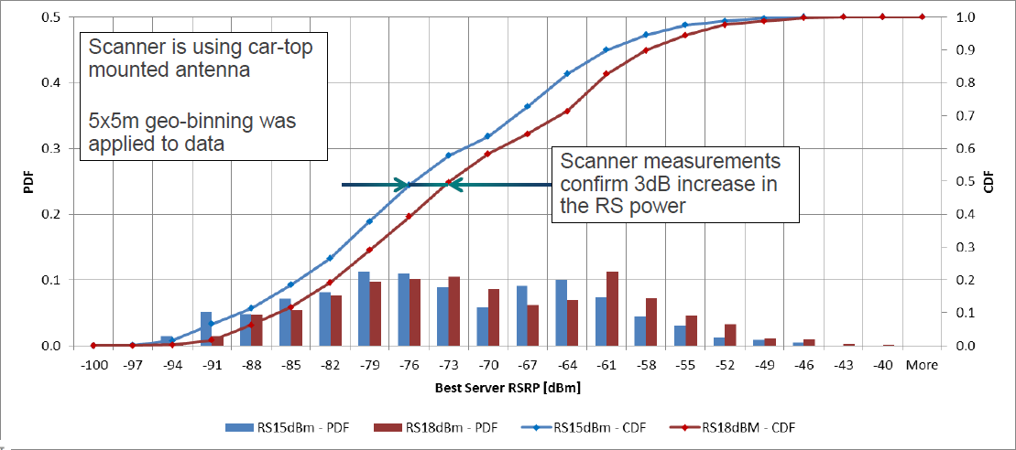
Figure 68: Impact of Reference Signal power boosting upon RSRP
Figure 69 illustrates the impact of Reference Signal power boosting upon RRC connection setup success rate. This example illustrates the requirement to increase Qrxlevmin after applying Reference Signal power boosting. The RRC connection setup success rate decreases after enabling power boosting. The performance is only recovered after Qrxlevmin is increased. Increasing Qrxlevmin ensures that the idle mode cell range is not increased after applying power boosting.
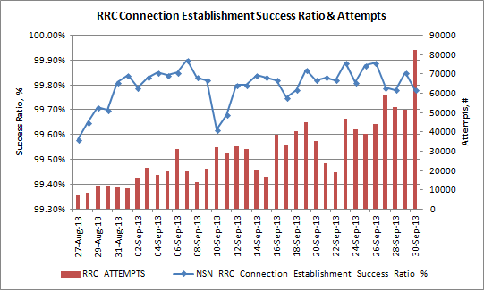
Qrxlevmin increased
Boost applied
Figure 69: Impact of Reference Signal power boosting upon RRC setup success rate
Figure 70 illustrates the impact of Reference Signal power boosting upon the normal release ratio. This example illustrates the requirement to increase RSRP based mobility thresholds after applying Reference Signal power boosting. The normal release ratio decreases after enabling power boosting. The performance is only recovered after threshold4 is increased. Increasing threshold4 ensures that the connected mode cell range is not increased after applying power boosting (note that thresholds for inter-frequency and inter-system handover should also be adjusted if applicable).
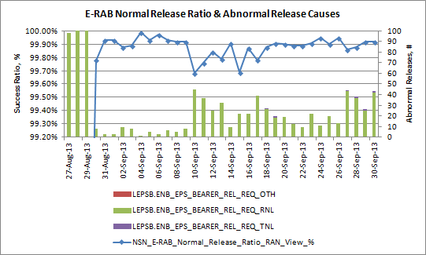
threshold4 increased
Boost applied
Figure 70: Impact of Reference Signal power boosting upon normal release ratio
Figure 71 illustrates the impact of Reference Signal power boosting upon neighbor list length. Phases 3 and 4 of the field trial had power boosting enabled. Phases 2 and 3 had both active and passive ANR enabled, whereas phases 1 and 2 had only passive ANR enabled. Power boosting has caused a significant increase to the number of LNADJ at each eNodeB.
Figure 71: Impact of Reference Signal power boosting upon neighbour list length

Uplink Power Control

Introduction
Uplink power control is responsible for setting the transmit power for each uplink signal and each uplink physical channel:
- PRACH
- PUSCH and PUSCH Demodulation Reference Signal
- PUCCH and PUCCH Demodulation Reference Signal
- Sounding Reference Signal (SRS)
Power control is important to help minimize intercell interference and to help ensure that SINR requirements are achieved. Both of these impact connection throughputs and cell capacity. Uplink power control is standardized by 3GPP TS 36.213 and TS 36.321.
The LTE1336 Interference Aware Uplink Power Control feature offers an alternative algorithm for generating the closed loop power control commands. Interference Aware Uplink Power Control is applicable to the PUSCH and SRS. It aims to optimize the trade-off between own cell throughput and intercell interference, i.e. UE towards cell edge have their transmit powers reduced. Interference Aware Uplink Power Control is most applicable to dense urban scenarios where there is the greatest potential for intercell interference. The algorithm runs within the eNodeB and is transparent to the UE.

Typical Issues
Issues associated with uplink power control include:
- PRACH Preambles not received by eNodeB
UE transmit their PRACH preambles using a common Resource Block allocation. If one UE is received with high power then it becomes more difficult for the eNodeB to detect preambles from other UEs. This scenario can occur when an aggressive power control strategy is adopted for the PRACH. If the PRACH received target power is set high then UE in good coverage will be able to achieve that received target power, but UE in weaker coverage will become power limited and will be received with less power.
- Unreliable MSG3 reception
MSG3 is the first transmission on the PUSCH. Power control is particularly important for this first transmission because link adaptation has not yet had a chance to converge according to the channel conditions and BLER. The initial MCS is typically configured to a low value to remain conservative until channel conditions are known. Feature LTE1495: Fast Uplink Link Adaptation provides a solution for rapidly increasing the MCS from its initial value.
- High uplink intercell interference
High uplink intercell interference can be generated by:
  - non-ideal RF planning causes increased levels of intercell interference. Antenna heights, tilts and azimuths should be selected to help achieve good dominance with only limited cell overlap.
  - proactive scheduling which increases the number of uplink transmissions on the PUSCH. Longer proactive scheduling periods have greater impact. Configuring ilReacTimerUl with a value of 5 ms means that proactive scheduling is only applied to the signalling procedures and levels of intercell interference are reduced. Rel-14 compliant UEs may support functionality that allows them to skip the transmission of the uplink data during proactive scheduling, if there is no user data in the buffer, which can limit the impact to uplink interference; this is supported in the eNode B from LTE18A using LTE4066 Low Latency Fast Uplink Grants.
  - uplink power control strategy which may result in cell edge UE transmitting at relatively high transmit powers. Either fractional power control or LTE1336 Interference Aware Uplink Power Control can be used to limit the UE transmit power at cell edge.
  - mobility configuration can cause uplink interference if handovers are completed either early or late, i.e. UE are not connected to the best server. Feature LTE1140: Intra Frequency Load Balancing can increase uplink intercell interference if relatively large cell individual offsets are applied.
- Reduced uplink throughputs
Non-ideal power control can lead to decreased uplink throughputs. The parameter set associated with uplink power control should be optimised to ensure that uplink throughputs are maximised.

Performance Analysis
Uplink power control impacts the uplink throughput performance. The counters and KPI specified in section 6.11.3 should be used to quantify the impact upon uplink throughput.
Using network statistics to monitor the performance of power control for the PRACH is relatively challenging because the eNodeB has no knowledge of preambles which are not received due to inadequate transmit power. However, as long as traffic levels are stable from day to day, parameter changes can be made and the number of received preambles can be quantified. An increase in the number of received preambles indicates an improvement in the PRACH power control assuming a constant number of preamble transmissions. The counters used to quantify the number of received preambles are shown in Table 75. All 3 types of preamble use the same power control calculation.

Counter Id | Counter Name | Comments
M8001C6 | RACH_STP_ATT_SMALL_MSG | Sum of counters quantifies the total number of received preambles
M8001C7 | RACH_STP_ATT_LARGE_MSG
M8001C286 | RACH_STP_ATT_DEDICATED
Table 75: Counters used to quantify the number of received preambles
The performance of PRACH power control can also be studied using a UE logging tool. The success rate of the MSG1-MSG2 handshake can be quantified as the UE is moved from areas of good coverage to areas of poor coverage. This approach assumes that MSG2 reception is reliable. This approach has the advantage of providing information regarding the number of PRACH preambles belonging to each power ramping cycle. If large numbers of PRACH preambles are used for each power ramping cycle, then the initial transmit power is likely to be too low.
The counters presented in Table 76 record the UE transmit power headrooms reported by the population of UE. These counters can be used to identify cells with relatively poor uplink coverage conditions. An example scenario where low UE transmit power headrooms are recorded is an outdoor macrocell which serves a large number of indoor users.
Counter Id | Counter Name | Comments
M8005C54 | UE_PWR_HEADROOM_PUSCH_LEVEL1 | Distribution of reported UE transmit power headrooms
M8005C55 | UE_PWR_HEADROOM_PUSCH_LEVEL2 | Distribution of reported UE transmit power headrooms
… | … | Distribution of reported UE transmit power headrooms
M8005C84 | UE_PWR_HEADROOM_PUSCH_LEVEL31 | Distribution of reported UE transmit power headrooms
M8005C85 | UE_PWR_HEADROOM_PUSCH_LEVEL32 | Distribution of reported UE transmit power headrooms
M8005C87 | UE_PWR_HEADROOM_PUSCH_MIN | Minimum, maximum and average reported UE transmit power headrooms
M8005C88 | UE_PWR_HEADROOM_PUSCH_MAX
M8005C89 | UE_PWR_HEADROOM_PUSCH_AVG
Table 76: Counters recording the reported UE transmit power headroom
Changes to uplink power control are likely to impact the uplink RSSI and SINR for both the PUCCH and PUSCH. Counters for the PUCCH are presented in section 6.5.3. The counters shown in Table 77 record the RSSI across active PUSCH Resource Blocks. There are minimum, maximum and average counters, as well as a set of counters recording the distribution of RSSI values. These counters can be used to identify cells which are receiving the PUSCH with relatively low powers, i.e. cells which are likely to have poor coverage.

Counter Id | Counter Name | Comments
M8005C3 | RSSI_PUSCH_MIN | Minimum, maximum and average RSSI values measured across active PUSCH Resource Blocks
M8005C4 | RSSI_PUSCH_MAX
M8005C5 | RSSI_PUSCH_AVG
M8005C28 | RSSI_PUSCH_LEVEL_01 | Distribution of RSSI values measured across active PUSCH Resource Blocks
M8005C29 | RSSI_PUSCH_LEVEL_02
-- | --
M8005C48 | RSSI_PUSCH_LEVEL_21
M8005C49 | RSSI_PUSCH_LEVEL_22
Table 77: Counters recording RSSI across active PUSCH Resource Blocks
The counters shown in Table 78 record the RSSI across all PUSCH Resource Blocks. There are minimum, maximum and average counters, as well as a set of counters recording the distribution of RSSI values. These counters reflect a combination of PUSCH RSSI and the number of connections within a cell. Low numbers of connections will result in low counter results because the counter results are averaged across both active and inactive Resource Blocks.
Counter Id | Counter Name | Comments
M8005C231 | RSSI_CELL_PUSCH_MIN | Minimum, maximum and average RSSI values measured across all PUSCH Resource Blocks
M8005C232 | RSSI_CELL_PUSCH_MAX
M8005C233 | RSSI_CELL_PUSCH_MEAN
M8005C234 | RSSI_CELL_PUSCH_LEVEL_1 | Distribution of RSSI values measured across all PUSCH Resource Blocks
M8005C235 | RSSI_CELL_PUSCH_LEVEL_2
-- | --
M8005C254 | RSSI_CELL_PUSCH_LEVEL_21
M8005C255 | RSSI_CELL_PUSCH_LEVEL_22
Table 78: Counters recording RSSI across all PUSCH Resource Blocks
The counters shown in Table 79 record the SINR across active PUSCH Resource Blocks. These counters can be used to identify cells which are receiving the PUSCH with relatively low powers, i.e. cells which are likely to have poor coverage.

Counter Id | Counter Name | Comments
M8005C93 | SINR_PUSCH_MIN | Minimum, maximum and average SINR values measured across active PUSCH Resource Blocks
M8005C94 | SINR_PUSCH_MAX
M8005C95 | SINR_PUSCH_AVG
M8005C118 | SINR_PUSCH_LEVEL_1 | Distribution of RSSI values measured across active PUSCH Resource Blocks
M8005C119 | SINR_PUSCH_LEVEL_2
-- | --
M8005C138 | SINR_PUSCH_LEVEL_21
M8005C139 | SINR_PUSCH_LEVEL_22
Table 79: Counters recording SINR across active PUSCH Resource Blocks
The counters shown in Table 80 record the SINR across all PUSCH Resource Blocks. These counters reflect a combination of PUSCH SINR and the number of connections within a cell. Low numbers of connections will result in low counter results because the counter results are averaged across both active and inactive Resource Blocks.
Counter Id | Counter Name | Comments
M8005C281 | SINR_CELL_PUSCH_MIN | Minimum, maximum and average SINR values measured across all PUSCH Resource Blocks
M8005C282 | SINR_CELL_PUSCH_MAX
M8005C283 | SINR_CELL_PUSCH_MEAN
M8005C284 | SINR_CELL_PUSCH_LEVEL_1 | Distribution of RSSI values measured across all PUSCH Resource Blocks
M8005C285 | SINR_CELL_PUSCH_LEVEL_2
-- | --
M8005C304 | SINR_CELL_PUSCH_LEVEL_21
M8005C305 | SINR_CELL_PUSCH_LEVEL_22
Table 80: Counters recording SINR across all PUSCH Resource Blocks

Parameter Definition

PRACH
Power control for the PRACH refers to the transmit power of the PRACH preambles, i.e. MSG1. The transmit powers for MSG3 and MSG5 are determined by power control for the PUSCH.
PRACH power control uses the following open loop calculation (assuming a UE maximum transmit power capability of 23 dBm):
P_{PRACH} = Min{23, ulpcIniPrePwr + (Preamble_Tx_Cnt – 1) × prachPwrRamp + Path Loss}
The Preamble_Tx_Cnt variable is a counter maintained by the UE which records the number of PRACH preambles which have been transmitted for a specific access attempt. The number of transmissions is limited by the preambTxMax parameter. The Path Loss variable is calculated by the UE based upon RSRP measurements. The ulpcIniPrePwr, prachPwrRamp and preambTxMax parameters are shown in Table 81.
Parameter | Object | Range | Default
ulpcIniPrePwr | SIB | -120 to -90 dBm | -96 dBm
prachPwrRamp | SIB | 0, 2, 4, 6 dB | 2 dB
preambTxMax | SIB | 3 to 20 | 10
Table 81: Parameters associated with PRACH power control
The power control calculation simplifies to Min{23, ulpcIniPrePwr + Path Loss} for the first preamble transmission. Assuming the default value for ulpcIniPrePwr (-96 dBm), the UE becomes power limited when the path loss equals 119 dB. Assuming a 20 W total downlink transmit power, this path loss can be converted to an equivalent RSRP for each channel bandwidth. This has been done in Table 82 while assuming that Reference Signal power boosting is disabled.
Channel Bandwidth | Resource Blocks | Resource Element Transmit Power | Power Limited RSRP
1.4 MHz | 6 | 24.4 dBm | -94.6 dBm
3 MHz | 15 | 20.4 dBm | -98.6 dBm
5 MHZ | 25 | 18.2 dBm | -100.8 dBm
10 MHz | 50 | 15.2 dBm | -103.8 dBm
15 MHz | 75 | 13.5 dBm | -105.5 dBm
20 MHz | 100 | 12.2 dBm | -106.8 dBm
Table 82: RSRP at which the UE becomes power limited for the first PRACH preamble
These results illustrate that the UE becomes power limited at relatively high RSRP, i.e. before the UE reaches cell edge. In the case of the 10 MHz channel bandwidth, the UE becomes power limited at an RSRP of -103.8 dBm. If the cell is configured with a Qrxlevmin = -124 dBm then a UE at cell edge with be received with 20 dB less power than a UE which has an RSRP greater than, or equal to -104 dBm. PRACH preambles are transmitted on shared Resource Blocks so there is a danger that the signal received from the UE at cell edge will become swamped by the signals received from UE in better coverage conditions. This scenario is illustrated in Figure 72.
Figure 72: PRACH preamble received power differences
This scenario corresponds to an aggressive PRACH power control strategy which tends to allocate a high PRACH preamble transmit power to help improve the probability of reception. This strategy sacrifices some cell edge performance for an improved average cell performance. Reducing the value of ulpcIniPrePwr means that preambles are transmitted with lower power and there will be a smaller received power difference between cell edge UE and UE in good coverage. This strategy will help to improve cell edge performance but may reduce the average cell performance because UE in good coverage will be received with less power.

PUSCH
Power control for the PUSCH is managed using the actUlpcMethod parameter shown in Table 83. This parameter also manages power control for the PUCCH and SRS. The parameter provides a choice between using only open loop power control and using the combination of open and closed loop power control. In addition, either conventional or Interference Aware (IAw) closed loop power control can be selected.
Parameter | Object | Range | Default
actUlpcMethod | LNCEL | PuschOLPucchOL (0), PuschOLPucchCL (1), PuschCLPucchOL (2), PuschCLPucchCL (3), PuschCLSrsPucchOL (4), PuschCLSrsPucchCL (5), PuschIAwPucchOL (6), PuschIAwPucchCL (7) | PuschOLPucchOL (0)
Table 83: Parameter used to manage PUSCH, PUCCH and SRS power control
The 3GPP equation for PUSCH power control is shown in Figure 73. This equation includes both the open loop and closed loop components.
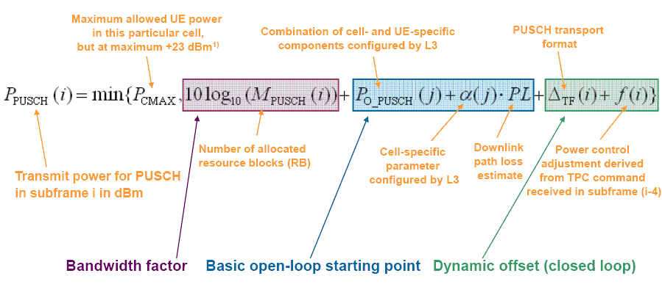
Figure 73: PUSCH power control calculation
- M_{PUSCH} is the number of allocated Resource Blocks. The UE transmit power is increased in direct proportion to the number of allocated Resource Blocks. Each of the remaining terms in the calculation are per Resource Block
- P_{0_PUSCH} represents the eNodeB received power requirement. Its value depends upon the type of PUSCH transmission:
  - in the case of MSG3transmission, P_{0_PUSCH} is given by ulpcIniPrePwr + deltaPreMsg3
  - in the case of PUSCH transmissions after MSG3:
    - interference aware uplink power control disabled, P_{0_PUSCH} = p0NomPusch
    - interference aware uplink power control enabled, P_{0_PUSCH} = p0NomPuschIAw
- α is used to enable/disable fractional power control. It is configured using the ulpcAlpha parameter. Setting a value of 1 means that fractional power control is disabled, and conventional power control is applied. It is mandatory to disable fractional power control when using interference aware uplink power control. The value of ulpcAlpha has an impact upon the recommended value for p0NomPusch. Fractional power control and its impact upon the recommended parameter settings are described later in this section.
- PL is the downlink path loss calculated by the UE based upon RSRP measurements and knowledge of the Reference Signal transmit power, i.e. PL= RS transmit power – RSRP measurement
- Delta_TF links the UE transmit power to the uplink MCS. It provides the UE with a transmit power boost when using high MCS values. Use of Delta_TF is enabled using the deltaTfEnable parameter
- f(i) is determined by the inner loop power control commands sent by the eNodeB on the PDCCH. In the case of MSG3, f(i) is determined by the ulpcRarespTpc parameter. When Interference Aware Uplink Power Control is disabled, the inner loop power control commands are generated using the grid shown in Figure 74. The UE is instructed to increase its transmit power when either the uplink SINR or the uplink RSSI are weak. The grid is defined by the ulpcUpqualSch, ulpcLowqualSch, ulpcUplevSch, ulpcLowlevSch parameters.
Figure 74: PUSCH inner loop power control grid
Parameter | Object | Range | Default
ulpcUpqualSch | LNCEL. ulpcPuschConfig | -47 to 80 dB | 20 dB
ulpcLowqualSch | LNCEL. ulpcPuschConfig | -47 to 80 dB | 0 dB
ulpcUplevSch | LNCEL. ulpcPuschConfig | -127 to 0 dBm | -88 dBm
ulpcLowlevSch | LNCEL. ulpcPuschConfig | -127 to 0 dBm | -103 dBm
Table 84: Parameters used to configure the PUSCH inner loop power control grid

The remaining power control parameters referenced above are presented in Table 85.
Parameter | Object | Range | Default
ulpcIniPrePwr | SIB | -120 to -90 dBm | -96 dBm
deltaPreMsg3 | LNCEL | -1 to 6 (-2 to 12 dB) | 1 (2 dB)
preambTxMax | SIB | 3 to 200 | 10
p0NomPusch | LNCEL | -126 to 24 dBm | -80 dBm
p0NomPuschIAw | LNCEL.ulpcIAwConfig | -110 to -70 dBm | -100 dBm
ulpcAlpha | LNCEL | 0 to 1 | 1
deltaTfEnabled | LNCEL | 0 (false), 1 (true) | 0 (false)
ulpcRarespTpc | LNCEL_FDD | -6 to 8 dB | 4
Table 85: Parameters associated with PUSCH power control
The concepts of conventional and fractional power control are shown in Figure 75. Conventional power control schemes aim to maintain a constant SINR at the receiver, so the UE increases its transmit power to fully compensate for increases in the path loss. Fractional power control schemes allow the received SINR to decrease as the path loss increases so the UE transmit power increases at a lower rate compared to conventional power control. The objective of fractional power control is to reduce intercell interference and consequently to increase network capacity.
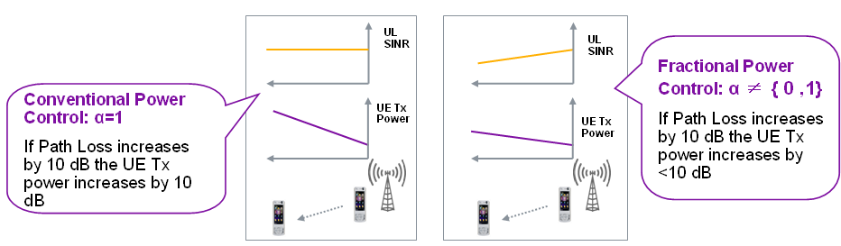
Figure 75: Conventional and Fractional power control schemes
The use of fractional power control has an impact upon the configuration of other power control parameters:
- ulpcAlpha = 1 (conventional power control): p0NomPusch is configured with a relatively small value to allow for sufficient UE transmit power headroom as the path loss increases
- ulpcAlpha < 1 (fractional power control): p0NomPusch is configured with a larger value because less UE transmit power headroom is required as the path loss increases
Use of only Open Loop Power Control
In this case, the UE transmit power accounts for changes in the path loss but the eNodeB is unable to fine tune the UE transmit power using Transmit Power Control (TPC) commands. The value of p0NomPusch determines the uplink SINR target. Allocating a high value to this parameter will generate a high SINR at the eNodeB when the UE has a small path loss and will consequently allow a high throughput. As the path loss increases, the UE will increase its transmit power in an attempt to maintain the SINR target at the eNodeB (assuming fractional power control is disabled). A high value of p0NomPusch means that the UE will reach its maximum UE transmit power capability sooner. At this point the Automatic Transmission Bandwidth (ATB) component of link adaptation will be triggered. ATB limits the maximum number of allocated Resource Blocks so can limit the maximum achieved throughput. This can mean that connection throughputs towards cell edge can be lower when configuring a high value for p0NomPusch . This trend is illustrated by Figure 76 and Figure 77.
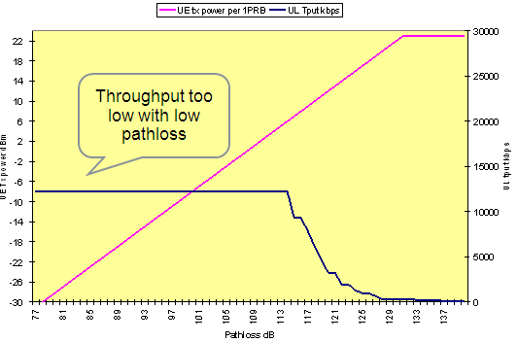
Figure 76: Pathloss vs. UE Tx Power/Throughput (Po =-110dB)
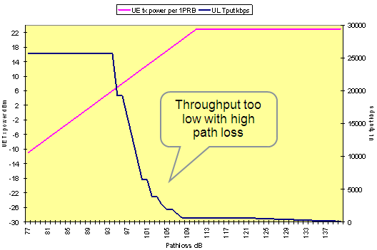
Figure 77: Pathloss vs. UE Tx Power/Throughput (Po =-90dB)
Enabling fractional power control will tend to reduce the UE transmit power towards cell edge and thus reduce the probability of triggering ATB. This means that the value of ulpcAlpha should be tuned in combination with the value of p0NomPusch (ulpcAlpha must be set to 1 when using Interference Aware Uplink Power Control). Figure 78 provides a set of simulation results which illustrate the impact of p0NomPusch and ulpcAlpha upon both average cell throughput and cell edge throughput. Each line is for a different value of ulpcAlpha, whereas each point is for a different value of p0NomPusch.
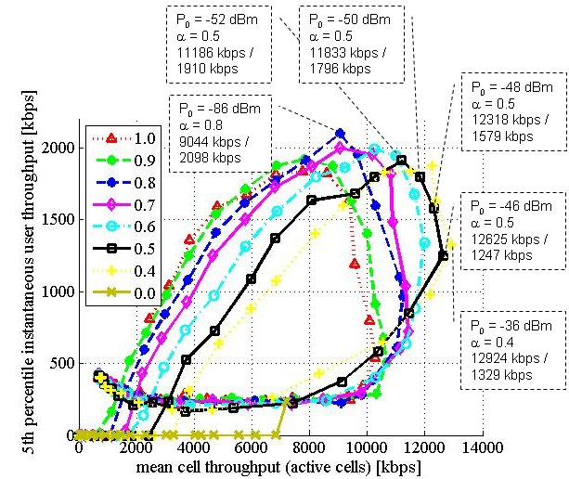
Figure 78: Coverage vs. Capacity trade off as a function of ulpcAlpha and p0NomPusch
Current recommendations are:
- medium to high load scenarios (where intercell interference is more significant)
  - ulpcAlpha = 0.8
  - p0NomPusch = -80 dBm
- low load scenarios:
  - ulpcAlpha = 1.0
  - p0NomPusch = -100 dBm
These recommendations are based upon the rule-of-thumb that p0NomPusch = -100 × ulpcAlpha. Some data suggests the rule of thumb should be p0NomPusch = -95 × ulpcAlpha so both options can be considered.
Note that the use of an MHA can introduce an offset between the uplink and downlink path losses. The UE measures the downlink path loss whereas the PUSCH experiences the uplink path loss. If an MHA is used then the value of p0NomPusch can be reduced by the feeder loss to compensate for the lower uplink path loss.
Interference Aware Uplink Power Control
The Nokia proprietary interference aware uplink power control scheme offers an alternative to the 3GPP Fractional power control scheme. The two schemes cannot be enabled simultaneously. Interference aware uplink power control is based upon using CQI reports to estimate the proximity of the UE to cell edge. Downlink CQI values are translated into downlink SINR values. SINR values are then combined with uplink RSSI measurements to generate a target uplink SINR. Power control commands are then generated by comparing the target SINR with the achieved SINR.
The majority of parameters associated with interference aware uplink power control are included within the ulpcIAwConfig LNCEL parameter structure. These parameters are shown in Table 86.
Parameter | Object | Range | Default
p0NomPuschIAw | LNCEL.ulpcIAwConfig | -110 to -70 dBm | -100 dBm
ulpcCEBalanceIAw | LNCEL.ulpcIAwConfig | 0.5 to 1.4 | 1
ulpcMinQualIAw | LNCEL.ulpcIAwConfig | 0 to 5 | 2
ulpcMinWaitForPc | LNCEL.ulpcIAwConfig | 6 to 80 TTI | 25 TTI
ulpcRefPwrIAw | LNCEL.ulpcIAwConfig | -110 to -70 dBm | -104 dBm
Table 86: Parameters belonging to the ulpcIAwConfig structure

From LTE18A, block error rate for the PUSCH can be adapted dynamically per connection. Prior to LTE18A, a static BLER target is assigned by LNCEL parameter ulTargetBler. Dynamic uplink BLER adaptation uses several BLER target regions which are defined based upon hard-coded SINR thresholds. A UE will be allocated a BLER target according to the region in which it’s SINR resides. The SINR is normalised to account for the UE PRB allocation and power headroom. It is expected that the uplink throughput of UEs requiring a higher BLER target, e.g. those at cell edge, will benefit from having a link adaptation algorithm that allows more retransmissions before MCS downgrades are performed. Uplink Dynamic BLER Adaptation is enabled using the LNCEL parameter actUlDynamicTargetBler. Figure 79 shows an example of the improvement achieved from using dynamic uplink BLER on a cluster of FDD sites.
Figure 79: Uplink IP throughput based upon LTE_5510a showed average improvement of 110kbps

Uplink Proactive Scheduling
Uplink proactive scheduling can be used to improve latency for a UE, by retaining it in DRX active state for a period of time after the uplink buffer has emptied. If, subsequently, new uplink data enters the buffer, then the UE can immediately send a buffer status report, which triggers scheduling. This behavior can negatively impact uplink interference due to the transmission of dummy data.
LTE4066 Low Latency Fast UL Grants allows a UE to skip proactive uplink transmissions when there is no data to send, thus benefitting battery life and lowering interference. If the BSR value is 0, rather than transmit padding data, the UE will not transmit any data at all. This functionality is introduced in 3GPP Rel-14 specifications.
LTE5731: TCP Service Differentiation belongs to LTE19B software but is also available from LTE18A in CRL22975. TCP Service Differentiation allows a boost factor to be applied to the scheduling weight of DRBs that are classified as “medium” TCP flows. A medium TCP flow is defined as one that may be user experience impacting, i.e. it is larger than small flows that would constitute mainly background services, and smaller than full buffer downloads, both of which should not have scheduling weights boosted. The feature is activated using LNCEL parameter actTcpServiceDiff, whilst the structure tcpServiceDiffConfig can define the medium TCP flow size, the boost factor for the medium TCP flows vs other scheduling weights and the duration that the boost factor shall be applied for.
What constitutes a “medium” TCP flow should be defined based upon the traffic profile of an individual operator; these figures may be best provided from packet core network statistics. The example in Figure 80 shows that a medium TCP flow for this operator may be in the region of 5MB in the downlink (based on the second column) and a value of <200kB in the uplink (based on the third column).
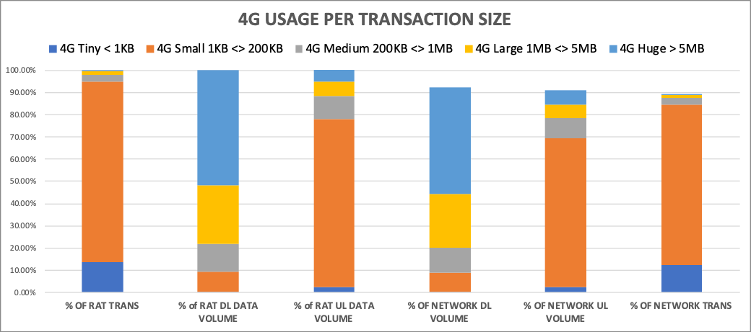
Figure 80: Example TCP flow sizes for an operator.
Further improvements to uplink proactive scheduling are possible from LTE19A where TCP Service Differentiation is enabled, by optimizing uplink proactive scheduling for medium TCP flows to minimise uplink interference. LNBTS parameter ilMinDataTrigGrantTcpBoost can be used to set a minimum payload size for triggering uplink proactive scheduling. To increase the number of UEs that can use proactive scheduling, the first uplink grant can be delayed using LNBTS parameter ilGrantDelayTcpBoost and the frequency of uplink grants can be reduced using ilGrantGapTcpBoost.
Also, from LTE19A, the LNBTS parameter actReduceAcqiReqTxSkip can be used to enable the skipping of aperiodic CQI reports during proactive scheduling. The LNCEL_FDD/LNCEL_TDD parameter cqiAperPollTxSkip overrides the legacy parameter cqiAperPollT,

PUCCH
Power control for the PUCCH is managed using the same parameter as for the PUSCH, i.e. the actUlpcMethod parameter shown in Table 83. This parameter allows either open or closed loop power control to be enabled.
The 3GPP equation for PUCCH power control is shown below. This equation includes both the open loop and closed loop components. In contrast to the PUSCH, this equation excludes any dependency upon Resource Block allocation because the PUCCH is always transmitted using a single Resource Block in the frequency domain. The PUCCH equation also excludes the option for fractional power control, i.e. the path loss is not multiplied by alpha.
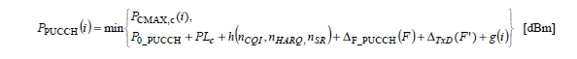
- P_{0_PUCCH} represents the eNodeB received power requirement. Its value is configured using the p0NomPucch parameter.
- PL is the downlink path loss calculated by the UE based upon RSRP measurements and knowledge of the Reference Signal transmit power, i.e. PL= RS transmit power – RSRP measurement
- h(n_{CQI}, n_{HARQ}, n_{SR}) is dependent upon the PUCCH format. In the case of PUCCH formats 1, 1a and 1b this variable is set to 0. If PUCCH format 1b with channel selection is being used and the UE is configured with more than one serving cell then this variable is dependent upon the number of HARQ bits. If PUCCH formats 2, 2a or 2b are used then this variable is dependent upon the number of CQI bits. If PUCCH format 3 is used then this variable is dependent upon the number of HARQ and Scheduling Request bits.
- Δ_{F_PUCCH}(F) is dependent upon the PUCCH format. Its value is defined by the relevant parameter from Table 87.
Parameter | Object | Range | Default
dFpucchF1 | LNCEL.dFListPucch | -2, 0, 2 dB | 0 dB
dFpucchF1b | LNCEL.dFListPucch | 1, 3, 5 dB | 1 dB
dFpucchF2 | LNCEL.dFListPucch | -2, 0, 1, 2 dB | 0 dB
dFpucchF2a | LNCEL.dFListPucch | -2, 0, 2 dB | 0 dB
dFpucchF2b | LNCEL.dFListPucch | -2, 0, 2 dB | 0 dB
deltaFPucchF1bCSr10 | SIB.uplinkPCCommonr10. | 1, 2 dB | Not populated
deltaFPucchF3r10 | SIB.uplinkPCCommonr10. | -1, 0, 1, 2, 3, 4, 5, 6 dB | 0 dB
Table 87: Parameters used to specify the PUCCH format dependency upon UE transmit power

- Δ_{TxD}(F’) is not applicable because it is used when the UE transmits the PUCCH on more than a single antenna port.
- g(i) is determined by the inner loop power control commands sent by the eNodeB on the PDCCH. Inner loop power control commands are generated using the grid shown in Figure 81. The UE is instructed to increase its transmit power when either the uplink SINR or the uplink RSSI are weak. The grid is defined by the ulpcUpqualCch, ulpcLowqualCch, ulpcUplevCch, ulpcLowlevCch parameters shown in Table 88.
Figure 81: PUCCH inner loop power control grid

Parameter | Object | Range | Default
ulpcUpqualCch | LNCEL.ulpcPucchConfig | -47 to 80 dB | 2 dB
ulpcLowqualCch | LNCEL.ulpcPucchConfig | -47 to 80 dB | -1 dB
ulpcUplevCch | LNCEL.ulpcPucchConfig | -127 to 0 dBm | -113 dBm
ulpcLowlevCch | LNCEL.ulpcPucchConfig | -127 to 0 dBm | -118 dBm
Table 88: Parameters used to configure the PUCCH inner loop power control grid

SRS
Power control for the SRS is managed using the actUlpcMethod parameter shown in Table 83. The PUSCH and SRS use the same power control approach, e.g. the SRS will use closed loop power control when the PUSCH is configured for closed loop power control. The options available for the PUSCH and SRS are:
- open loop power control
- closed loop power control
- closed loop power control which accounts for measurements from the SRS
- interference aware closed loop power control
The 3GPP equation for SRS power control is shown below. This equation includes both the open loop and closed loop components.
- P_{SRS_OFFSET} is based upon the srsPwrOffset parameter presented in Table 89. Interpretation of this parameter depends upon the value of the deltaTfEnabled parameter:
  - deltaTfEnabled = ‘true’ then actual value = srsPwrOffset – 3
  - deltaTfEnabled = ‘false’ then actual value = srsPwrOffset × 1.5 – 10.5
Parameter | Object | Range | Default
srsPwrOffset | LNCEL_FDD | 0 to 15, step 1 | 7
Table 89: Parameter defining the SRS power offset
- M_{SRS} is the number of allocated Resource Blocks for the SRS transmission
- P_{0_PUSCH} represents the eNodeB received power requirement. Its value is dependent upon whether or not interference aware uplink power control is enabled:
  - interference aware uplink power control disabled, P_{0_PUSCH} = p0NomPusch
  - interference aware uplink power control enabled, P_{0_PUSCH} = p0NomPuschIAw
- α is used to enable/disable fractional power control. It is configured using the ulpcAlpha parameter. Setting a value of 1 means that fractional power control is disabled and conventional power control is applied. It is mandatory to disable fractional power control when using interference aware uplink power control.
- PL is the downlink path loss calculated by the UE based upon RSRP measurements and knowledge of the Reference Signal transmit power, i.e. PL= RS transmit power – RSRP measurement
- f(i) is determined by the inner loop power control commands sent by the eNodeB on the PDCCH. When Interference Aware Uplink Power Control is disabled, the inner loop power control commands are generated using the grid shown in Figure 74. The UE is instructed to increase its transmit power when either the uplink SINR or the uplink RSSI are weak. The grid is defined by the ulpcUpqualSch, ulpcLowqualSch, ulpcUplevSch, ulpcLowlevSch parameters.

Optimization Procedure
Figure 82 illustrates a procedure for the optimisation of PRACH preamble reception. The procedure requires UE log files to be used to identify whether or not UE are transmitting high numbers of PRACH preambles prior to receiving a Random Access Response.
Figure 82: Checks for PRACH initial target power and step size
If UE are always receiving their random access response after the first PRACH preamble transmission then there may be scope to reduce the initial target power configured by the ulpcIniPrePwr parameter. This will help to reduce intercell interference and also help to ensure that preambles belonging to power limited UE at cell edge are received successfully, i.e. avoiding cell edge preambles from being masked by preambles transmitted by UE in better coverage conditions.
If UE transmit multiple preambles before receiving their random access response then it may be necessary to increase the initial target power configured by the ulpcIniPrePwr parameter, or to increase the preamble step size configured by the prachPwrRamp parameter.
Figure 83 illustrates a procedure for the optimisation of the PRACH target power when cell edge UE do not receive Random Access Response messages. When this procedure is triggered, a check should be completed to ensure that UE are within the maximum planned cell range. If UE are located outside the maximum planned cell range, then either the cell range should be increased, or RF optimisation should be used to reduce the distance at which the Cell specific Reference Signal is received.
Figure 83: Checks applicable when cell edge UE do not receive Random Access Responses
The RSRP at which UE become power limited can be calculated by identifying the path loss at which the UE reaches its maximum transmit power capability. If the PRACH target power defined by ulpcIniPrePwr is -96 dBm and if the UE transmit power capability is 23 dBm, then the UE will become power limited when the path loss becomes 119 dB. Assuming a Reference Signal transmit power of 15 dBm, this corresponds to an RSRP of -104 dBm. If this RSRP is significantly less than Qrxlevmin then the value allocated to ulpcIniPrePwr may be too large. This is most likely to have an impact in busy cells where both UE in good coverage and cell edge UE attempt access to the cell simultaneously.
Figure 84 illustrates a procedure to check for the applicability of Fractional and Interference Aware power control. Both of these solutions are most applicable to high site densities where there is the greatest potential for intercell interference. Fractional power control is a 3GPP solution whereas Interference Aware power control is a Nokia solution. Both options can be trialed to determine the solution which provides the best results.
Figure 84: Checks for application of Fractional and Interference Aware power control
Figure 85 illustrates a procedure to check the PUSCH power control target power defined by p0NomPusch (or by p0NomPuschIAw if Interference Aware power control is enabled). The value allocated to this parameter can have an impact upon uplink throughputs and levels of intercell interference. Its value should be considered in combination with the use of Fractional or Interference Aware power control.
Figure 85: Checks for configuration of PUSCH target received power

Field Results
Figure 86 illustrates some lab testing results which demonstrate an improvement in uplink throughput after optimising the uplink power control parameters. Uplink throughput was measured during 10 FTP upload sessions. Prior to applying the changes, the Ericsson throughput was greater than the Nokia throughput. The parameter changes increased the Nokia throughput to a level above the Ericsson throughput. The associated parameter changes are presented in Table 90. It should be recognised that these results are from the lab environment so do not account for realistic levels of intercell interference which may be presented in the field.
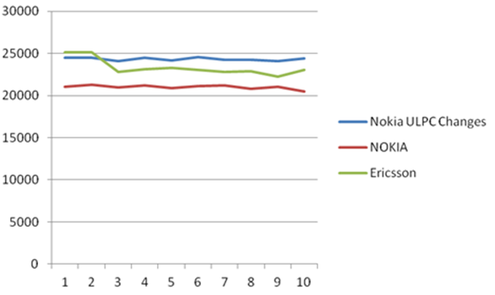
Throughput (kbps)
FTP session
Figure 86: Uplink throughput improvement after power control parameter changes

Parameter | Object | Initial Value | Changed Value
p0NomPusch | LNCEL | -106 dBm | -80 dBm
ulpcAlpha | LNCEL | 1 | 0.8
ulpcLowqualSch | LNCEL.ulpcPuschConfig | 8 dB | 0 dB
ulpcUpqualSch | LNCEL.ulpcPuschConfig | 11 dB | 20 dB
ulpcLowlevSch | LNCEL.ulpcPuschConfig | -103 dBm | -103 dBm
ulpcUplevSch | LNCEL.ulpcPuschConfig | -98 dBm | -88 dBm
Table 90: Parameters changes for uplink power control trial
Figure 87 to Figure 91 show an example of the improvements achieved when optimizing the uplink throughput by changing the power control configuration. Although these parameters significantly improved the performance it should be noted that these settings were specific to a certain UE which had some UL power control issues and in any case, they were not optimal as there were still areas where the BLER was well below the target and the UE was not being assigned the max number of PRB. This leads to the conclusion that the UL SINR at the eNodeB receiver was higher than needed due to excessive UE transmission power.
Figure 87: Impact of UL PC settings on UL Performance
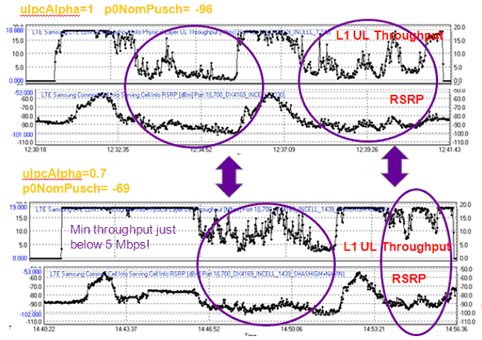
Figure 88: Comparison between UL L1 Throughput and RSRP for different UL PC settings
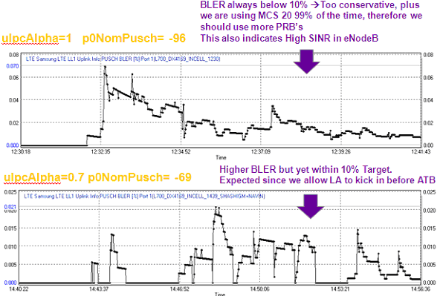
Figure 89: PUSCH BLER for different UL PC settings
Figure 90: Impact of UL PC settings on UL PRB allocations (alpha =1, P0Nom=-96 dB)
Figure 91: Impact of UL PC settings on UL PRB allocations (alpha =0.7, P0Nom=-69dB)
The performance illustrated above was obtained with the following parameter set which could be a good starting point for further optimization:
Table 91: Starting point for uplink power control parameter optimization
Two different sets of quality thresholds are compared within this section. The default ones in PDDB (CL set 1: ulpcUpqualSch =11, ulpcLowqualSch =8) and a higher quality (i.e. higher UL SINR) one (CL set 2: ulpcUpqualSch =17, ulpcLowqualSch =14). Level (RSSI) thresholds remain as per default: ulpcLowlevSch = -103 dBm and ulpcUpLevSch = -98 dBm. A CLPC update interval of 50 ms has been selected.
Figure 92 shows the UE Tx power and throughput for a single UE moving from cell centre (right hand side of the picture) to the cell edge. Drive test was repeated twice each one with the different CL sets.
Figure 92: UL single user throughput vs. Closed Loop power control settings
In the cell edge (RSRP lower than -105 dBm) there is no appreciable difference between CL set 1 and CL set 2 regarding UL throughput and UL UE Tx power. However, in those cell ranges where the UE Tx power is not limited by the UE capability there is significant difference in performance between both CL set 1 (lower quality threshold) and CL set 2 (higher quality threshold. For the CL set 1 lower UE Tx are required and correspondingly, lower UL throughputs are measured.
Below figures and table provide a comparison of the drive test results for both sets:
Figure 93: UL Throughput, SINR and BLER for different CL sets
Table 92: Comparison between both sets of parameters
Figure 94 illustrates an example impact of PUCCH power control upon the RRC Connection Setup success ratio. This improvement was achieved by reducing the value of p0NumPucch. In early releases, this parameter had a default value of -100 dBm which resulted in relatively high transmit powers and relatively high uplink interference. The default value was reduced to -116 dBm after field trials demonstrated that a high transmit power was not necessary and that performance could be improved when using a lower value.
Figure 94: Improvement in RRC Setup Success Ratio with less aggressive PUCCH Power Control
Figure 95 illustrates the corresponding reduction in PUCCH RSSI and SINR when the value of p0NumPucch was reduced. There is a clear step change in these metrics.
Figure 95: Reduced PUCCH SINR and RSSI with less aggressive PUCCH Power Control

MIMO Mode Control

Introduction
LTE19B supports the downlink transmission modes presented in Table 93, for FDD. The downlink transmission mode is selected using the dlMimoMode parameter. The Closed Loop MIMO (4x4) configuration uses both transmission modes 4 and 9 according to the UE capability (UE must be at least 3GPP release 10 to support transmission mode 9).
Transmission Mode | PDSCH Transmission Scheme | dlMimoMode
1 | Single Antenna Port | SingleTX (0)
2 | Transmit Diversity | TxDiv (10),  4-way TXDiv (11)
3 | Transmit Diversity | Dynamic Open Loop MIMO (30)
3 | Open Loop Spatial Diversity | Dynamic Open Loop MIMO (30)
3 | Open Loop Spatial Multiplexing | Dynamic Open Loop MIMO (30)
4 | Transmit Diversity | Closed Loop MIMO (40),  Closed Loop MIMO (4x2) (41)  Closed Loop MIMO (4x4) (43)
4 | Closed Loop Spatial Diversity
4 | Closed Loop Spatial Multiplexing
9 | Transmit Diversity | Closed Loop MIMO (4x4) (43)  Closed Loop MIMO (8x2) (42)  Closed Loop MIMO (8x4) (44)
9 | Closed Loop Spatial Diversity
9 | Closed Loop Spatial Multiplexing
Table 93: Downlink transmission modes supported for FDD by LTE19B
MIMO mode control refers to the dynamic switching between the transmission schemes belonging to transmission modes 3, 4 and 9, e.g. when using transmission mode 3 the eNodeB is able to dynamically switch between transmit diversity, open loop spatial diversity and open loop spatial multiplexing.
Transmission modes 3, 4 and 9 switch between spatial diversity and spatial multiplexing based upon the reported Channel Quality Indicator (CQI) and Rank Indicator (RI). Transmit diversity is used as a fallback option in case the eNodeB fails to receive reported CQI and RI values. The eNodeB databuild includes configurable parameters to define the CQI and RI thresholds used for dynamic switching.
The CQI and RI reports are typically averaged before comparing against the MIMO mode thresholds. ‘Fast Adaptive MIMO Switching’ for transmission mode 4 reduces the quantity of averaging to make the system more responsive. It is enabled using the actFastMimoSwitch parameter.

Typical Issues
Issues with MIMO mode control can cause:
- Inappropriate selection between spatial diversity and spatial multiplexing
Downlink throughputs depend upon the selection between spatial diversity and spatial multiplexing. Spatial multiplexing provides higher throughputs than spatial diversity. Inappropriate selection between the two transmission schemes can mean that downlink throughput is not maximised. It can also mean that high downlink throughputs are attempted when the UE is unable to receive them, resulting in high re-transmission rates. Thus, it is important to optimise the switching between transmission schemes.
- Ping-Pong between spatial diversity and spatial multiplexing
Ping-pong between transmission schemes does not fundamentally cause any issues because it does not create any additional signalling. The eNodeB uses the PDCCH to signal the transmission scheme for every subframe that the UE is allocated resources. Nevertheless, ping-pong should be discouraged if it is leading to the inappropriate selection between spatial multiplexing and spatial diversity which could then be reducing throughput performance.

Performance Analysis
The counters shown in Table 94 quantify the utilization of each transmission scheme. They also quantify the volume of switches between transmission schemes.
Counter Id | Counter Name | Comments
M8010C55 | MIMO_OL_DIV | Open loop diversity mode subframes
M8010C56 | MIMO_OL_SM | Open loop multiplexing mode subframes
M8010C57 | MIMO_CL_1CW | Closed loop single codeword subframes
M8010C58 | MIMO_CL_2CW | Closed loop double codeword subframes
M8010C59 | MIMO_SWITCH_OL | Open Loop MIMO mode switches
M8010C60 | MIMO_SWITCH_CL | Closed Loop MIMO mode switches
M8010C71 | MIMO_CL_2CW_3LAYER | Codewords and Layers used by Closed Loop MIMO non-TM9
M8010C72 | MIMO_CL_2CW_4LAYER | Codewords and Layers used by Closed Loop MIMO non-TM9
M8010C73 | MIMO_CL_1CW_2LAYER | Codewords and Layers used by Closed Loop MIMO non-TM9
M8010C92 | MIMO_FALLBACK_TXDIV | Transmit Diversity subframes for non-TM9
M8010C95 | MIMO_CL_1CW_1LAYER_TM9 | Codewords and Layers used by Transmission Mode 9
M8010C96 | MIMO_CL_1CW_2LAYER_TM9 | Codewords and Layers used by Transmission Mode 9
M8010C97 | MIMO_CL_2CW_2LAYER_TM9 | Codewords and Layers used by Transmission Mode 9
M8010C98 | MIMO_CL_2CW_3LAYER_TM9 | Codewords and Layers used by Transmission Mode 9
M8010C99 | MIMO_CL_2CW_4LAYER_TM9 | Codewords and Layers used by Transmission Mode 9
M8010C100 | MIMO_FALLBACK_TXDIV_TM9 | Transmit Diversity subframes for TM9
Table 94: Counters applicable to MIMO mode utilisation
In addition to the counters shown in Table 94, the downlink throughput counters and KPI presented in section 6.10.3 should be studied.

Parameter Definition
The parameters associated with the selection of the downlink transmission scheme and MIMO mode control are presented in Table 95. The dlMimoMode parameter allows the selection of the downlink transmission scheme. A number of operators have demonstrated a downlink throughput gain of about 10% when using Closed Loop MIMO (see section 6.10.6). Open loop MIMO requires the UE to report Channel Quality Indicators (CQI) and Rank Indicator (RI) values. Closed loop MIMO requires the UE to report CQI, RI and Precoding Matrix Indicators (PMI).
Parameter | Object | Range | Default
dlMimoMode | LNCEL_FDD | SingleTX (0), TXDiv (10),  4-way TXDiv (11),  Dynamic Open Loop MIMO (30),  Closed Loop Mimo (40),  Closed Loop MIMO (4x2) (41)  Closed Loop MIMO (8x2) (42)  Closed Loop MIMO (4x4) (43)  Closed Loop MIMO (8x4) (44) | TXDiv (10)
mimoClCqiThU | LNCEL_FDD | 0 to 16 | 8
mimoClCqiThD | LNCEL_FDD | 0 to 16 | 7
mimoClRiThU | LNCEL_FDD | 1 to 2 | 1.6
mimoClRiThD | LNCEL_FDD | 1 to 2 | 1.4
mimoOlCqiThU | LNCEL_FDD | 0 to 16 | 8
mimoOlCqiThD | LNCEL_FDD | 0 to 16 | 7
mimoOlRiThU | LNCEL_FDD | 1 to 2 | 1.6
mimoOlRiThD | LNCEL_FDD | 1 to 2 | 1.4
actFastMimoSwitch | LNCEL_FDD | 0 (false), 1 (true) | 0 (false)
Table 95: Parameters associated with MIMO mode control
Closed loop MIMO uses the switching thresholds illustrated in Figure 96. There is a pair of switching thresholds used to change from spatial diversity to spatial multiplexing (mimoClRiThU and mimoClCqiThU). Likewise, there is a pair of switching thresholds used to change from spatial multiplexing to spatial diversity (mimoClRiThD and mimoClCqiThD).
Open loop MIMO uses the switching thresholds illustrated in Figure 97. There is a pair of switching thresholds used to change from spatial diversity to spatial multiplexing (mimoOlRiThU and mimoOlCqiThU). Likewise, there is a pair of switching thresholds used to change from spatial multiplexing to spatial diversity (mimoOlRiThD and mimoOlCqiThD).

Figure 96: Closed loop MIMO switching thresholds

Figure 97: Open loop MIMO switching thresholds
Fast MIMO Switching as part of the LTE568: Downlink Adaptive Closed Loop MIMO (4x2) feature is enabled using the actFastMimoSwitch parameter. In this case, the eNodeB does not apply filtering to the reported Rank Indicator values and the number of transmission layers is based directly upon the latest reported Rank Indicator.

Optimization Procedure
Figure 82 illustrates procedures for optimising the downlink transmission mode. A first procedure is included to evaluate the performance benefit of closed loop MIMO over open loop MIMO. If closed loop MIMO is tested then Fast MIMO mode switching should also be considered.
The second procedure proposes the evaluation of non-default values for the MIMO mode switching thresholds. It may be possible to improve downlink throughput by reducing the switching thresholds so spatial multiplexing is selected more frequently.
Figure 98: Downlink transmission mode optimization procedures

Field Results
A field trial for open loop MIMO attempted to encourage the use of spatial multiplexing. The CQI triggering thresholds were reduced to allow easier selection of spatial multiplexing. The parameter values tested are shown in Table 96.
Parameter | Object | Benchmark Value | New Value
mimoOlCqiThU | LNCEL_FDD | 8 | 5
mimoOlCqiThD | LNCEL_FDD | 7 | 4
Table 96: Parameters changes for open loop MIMO mode switching trial
The impact upon the selection of spatial multiplexing is shown in Figure 99. The reduced triggering thresholds led to an increased allocation of spatial multiplexing.
Figure 99: Spatial multiplexing percentage during field trial
The impact upon the MCS is shown in Figure 100.
Figure 100: MCS allocations during field trial
The reduced triggering thresholds led to an increased allocation of lower MCS, i.e. the use of spatial multiplexing allowed the selection of a lower MCS because the same data volume was transferred with 2 data streams instead of 1 data stream.
The net impact upon downlink cell throughput is shown in Figure 101. There was little impact upon throughput so the conclusion of the trial was to maintain the original Nokia default values for the MIMO mode switching thresholds.
Figure 101: Downlink cell throughput during field trial

TDD Multi-User MIMO

Introduction
TD-LTE allows the use of Transmission Mode 8.
Transmission Mode | PDSCH Transmission Scheme | dlMimoMode
1 | Single Antenna Port | SingleTX (0)
2 | Transmit Diversity | TxDiv (10),  4-way TXDiv (11)
3 | Transmit Diversity | Dynamic Open Loop MIMO (30)
3 | Open Loop Spatial Diversity | Dynamic Open Loop MIMO (30)
3 | Open Loop Spatial Multiplexing | Dynamic Open Loop MIMO (30)
4 | Transmit Diversity | Closed Loop MIMO (40),  Closed Loop MIMO (4x2) (41)  Closed Loop MIMO (4x4) (43)
4 | Closed Loop Spatial Diversity
4 | Closed Loop Spatial Multiplexing
8 | Transmit Diversity | Dual-Stream Beamforming (60)
8 | Single-stream beamforming | Dual-Stream Beamforming (60)
8 | Dual-stream beamforming | Dual-Stream Beamforming (60)
9 | Transmit Diversity | Closed Loop MIMO (4x4) (43)  Closed Loop MIMO (8x2) (42)  Closed Loop MIMO (8x4) (44)
9 | Closed Loop Spatial Diversity
9 | Closed Loop Spatial Multiplexing
Table 97: Downlink transmission modes supported by TDD

TM8 allows uplink and downlink beamforming to be used in TDD cells. By increasing the number of transceivers in the base station and the number of cross-polar antenna elements in the antenna array, a beam can be steered towards a UE through the use of phase shifts applied to each antenna element. This technique can improve the SINR for an individual UE and reduce interference towards other UE. Channel reciprocity allows the eNode B to determine downlink beamforming weights based upon uplink channel estimations. An antenna with 8 transceivers can be used to transmit
When two UEs in a cell have uncorrelated channel conditions and sufficient uplink SINR, they can be allocated the same PRB resources. This is known as multi-user MIMO. Each UE will receive separately beamformed data streams that are made orthogonal through the use of a scrambling identity. This is shown in Figure 102.
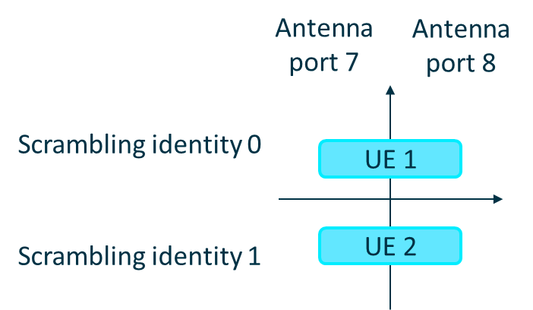
Figure 102: Dual-stream beamforming allows two users to be served by the same antenna ports in the same frequency and time resources

Peak throughputs can increase, however downlink PDSCH power per UE is halved.
Similarly, uplink multi-user MIMO can be enabled through the use of an advanced eNode B receiver and comparable channel conditions.
The features that enable TDD multi-user MIMO are listed in Table 188.

Feature Id | Feature Name | Available Since | Application or Basic Software
LTE541 | Dual Stream Beamforming | RL25 | ASW
LTE1169 | Dual User Single Layer MU-MIMO | RL35 | ASW
LTE1545 | Uplink MU-MIMO 8 Rx | RL55 | ASW
Table 98: Feature providing TDD multi-user MIMO

Typical Issues
Typical issues with TDD multi-user MIMO are:
- High correlation between candidate UE pairs
Transmissions in the same frequency and time resources need to be sufficiently uncorrelated, thus a high correlation will reduce the likelihood of multi-user MIMO. Low correlation is possible where UEs in a candidate pair have very different channel conditions and beamforming weights applied.
- Low use of multi-user MIMO
Potential reasons for low use of multi-user MIMO include low traffic scenarios where UEs do not need to be multiplexed within the same PRB or UEs being located in excellent SINR conditions where TM3 is preferred to TM8.

Performance Analysis
Counters shown in Table 94 quantify the utilization of each transmission scheme and paired PRB utilisation.
Counter Id | Counter Name | Comments
M8010C55 | MIMO_OL_DIV | TM3 counters for monitoring fallback mode
M8010C56 | MIMO_OL_SM | TM3 counters for monitoring fallback mode
M8010C63 | TM8_DUAL_BF_MODE | TM8 counters for each transmission scheme
M8010C64 | TM8_SINGLE_BF_MODE | TM8 counters for each transmission scheme
M8010C65 | TM8_TXDIV_MODE | TM8 counters for each transmission scheme
M8010C66 | TM8_DUAL_USER_SINGLE_BF_MODE | TM8 counters for each transmission scheme
M8001C201 | UL_MU_MIMO_PAIRED_UE_AVG | Uplink shared PRB statistics
M8011C80 | UL_MU_MIMO_SHA_PUSCH_PRB_AVG | Uplink shared PRB statistics
Table 99: Counters applicable to TM8 and multi-user MIMO utilisation

Using counters M8010C63-C66, a distribution of the TM8 downlink transmission scheme usage can be plotted. Counters M8010C55-C56 indicate the TM3 transmission scheme usage, thus a ratio of the TM3 to TM8 transmission mode usage can also be determined. In the uplink, counter M8001C201 provides the proportion of uplink PRBs that are shared by 2 UE.

Parameter Definition
The parameters associated with enabling dual-stream beamforming with multi-user MIMO are shown in Table 100.
Parameter | Object | Range | Default
dlMimoMode | LNCEL_TDD | SingleTX (0), TXDiv (10),  4-way TXDiv (11),  Dynamic Open Loop MIMO (30),  Closed Loop Mimo (40),  Closed Loop MIMO (4x2) (41)  Closed Loop MIMO (8x2) (42)  Closed Loop MIMO (4x4) (43)  Closed Loop MIMO (8x4) (44)  Dual Stream Beamforming (60) | TXDiv (10)
actDlMuMimo | LNCEL_TDD | false (0), true (1) | false (0)
actUlMuMimo | LNCEL_TDD | false (0), true (1) | false (0)
Table 100: Parameter used to select the downlink transmission mode

Dual-stream beamforming is enabled by setting dlMimoMode to a value of Dual Stream Beamforming (60). The eNode B can transmit a single codeword to two users using the same frequency and time resources, each user being allocated 4 antenna ports belonging to one polarisation.
By setting actDlMuMimo and actUlMuMimo to a value of true (1), downlink and uplink multi-user MIMO can be enabled respectively. Several parameter structures must be populated to control the behaviour of the transmission scheme allocation. This is illustrated in Figure 103, with parameters listed in
Figure 103: Schematic of transitions between different transmission schemes

Parameter | Object | Range | Default
timeChInfoValid | LNCEL_TDD | 0: invalid, 1: 10ms … 10: infinite | 200ms (5)
bfCqiThDown | LNCEL_TDD | 0...16, step 0.1 | 9
bfCqiThUp | LNCEL_TDD | 0...16, step 0.1 | 11
bfRankThDown | LNCEL_TDD | 1...2, step 0.05 | 1.4
bfRankThUp | LNCEL_TDD | 1...2, step 0.05 | 1.6
mimoBfdlRiAvg | LNCEL_TDD | 0.05...1, step 0.05 | 0.5
mimoBfCqiAvg | LNCEL_TDD | 0.05...1, step 0.05 | 0.5
mimoBfCqidlComp | LNCEL_TDD | 0...10, step 0.1 | 3
actBfFallback | LNCEL_TDD | 0 (false), 1 (true) | 0 (false)
dlMuMimoParSe: dlMuMimoCorrThd | LNCEL_TDD | 0...1, step 0.01 | 0.15
ulMuMimoParaSet: ulMuMimoOrthThreshold | LNCEL_TDD | 0...1, step 0.1 | 0.4
Table 101: Parameters used to modify Mulit-User MIMO behaviour.

Fallback to transmit diversity is possible where a UE is allocated a single stream and a UE reports high CQI values; in such cases it is not advantageous for the eNode B to use beamforming, since the channel conditions for the UE are already very good and overheads can be reduced by not sending the UE specific reference signal in the downlink. The parameter actBfFallback is the switch for enabling this functionality. The CQI threshold above which fallback to transmit diversity is performed, is set by mimoBfslCqiThU. As the reported CQI decreases below threshold mimoBfslCqiThD, the eNode B will begin using single-stream beamforming for the UE. In these conditions, it is also possible for the eNode B to perform multi-user MIMO with another UE receiving a single stream; each UE will be allocated 4 antenna ports each and phase shifts and scrambling identities will maintain orthogonality between transmissions in the same PRBs. Where the reported rank indicator for a UE is high, i.e. on average above bfRankThUp, the UE will be allocated dual-stream beamforming, thus multi-user MIMO will not be possible for the PRB allocated to this UE. Multi-user MIMO is possible only where both UEs in the UE-pair are allocated a single stream, i.e. using rank 1 transmission.

Field Results
A UE pair is selected if the UE are situated in non-coherent channel conditions, to ensure both transmissions using the same PRB can retain orthogonality. The parameter dlMuMimoCorrThd defines a correlation threshold below which two UE can be paired in a downlink PRB. The parameter ulMuMimoOrthThreshold defines a correlation threshold above which two UE can be paired in an uplink PRB.
Figure 104 shows that increasing dlMuMimoCorrThd from 0.15 to 0.3 can increase the allocation of shared PRBs. Although absolute use of MU-MIMO is low, this is dependent upon the volume of traffic in the cell, plus the relative coherence of UEs. Higher use of MU-MIMO is observed in busier cells with UEs distributed across a variety of coverage conditions.

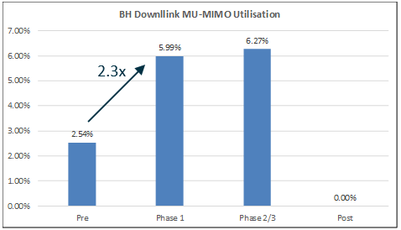
Figure 104: Higher downlink MU-MIMO utilisation when dlMuMimoCorrThd is increased.

Downlink Throughput

Introduction
Downlink throughput can be quantified in terms of cell throughput and connection throughput. Cell throughput is an important metric in terms of network capacity, whereas connection throughput is an important metric in terms of end-user experience. Both metrics are often management level KPI compared across networks and across network vendors.
Drive testing can be used to quantify throughput across specific parts of the network and during specific times of the day. Network statistics must be used for wide area analysis. Some third-party organisations which offer speed test services from the internet also record and sell throughput data.
Downlink throughput expectations are determined primarily by the channel bandwidth and the use of MIMO. Larger channel bandwidths support increased numbers of Resource Blocks and correspondingly higher throughputs. The use of MIMO increases spectrum efficiency and so increases the throughput per Resource Block. Carrier Aggregation can significantly increase peak connection throughputs when cells are not heavily loaded. Throughput gains are more modest when cells are loaded because the UE is less likely to be allocated resources from all Component Carriers during all subframes.
Downlink throughput relies upon the PDSCH physical channel. Other downlink channels and signals represent an overhead from the perspective of the PDSCH. This means that resources allocated to the PHICH and PDCCH should be minimised to help maximise downlink throughputs.
Connection throughputs depend upon the number of active connections in the cell. Connection throughputs will decrease as the number of active connections increase, i.e. the cell resources are shared amongst all connections.
Both cell throughput and connection throughput depend upon the type of traffic loading the network, e.g. network traffic dominated by smart phone keep-alives tends to reduce measured throughputs. VoLTE and QoS are also likely to have a negative impact upon cell throughput.
From the radio network perspective, the PDCP layer is the highest protocol stack layer for application data. Measuring throughput at the PDCP layer provides a good indication of net throughput capability. The actual end-user experience would be measured at the application layer so would be reduced by the overheads generated by the higher layers, e.g. TCP/IP layers.

Typical Issues
Issues with downlink throughput can result from:
- Poor radio conditions
Weak coverage and poor dominance are both likely to result in reduced throughput performance. RF optimisation in terms of antenna tilts, azimuths and heights should be the first solution for improving the radio conditions. Intercell interference should be reduced while maintaining some neighbouring cell overlap for handover purposes
- Limited Transport Bandwidth
The S1 interface will limit throughput performance if it has been under dimensioned. The S1 has to support all cells at an eNodeB so it may not be possible for all cells to simultaneously achieve peak throughputs. X2 transport bandwidth may have some impact upon throughput during handovers although data is transferred across the X2 interface for only a short period of time
- Application Server
The location of the application server can have an impact upon the round-trip time and the corresponding throughput performance. Application servers within the public internet are likely to provide lower throughputs than application servers which are local to the Serving Gateway
- Traffic Profile
Cells which have traffic dominated by Smart Phone keep-alives may have relatively low throughput recorded by KPI because some active subframes may transfer only small volumes of data, i.e. transferring a single keep-alive during an active subframe will tend to decrease the measured average cell throughput
- KPI Definition
The KPI definition should be fully understood when studying throughput results. Cell throughput is generally quantified in terms of data volume / time. The ‘time’ appearing in the denominator may be the complete measurement period, or it could be just the duration of active subframes. Carrier Aggregation complicates the definition and it is necessary to understand whether the data volume includes only primary cell data or both primary and secondary cell data. Likewise, it is necessary to understand whether the ‘time’ appearing in the denominator includes only primary cell ‘time’ or both primary and secondary cell ‘time’.

Performance Analysis
The counters associated with measuring cell throughput at the PDCP layer are presented in Table 102. The data volume counters have units of bytes, whereas the active TTI counters have units of ms. Throughput at the PDCP layer reflects the throughput available to the higher layer packets. It excludes overheads generated by RLC and MAC re-transmissions. It also excludes overheads generated by lower layer padding, protocol stack headers and channel coding.

Counter Id | Counter Name | Comments
M8012C20 | PDCP_SDU_VOL_DL | Combined to quantify downlink cell throughput
M8012C90 | ACTIVE_TTI_DL | Combined to quantify downlink cell throughput
Table 102: Counters applicable to PDCP downlink cell throughput KPI
The corresponding KPI based upon these counters is shown below. This KPI has units of kbps and the results represent the cell throughput measured during active TTI.
LTE_5292d E-UTRAN Average PDCP Layer Active Cell Throughput DL
8 * SUM(PDCP_SDU_VOL_DL) / SUM(ACTIVE_TTI_DL)

When using Carrier Aggregation, the downlink data is divided between the primary and secondary cells at the MAC layer. PDCP data volume is always associated with the primary cell. This means that the cell throughput includes the data volume transferred by both the primary and secondary cells. The active TTI counter records activity for both the primary and secondary cells. Some example counter results generated by a single Carrier Aggregation connection are:
Primary Cell
PDCP_SDU_VOL_DL = 1.11E+09 bytes
ACTIVE_TTI_DL = 272244
Secondary Cell
PDCP_SDU_VOL_DL = 0 bytes
ACTIVE_TTI_DL = 242176
This pattern means that the primary cell will tend to have a high throughput result while the secondary cell will tend to have a low throughput result. If Carrier Aggregation is configured to be symmetric such that the secondary cell can also act as a primary cell then the effect will balance assuming a similar number of connections on each carrier. Nevertheless, it should be recognized that the cell level throughput result will include data volume transferred using the secondary cell.
The same argument is applicable if measuring data volume at the RLC and MAC layers, i.e. the RLC_SDU_VOL_DL_DTCH and MAC_SDU_VOL_DL_DTCH counters belonging to the primary cell record data volume transferred by both the primary and secondary cells.
There are various solutions for calculating connection throughput. The first solution is to divide the cell throughput by the number of UE with buffered data. The counter which quantifies the number of UE with buffered data is presented in Table 103. This counter must be divided by 100 to obtain the actual value. Also note that this counter is incremented only during active subframes. For example, 1 UE with buffered data for 10 ms during the measurement period will generate a counter result of 100 (with an actual value of 1).

Counter Id | Counter Name | Comments
M8001C147 | DL_UE_DATA_BUFF_AVG | Divide by 100 to obtain actual value
Table 103: Counter for the average number of UE with downlink buffered data
The corresponding connection throughput KPI is then given by the expression below:
E-UTRAN Average PDCP Layer Connection Throughput DL
8 * SUM(PDCP_SDU_VOL_DL) / [SUM(ACTIVE_TTI_DL) * SUM (DL_UE_DATA_BUFF_AVG / 100)]

When using Carrier Aggregation, the DL_UE_DATA_BUFF_AVG counter is only incremented for the primary serving cell. This maintains consistency with the PDCP_SDU_VOL_DL counter.
Alternatively, connection throughput can be calculated using the QCI specific counters presented in Table 104.
Counter Id | Counter Name | Comments
M8012C117 | IP_TPUT_VOL_DL_QCI_1 | Data volumes per QCI
M8012C119 | IP_TPUT_VOL_DL_QCI_2 | Data volumes per QCI
M8012C121 | IP_TPUT_VOL_DL_QCI_3 | Data volumes per QCI
M8012C123 | IP_TPUT_VOL_DL_QCI_4 | Data volumes per QCI
M8012C125 | IP_TPUT_VOL_DL_QCI_5 | Data volumes per QCI
M8012C127 | IP_TPUT_VOL_DL_QCI_6 | Data volumes per QCI
M8012C129 | IP_TPUT_VOL_DL_QCI_7 | Data volumes per QCI
M8012C131 | IP_TPUT_VOL_DL_QCI_8 | Data volumes per QCI
M8012C133 | IP_TPUT_VOL_DL_QCI_9 | Data volumes per QCI
M8012C118 | IP_TPUT_TIME_DL_QCI_1 | Data transfer times per QCI
M8012C120 | IP_TPUT_TIME_DL_QCI_2 | Data transfer times per QCI
M8012C122 | IP_TPUT_TIME_DL_QCI_3 | Data transfer times per QCI
M8012C124 | IP_TPUT_TIME_DL_QCI_4 | Data transfer times per QCI
M8012C126 | IP_TPUT_TIME_DL_QCI_5 | Data transfer times per QCI
M8012C128 | IP_TPUT_TIME_DL_QCI_6 | Data transfer times per QCI
M8012C130 | IP_TPUT_TIME_DL_QCI_7 | Data transfer times per QCI
M8012C132 | IP_TPUT_TIME_DL_QCI_8 | Data transfer times per QCI
M8012C134 | IP_TPUT_TIME_DL_QCI_9 | Data transfer times per QCI
Table 104: QCI specific counters for quantifying downlink connection throughput
For example, the connection throughput KPI for QCI 8 connections is given by:

E-UTRAN Average IP Layer Connection Throughput DL
SUM(IP_TPUT_VOL_DL_QCI_8) / SUM(IP_TPUT_TIME_DL_QCI_8)

This KPI tends to generate larger throughput results because it attempts to exclude the impact of Smart Phone keep-alives and other small data transfers. The counters belonging to this KPI are not incremented for a specific subframe if the downlink buffer becomes empty. Small data transfers completed within a single subframe should not increment these counters.
The risk associated with using this KPI for connection throughput is that it loses consistency with the cell throughput KPI which includes both small and large data transfers. This loss in consistency means that the connection throughput result can often exceed the cell throughput result.

Parameter Definition
Once the downlink transmission mode has been selected, downlink throughput improvements tend to result from troubleshooting, RF optimisation and capacity upgrades rather than parameter changes. Nevertheless, there are some parameters which should be considered within the context of maximizing downlink throughput performance.
The downlink transmission mode is configured using the dlMimoMode parameter presented in Table 105. 2x2 MIMO provides improved throughput relative to single antenna transmission and transmit diversity. Simulations indicate that closed loop MIMO provides better performance than open loop MIMO when UE speeds are relatively low. Practical results have demonstrated a throughput gain of about 10% when using closed loop MIMO (see section 6.10.6). The use of 4x2 MIMO increases downlink throughputs but requires 4 power amplifiers per cell.

Parameter | Object | Range | Default
dlMimoMode | LNCEL_FDD | SingleTX (0), TXDiv (10),  4-way TXDiv (11),  Dynamic Open Loop MIMO (30),  Closed Loop Mimo (40),  Closed Loop MIMO (4x2) (41)  Closed Loop MIMO (8x2) (42)  Closed Loop MIMO (4x4) (43)  Closed Loop MIMO (8x4) (44) | TXDiv (10)
Table 105: Parameter used to select the downlink transmission mode
The MIMO transmission modes are able to dynamically switch between transmit diversity, spatial diversity (single stream MIMO) and spatial multiplexing (dual stream MIMO). This is known as MIMO mode control and is discussed in section 6.8.
The initial MCS can have an impact upon throughput performance. A low conservative value will tend to reduce throughputs, especially when the traffic profile is dominated by large numbers of small packets. A larger aggressive value will tend to increase the risk of re-transmissions for UE in relatively weak coverage. The initial MCS is applied by link adaptation until the first CQI report is received from the UE. It is managed using the iniMcsDl parameter shown in Table 106. It is recommended to use the default value of 4.

Parameter | Object | Range | Default
iniMcsDl | LNCEL | 0 to 28, step 1 | 4
Table 106: Parameter used to define the downlink initial MCS

The maximum permitted number of HARQ re-transmissions can have an impact upon throughput performance. Increasing the number of re-transmissions benefits throughput performance by providing a soft combining gain, i.e. combining the original transmission with one or more re-transmissions. This allows a reduced SINR requirement per transmission. The drawback associated with increasing the number of re-transmissions is increased resource utilization per connection, i.e. the original transmission and each re-transmission consumes Resource Blocks.
The maximum number of HARQ re-transmissions in the downlink is controlled using the harqMaxTrDl parameter shown in Table 107. The value of this parameter defines the total number of transmissions (original transmission plus re-transmissions), i.e. the default value of 5 allows up to 4 re-transmissions. It is generally recommended to use the default value.

Parameter | Object | Range | Default
harqMaxTrDl | LNCEL | 1 to 16, step 1 | 5
Table 107: Parameters used to define the maximum number of downlink re-transmissions

The configuration of the RLC layer can also impact throughput performance. RLC control PDU are always prioritized over RLC data PDU so their overhead should be minimized. Non-GRB bearers are configured to use RLC profile 2 by default (acknowledged mode RLC). The parameters belonging to RLC profile 2 are presented in Table 108.

Parameter | Object | Range | Default
rlcProf2 - rlcProfileId | LNBTS | 2 | 2
rlcProf2 - pollPdu | LNBTS | 4, 8, 16, 32, 64, 128, 256, infinity | 64
rlcProf2 - tProhib | LNBTS | 0 to 500 ms | 50 ms
rlcProf2 - tPollRetr | LNBTS | 5 to 500 ms | 120 ms
rlcProf2 - tReord | LNBTS | 0 to 200 ms | 50 ms
Table 108: Parameters belonging to RLC profile 2

Acknowledged mode RLC transfers Status Reports from the receiving end to the transmitting end to acknowledge successful reception of PDU. The transmitting end can poll the receiving end to request a Status Report. Frequent polling helps the transmit window to advance and helps to reduce data forwarding across the X2 during handover. However, frequent polling also increases the control PDU overhead.
The pollPdu parameter determines the number of PDU after which the receiving end is polled for a status report. For example, the default value of 64 means that the transmitting end sends 64 PDU and then polls for a Status Report. When using dual stream MIMO, 2 RLC PDU are transferred during each subframe. This means that it would take 32 ms to transfer 64 PDU when the UE is allocated resources in every subframe. The tProhib parameter defines the minimum period between Status Reports. The default value of 50 ms means tProhib will dominate the Status Report rate for quiet cells where UE are scheduled in every subframe, whereas pollPdu will dominate in busy cells where UE are not scheduled in every subframe.
The tpollRetr timer defines the wait time for a Status Report after polling. The transmitting end will re-poll the receiving end if a Status Report has not been received when this timer expires. The value needs to be greater than the RLC round-trip time to allow sufficient time for the Status Report to be received.
The tReord timer is used by the receiver for reordering, PDU loss detection and delay of Status Report. This timer depends upon the HARQ round-trip time and the maximum number of HARQ retransmissions. It is recommended to set tpollRetr to be at least twice as large as tReord. This ensures that the RLC Status report is transmitted after HARQ reordering.
It has been recommended to decrease the value of pollPdu from the default value of 64 to 16. This will tend to increase the rate at which Status Reports are sent. It has also been recommended to increase the value of tpollRetr from the default value of 120 ms to 250 ms. This will increase the time allowed for successful reception of a Status Report.
RLC profile 6 was introduced for Carrier Aggregation with more than a single Secondary Cell, i.e. the eNodeB configures RLC profile 6 when 3 Component Carriers are used. RLC profile 7 was introduced for Carrier Aggregation with more than two Secondary Cells, i.e. the eNodeB configures RLC profile 7 when 4 Component Carriers are used. Both profiles include parameter settings to allow higher throughputs.
The configuration of the PDCP layer can also impact throughput performance. Non-GRB bearers are configured to use PDCP profile 2 by default. The parameters belonging to PDCP profile 2 are presented in Table 109.
Parameter | Object | Range | Default
pdcpProf2 - pdcpProfileId | LNBTS | 2 | 2
pdcpProf2 - statusRepReq | LNBTS | 0, 1, 2, 3 | 3
pdcpProf2 - tDiscard | LNBTS | 300 to 1500 ms, infinity | 750 ms
Table 109: Parameters belonging to PDCP profile 2

The values allocated to the statusRepReq parameter are interpreted as:
0: no Status Report
1: eNodeB Status Report
2: UE Status Report
3: eNodeB and UE Status Reports
It is recommended to keep the default value of 3 to help ensure that the UE and eNodeB remain synchronized in terms of their PDCP status.
The dlamcEnable parameter shown in Table 110 is used to enable dynamic link adaptation in the downlink direction. It is recommended to leave this parameter at its default value of ‘true’. Link adaptation helps to maximise cell throughput by adjusting the connection throughputs to match their channel conditions. Being too aggressive with link adaptation leads to an increased number of re-transmissions. Being too conservative leads to wasted air-interface capacity.
The dl64QamEnable parameter shown in Table 110 is used to enable/disable the use of 64QAM in the downlink direction. It is recommended to configure this parameter with a value of ‘true’. 64QAM should be allocated to UE which are in relatively good coverage conditions. The percentage of cell area where 64QAM is allocated for LTE, is greater than the corresponding percentage for UMTS. This results from the improved SINR which can be achieved by OFDMA.
The actModulationSchemeDl parameter replaced the dl64QamEnable parameter. This parameter defines the highest modulation order available to link adaptation, e.g. configuring a value of 256QAM, allows the use of QPSK, 16QAM, 64QAM and 256 QAM
Parameter | Object | Range | Default
dlamcEnable | LNCEL | 0 (false), 1 (true) | 1 (true)
dl64QamEnable | LNCEL | 0 (false), 1 (true) | 0 (false)
actModulationSchemeDl | LNCEL | QPSK (0), 16QAM (1), 64QAM (2), 256QAM (3) | QPSK (0)
dlOlqcEnable | LNCEL | 0 (false), 1 (true) | 1 (true)
dlTargetBler | LNCEL | 0.1 to 99.9 % | 10 %
dlamcCqiDef | LNCEL | 0 to 15 | 2
Table 110: Parameters associated with downlink link adaptation

Link adaption uses the compensated CQI as an input when selecting an appropriate throughput. The reported CQI is translated into a compensated CQI using Outer Loop Link Quality Control (OLQC). The reported CQI is compensated downwards if the achieved BLER is relatively high, whereas the reported CQI is compensated upwards of the achieved BLER is relatively low. This helps to compensate for UE which may be reporting CQI values which are either too high or too low. OLQC is enabled using the dlOlqcEnable parameter shown in Table 110. It is recommended to enable OLQC. The target BLER used by OLQC is defined by the dlTargetBler parameter shown in Table 110. If the eNodeB does not receive a CQI value from the UE, then a default value defined by the dlamcCqiDef parameter is assumed. This parameter has a low value because UE are most likely to be in poor coverage when reception of the reported CQI fails. In addition, if the reported CQI value is not known then the coverage conditions of the UE are not known so it is safest to be conservative with the assumed value.
System information, paging, random access responses (MSG2) and RRC Connection Setup messages (MSG4) represent overheads from the perspective of user plane throughputs. The coding rate for these transmissions determines the size of the overhead. Low coding rates correspond to increased redundancy and an increased overhead. It is important that these transmissions have sufficient redundancy to ensure that they are received reliably. The parameters presented in Table 111.

Parameter | Object | Range | Default
maxCrSibDl | LNCEL | 0.05 to 0.5 | 0.26
maxCrPgDl | LNCEL | 0.05 to 0.5 | 0.12
maxCrRaDl | LNCEL | 0.05 to 0.5 | 0.12
maxCrRa4Dl | LNCEL | 0.05 to 0.5 | 0.12
Table 111: Coding rates for downlink signalling (system information, paging, MGS2, MSG4)

Downlink cell and connection throughputs can be impacted by the number of UE which are scheduled per subframe. A low value means that UE are likely to be allocated an increased number of Resource Blocks per allocation but are likely to be allocated less frequently. The maximum number of UE which can be scheduled per subframe is controlled using the maxNumUeDl parameter shown in Table 112.

Parameter | Object | Range | Default
maxNumUeDl | LNCEL_FDD | 1.4 MHz channel: 1 to7  3 MHz channel: 1 to7  5 MHz channel: 1 to7  10 MHz channel: 1 to 14  15 MHz channel: 1 to 17  20 MHz channel: 1 to 20 | 1.4 MHz channel: 7  3 MHz channel: 7  5 MHz channel: 7  10 MHz channel: 14  15 MHz channel: 17  20 MHz channel: 20
Table 112: Maximum number of UE scheduled per subframe

The minimum bit rate defined by the minBitrateDl parameter can also impact downlink throughput performance. The eNodeB scheduler will try to ensure that all connections achieve at least the minimum bit rate. This means that UE which are at cell edge and which would not normally achieve the minimum bit rate, are allocated an increased quantity of resources. The resources available to other UE are then reduced. The net result can be an improved user experience for cell edge UE but a reduced total cell throughput.

Parameter | Object | Range | Default
minBitrateDl | LNCEL | 5 to 300 000 kbps | 30 kbps
Table 113: Parameter used to configure the minimum bit rate

As detailed in section 6.7.4.2, LTE5731 TCP Service Differentiation can be used to apply a scheduler weighting boost to certain UE to offer higher throughputs for short periods.

Optimization Procedure
Downlink throughput performance can be influenced by many factors. Figure 105 presents some of the activities associated with the optimisation of downlink throughput. The measurement method can impact the throughput performance observed by a UE logging tool.
It is common to measure throughput using a large FTP file transfer with the TCP/IP protocol stack. TCP performance is dependent upon the round trip time as well as the TCP configuration. Large round trip times and TCP re-transmissions will tend to reduce throughput performance. Checks can be made to ensure that transmit and receive window sizes remain large during the data transfer. If the TCP protocol is limiting the measured throughput then multiple parallel TCP sessions can be used to increase the total connection throughput. If the throughput does not increase when using multiple TCP sessions then it is an indication that the TCP protocol is not limiting the total measured throughput.
UDP provides a good solution for measuring the maximum throughput performance because it does not involve any transmit / receive windows nor any re-transmissions. A UDP session can be used to push as much data as possible through the network. Measuring throughput using UDP requires a UDP packet generator on the application server. The packet generator can be configured to push packets towards the IP address of the UE.
In some cases, the application server can limit throughput performance. It can be useful to test with multiple application servers to determine whether or not the server is having an impact. Throughputs are generally maximised when the application server is located within the local operator network rather than within the internet.
Throughput can also be measured from network statistics but the results can be more complex to interpret due to their dependency upon the traffic profile within the cell, e.g. throughputs may appear low because the traffic profile is dominated by Smart Phone keep-alives rather than larger file transfers.
Figure 105: Activities associated with the optimisation of downlink throughput
When optimising the downlink throughput performance, the transport bandwidth should be checked to ensure that it is not limiting the transfer of data. The transport bandwidth will be shared by all cells at the eNodeB so the impact of other cells should be taken into account. Checks should also be made to determine whether or not QoS is applied to the transport network. Packet queuing times could be increased if measurements are recorded while using a low QoS.
The cell load should be checked in terms of other users and Physical Resource Block (PRB) utilisation. Air-interface and transport capacity is shared so other users will reduce the individual connection throughput. It is common to complete throughput measurements during quiet periods of the day so the impact from other users is minimised. PRB utilisation should be checked to help determine whether or not the air-interface is limiting the throughput. If the set of PRB are not fully utilised then it indicates that the air-interface is not limiting throughput and the focus for performance improvement should be elsewhere.
The QoS profile associated with the EPS bearer should be checked to determine whether or not there is a maximum bit rate which is limiting the throughput. The Nokia eNodeB does not currently enforce the maximum bit rate belonging to an EPS bearer. However, core network elements may enforce this limit and prevent throughputs from increasing above the maximum bit rate. The Nokia eNodeB can restrict the downlink throughput if the LNCEL – mbrSelector parameter is set to ‘OaM’ and the LNCEL – maxBitrateDl parameter is set to an appropriate value but this restriction will then be applied to all UE within the cell.
The application server should be checked in terms of its location and its round-trip time performance. Large round-trip times will impact the measured throughput when using a TCP protocol stack.
The air-interface should be checked to ensure that weak signal strength or high interference are not impacting performance. The UE should be reporting CQI values close to, or equal to 15 when attempting to achieve the maximum connection throughput. The RSRP and RSRQ should be as high as possible. The UE should also be reporting a Rank Indicator of 2 rather than 1.
The eNodeB databuild should be checked to ensure that errors are not causing a reduced throughput. This check can also serve to identify any features which are enabled which may also be having an impact upon throughput performance, e.g. Reference Signal power boosting can have an impact upon throughput. Reference Signal power boosting tends to increase levels of intercell interference and can steal power from the PDSCH if the boost is set relatively high.
The uplink throughput should also be checked when measuring downlink throughput in case TCP acknowledgments are being delayed. In general, uplink throughputs should not limit the downlink throughput – assuming the uplink throughput capability is at least 5% of the downlink capability.
The downlink transmission mode should be checked. The most common downlink transmission mode is open loop 2x2 MIMO. Some operators have demonstrated a 10% increase in downlink cell throughput when enabling Closed Loop MIMO (see section 6.10.6). Downlink throughputs can be increased by configuring 4 antenna elements at the eNodeB and using closed loop 4x2 MIMO but this requires the installation of additional hardware.
The KPI definition should be checked when measuring throughput using the network counters. This helps to ensure that the results are interpreted correctly. There are a few variations to the way in which throughput KPI can be defined. Some KPI average across the complete measurement period rather than just the active subframes. Some KPI attempt to exclude the impact of Smart Phone keep-alives by ignoring subframes where the downlink buffers became empty. Carrier Aggregation can also impact throughput measurements because PDCP data volume is recorded on the primary serving cell whereas active subframes are recorded on both the primary and secondary serving cells.

Field Results
Figure 106 and Figure 107 illustrate the performance gains which were achieved by an example operator when enabling the combination of Fast MIMO Switching and Closed Loop Spatial Multiplexing, i.e. the following parameter configurations were applied:
- LNCEL_FDD – actFastMimoSwitch = True
- LNCEL_FDD – dlMimoMode = Closed Loop MIMO
In this case, the reported CQI increased by 1 step, while the downlink average cell throughput improved by approximately 10 %. Note that these results are taken from a network wide rollout completed over a number of days. This means that the performance improvements are not characterised by a single step upwards but ramp upwards over a number of days.
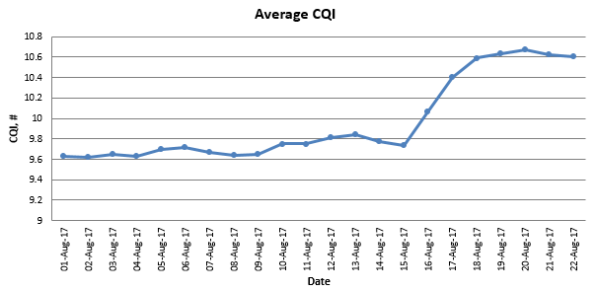
Figure 106: Increase in reported CQI after enabling Closed Loop MIMO

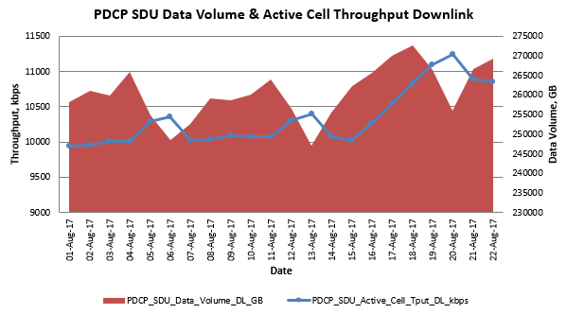
Figure 107: Increase in Downlink Throughput after enabling Closed Loop MIMO

Uplink Throughput

Introduction
Uplink throughput can be quantified in terms of cell throughput and connection throughput. Cell throughput is an important metric in terms of network capacity, whereas connection throughput is an important metric in terms of end-user experience. Both metrics are often management level KPI compared across networks and across network vendors.
Drive testing can be used to quantify throughput across specific parts of the network and during specific times of the day. Network statistics must be used for wide area analysis. Some third party organisations which offer speed test services from the internet also record and sell throughput data.
Uplink throughput expectations are determined primarily by the channel bandwidth. FDD-LTE19B supports uplink MIMO, and uplink 256 QAM (LTE4581). Uplink throughput performance is often influenced by intercell interference which can be affected by uplink power control and uplink proactive scheduling. The uplink offers solutions such as Interference Rejection Combining (IRC) and Co-ordinated Multipoint (CoMP) to improve throughput performance.
Uplink throughput relies upon the PUSCH physical channel. Other uplink channels and signals represent an overhead from the perspective of the PUSCH. This means that resources allocated to the PUCCH and PRACH should be minimised to help maximise uplink throughputs.
Connection throughputs depend upon the number of active connections in the cell. Connection throughputs will decrease as the number of active connections increase, i.e. the total cell resources are shared amongst all connections.
Both cell throughput and connection throughput depend upon the type of traffic loading the network, e.g. network traffic dominated by smart phone keep-alives tends to reduce measured throughputs. The introduction of VoLTE and QoS are also likely to have a negative impact upon cell throughput.
From the radio network perspective, the PDCP layer is the highest protocol stack layer for application data. Measuring throughput at the PDCP layer provides a good indication of net throughput capability. The actual end-user experience would be measured at the application layer so would be reduced by the overheads generated by the higher layers, e.g. TCP/IP layers.

Typical Issues
Issues with uplink throughput can result from:
- Poor radio conditions
Weak coverage and poor dominance are both likely to result in reduced throughput performance. RF optimisation in terms of antenna tilts, azimuths and heights should be the first solution for improving the radio conditions. Intercell interference should be reduced while maintaining some neighbouring cell overlap for handover purposes. Poor radio conditions can also be created by non-optimal neighbour lists. Missing incoming neighbours can result in high levels of intercell interference. Missing outgoing neighbours can result in UE remaining connected to the cell while moving into poor radio conditions.
- Inappropriate power control configuration
The uplink power control strategy defines a balance between own connection throughput and intercell interference. Configuring high uplink target powers tends to increase connection throughputs as the wanted signal strength for each connection increases. However, it also increases intercell interference which can then have a negative impact upon network throughput. Various solutions exist to optimise this trade-off by limiting UE transmit powers towards cell edge. These solutions include fractional power control and interference aware uplink power control. Uplink power control is discussed in section 6.7.
- Aggressive proactive scheduling strategy
Proactive scheduling can generate significant quantities of intercell interference and can have a negative impact upon uplink throughputs. When proactive scheduling is enabled, the majority of uplink transmissions can originate from dummy grants. These dummy grants ensure that the UE always has an uplink resource to transfer data but each dummy grant increases intercell interference. Proactive scheduling is discussed in section 6.14.
- Over-dimensioning of PUCCH
The PUCCH represents an overhead from the perspective of the PUSCH. Over-dimensioning the PUCCH reduces the quantity of Resource Blocks available to the PUSCH. The PUCCH is dimensioned according to the maximum number of RRC connections to be supported in a cell. Over-dimensioning to some extend is normal to avoid frequent reconfigurations as the number of users increases over time. Excessive over-dimensioning can reduce PUSCH capacity unnecessarily. The following features can be used to help improve the efficiency of the PUCCH allocation: LTE1130 Dynamic PUCCH Allocation and LTE2664 Load based PUCCH Region. For TDD, LTE2615 Extended CQI Period for High Capacity Cells can lower PUCCH requirements.
- Lack of enabled features
There are features which can be used to help improve uplink throughput performance. These include Interference Rejection Combining (IRC) and Co-ordinated Multi-Point (CoMP). Both of these features operate across intra-eNodeB cells. IRC can also operate across inter-eNodeB cells, but performance is maximised when cells are time synchronised.

- Non-optimal packet scheduler and link adaptation selection
The packet scheduler and link adaptation algorithms have an impact upon uplink throughput performance. The Channel Aware packet scheduler (LTE46) uses measurements from the Sounding Reference Signal (SRS) to identify the best Resource Blocks for each UE. Fast Uplink Link Adaptation (LTE 1495) allows rapid changes between consecutive allocated MCS values.
- Application Server
The location of the application server can have an impact upon the round-trip time and the corresponding throughput performance. Application servers within the public internet are likely to provide lower throughputs than application servers which are local to the Serving Gateway.
- Traffic Profile
Cells which have traffic dominated by Smart Phone keep-alives may have relatively low throughput recorded by KPI because some active subframes may transfer only small volumes of data, i.e. transferring a single keep-alive during an active subframe will tend to decrease the measured average cell throughput.
- KPI Definition
The KPI definition should be fully understood when studying throughput results. Cell throughput is generally quantified in terms of data volume / time. The ‘time’ appearing in the denominator may be the complete measurement period, or it could be just the duration of active subframes.

Performance Analysis
The counters associated with measuring cell throughput at the PDCP layer are presented in Table 114. The data volume counters have units of bytes, whereas the active TTI counters have units of ms. Throughput at the PDCP layer reflects the throughput available to the higher layer packets. It excludes the overheads generated by RLC and MAC re-transmissions. It also excludes the overheads generated by lower layer padding, protocol stack headers and channel coding.
Counter Id | Counter Name | Comments
M8012C19 | PDCP_SDU_VOL_UL | Combined to quantify uplink cell throughput
M8012C89 | ACTIVE_TTI_UL | Combined to quantify uplink cell throughput
Table 114: Counters applicable to PDCP uplink cell throughput KPI

The corresponding KPI based upon these counters is shown below. This KPI has units of kbps and the results represent the cell throughput measured during active TTI. This KPI excludes the impact of proactive scheduling, i.e. the data volume excludes the padding transmitted when UE are allocated dummy grants, and the active TTI excludes TTI which are active only for the purposes of dummy grants.
LTE_5289d E-UTRAN Average PDCP Layer Active Cell Throughput UL
8 * SUM(PDCP_SDU_VOL_UL) / SUM(ACTIVE_TTI_UL)

There are various solutions for calculating connection throughput. The first solution is to divide the cell throughput by the number of UE with buffered data. The counter which quantifies the number of UE with buffered data is presented in Table 115. This counter must be divided by 100 to obtain the actual value. Also note that this counter is incremented only during active subframes.
Counter Id | Counter Name | Comments
M8001C150 | UL_UE_DATA_BUFF_AVG | Divide by 100 to obtain actual value
Table 115: Counter for the average number of UE with uplink buffered data
The corresponding connection throughput KPI is then given by the expression below:
E-UTRAN Average PDCP Layer Connection Throughput UL
8 * SUM(PDCP_SDU_VOL_UL) / [SUM(ACTIVE_TTI_UL) * SUM(UL_UE_DATA_BUFF_AVG / 100)]

Alternatively, connection throughput can be calculated using the QCI specific counters presented in Table 116.
Counter Id | Counter Name | Comments
M8012C91 | IP_TPUT_VOL_UL_QCI_1 | Data volumes per QCI
M8012C93 | IP_TPUT_VOL_UL_QCI_2 | Data volumes per QCI
M8012C95 | IP_TPUT_VOL_UL_QCI_3 | Data volumes per QCI
M8012C97 | IP_TPUT_VOL_UL_QCI_4 | Data volumes per QCI
M8012C99 | IP_TPUT_VOL_UL_QCI_5 | Data volumes per QCI
M8012C101 | IP_TPUT_VOL_UL_QCI_6 | Data volumes per QCI
M8012C103 | IP_TPUT_VOL_UL_QCI_7 | Data volumes per QCI
M8012C105 | IP_TPUT_VOL_UL_QCI_8 | Data volumes per QCI
M8012C107 | IP_TPUT_VOL_UL_QCI_9 | Data volumes per QCI
M8012C92 | IP_TPUT_TIME_UL_QCI_1 | Data transfer times per QCI
M8012C94 | IP_TPUT_TIME_UL_QCI_2 | Data transfer times per QCI
M8012C96 | IP_TPUT_TIME_UL_QCI_3 | Data transfer times per QCI
M8012C98 | IP_TPUT_TIME_UL_QCI_4 | Data transfer times per QCI
M8012C100 | IP_TPUT_TIME_UL_QCI_5 | Data transfer times per QCI
M8012C102 | IP_TPUT_TIME_UL_QCI_6 | Data transfer times per QCI
M8012C104 | IP_TPUT_TIME_UL_QCI_7 | Data transfer times per QCI
M8012C106 | IP_TPUT_TIME_UL_QCI_8 | Data transfer times per QCI
M8012C108 | IP_TPUT_TIME_UL_QCI_9 | Data transfer times per QCI
Table 116: QCI specific counters for quantifying uplink connection throughput
For example, the connection throughput KPI for QCI 8 connections is given by:
E-UTRAN Average IP Layer Connection Throughput UL
SUM(IP_TPUT_VOL_UL_QCI_8) / SUM(IP_TPUT_TIME_UL_QCI_8)

This KPI tends to generate larger throughput results because it attempts to exclude the impact of Smart Phone keep-alives and other small data transfers. The counters belonging to this KPI are not incremented for a specific subframe if the uplink buffer becomes empty. Small data transfers which are completed within a single subframe should not increment these counters at all.
The risk associated with using this KPI for connection throughput is that it loses consistency with the cell throughput KPI which includes both small and large data transfers. This loss in consistency means that the connection throughput result can often exceed the cell throughput result.

Parameter Definition
The following have an important influence upon uplink throughput performance:
- uplink power control: the parameters associated with uplink power control are presented in section 6.7
- proactive scheduling: the parameters associated with proactive scheduling are presented in section 6.14
- PUCCH dimensioning: the parameters associated with PUCCH dimensioning are presented in [2]
- Enabling features such as Interference Rejection Combining (IRC) and Coordinated Multipoint (CoMP). Parameters are presented below.
- Selecting the Packet Scheduling and Link Adaptation algorithms. Parameters are presented below.
IRC for 2 antenna elements (LTE979) and IRC for 4 antenna elements (LTE980) enable IRC using the LNCEL parameter, ulCombinationMode presented in Table 117. This is the only parameter associated with IRC.
Parameter | Object | Range | Default
ulCombinationMode | LNCEL_FDD | MRC (0), IRC (1) | MRC (0)
Table 117: Parameter used to enable IRC
CoMP for 2 antenna elements (LTE1402) and CoMP for 4 antenna elements (LTE1691) enable CoMP using a value of 1 for LNBTS parameter, actCoMp presented in Table 118.
Parameter | Object | Range | Default
actCoMp | LNBTS | 0 (disabled), 1 (fixedUlCoMp), 2 (CRAN), 3 (measBasedCoMp) | 0 (disabled)
Table 118: Parameter used to enable CoMP
CoMP also introduces the ULCOMP parameter object which lists the cells belonging to the CoMP cooperating set. It also specifies the SINR threshold used to determine whether or not uplink signals from different cells are combined.
Packet scheduling is divided into time domain and frequency domain phases. Time domain scheduling is completed first to select the subset of UE which are to be allocated Resource Blocks during the next subframe. The maxNumUeUl parameter specifies the maximum number of UE which can be selected by time domain scheduling.
Parameter | Object | Range | Default
maxNumUeUl | LNCEL_FDD | 1 to 20, step 1 | 14
Table 119: Parameter used to specify the maximum number of UE scheduled per TTI in the uplink
Time domain scheduling prioritizes UE according to the type of transmission. HARQ re-transmissions are allocated the highest priority, followed by SRB transmissions, GBR transmissions and non-GBR transmissions. The scheduling metric is used to prioritize between UE having similar types of transmission. In the case of non-GBR data transmission, the scheduling weight from the QCI profile is used as an input. In the case of GBR data transmission, a delay dependent term is included.
Frequency domain scheduling starts by determining the number of Resource Blocks to allocate to each UE. It then proceeds to determine which Resource Blocks to allocate to each UE. The number of Resource Blocks allocated to each UE is determined by an algorithm managed using the ulsFdPrbAssignAlg parameter shown in Table 120.
Parameter | Object | Range | Default
ulsFdPrbAssignAlg | LNCEL | RoundRobinFD (0), ExhaustiveFD (1), MixedFD (2) | MixedFD (2)
Table 120: Parameter used to manage the algorithm which determines the number of Resource Blocks allocated to each UE
The round robin algorithm allocates one Resource Block at a time to each UE, rotating around the set of UE selected by time domain scheduling. Allocations finish either when a UE has sufficient Resource Blocks to transfer its data, or when all Resource Blocks have been allocated.
The exhaustive algorithm allocates all Resource Blocks required by the UE with the highest scheduling metric, before proceeding to do the same for the next highest priority UE. It’s possible that not all UE will receive Resource Blocks if the higher priority UE require relatively large numbers of Resource Blocks.
The mixed algorithm applies the exhaustive scheduler to SRB and GBR transfers, and then applies the round robin algorithm to non-GBR transfers. It is mandatory to use the mixed algorithm when using either the interference aware or channel aware frequency domain packet schedulers. These are the recommended frequency domain packet schedulers so the mixed algorithm is also recommended.
The algorithm used to select which Resource Blocks to allocate to each UE is managed using the ulsSchedMethod parameter shown in Table 121.
Parameter | Object | Range | Default
ulsSchedMethod | LNCEL | Channel unaware (0), Channel aware (1), Interference aware (2) | Channel unaware (0)
Table 121: Parameter used to select uplink packet scheduler type
It is recommended to enable the channel aware scheduler. The channel aware scheduler uses measurements from the uplink Sounding Reference Signal (SRS) to identify the best parts of the channel bandwidth to allocate Resource Blocks. SRS measurements are UE specific. The interference aware scheduler uses uplink interference measurements to identify the best parts of the channel bandwidth to allocate Resource Blocks. Interference measurements are cell specific rather than UE specific. The interference aware scheduler uses UE specific Power Headroom (PHR) reports to identify the UE which should be allocated the parts of the channel bandwidth with the lowest interference.
Uplink throughputs are influenced by link adaptation and Automatic Transmission Bandwidth (ATB) functions. Link adaptation selects a throughput which is appropriate for the channel conditions. ATB ensures that the UE is not allocated too many Resource Blocks, i.e. it ensures that the UE transmit power is focused across an appropriate number of Resource Blocks.
The link adaptation algorithm is selected using the actLnkAdp parameter shown in Table 122. The set of values associated with this parameter has evolved with each software release. The set of values shown in Table 122 is applicable to FDD-LTE18A. It is recommended to use Fast Uplink Link Adaptation (fUlLA) which allows the eNodeB to rapidly change the MCS from one value to another without having to step through all intermediate values. Other link adaptation algorithms are only able to change the MCS using a step size of 1.
Parameter | Object | Range | Default
actUlLnkAdp | LNCEL | Off (0)  slowAMcOllaATB (4)  eUlLa (5)  fUlLa (6) | eUlLa (5)
Table 122: Parameter used to enable uplink link adaptation
Fast Uplink Link Adaptation includes both inner and outer loop functions (ILLA and OLLA). The inner loop function generates an MCS value based upon uplink SINR measurements. This MCS can be anywhere within the MCS table. The outer loop function generates an MCS correction factor based upon HARQ acknowledgements. The outer loop function attempts to achieve a target BLER defined by the ulTargetBler parameter presented in Table 123. The ulamcDeltaCmax and ulamcDeltaCmin parameters define thresholds which trigger the outer loop function to increase or decrease the inner loop MCS by 1. The ulamcSwitchPer parameter defines the period over which the achieved BLER is evaluated. This period is defined in terms of received transport blocks.
From LTE18A, it is possible to enable a dynamic uplink BLER algorithm, that sets a variable uplink BLER target for a UE based upon radio conditions. The dynamic range of the BLER target is 5%-30%, with UEs in the highest SINR conditions being allocated the most restrictive BLER targets. This functionality is enabled by LNCEL parameter actUlDynamicTargetBler.
Parameter | Object | Range | Default
ulTargetBler | LNCEL | 1 to 50 % | 10 %
ulamcDeltaCmax | LNBTS | 0 to 10 | 5
ulamcDeltaCmin | LNBTS | -10 to 0 | -5
ulamcSwitchPer | LNCEL | 10 to 500 transport blocks | 30 transport blocks
actUlDynamicTargetBler | LNCEL | false (0), true (1) | false (0)
Table 123: Parameter used to specify the target BLER
The support for 64QAM in the uplink requires support from the UE. Use of 64QAM can be enabled using the actModulationSchemeUL parameter shown in Table 124. This parameter also allows high MCS values to be allocated to UE which support 16QAM but not 64QAM. The 16QAMHighMCS values allow the use of MCS 21, 22, 23 and 24 for 16QAM (although MCS 21 is not used because it is the same as MCS 20 when using 16QAM for both MCS values).
Parameter | Object | Range | Default
actModulationSchemeUL | LNCEL | QPSK (0)  16QAM (1)  16QAMHighMCS (2)  64QAM (3),  64QAMand16QAMHighMCS (4), 256QAM (5), 256QAMand16QAMHighMCS (6) | QPSK (0)
Table 124: Parameter used to select the allowed modulation schemes and MCS values
The initial MCS can have an impact upon uplink throughput performance, especially when Fast Uplink Link Adaptation is not used. This is because many data transfers are very short and do not allow time for the MCS to ramp upwards from the initial value. It is necessary to be conservative with the initial value because it is applied prior to the eNodeB having good knowledge of the radio conditions. The initial MCS is configured using the parameter shown in Table 125.
Parameter | Object | Range | Default
iniMcsUl | LNCEL | 0 to 20 | 5
Table 125: Parameter used to define the initial MCS
The rate at which the ATB function operates is defined by the ulatbEventPer parameter shown in Table 126. This parameter specifies the rate of the ATB function in terms of link adaptation events. The default value of 1 means that ATB operates every time link adaptation operates.
Parameter | Object | Range | Default
ulatbEventPer | LNCEL | 1 to 50 events | 1 event
Table 126: Parameter used to configure the rate at which the ATB function operates
The minimum bit rate defined by the minBitrateUl parameter can also impact uplink throughput performance. The eNodeB scheduler will try to ensure that all connections achieve at least the minimum bit rate. This means that UE which are at cell edge and which would not normally achieve the minimum bit rate, are allocated an increased quantity of resources. The resources available to other UE are then reduced. The net result can be an improved user experience for cell edge UE but a reduced total cell throughput.
Parameter | Object | Range | Default
minBitrateUl | LNCEL | 5 to 75 000 kbps | 30 kbps
Table 127: Parameter used to configure the minimum bit rate
Figure 108 illustrates the impact of reducing the minimum bit rate from 300 kbps (blue) to 5 kbps (yellow). The results indicate:
- no impact upon the no load scenario
- 18% of gain in 50% load scenario
- 22% of gain in fully loaded scenario
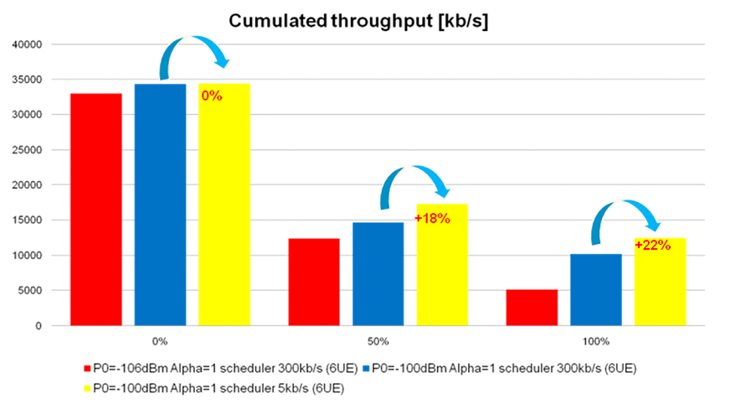
Figure 108: Impact of minimum bit rate upon uplink cell capacity
As detailed in section 6.7.4.2, LTE5731 TCP Service Differentiation can be used to apply a scheduler weighting boost to certain UE to offer higher throughputs for short periods.

Optimization Procedure
Uplink throughput performance can be influenced by many factors. Figure 109 presents some of the activities associated with the optimisation of uplink throughput. The measurement method can impact the throughput performance observed by a UE logging tool.
It is common to measure throughput using a large FTP file transfer with the TCP/IP protocol stack. TCP performance is dependent upon the round-trip time as well as the TCP configuration. Large round-trip times and TCP re-transmissions will tend to reduce throughput performance. Checks can be made to ensure that transmit and receive window sizes remain large during the data transfer. If the TCP protocol is limiting the measured throughput then multiple parallel TCP sessions can be used to increase the total connection throughput. If the throughput does not increase when using multiple TCP sessions then it is an indication that the TCP protocol is not limiting the total measured throughput.
UDP provides a good solution for measuring the maximum throughput performance because it does not involve any transmit / receive windows nor any re-transmissions. A UDP session can be used to push as much data as possible through the network. Measuring throughput using UDP requires a UDP packet generator on the test laptop. The packet generator can be configured to push packets towards the IP address of the application server.
In some cases, the application server can limit throughput performance. It can be useful to test with multiple application servers to determine whether or not the server is having an impact. Throughputs are generally maximised when the application server is located within the local operator network rather than within the internet.
Throughput can also be measured from network statistics but the results can be more complex to interpret due to their dependency upon the traffic profile within the cell, e.g. throughputs may appear low because the traffic profile is dominated by Smart Phone keep-alives rather than larger file transfers.
Figure 109: Activities associated with the optimisation of uplink throughput
When optimising uplink throughput performance, the transport bandwidth should be checked to ensure that it is not limiting the transfer of data. In general, the transport bandwidth is dimensioned according to the downlink throughput requirements. Downlink throughput requirements are usually greater than uplink throughput requirements so it is relatively unlikely that the transport bandwidth limits uplink throughput. The transport bandwidth will be shared by all cells at the eNodeB so the impact of other cells should be taken into account. Checks should also be made to determine whether or not QoS is applied to the transport network. Packet queuing times could be increased if measurements are recorded while using a low QoS.
The cell load should be checked in terms of other users and Physical Resource Block (PRB) utilisation. Air-interface and transport capacity is shared so other users will reduce the individual connection throughput. It is common to complete throughput measurements during quiet periods of the day so the impact from other users is minimised. PRB utilisation should be checked to help determine whether or not the air-interface is limiting the throughput. If the set of PRB are not fully utilised then it indicates that the air-interface is not limiting throughput and the focus for performance improvement should be elsewhere.
The QoS profile associated with the EPS bearer should be checked to determine whether or not there is a maximum bit rate which is limiting the throughput. The Nokia eNodeB does not currently enforce the maximum bit rate belonging to an EPS bearer. However, core network elements may enforce this limit and prevent throughputs from increasing above the maximum bit rate.
The application server should be checked in terms of its location and its round trip time performance. Large round trip times will impact the measured throughput when using a TCP protocol stack.
The air-interface should be checked to ensure that weak signal strength or high interference are not impacting performance. The UE should be reporting CQI values close to, or equal to 15 when attempting to achieve the maximum connection throughput. The RSRP and RSRQ should be as high as possible.
The eNodeB databuild should be checked to ensure that errors are not causing a reduced throughput. This check can also serve to identify any features which are enabled which may also be having an impact upon throughput performance, e.g. Proactive Scheduling can have an impact upon throughput. Proactive Scheduling tends to increase levels of intercell interference.
The downlink throughput should also be checked when measuring uplink throughput in case TCP acknowledgment are being delayed. In general, downlink throughputs should not limit the uplink throughput – assuming the downlink throughput capability is at least 5% of the uplink capability.
The power control strategy can have a significant impact upon the uplink throughput performance. Both the nominal target power and the use of fractional power control should be checked. Fractional power control is suitable for urban areas where the site density is relatively high. The guidelines in section 6.7 should be checked.
Proactive scheduling can have a significant impact upon uplink throughput performance. Enabling Proactive Scheduling helps to reduce latency but increases intercell interference. It provides UE with dummy resource allocations in case they need to transmit some uplink data. UE transmit padding if they do not have any uplink data to transfer.
The PUCCH and PRACH represent overheads from the perspective of the PUSCH. These overheads should be minimised to help maximise uplink throughput. Both the PUCCH and PRACH should be dimensioned to match the capacity requirements of the cell. The PUCCH is discussed in section 6.5.
The scheduler type can also impact uplink throughput performance. It is recommended to use the Channel Aware Scheduler in combination with Fast Uplink Link Adaptation. The Channel Aware Scheduler instructs the UE to transmit the Sounding Reference Signal (SRS) which is then used to measure the uplink channel conditions across the channel bandwidth. Fast Uplink Link Adaptation allows the MCS to be rapidly increased from its initial value.
Interference Rejection Combining (IRC) can improve uplink throughput by reducing intercell interference. Performance is maximised when neighbouring cells are time synchronised but gains can be achieved even when the network is not synchronised (cells belonging to the same eNodeB are time synchronised).
The KPI definition should be checked when measuring throughput using the network counters. This helps to ensure that the results are interpreted correctly. There are a few variations to the way in which throughput KPI can be defined. Some KPI average across the complete measurement period rather than just the active subframes. Some KPI attempt to exclude the impact of Smart Phone keep-alives by ignoring subframes where the uplink buffers became empty.

Field Results
The scenario illustrated in Figure 110 was used to quantify the performance benefit of Interference Rejection Combining (IRC). A first test device was used to transfer uplink data within the dominance area of the sector with PCI 306. A second test device acted as a source of uplink interference. This second test device was connected to the sector with PCI 307 but was positioned close to the sector with PCI 306, i.e. intercell interference was generated.
Figure 110: Scenario used to test Interference Rejection Combining (IRC)

Figure 111 illustrates the throughput achieved by the first test device with IRC disabled and with IRC enabled. The uplink throughput is almost 19 Mbps when the second test device is inactive. The throughput decreases then the second test device becomes active. The throughput is significantly greater when IRC is enabled, i.e. ~14 Mbps rather than ~8 Mbps. These results demonstrate the potential benefit of IRC although the test scenario was manufactured to maximise the throughput gain, i.e. the interfering device was carefully positioned to maximise intercell interference. IRC performs best when neighbouring cells are time synchronised, so the test was completed using 2 cells belonging to the same eNodeB.
Figure 111: Throughput improvement achieved with Interference Rejection Combining (IRC)
Figure 112 illustrates the performance gain measured by enabling the Channel Aware Scheduler (CAS). The benchmark scheduler was the Interference Aware Scheduler. The throughput gain is relatively small but is consistent after enabling the CAS. These throughput results have been generated using eNodeB counters, i.e. PDCP data volume divided by active subframes. The CAS was tested with 3 different SRS configurations (5, 1 and 3). All three SRS configurations had a 10 ms reporting period. The SRS transmission bandwidth is different for each configuration (configuration 5 => 20 Resource Blocks; configuration 1 => 12 Resource Blocks; configuration 3 => 8 Resource Blocks). The throughput performance was maximised when using configuration 1 although the throughput difference is small.
Figure 112: Throughput improvement achieved with the Channel Aware Scheduler (CAS)
Figure 113 illustrates the throughput improvement which can be achieved by disabling proactive scheduling. Proactive scheduling helps to improve latency by allocating dummy grants to each connection for a period of time defined by the ilReacTimerUl parameter. These dummy grants generate uplink intercell interference and so have an impact upon uplink throughput performance. Although not illustrated in Figure 113 a special value of 5 ms can be configured which applies proactive scheduling to only SRB transactions. This helps to improve the rate at which signalling procedures are completed while having only a minor impact upon uplink throughput performance.
Figure 113: Throughput improvement achieved by disabling Proactive Scheduling
Figure 114 illustrates an improvement in uplink Modulation and Coding Scheme (MCS) which was achieved by changing the power control parameter set. The parameter set was modified to enable fractional power control. In addition, the closed loop power control thresholds were adjusted. The complete set of parameter changes are shown in Table 128.
Figure 114: MCS improvement achieved by changing power control parameter set

Parameter | Old Value | New Value
p0NomPusch | -106 dBm | -80 dBm
ulpcAlpha | 1 | 0.8
ulpcLowqualSch | 8 dB | 0 dB
ulpcUpqualSch | 11 dB | 20 dB
ulpcLowlevSch | -103 dBm | -103 dBm
ulpcUplevSch | -98 dBm | -88 dBm
Table 128: Uplink power control parameter changes

Uplink dynamic BLER adaptation provides a small increase in uplink user throughput, as shown in Figure 115.
Figure 115: Uplink user throughput improvement on a cluster of FDD sites

Interference Mitigation

Introduction
LTE networks use a frequency re-use of 1. This means there is co-channel interference between neighbouring cells which can have a significant impact upon throughput performance. RF optimisation should precede parameter optimization whenever possible, i.e. downtilting can help to improve dominance and reduce both uplink and downlink inter-cell interference. The drawback is likely to be an impact upon coverage. This may be acceptable in an urban area where the site density is high although there could still be an impact upon indoor coverage.
The features associated with mitigating uplink interference are listed in Table 129. Features have been categorised as being linked to Power Control, Scheduler, Receiver or Hierarchical Cell Structure (HCS).
Id | Name | Category | Software Release
LTE27 | Open loop UL power control and DL power setting | Power Control | RL10
LTE619 | Interference aware UL scheduling | Scheduler | RL30
LTE46 | Channel-aware Scheduler (UL) | Scheduler | RL40
LTE979 | IRC for 2 RX Paths | Receiver | RL40
LTE980 | IRC for 4 RX Paths | Receiver | RL50
LTE1336 | Interference aware UL power control | Power Control | RL60
LTE1402 | Uplink Intra-eNB CoMP | Receiver | RL60
LTE1691 | Uplink intra-eNB CoMP 4Rx | Receiver | RL70
LTE1496 | eICIC - micro | HCS | RL70
LTE1113 | eICIC - macro | HCS | RL70
LTE2470 | Centralized RAN for FL16 | Receiver | FL16
LTE2564 | Centralized RAN CL16A Release | Receiver | FL16A
LTE3933 | Flexible Inter eNB UL CoMP | Receiver | FL18A
Table 129: Features supporting uplink interference mitigation
Power control can be used to help interference mitigation by using it to instruct cell edge UE to reduce their transmit powers. This can be achieved using either the 3GPP standardised fractional power control (part of the open loop power control calculation), or by the Nokia proprietary Interference Aware Uplink Power Control. Reducing uplink transmit powers at cell edge tends to reduce connection throughput for those specific connections but increases overall network throughput by reducing the quantity of interference in the system.
The scheduler can be used to help interference mitigation by providing a co-ordination function between neighbouring cells. This co-ordination can be achieved without explicit signalling between neighbouring cells. For example, if one cell starts to transmit at the bottom of the channel bandwidth then neighbouring cells will experience better channel conditions at the top of the channel bandwidth so will select that area for serving its UE.
The receiver implementation can be used to provide benefits in terms of both rejection and combining. The Interference Rejection Combining (IRC) features use a coarse form of beamforming to reject dominant sources of interference while attempting to combine the dominant wanted signal paths. Co-ordinated Multi-Point (CoMP) and Centralised RAN (CRAN) provide a combining gain across cells. This provides a benefit similar to softer handover in UMTS. Uplink transmissions received across multiple cells are combined prior to decoding.
Enhanced Inter-Cell Interference Co-ordination (eICIC) features use signalling across the X2 interface to co-ordinate transmissions in the time domain. These features are primarily targeted toward hierarchical cell structures where small cells can receive high levels of interference from umbrella macrocells. The umbrella macrocell uses Almost Blank Subframes (ABS) to effectively mute its transmissions during specific subframes. The small cell can then use those subframes to serve its cell edge UE, i.e. those which normally experience high interference from the macrocell.
The features associated with mitigating downlink interference are listed in Table 130. Features have been categorised as being linked to Power Control, Scheduler, RSRQ Mobility or Hierarchical Cell Structure (HCS).
Id | Name |  | Software Release
LTE767 | Support of aperiodic CQI reports | Scheduler | RL10
LTE1036 | RSRQ Based Cell Reselection | RSRQ Mobility | RL50
LTE1407 | RSRQ Based Redirect | RSRQ Mobility | RL50
LTE1198 | RSRQ triggered Mobility | RSRQ Mobility | RL60
LTE1800 | Downlink Interference Shaping | Scheduler | RL70
LTE1496 | eICIC - micro | HCS | RL70
LTE1113 | eICIC - macro | HCS | RL70
LTE1894 | Reference Signal Power De-boosting | Power Control | RL70
LTE2572 | RSRQ-based B2 | RSRQ Mobility | FL16A
LTE2551 | RSRQ-based A5 | RSRQ Mobility | FL16A
LTE4300 | 16TRX FDD mMIMO: DL USBF based on UE Feedback | Beamforming | FL18A
LTE4613 | TM9 in MBSFN Subframes | Beamforming | FL18A
Table 130: Features supporting downlink interference mitigation
Power control can be used to limit the downlink transmit power and consequently limit downlink intercell interference. The Reference Signal Power De-boosting feature allows the Reference Signal transmit power to be reduced by 3 dB and so reduce cell dominance, but this feature has limited impact upon the total downlink transmit power. Instead, the total downlink transmit power can be limited using the dlCellPwrRed LNCEL parameter. These power reductions should only be applied at specific problem sites and only after all possible RF optimisation has been completed. It should be recognised that decreasing all transmit powers in an interference limited scenario does not improve SINR because both the wanted signal and interference power decrease by the same amount.
Similar to the uplink, the downlink scheduler can be used to help interference mitigation by providing a co-ordination function between neighbouring cells. In the case of the downlink, frequency domain scheduling relies upon sub-band CQI reports. These sub-band CQI reports are sent as aperiodic reports using feature LTE767. These sub-band reports help to identify sections of the channel bandwidth which have relatively low inter-cell interference. The Downlink Interference Shaping feature allows the scheduler to define preferred areas within the channel bandwidth. These preferred areas can be based upon the ‘PCI mod 3’ rule so PCI planning can be used to ensure that neighbouring cells have different preferred areas. The preferred areas increase and decrease in size as the cell load changes. The benefit of the feature reduces if all cells have high load. In that case, all cells have preferred areas which occupy the majority of the channel bandwidth and those preferred areas will overlap.
The RSRQ mobility features do not directly reduce interference but allow mobility procedures to be triggered by high interference. These mobility procedures can be cell reselection, RRC Release with Redirection or handovers.
The eICIC features are common to the uplink because these features provide time domain interference co-ordination for both the uplink and downlink directions. Umbrella macrocells use Almost Blank Subframes (ABS) to effectively mute their transmissions during specific subframes. Small cells can then use those subframes to serve their cell edge UE, i.e. those which normally experience high interference from the macrocell.
In contrast to the features in Table 129 and Table 130, the LTE1140 Intra-Frequency Load Balancing can increase inter-cell interference. This feature prioritises load balancing over inter-cell interference. Measurement offsets are used to move handover boundaries and towards busy cells to reduce the quantity of traffic collected. Moving handover boundaries means that UE are no longer connected to their normal best serving cell, i.e. they have to transmit with increased power and so increase levels of interference in the network.
Proactive scheduling is another example of a feature which tends to increase inter-cell interference. Proactive scheduling allocates dummy uplink grants to ensure that UE always have uplink resources available for transmission. These dummy grants can have a significant impact upon levels of uplink interference. The LTE4066: ‘Low Latency Fast UL Grants’ feature allows release 14 UE to skip dummy grants when their uplink buffers are empty. This helps to reduce the uplink interference generated by dummy grants. This feature also increases the flexibility of proactive scheduling, e.g. a proactive grant timer can be used to allocate dummy grants periodically rather than within every subframe.

Typical Issues
Issues associated with inter-cell interference may include:
- Reduced Uplink Throughput
Uplink throughput performance is sensitive to the quantity of uplink interference, i.e. SINR is degraded when interference levels are high. Uplink interference can be relatively high due to poor RF planning, i.e. poor cell dominance. It is most likely to be high in urban areas where the site density is high and UE are relatively close to neighboring eNodeB. Uplink interference can also be increased by features such as Proactive Scheduling and Intra-Frequency Load Balancing. These features increase inter-cell interference to help achieve other objectives, i.e. reduced latency and load balancing.
- Reduced Downlink Throughput
Downlink throughput performance is sensitive to the quantity of downlink interference, i.e. the reported CQI is degraded when interference levels are high. Similar to the uplink, downlink interference can be relatively high due to poor RF planning and inter-cell interference is most likely to be high in urban areas where the site density is high.
- Increased Drop Rate
Mobility procedures may be configured to use RSRP thresholds. This means that UE can remain connected to the serving cell while the RSRQ becomes poor. This can lead to dropped calls on networks where the level of interference is relatively high. Levels of interference will increase as the network load increases over time. This increases the importance of enabling RSRQ triggered mobility procedures.

Performance Analysis
The impact of uplink interference level changes can be quantified using the set of uplink cell and connection throughput KPI provided in section 6.11.3. Similarly, the impact of downlink interference level changes can be quantified using the set of downlink cell and connection throughput KPI provided in section 6.10.3.
In addition, uplink interference levels can be quantified using the counters within table M8005 (LTE Power and Quality UL Measurement). This table includes counters for SINR, RSSI, and UE Transmit Power Headroom.
The counters shown in Table 131 record the SINR across active PUSCH Resource Blocks. These counters can be used to identify cells which are experiencing high uplink interference.

Counter Id | Counter Name | Comments
M8005C93 | SINR_PUSCH_MIN | Minimum, maximum and average SINR values measured across active PUSCH Resource Blocks
M8005C94 | SINR_PUSCH_MAX
M8005C95 | SINR_PUSCH_AVG
M8005C118 | SINR_PUSCH_LEVEL_1 | Distribution of RSSI values measured across active PUSCH Resource Blocks
M8005C119 | SINR_PUSCH_LEVEL_2
-- | --
M8005C138 | SINR_PUSCH_LEVEL_21
M8005C139 | SINR_PUSCH_LEVEL_22
Table 131: Counters recording SINR across active PUSCH Resource Blocks
The counters shown in Table 132 record the SINR across all PUSCH Resource Blocks. These counters reflect a combination of PUSCH SINR and the number of connections within a cell. Low numbers of connections will result in low counter results because the counter results are averaged across both active and inactive Resource Blocks.
Counter Id | Counter Name | Comments
M8005C281 | SINR_CELL_PUSCH_MIN | Minimum, maximum and average SINR values measured across all PUSCH Resource Blocks
M8005C282 | SINR_CELL_PUSCH_MAX
M8005C283 | SINR_CELL_PUSCH_MEAN
M8005C284 | SINR_CELL_PUSCH_LEVEL_1 | Distribution of RSSI values measured across all PUSCH Resource Blocks
M8005C285 | SINR_CELL_PUSCH_LEVEL_2
-- | --
M8005C304 | SINR_CELL_PUSCH_LEVEL_21
M8005C305 | SINR_CELL_PUSCH_LEVEL_22
Table 132: Counters recording SINR across all PUSCH Resource Blocks
The counters presented in Table 133 record the UE transmit power headrooms reported by the population of UE. These counters can be used to identify cells with relatively high uplink interference (if closed loop power control is enabled).
Counter Id | Counter Name | Comments
M8005C54 | UE_PWR_HEADROOM_PUSCH_LEVEL1 | Distribution of reported UE transmit power headrooms
M8005C55 | UE_PWR_HEADROOM_PUSCH_LEVEL2 | Distribution of reported UE transmit power headrooms
… | … | Distribution of reported UE transmit power headrooms
M8005C84 | UE_PWR_HEADROOM_PUSCH_LEVEL31 | Distribution of reported UE transmit power headrooms
M8005C85 | UE_PWR_HEADROOM_PUSCH_LEVEL32 | Distribution of reported UE transmit power headrooms
M8005C87 | UE_PWR_HEADROOM_PUSCH_MIN | Minimum, maximum and average reported UE transmit power headrooms
M8005C88 | UE_PWR_HEADROOM_PUSCH_MAX
M8005C89 | UE_PWR_HEADROOM_PUSCH_AVG
Table 133: Counters recording the reported UE transmit power headroom
The counters shown in Table 134 record the RSSI across active PUSCH Resource Blocks. There are minimum, maximum and average counters, as well as a set of counters recording the distribution of RSSI values. These counters can be used to identify cells which are experiencing high uplink interference.
Counter Id | Counter Name | Comments
M8005C3 | RSSI_PUSCH_MIN | Minimum, maximum and average RSSI values measured across active PUSCH Resource Blocks
M8005C4 | RSSI_PUSCH_MAX
M8005C5 | RSSI_PUSCH_AVG
M8005C28 | RSSI_PUSCH_LEVEL_01 | Distribution of RSSI values measured across active PUSCH Resource Blocks
M8005C29 | RSSI_PUSCH_LEVEL_02
-- | --
M8005C48 | RSSI_PUSCH_LEVEL_21
M8005C49 | RSSI_PUSCH_LEVEL_22
Table 134: Counters recording RSSI across active PUSCH Resource Blocks
The impact of downlink interference levels can be quantified using the counters within table M8010 (LTE Power and Quality DL Measurement). This table includes counters for reported CQI, as well as the CQI offset generated during CQI compensation. The KPI LTE_5427c quantifies the average reported CQI value in a cell:
LTE_5427c E-UTRAN Average CQI
SUM(1*UE_REP_CQI_LEVEL_01+ 2*UE_REP_CQI_LEVEL_02+ 3*UE_REP_CQI_LEVEL_03+ 4*UE_REP_CQI_LEVEL_04+ 5*UE_REP_CQI_LEVEL_05+ 6*UE_REP_CQI_LEVEL_06+
7*UE_REP_CQI_LEVEL_07+ 8*UE_REP_CQI_LEVEL_08+ 9*UE_REP_CQI_LEVEL_09+ 10*UE_REP_CQI_LEVEL_10+ 11*UE_REP_CQI_LEVEL_11+ 12*UE_REP_CQI_LEVEL_12+
13*UE_REP_CQI_LEVEL_13+ 14*UE_REP_CQI_LEVEL_14+ 15*UE_REP_CQI_LEVEL_15) / SUM(UE_REP_CQI_LEVEL_00+UE_REP_CQI_LEVEL_01+ UE_REP_CQI_LEVEL_02+UE_REP_CQI_LEVEL_03+ UE_REP_CQI_LEVEL_04+UE_REP_CQI_LEVEL_05+ UE_REP_CQI_LEVEL_06+UE_REP_CQI_LEVEL_07+ UE_REP_CQI_LEVEL_08+UE_REP_CQI_LEVEL_09+ UE_REP_CQI_LEVEL_10+UE_REP_CQI_LEVEL_11+ UE_REP_CQI_LEVEL_12+UE_REP_CQI_LEVEL_13+ UE_REP_CQI_LEVEL_14+UE_REP_CQI_LEVEL_15)

Parameter Definition
The parameters associated with uplink power control are presented in section 6.7.4. The key enabling parameter is repeated in Table 135. This parameter allows selection between open loop, closed loop and interference aware power control algorithms. It is recommended to use interference aware power control.
Parameter | Object | Range | Default
actUlpcMethod | LNCEL | PuschOLPucchOL (0), PuschOLPucchCL (1), PuschCLPucchOL (2), PuschCLPucchCL (3), PuschCLSrsPucchOL (4), PuschCLSrsPucchCL (5), PuschIAwPucchOL (6), PuschIAwPucchCL (7) | PuschOLPucchOL (0)
Table 135: Parameter used to manage PUSCH, PUCCH and SRS power control
The key enabling parameter for the uplink packet scheduler is presented in Table 136. This parameter allows selection between the channel unaware, channel aware and interference aware scheduling algorithms. It is recommended to use channel aware scheduling.
Parameter | Object | Range | Default
ulsSchedMethod | LNCEL | Channel unaware (0), Channel aware (1), Interference aware (2) | Channel unaware (0)
Table 136: Parameter used to manage the algorithm which selects which uplink Resource Blocks to allocate to each UE
The key enabling parameter for the uplink receiver type is presented in Table 137. This parameter allows selection between Maximal Ratio Combining (MRC) and Interference Rejection Combining (IRC). It is recommended to use IRC.
Parameter | Object | Range | Default
ulCombinationMode | LNCEL_FDD | MRC (0), IRC (1) | MRC (0)
Table 137: Parameter used to enable IRC
The parameter used to enable uplink Co-ordinated Multipoint (CoMP) is presented in Table 138. It is recommended to enable CoMP to help improve uplink performance.
Parameter | Object | Range | Default
actCoMp | LNBTS | 0 (disabled), 1 (fixedUlCoMp), 2 (CRAN), 3 (measBasedCoMp) | 0 (disabled)
Table 138: Parameter used to enable CoMP
The parameters used to control proactive scheduling are presented in Table 139. The LTE4066: ‘Low Latency Fast Uplink Grants’ feature should be used to configure proactive scheduling such that it improves latency without generating significant levels of uplink interference. Some aspects of this feature rely upon release 14 UE.

Parameter | Object | Range | Default
ilReactimerUl | LNCEL | 0 to 2000 ms | 5 ms
actProactSchedBySrb | LNCEL | 0 (false), 1 (true) | 1 (true)
actTcpBoost | LNBTS | 0 (false), 1 (true) | 0 (false)
actUlTxSkip | LNBTS | 0 (false), 1 (true) | 0 (false)
maxNumUeProactiveUl | LNCEL | 0 to 20, step 1 | 10
maxNumUeProactiveUlNonTxSkip | LNCEL | 0 to 20, step 1 | 10
ilReacTimerUlTcpBoost | LNBTS | 0 to 2000, step 10 ms | 10
ilMinDatvolUlTcpBoost | LNBTS | 0 to 4000, step 80 bits | 560
ilReacTimerUlTxSkip | LNBTS | 0 to 2000, step 10 ms | 0
ilReacTimerUlTcpBoostTxSkip | LNBTS | 0 to 2000, step 10 ms | 10
ilGrantGapTxSkip | LNBTS | 0 to 2000, step 10 ms | 10
ilGrantGapTcpBoostTxSkip | LNBTS | 0 to 2000, step 10 ms | 10
Table 139: Parameters used to configure proactive scheduling
The parameters associated with downlink power control are presented in section 6.6.4. These parameters allow the total downlink transmit power to be controlled. They also allow the transmit power of the control channels and Reference Signal to be controlled.
The parameters used to enable and configure aperiodic CQI reporting are presented in Table 140. Aperiodic CQI reports provide sub-band channel quality information so help the scheduler avoid sections of the channel bandwidth with high interference.
Parameter | Object | Range | Default
cqiAperEnable | LNCEL | False (0), True (1) | True (1)
cqiAperMode | LNCEL | FBT1 (0), FBT2 (1) | FBT2 (1)
Table 140: Parameters used to configure aperiodic CQI reporting
The parameter used to enable Downlink Interference Shaping is presented in Table 141. This feature has a relatively large parameter set included within the ISHPR object.
Parameter | Object | Range | Default
actDlIsh | LNCEL | False (0), True (1) | True (1)
Table 141: Parameter used to enable Downlink Interference Shaping
The parameters associated with RSRQ triggered Release with Redirection are presented in Table 142. These parameters include a triggering threshold, a hysteresis and a time-to-trigger.

Parameter | Object | Range | Default
a2TimeToTriggerRedirectRsrq | LNCEL | 0 to 5120 ms | 480 ms
hysThreshold4Rsrq | LNCEL | 0 to 15 dB | 0 dB
Threshold4Rsrq | LNCEL | -20 to -3 dB | -19 dB
Table 142: Parameters associated with RSRQ triggered Release with Redirection
LNCEL parameters associated with RSRQ based cell selection and reselection are presented in Table 143. These parameters include qQualmin for both the serving cell and neighbouring intra-frequency cells. The parameter set also includes thresholds used to trigger intra-frequency, inter-frequency and inter-system measurements. These parameters do not have Nokia default values so are unpopulated by default.
Parameter | Object | Range | Default
cellSelectionInfoV920 – qQualMinOffsetR9 | SIB | 1 to 8 dB | -
cellSelectionInfoV920 – qQualMinR9 | SIB | -34 to -3 dB | -
sIntraSearchV920 – sIntraSearchPR9 | SIB | 0 to 62 dB | -
sIntraSearchV920 – sIntraSearchQR9 | SIB | 0 to 31 dB | -
sNonIntraSearchV920 – sNonIntraSearchPR9 | SIB | 0 to 62 dB | -
sNonIntraSearchV920 – sNonIntraSearchQR9 | SIB | 0 to 31 dB | -
qQualMinR9 | SIB | -34 to -3 dB | -
threshServingLowQR9 | SIB | 0 to 31 dB | -
Table 143: LNCEL Parameters associated with RSRQ based Cell Reselection
IRFIM parameters associated with RSRQ based cell selection and reselection are presented in Table 144. These parameters include qQualmin for neighbouring inter-frequency cells. They also define thresholds for higher and lower priority target cell quality requirements.
Parameter | Object | Range | Default
interFrqQThrR9 – interFrqQThrHighR9 | IRFIM | 0 to 31 dB | -
interFrqQThrR9 – interFrqQThrLowR9 | IRFIM | 0 to 31 dB | -
qQualMinR9 | IRFIM | -34 to -3 dB | -
Table 144: IRFIM Parameters associated with RSRQ based Cell Reselection
UFFIM parameters associated with RSRQ based cell reselection are presented in Table 145. These parameters define thresholds for higher and lower priority target cell qualities.
Parameter | Object | Range | Default
utrFddCarFrqL – utraFrqQThrHighR9 | UFFIM | 0 to 31 dB | -
utrFddCarFrqL – utraFrqQThrLowR9 | UFFIM | 0 to 31 dB | -
Table 145: UFFIM Parameters associated with RSRQ based Cell Reselection
Table 146 presents the set of LNCEL parameters associated with RSRQ triggered SRVCC, inter-frequency handover and inter-system handover. A single threshold is used to trigger all of these procedures (defined by threshold2MobRsrq). The corresponding 2a threshold is used to cancel the mobility procedures if the radio conditions improve.
Parameter | Object | Range | Default
rsrqMobilityParams – threshold2MobRsrq | LNCEL | -20 to -3 dB | -15 dB
rsrqMobilityParams – threshold2aRsrq | LNCEL | -20 to -3 dB | -12 dB
rsrqMobilityParams – a1ReportInterval | LNCEL | 120 ms to 60 min | 1024 ms
rsrqMobilityParams – a2TimeToTriggerMobRsrq | LNCEL | 0 to 5120 ms | 480 ms
rsrqMobilityParams – hysThreshold2MobRsrq | LNCEL | 0 to 15 dB | 0 dB
filterCoefficientRSRQ | LNCEL | 0 to 19 | 4
Table 146: Parameters associated with RSRQ triggered SRVCC, Inter-frequency Handover and Inter-system Handover
Table 147 presents the set of LNHOIF parameters associated with RSRQ triggered inter-frequency handover. These parameters are used to configure event a3.
Parameter | Object | Range | Default
a3OffsetRsrqInterFreq | LNHOIF | -15 to 15 dB | -
a3ReportIntervalRsrqInterFreq | LNHOIF | 120 ms to 60 min | -
a3TimeToTriggerRsrqInterFreq | LNHOIF | 0 to 5120 ms | -
hysA3OffsetRsrqInterFreq | LNHOIF | 0 to 15 dB | -
measQuantInterFreq | LNHOIF | rsrp (0), rsrq (1), both (2) | rsrp (0)
Table 147: Parameters associated with RSRQ triggered Inter-frequency Handover

Optimization Procedure
A high-level process for managing uplink interference is presented in Figure 116. As with all optimisation, the process should start with RF optimisation. Applying additional downtilt will help to reduce inter-cell interference but may also have a negative impact upon coverage. A balance between coverage and interference levels must be achieved.
Figure 116: Management of uplink interference
The power control solution should be checked in terms of enabling either Fractional Power Control or Interference Aware Power Control. These features are most important in urban areas where the site density is high. Their impact should be to reduce UE transmit powers at cell edge to help reduce inter-cell interference. Fractional Power Control is based upon path loss whereas Interference Aware Power Control is based upon signal to noise ratio.
The scheduler solution should be checked in terms of the scheduler type, i.e. channel unaware, interference aware or channel aware. The interference aware scheduler uses cell level RSSI measurements to select the best part of the channel bandwidth for each UE. Cell edge UE which have lower transmit power headrooms are allocated sections of the channel which have lower RSSI. The channel aware scheduler uses UE specific SINR measurements to select the best part of the channel bandwidth for each UE. In this case, the UE is instructed to transmit the Sounding Reference Signal to allow measurements across the channel bandwidth. In general, the channel aware scheduler provides the best performance.
The receiver solution should be checked in terms of using Interference Rejection Combining (IRC) and Co-ordinated Multi-Point (CoMP). IRC aims to improve signal to noise ratio by maximising antenna gain towards the wanted signal and minimising antenna gain towards dominant sources of interference. This is achieved using a coarse beamforming effect. CoMP aims to improve signal to noise ratio by combining wanted signal across sectors. Both of these features can be enabled simultaneously and are transparent to the UE.
Features should be checked in terms of identifying any enabled features which could be increasing uplink interference levels. Proactive Scheduling increases uplink interference by allocating dummy grants to the population of UE. This helps to reduce latency but has a negative impact upon uplink interference and uplink throughput. A compromise solution may be to limit Proactive Scheduling to a relatively short period, e.g. 50 ms, or to enable it only for the Signalling Radio Bearer. Intra-frequency Load Balancing can also increase uplink interference by moving UE onto cells which are not their normal best server. This feature provides benefits in terms of load balancing but may have a negative impact upon local interference.
The requirement for eICIC should be checked, especially if the network includes a combination of macrocells and co-channel small cells. This feature allows a time domain interference co-ordination function between the macrocell and small cells. Almost Blank Subframes (ABS) are used by the macrocell to effectively mute its transmissions during specific subframes. The small cells can then use those subframes to serve its cell edge UE, i.e. those which normally experience high interference from the macrocell.
A high-level process for managing downlink interference is presented in Figure 117. Similar to the uplink, the process should start with RF optimisation to achieve a balance between coverage and inter-cell interference.
Figure 117: Management of downlink interference
Downlink power control should be checked in terms of Reference Signal boosting/de-boosting. It is recommended to disable Reference Signal boosting and in some cases, it may be appropriate to apply de-boosting. However, de-boosting has limited impact upon the total downlink transmit power. The total downlink transmit power will tend to depend upon cell load and the Resource Block utilisation. Power Control should be enabled for the PDCCH to allow increased flexibility when selecting aggregation levels for each transmission, i.e. increasing the transmit power allocation can reduce the aggregation level requirement.
The downlink scheduler should be checked in terms of verifying that aperiodic CQI reporting is enabled. These reports will provide the main input to link adaptation during periods of data activity. Aperiodic reports are configured to be sub-band reports so the scheduler gains information which is specific to sub-sections of the channel bandwidth. The downlink scheduler can also be influenced by the Downlink Interference Shaping feature. This feature allows the scheduler to define preferred areas within the channel bandwidth. These preferred areas can be based upon the ‘PCI mod 3’ rule so PCI planning can be used to ensure that neighbouring cells have different preferred areas. The preferred areas increase and decrease in size as the cell load changes.
RSRQ mobility should be checked in terms of identifying whether or not it is enabled. The benefit of RSRQ mobility increases as LTE traffic increases and interference levels become greater. RSRQ mobility can be categorised as:
- Cell selection/re-selection
- RRC Release with Redirection
- Inter-frequency Handover
- Inter-system Handover
- SRVCC
In general, all of these solutions will help to improve accessibility and retainability metrics. Triggering thresholds can initially be selected to be low to introduce the features with minimal impact. Higher values can subsequently be trialled to determine their impact upon the system. Higher triggering thresholds will improve network performance but will also tend to offload more traffic away from the LTE network.
Similar to the uplink, the requirement for eICIC should be checked, especially if the network includes a combination of macrocells and co-channel small cells. This feature allows a time domain interference co-ordination function between the macrocell and small cells. Almost Blank Subframes (ABS) are used by the macrocell to effectively mute its transmissions during specific subframes. The small cells can then use those subframes to serve its cell edge UE, i.e. those which normally experience high interference from the macrocell.

Field Results
Field trial results associated with uplink power control are presented in section 6.7.6.
Field trial results associated with the uplink packet scheduler, the uplink receiver and the impact of proactive scheduling are presented in section 6.11.6.
Figure 118 illustrates the increase in the number of RRC Connection Release with Redirections which are triggered when the RSRQ triggering mechanism is enabled, in addition to the existing RSRP triggering mechanism. This example is for a dense urban site which has relatively high interference and low RSRQ.
Figure 118: RRC Release with Redirections before/after enabling RSRQ triggered Release with Redirection (urban site)
Figure 119 illustrates the same results for a rural site. In this case, the levels of interference are relatively low so the RSRQ is high and the feature does not trigger very frequently.
Figure 119: RRC Release with Redirections before/after enabling RSRQ triggered Release with Redirection (rural site)
Figure 120 presents the reduction in drop call ratio achieved at the dense urban site when enabling RSRQ triggered release with redirection, i.e. the drop call ratio can be improved by enabling this feature. The drawback is that traffic can be offloaded towards 3G and 2G if the RSRQ triggering threshold is set too high. A balance must be achieved between keeping traffic on LTE and improving the drop call ratio.
Figure 120: Drop Ratio before/after enabling RSRQ triggered Release with Redirection (dense urban site)
Figure 121 illustrates an example of the reduction in RSRP measured across an area after applying a 3 dB reduction in downlink transmit power (dlCellPwrRed = 3 dB), and applying a series of downtilts. The objective of this downlink transmit power reduction and increased downtilts was reduced intercell interference.
Figure 121: Example RSRP distribution before/after reducing the downlink transmit power by 3 dB and applying downtilts
Figure 122 illustrates the network statistics for the corresponding traffic collected in terms of RRC Connection Requests and downlink data volume. As expected, the reduced downlink transmit power and increased downtilts leads to a slight reduction in traffic due to the reduced coverage.

Figure 122: Traffic collected before/after reducing the downlink transmit power by 3 dB and applying downtilts
Figure 123 illustrates the network statistics for the corresponding uplink quality. The reduced coverage leads to a decrease in intercell interference and improved uplink SINR and MCS.
Figure 123: Uplink Quality before/after reducing the downlink transmit power by 3 dB and applying downtilts

RSRQ Mobility

Introduction
3G networks have used mobility solutions based upon CPICH Ec/Io since their initial launch. LTE networks were launched using mobility solutions based upon RSRP. Both 3G and LTE networks use a frequency re-use pattern of 1 and so experience relatively high levels of inter-cell interference. LTE benefits from significantly higher orthogonality than 3G so intra-cell interference is much lower.
The requirement for RSRQ mobility increases as the network load increases and levels of interference become more significant. In general, there is an increased requirement for RSRQ mobility when using the lower operating bands. For example, a deployment using L800 is more likely to require RSRQ mobility than a deployment using L2600. RSRQ mobility is also most likely to be required in urban areas where the site density is high and the network is interference limited.
Figure 124 illustrates an example set of RSRQ reports from an L800 network layer within an urban area. This plot has been generated using ‘Immediate Minimisation of Drive Testing (MDT)’. It is clear that there are many locations which experience an RSRQ below -18 dB. LTE has poor accessibility and retainability once the RSRQ falls to -19 dB. If RSRQ mobility remains disabled then it is possible that there are locations where UE can remain camped on a cell due to adequate RSRP but cannot establish a connection due to poor RSRQ.
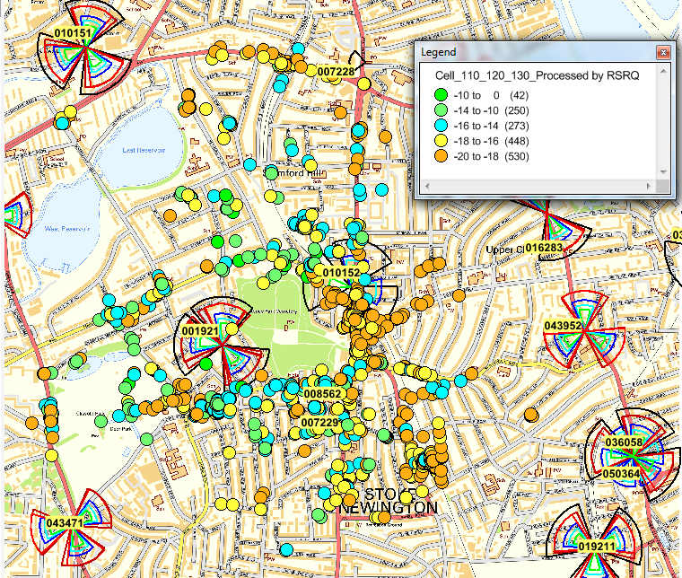
Figure 124: Example set of RSRQ reports illustrating areas of poor RSRQ
Enabling RSRQ mobility generally involves moving the UE to another network layer. This improves the performance of the source network layer. Care should be taken because it may degrade the performance of the target network layer. For example, if 3G and LTE networks are deployed using the same site grid then locations with poor RSRQ are likely to be locations with poor CPICH Ec/Io. Triggering mobility from LTE to 3G will move the UE away from the poor RSRQ locations but into the poor CPICH Ec/Io locations. The impact is likely to be scenario specific and require case-by-case analysis. If moving from L800 to U2100 then the levels of 3G inter-cell interference may be lower due to the increased propagation loss. This type of mobility can also lead to a reduction in LTE traffic and an increase in 3G traffic. This may not be viewed positively if the general strategy is to keep as much traffic as possible on the LTE network.
Alternatively, RSRQ mobility can be used to trigger inter-frequency mobility rather than inter-system mobility. This should be considered case-by-case, e.g. if moving traffic away from L800 based upon RSRQ then the coverage provided by higher operating bands will depend upon the site density. L2600 coverage may be relatively weak at locations where L800 has poor RSRQ.
The features associated with RSRQ mobility are listed in Table 148. A general capability for both RRC Idle Mode and RRC Connected Mode was provided in early software releases. Enhancements have been added with the later software releases.
Id | Name | Software Release
LTE1036 | RSRQ Based Cell Reselection | RL50
LTE1407 | RSRQ Based Redirect | RL50
LTE1198 | RSRQ triggered mobility | RL60
LTE2551 | RSRQ-based A5 | FL16A
LTE2572 | RSRQ-based B2 | FL17A
LTE3462 | Support for Intra-Frequency A3 RSRQ Measurement | FL17A
Table 148: Features associated with RSRQ based mobility

Typical Issues
Issues associated with poor RSRQ and RSRQ mobility are:
- Poor Accessibility
RRC Connection Setup success rate is generally poor at locations where the RSRQ is low, i.e. less than -19 dB. This can be visible in the network statistics for MSG1 -> MSG3 success rate. UE tend to make repeated attempts when failing the random access procedure so a small number of UE can have a relatively large impact upon the network statistics.

- Poor Retainability
Drop rates are generally high at locations where the RSRQ is low, i.e. less than -19 dB. This can be visible in the network statistics for the end-user drop rate and the number of RRC Connection Re-establishment attempts.
- Pre-Alerting and Alerting SRVCC for VoLTE
If RSRQ based SRVCC is enabled then it may trigger during the pre-alerting or alerting phases of VoLTE connection establishment. This will cause setup failures if the network does not support pre-alerting or alerting SRVCC. This scenario can be mitigated by configuring RSRQ Idle Mode parameters to ensure that the RSRQ is always relatively good when UE enter RRC Connected mode. However, this could then lead to traffic migrating from LTE to 3G (depending upon the deployment strategy)
- Migration of Traffic from LTE to 3G
Depending upon the deployment strategy, RSRQ mobility may lead to an increased volume of traffic on 3G and a reduced volume of traffic on LTE. This would be the case if RSRQ mobility is configured to trigger inter-system mobility, e.g. RSRQ Idle Mode Mobility to 3G, RRC Release with Redirection to 3G, PS data handover to 3G, SRVCC to 3G. This does not reflect the general strategy of keeping traffic on LTE for as long as possible.
- Ping-Pong between Network Layers
There is a risk of ping-pong between layers if RSRQ mobility is only partially implemented. For example, if RSRQ Release with Redirection is enabled but RSRQ Idle Mode parameters are not enabled then connections can be redirected to 3G Idle Mode due to poor RSRQ but then immediately return to LTE if the RSRP is relatively good.

Performance Analysis
The set of counters associated with RSRQ mobility and measurements is presented in Table 149.

Counter Id | Counter Name | Comments
M8033C4 | REPORTS_RSRQ_A2 | Incremented when Event A2 is triggered by RSRQ rather than RSRP
M8033C6 | REPORTS_RSRQ_A2_REDIR
M8052C18 | NUM_RSRQ_MEAS_BIN1 | Histogram of RSRQ measurements within a cell
M8052C19 | NUM_RSRQ_MEAS_BIN2 | Histogram of RSRQ measurements within a cell
M8052C20 | NUM_RSRQ_MEAS_BIN3 | Histogram of RSRQ measurements within a cell
M8052C21 | NUM_RSRQ_MEAS_BIN4 | Histogram of RSRQ measurements within a cell
M8052C22 | NUM_RSRQ_MEAS_BIN5 | Histogram of RSRQ measurements within a cell
M8052C23 | NUM_RSRQ_MEAS_BIN6 | Histogram of RSRQ measurements within a cell
M8052C24 | NUM_RSRQ_MEAS_BIN7 | Histogram of RSRQ measurements within a cell
M8052C25 | NUM_RSRQ_MEAS_BIN8 | Histogram of RSRQ measurements within a cell
M8052C26 | NUM_RSRQ_MEAS_BIN9 | Histogram of RSRQ measurements within a cell
M8052C27 | NUM_RSRQ_MEAS_BIN10 | Histogram of RSRQ measurements within a cell
Table 149: Counters associated with RSRQ mobility and RSRQ measurements
The first two counters are incremented when an Event A2 measurement report is received from a UE. The first counter captures all Event A2 measurement reports triggered by RSRQ, whereas the second counter capture those associated with the Release with Redirection procedure. The remaining counters can be used to generate a cell level distribution of RSRQ. This can be used to identify cells which have traffic located in areas of poor RSRQ.
RSRQ levels can also be quantified from drive testing and Minimisation of Drive Testing (MDT). The benefit of MDT is that measurements are captured by the actual subscriber population. This is in contrast to drive testing which tends to be limited to roads and does not necessarily reflect the experience of subscribers. MDT data can be captured and processed either with, or without GPS location information.
An example set of counters and KPI which could be monitored when introducing RSRQ mobility include:
- E-UTRAN Initial E-RAB Accessibility (LTE_5060j)
- E-UTRAN Complete Contention Based RACH Setup Success Rate (LTE_5670a)
- E-UTRAN E-RAB Drop Ratio, User Perspective (LTE_5119g)
- REPORTS_RSRQ_A2_REDIR (M8033C6)
- E-UTRAN PDCP SDU Volume DL (LTE_5212a)
- PS DL Data Volume (RNC_3124a)
- SIGN_CONN_ESTAB_ATT_MO_S (M8013C19)
- Registration Attempts (RNC_218a)
- CS Voice, Erlangs (RNC_744a)
- VoLTE Total Traffic (LTE_1067c)
- E-UTRAN Total Inter RAT HO UTRAN with SRVCC Success Ratio (LTE_6115a)
These KPI should be studied for each network layer to gain an understanding of the impact of moving traffic from one layer to another.

Parameter Definition
The parameters associated with RSRQ Idle Mode mobility are presented in Table 150. These parameters define the minimum RSRQ required to camp on a cell (qQualmin) and the thresholds used to initiate cell reselection measurements. They also define the thresholds used to complete cell reselection towards either higher or lower priority layers. Parameters are included within the IFIM and UFIM objects for inter-frequency cell reselection and inter-system cell reselection.
Parameter | Object | Range | Default
cellSelectionInfoV920 - qQualMinOffsetR9 | SIB | 1 to 8 dB | -
cellSelectionInfoV920 - qQualMinR9 | SIB | -34 to -3 dB | -
sIntraSearchV920 - sIntraSearchPR9 | SIB | 0 to 62 dB | -
sIntraSearchV920 - sIntraSearchQR9 | SIB | 0 to 31 dB | -
sNonIntraSearchV920 - sNonIntraSearchPR9 | SIB | 0 to 62 dB | -
sNonIntraSearchV920 - sNonIntraSearchQR9 | SIB | 0 to 31 dB | -
qQualMinR9 | SIB | -34 to -3 dB | -
threshServingLowQR9 | SIB | 0 to 31 dB | -
interFrqQThrR9 - interFrqQThrHighR9 | IRFIM | 0 to 31 dB | -
interFrqQThrR9 - interFrqQThrLowR9 | IRFIM | 0 to 31 dB | -
qQualMinR9 | IRFIM | -34 to -3 dB | -
utrFddCarFrqL - utraFrqQThrHighR9 | UFIM | 0 to 31 dB | -
utrFddCarFrqL - utraFrqQThrLowR9 | UFIM | 0 to 31 dB | -
Table 150: Parameters associated with RSRQ Idle Mode design
The parameters associated with RSRQ Release with Redirection are presented in Table 151. The main parameter is the triggering threshold defined by threshold4Rsrq. There may be a requirement to increase the time-to-trigger to avoid the procedure triggering during VoLTE call setup, prior to the QCI 1 bearer being established. RRC Connection Release with Redirection can be disabled for VoLTE calls but this is only applied after the QCI 1 bearer has been established.
Parameter | Object | Range | Default
a2TimeToTriggerRedirectRsrq | LNCEL | 0 to 5120 ms | 480 ms
hysThreshold4Rsrq | LNCEL | 0 to 15 dB | 0 dB
threshold4Rsrq | LNCEL | -3 to -20 dB | -19 dB
Table 151: Parameters associated with RSRQ RRC Release with Redirection
The parameters associated with RSRQ mobility in RRC Connected Mode are presented in Table 152. Parameters are included for PS data inter-system handover, VoLTE SRVCC and inter-frequency handover. A common triggering threshold is used for PS data inter-system handover and PS data inter-frequency handover. A separate triggering threshold can be configured for VoLTE. There are LNHOIF and LNHOW parameters to support the inter-frequency and inter-system configurations.
Parameter | Object | Range | Default
rsrqMobilityParams - threshold2MobRsrq | LNCEL | -20 to -3 dB | -15 dB
rsrqMobilityParams - threshold2MobRsrqQci1 | LNCEL | -20 to -3 dB | -17 dB
rsrqMobilityParams - threshold2aRsrq | LNCEL | -20 to -3 dB | -12 dB
rsrqMobilityParams - threshold2aRsrqQci1 | LNCEL | -20 to -3 dB | -10 dB
rsrqMobilityParams - a1ReportInterval | LNCEL | 120 ms to 60 min | 1024 ms
rsrqMobilityParams - a2TimeToTriggerMobRsrq | LNCEL | 0 to 5120 ms | 480 ms
rsrqMobilityParams - hysThreshold2MobRsrq | LNCEL | 0 to 15 dB | 0 dB
filterCoefficientRSRQ | LNCEL | 0 to 14 | 4
a3OffsetRsrqInterFreq | LNHOIF | -15 to 15 dB | -
a3ReportIntervalRsrqInterFreq | LNHOIF | 120 ms to 60 min | -
a3TimeToTriggerRsrqInterFreq | LNHOIF | 0 to 5120 ms | -
hysA3OffsetRsrqInterFreq | LNHOIF | 0 to 15 dB | -
measQuantInterFreq | LNHOIF | RSRP, RSRQ, Both | RSRP
thresholdRsrqIFLBFilter | LNHOIF | -19.5 to -3 dB | -12 dB
thresholdRsrqIFSBFilter | LNHOIF | -19.5 to -3 dB | -12 dB
b2Threshold1RsrqUtra | LNHOW | -20 to -3 dB | -16 dB
b2Threshold1RsrqUtraQci1 | LNHOW | -20 to -3 dB | -14 dB
b2TimeToTriggerRsrqUtraMeas | LNHOW | 0 to 5120 ms | 480 ms
hysB2ThresholdRsrqUtra | LNHOW | 0 to 15 dB | 2 dB
reportIntervalRsrqUtra | LNHOW | 120 ms to 60 min | 640 ms
Table 152: Parameters associated with RSRQ Connected Mode Mobility

Optimization Procedure
A high level process for the introduction of RSRQ mobility is presented in Figure 125. It is generally recommended to introduce the Idle Mode parameters first to avoid ping-pong. If this is not done then there may be a risk that UE are moved between layers due to RSRQ in RRC Connected Mode but then those UE return to their original layers in RRC Idle Mode.
After configuring Idle Mode RSRQ mobility, checks should be completed to ensure that network performance has improved. Checks should also be completed to verify that ping pong is not occurring and that excessive volumes of traffic are not being offloaded. Idle Mode parameters should be configured on both the LTE and 3G systems to avoid ping-pong.
Figure 125: Activities for the introduction of RSRQ triggered mobility
After introducing the Idle Mode parameter set, the RRC Release with Redirection and Connected Mode Mobility parameter sets can be configured. Similar to RSRP mobility, the Release with Redirection threshold should be configured to trigger after inter-frequency and inter-system handover, i.e. Release with Redirection corresponds to a last resort escape mechanism.
Similar to RSRP mobility, triggering thresholds should be set carefully to balance the trade-off between protecting the UE from poor coverage and triggering the mobility procedures for large numbers of UE. Triggering late will mean that UE are more vulnerable to dropping their connections, whereas triggering early will mean that an increased number of UE will trigger the procedure.
After configuring Connected Mode RSRQ mobility, checks should be completed to ensure that network performance has improved. Similar to after enabling Idle Mode mobility, checks should also be completed to verify that ping pong is not occurring and that excessive volumes of traffic are not being offloaded.

Field Results
Figure 126 illustrates an example of the increase in RRC Release with Redirection procedures when RSRQ Release with Redirection is enabled with a triggering threshold of -19 dB. The number of procedures approximately doubles.
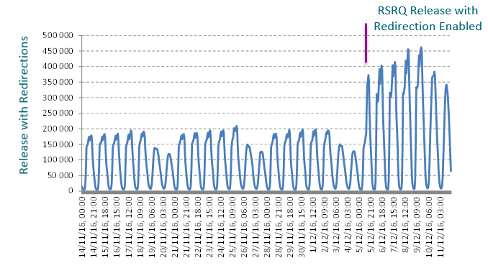
Figure 126: Increase in total number of Release with Redirections after enabling RSRQ mobility
Figure 127 illustrates the corresponding reduction in LTE Drop Ratio. This represents a significant improvement to the performance of the source network layer. The performance of the target network layer should also be checked, and the volume of traffic being offloaded should be quantified to ensure it is not excessive.
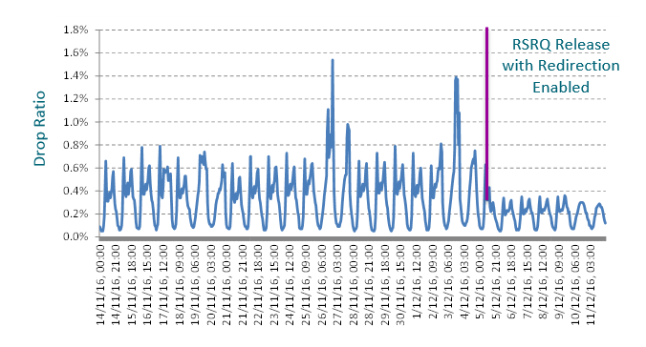
Figure 127: Reduction in Drop Ratio after enabling RSRQ mobility
Figure 128Figure 127 illustrates the corresponding improvement in Accessibility. Similar to the drop ratio, the performance of the target layer should also be checked.
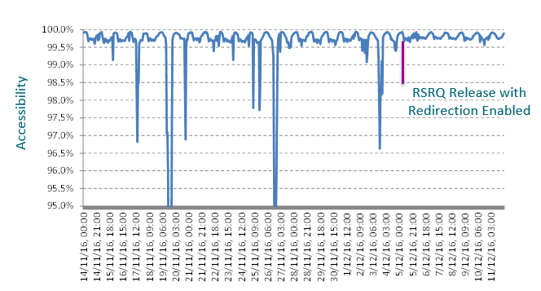
Figure 128: Improvement in Accessibility after enabling RSRQ mobility
Figure 129Figure 127 illustrates example changes to the number of mobile originated signalling attempts after RSRQ Idle Mode parameters have been configured. In this case, L800 is the normal access layer from 3G but after enabling RSRQ mobility (Phase 1), the L1800 layer becomes more attractive so UE start moving from 3G towards L1800 rather than from 3G towards L800 (despite L800 being configured with a higher absolute priority).
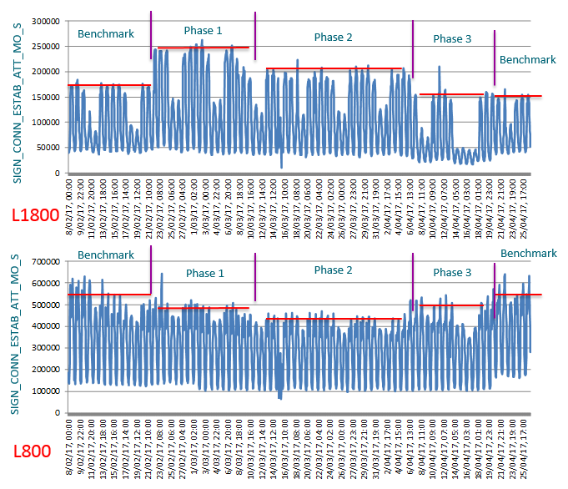
Figure 129: Mobile Originated Signalling Attempts after enabling RSRQ mobility
The hysteresis between 3G and LTE was increased for Phase 2 of the results shown in Figure 129. As expected, this reduces the number of UE moving between network layers. The path from 3G towards L1800 was completely removed for Phase 3 of the trial.

Latency

Introduction
Latency is typically measured using PING which quantifies the round-trip time between the UE and an application server. Latency is important for TCP based applications because it has a direct impact upon the throughput which can be achieved, i.e. high throughputs require low latency. The term latency can also be generalized to include connection setup delays. These delays are particularly important for bursty traffic profiles which have multiple start-up periods.
The initial conditions have a significant impact upon latency. UE in RRC Idle mode experience increased latency because they must establish an RRC connection and complete the security mode procedure prior to transferring any application data. UE in RRC connected mode with proactive scheduling experience reduced latency because uplink and downlink data can be transferred without delay.

Typical Issues
Issues with high latency can result from:
- PING configuration
If the benefit of proactive scheduling is to be demonstrated, then the interval between PING must be less than the proactive scheduling period defined by the ilReacTimerUl parameter. Otherwise, the UE will have to send a Scheduling Request to obtain an uplink resource allocation prior to sending the uplink PING message. The PING payload size will also have some impact upon latency
- Scheduling Request period
UE in RRC connected mode with uplink data to transfer must send a Scheduling Request to obtain an uplink resource allocation (assuming the UE is not already being allocated uplink resources). UE are not able to send a Scheduling Request at any time but must wait for their Scheduling Request subframe which has a period defined by the cellSrPeriod parameter.
- DRX cycle duration
In the case of downlink data transfer, the eNodeB must wait for the UE to be DRX active before transmitting across the air-interface. The wait time will depend upon the DRX cycle duration. Long DRX cycle durations help to reduce UE battery power consumption but increase system latency.

Performance Analysis
Latency is typically measured from the UE using a series of PING. Logging tools can be instructed to generate a series of PING and to record the resultant round-trip times. Alternatively, UE can be connected to a laptop and PING sent using the DOS command prompt.
Studying the various components of latency requires both UE and network logging. At least some information can be extracted from UE logs alone, but a complete picture requires both UE and network logs.
The eNodeB performance measurement database also includes some counters to quantify delay. These counters are shown in Table 153.
Counter Id | Counter Name | Comments
M8001C0 | PDCP_SDU_DELAY_DL_DTCH_MIN | Downlink PDCP SDU retention times within the eNodeB
M8001C1 | PDCP_SDU_DELAY_DL_DTCH_MAX | Downlink PDCP SDU retention times within the eNodeB
M8001C2 | PDCP_SDU_DELAY_DL_DTCH_MEAN | Downlink PDCP SDU retention times within the eNodeB
M8001C3 | PDCP_SDU_DELAY_UL_DTCH_MIN | Uplink PDCP SDU retention times within the eNodeB
M8001C4 | PDCP_SDU_DELAY_UL_DTCH_MAX | Uplink PDCP SDU retention times within the eNodeB
M8001C5 | PDCP_SDU_DELAY_UL_DTCH_MEAN | Uplink PDCP SDU retention times within the eNodeB
Table 153: Counters used to quantify uplink and downlink delays
The downlink counters represent the retention time for a downlink PDCP SDU within the eNodeB. They correspond to a timer which is started when the SDU is received and stopped when the first segment of the PDCP SDU is first transmitted as a transport block. The results from these counters will depend upon whether or not the cell is busy and the associated queuing time before transmission.
The uplink counters represent the retention time for an uplink PDCP SDU within the eNodeB. These counters should have very low values because uplink PDCP SDU should be immediately forwarded across the S1 interface.

Parameter Definition
Proactive scheduling for user plane data is enabled by configuring the ilReacTimerUl parameter shown in Table 154 with a value greater than 0. The value of the timer determines the period during which the UE can be allocated dummy grants to maintain resource allocations in case further uplink data arrives for transmission. The default value shown in Table 154 is applicable from the latest releases. Previously, it had a default value of 5 ms which was a special value to indicate that proactive scheduling should only be applied to the SRB. With the introduction of the actProactSchedBySrb parameterthe special value of 5 ms was no longer required.

Parameter | Object | Range | Default
ilReactimerUl | LNCEL | 0 to 2000 ms | 0 ms
actProactSchedBySrb | LNCEL | False, True | True
Table 154: Parameters used to enable proactive scheduling
When actProactSchedBySrb is set to ‘True’ proactive scheduling is applied for 20 subframes after a downlink SRB transmission. This helps to ensure that the UE has readily available resources to transmit the uplink SRB response.
The primary drawback associated with proactive scheduling is increased levels of uplink intercell interference. This intercell interference can have a negative impact upon uplink throughput performance.
The LTE4066: ‘Low Latency Fast UL Grants’ feature helps to improve the performance of proactive scheduling. It introduces dummy grant skipping for release 14 UE. This means that release 14 UE will not transmit using a dummy grant unless there is actual data to transfer, i.e. UE do not transmit packets of padding. The feature also introduces a TCP Boost capability which means that dummy grants are allocated after receiving some downlink data, until the UE transmits some uplink data. The downlink data is intended to be a downlink TCP packet while the uplink data is intended to be the TCP acknowledgement. The new parameters introduced by LTE4066 are presented in Table 155.
Parameter | Object | Range | Default
actTcpBoost | LNBTS | 0 (false), 1 (true) | 0 (false)
actUlTxSkip | LNBTS | 0 (false), 1 (true) | 0 (false)
maxNumUeProactiveUl | LNCEL | 0 to 20, step 1 | 10
maxNumUeProactiveUlNonTxSkip | LNCEL | 0 to 20, step 1 | 10
ilReacTimerUlTcpBoost | LNBTS | 0 to 2000, step 10 ms | 10
ilMinDatvolUlTcpBoost | LNBTS | 0 to 4000, step 80 bits | 560
ilReacTimerUlTxSkip | LNBTS | 0 to 2000, step 10 ms | 0
ilReacTimerUlTcpBoostTxSkip | LNBTS | 0 to 2000, step 10 ms | 10
ilGrantGapTxSkip | LNBTS | 0 to 2000, step 10 ms | 10
ilGrantGapTcpBoostTxSkip | LNBTS | 0 to 2000, step 10 ms | 10
Table 155: Parameters applicable to Low Latency Fast Uplink Grants
Proactive scheduling can significantly reduce latency by avoiding the requirement to wait for a Scheduling Request subframe and subsequently waiting for an uplink resource allocation. The precise gain depends upon the Scheduling Request period, configured using the cellSrPeriod parameter shown in Table 156. The default value of 20 ms means that on average UE have to wait 10 ms before sending a Scheduling Request and then at least a further 7 ms before being able to transmit on the PUSCH. Larger Scheduling Request periods increase latency when proactive scheduling is not enabled. Smaller Scheduling Request periods increase the PUCCH overhead and reduce PUSCH capacity.
Parameter | Object | Range | Default
cellSrPeriod | MPUCCH | 5, 10, 20, 40, 80 ms | 20 ms
Table 156: Parameter used to configure the Scheduling Request period
DRX cycle durations have an impact upon downlink latency because the eNodeB is only able to transmit downlink data when the UE is DRX active. DRX parameters are extracted from the relevant DRX profile. DRX profile selection is based upon the QCI. There are both long and short DRX cycle durations if Smart DRX is enabled. Otherwise, there is only a long DRX cycle duration. The long and short DRX cycle durations are defined by the parameters shown in Table 157.
Parameter | Object | Range | Default
drxLongCycle | SDRX/DRX | Depends upon DRX profile | Depends upon DRX profile
drxShortCycle | SDRX | Depends upon DRX profile | Depends upon DRX profile
Table 157: Parameters used to configure the DRX cycle durations

Optimization Procedure
The main options for improving latency are presented in Figure 130. All options are associated with a trade-off. Enabling Proactive Scheduling can have a negative impact upon uplink intercell interference and uplink throughput. Reducing the Scheduling Request period increases the PUCCH overhead. Reducing the DRX cycle duration has a negative impact upon UE battery life.
Figure 130: Options for improving latency

Field Results
Latency can be studied at various parts of the network if protocol analysers are available. The eNodeB itself includes a WireShark logging capability so packets can be captured at the transport side of the eNodeB. Figure 131 illustrates an example configuration where logging is completed at the UE, at the transport side of the eNodeB and at the internet side of the Packet Gateway.
Figure 131: Example measurement setup for studying end-to-end latency
Figure 132 illustrates some round-trip time results for the measurement configuration shown in Figure 131. At set of 250 PING were completed from the UE to the application server. The round-trip times measured at the eNodeB and Packet Gateway are relatively small and have little variance. The round-trip times measured at the UE are greater and have increased variance. Testing was completed using a Scheduling Request period of 20 ms so there is an expected variance of +/- 10 ms for the transmission of the PING request. There may also be some variance for the PING response if the UE is in DRX when the PING response arrives at the eNodeB.

Figure 132: PING round trip times measured at various points in the network
The trace shown in Figure 133 presents the layer 1 messages for a 1500B ping transfer, without Proactive Scheduling. In this example, the maximum number of Resource Blocks provided by a Scheduling Request was set to 10. The UE was in RRC connected mode at the start of the ping therefore the eNodeB had information about its radio conditions (although it could have been outdated) and decided to assign it MCS 20. Note: 3GPP TS36.216, MCS20 in case of 10 PRB corresponds to a transport block size of 4584 bits (573 Bytes)
Once the UE gets allocated the SR it sends 533B of the ping followed by a BSR informing the eNodeB it has another 967B of user data to send. After this information is received by the eNodeB the UL scheduler grants extra turns to the UE in order for it to be able to transfer its remaining data. In this example, the first set of resources granted to the UE after the eNodeB received the BSR is enough to send the remaining data in its buffer, i.e.18 Resource Blocks @ MCS20 = 8248bits= 1031B, enough to send the remaining 967B.
Since the UL scheduler is unloaded and the UE has no other data to send, once the information sent by the UE is acknowledged by the eNodeB (approx. 4ms), in order to improve latency, the UL scheduler keeps granting turns to the UE in case the data received by the UE is corrupted. These pre-emptive retransmissions introduce a gain of approx. 8ms which is the RTT for ACK/NACKs.
Once the remaining 967B are received correctly by the eNodeB, the data will be sent to the ping server and the ping echo will be sent in the DL as it can be observed in the trace.
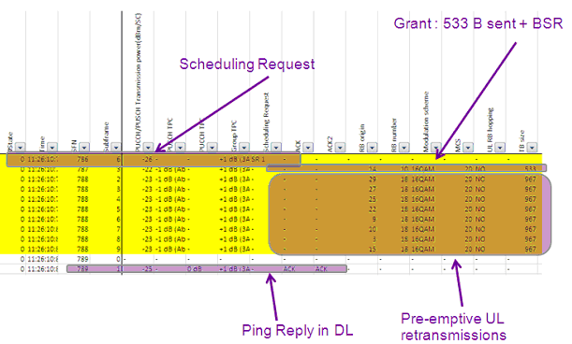
Figure 133: 1500B Ping L1 Trace
Figure 134 illustrates the round-trip time measurements for a range of coverage conditions and PING sizes. Results are also presented for Proactive Scheduling disabled and enabled. Trial results show that for small packets (32Bytes ping size) is possible to observe 10ms RTT in the pre-scheduled resource case with the following parameter settings:
- ilReacTimerUl =1500
- cellSrPeriod = 10ms (note: default is 20ms)
The value allocated to ilReacTimerUl could be reduced if the PING are transmitted at a higher rate, i.e. the period between PING should be less than the value allocated to ilReacTimerUl.
For the non-scheduled resource case, (ilReacTimerUl=0ms, cellSrPeriod=5ms) the 32Bytes RTT increases to 26ms. The longer RTT is expected as the UE has to send the scheduling request (SR) and receive the scheduling grant from the eNodeB before the data can be sent.
The SINR does not have any impact upon the 32Byte RTT in both, pre-scheduled and non-scheduled resource case. The reason is that the minimum UL resource (PRB) assigned by the initial resource request is enough to transmit a small packet like a 32Byte ping packet. The test shows that for larger ping sizes the UE requires more PRBs and higher MCS in order to send the data which triggers the scheduling event increasing the ping times.
RTT also increases when degrading SINR conditions for larger ping sizes in both cases, pre-scheduled and non-scheduled. This may suggest that some HARQ retransmission is required when SINR gets worse due to more PRBs and higher MCS used.
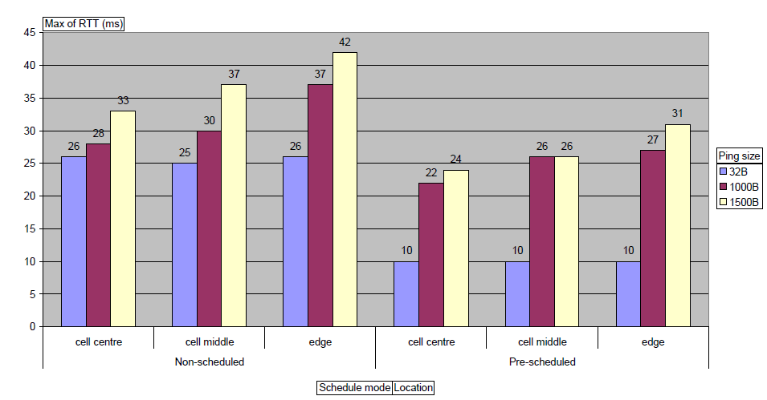
Cell Centre: -60 dBm< RSRP <= -70dBm; 25< SINR<=29 dB
Cell Middle: -75 dBm < RSRP <=-85dBm; 10< SINR<=15 dB
Cell Edge: -90 dBm < RSRP <= -105dBm; 0< SINR <=10 dB
Figure 134: Average Ping RRT (range of sizes and SINR) for non-Proactive Scheduling and Proactive Scheduling cases
In some cases, proactive scheduling can help to improve downlink throughput performance. In the case of applications using TCP, it is important that acknowledgements are returned in the uplink direction with minimum delay. Figure 135 illustrates the benefit of enabling proactive scheduling from the perspective of TCP acknowledgements.
Figure 135: Use of Proactive Scheduling to help improve downlink throughputs by reducing TCP acknowledgment latency
The plot on the left corresponds to having proactive scheduling disabled. In this case, the TCP acknowledgements are buffered until the Scheduling Request period allows uplink resources to be requested. TCP acknowledgements are then transferred in a burst. The plot on the right corresponds to having proactive scheduling enabled. In this case, the TCP acknowledgements can be transferred as soon as they arrive at the lower layers.

Connection Setup Delay

Introduction
Connection setup delay refers to the time required to establish the default data bearer from RRC Idle mode. It is typically assumed that the UE has already attached to the LTE network and has already established its default EPS bearer (default EPS bearer is maintained after the UE moves to RRC Idle mode). The main components of the connection setup delay are:
- Paging (if connection setup is mobile terminated)
- Random Access
- RRC Connection Setup
- Security Mode
- RRC Connection Reconfiguration
The delays associated with each of these components must be minimised to reduce the overall connection setup delay.

Typical Issues
Issues with connection setup delay can result from:
- Relatively long paging DRX cycle
This phase is only applicable if connection setup is mobile terminated. The paging DRX cycle may have been configured with a relatively large value to help conserve UE battery life. The paging DRX cycle can be configured with values of 32, 64, 128 or 256 radio frames. 256 radio frames corresponds to 2.56 seconds, i.e. on average a UE would have to wait 1.28 seconds to receive its paging message. This would have a significant impact upon the overall connection setup delay.
- Multiple PRACH preamble transmissions
If the PRACH preamble power control calculation results in a relatively low power then the UE may have to transmit multiple PRACH preambles before the eNodeB receives a preamble (transmit power ramping applied until the eNodeB acknowledges reception). Each preamble transmission creates additional delay which increases the overall setup time.
- Congestion
PRACH congestion may lead to contention for the selected preamble. This is detected relatively late in the PRACH procedure, and then the UE has to re-start the procedure. RRC connection congestion could result in the RRC Connection Request message being rejected. UE must then apply a back-off timer before re-attempting access.

Performance Analysis
Connection Setup Delay can be measured from a UE log file. For a mobile originating connection, it is quantified as the time difference between the Service Request and the RRC Connection Reconfiguration Complete. For a mobile terminating connection, it is quantified as the time difference between the Paging and the RRC Connection Reconfiguration Complete. The Service Request is a Non-Access Stratum (NAS) message which should appear in the UE log file prior to the RRC Connection Request, i.e. layer 3 of the UE generates this message, which subsequently triggers the PRACH procedure and the transmission of the RRC Connection Request message. The RRC Connection Reconfiguration Complete is the message associated with the reconfiguration which provides the UE with the default data bearer.
Connection Setup Delay can also be measured from the network, e.g. using Cell Trace or a Protocol Analyser on the S1 interface. However, these solutions provide different results because they do not have complete visibility of the procedure, e.g. neither Cell Trace nor a Protocol Analyser on the S1 has visibility of when the UE generated the Service Request and started to transmit PRACH preambles.
eNodeB counters can be used to quantify various components of Connection Setup Delay but counters are not available to quantify the complete delay from start to finish.
Table 158 specifies counters which record the delay between the eNodeB receiving the RRC Connection Request (MSG3) and RRC Connection Setup Complete (MSG5) messages. This delay should be minimized to improve the overall Connection Setup Delay. It should be noted that this KPI excludes the delays associated with MSG1 and MSG2.
Counter Id | Counter Name | Comments
M8008C17 | RRC_CON_STP_TIM_MEAN | RRC Connection Request to RRC Connection Setup Complete
M8008C18 | RRC_CON_STP_TIM_MAX | RRC Connection Request to RRC Connection Setup Complete
Table 158: Counters used to record RRC Connection Setup Time
Table 159 specifies counters which record the delay associated with establishing an E-RAB at an eNodeB. The counters quantify the delay between the eNodeB receiving an S1AP: E-RAB Setup Request / S1AP: Initial Context Setup Request and sending an S1AP: E-RAB Setup Response / S1AP: Initial Context Setup Response.
Counter Id | Counter Name | Comments
M8007C14 | ERAB_SETUP_TIME_MEAN | S1AP: E-RAB Setup Request to S1AP: E-RAB Setup Response
M8007C15 | ERAB_SETUP_TIME_MAX | S1AP: E-RAB Setup Request to S1AP: E-RAB Setup Response
Table 159: Counters used to record E-RAB Setup Time

Parameter Definition
Figure 136 illustrates the signaling flow for connection setup. This example assumes that a UE receives a PING request from elsewhere, i.e. connection setup is mobile terminated.
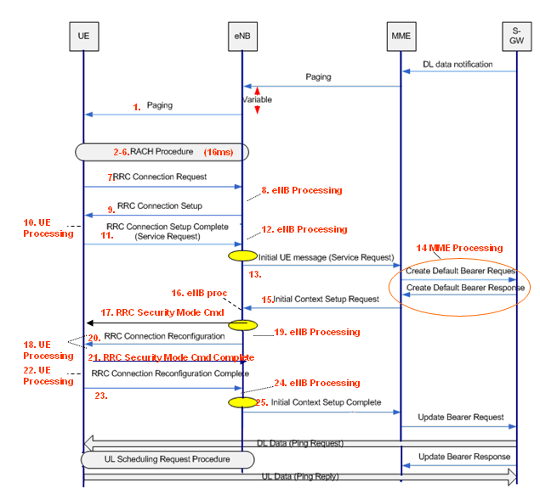
Figure 136: Signalling flow for Connection Setup Delay (mobile terminated)
Mobile terminating connection establishment uses the paging procedure which has a delay dependent upon the paging DRX cycle duration. The defPagCyc parameter shown in Table 160 is used to configure the paging DRX cycle duration. A long cycle duration helps to reduce UE battery power consumption whereas a short cycle reduces average Connection Setup Delay. The default value of 128 radio frames means that the UE checks for paging messages once every 1.28 seconds. This creates an average delay of 640 ms.
Parameter | Object | Range | Default
defPagCyc | LNCEL | 32, 64, 128, 256 radio frames | 128 radio frames
Table 160: Parameter used to configure the default paging DRX cycle duration
After paging (or at the start of connection setup for a mobile originating connection), the UE must transmit one or more PRACH preambles. Preambles can only be transmitted during specific subframes. Thus, there is a delay associated with waiting for a PRACH subframe. The set of PRACH subframes is defined by the prachConfigIndex parameter shown in Table 161. This parameter defines a pointer to a row within a 3GPP specified table (see Table 41 within section 6.2.4). For example, a value of 3 corresponds to 1 PRACH subframe in every 10 ms radio frame so there would be an average wait time of 5 ms.
Parameter | Object | Range | Default
prachConfIndex | LNCEL_FDD | 3 to 24 | Planning parameter
Table 161: Parameter used to configure the set of PRACH subframes
Configuring an increased number of PRACH subframes per radio frame results in both reduced delay and increased PRACH capacity. The increased PRACH capacity can also help to reduce connection establishment delay by reducing the probability of contention and the requirement for repeated PRACH procedures. The drawback is a reduced PUSCH capacity because the PRACH represents an overhead from the perspective of the PUSCH.
PRACH power control parameters are also important to help avoid the delay associated with PRACH transmit power ramping, i.e. delay is minimized if the transmit power of the first preamble is sufficient for successful reception at the eNodeB. The transmit power of the first preamble should not be too large otherwise UE will generate increased uplink interference. The parameters associated with PRACH preamble power control are presented in section 6.7.4.
Once the PRACH preamble has been received then setup delays are minimized if all signaling transactions are reliable and avoid the requirement for re-transmissions. Proactive Scheduling (section 6.14) can help to reduce the latency associated with signaling procedures by ensuring that the UE already has uplink resource allocations when it is necessary to transmit uplink signaling messages. The drawback associated with Proactive Scheduling is increased uplink interference but the impact can be minimized if the feature is enabled only for the SRB, or with a small value assigned to the ilReacTimerUl timer. If Proactive Scheduling is not used then setup delays may be impacted by the cellSrPeriod parameter which determines the rate at which the UE can send Scheduling Requests on the PUCCH. Scheduling Requests are used by the UE to request uplink resource allocations. These will be necessary for the transfer of uplink signaling messages. The drawback associated with configuring a small value for the Scheduling Request period is an increased PUCCH overhead.
Cell load may also have an impact because it will determine if UE are queued by the packet scheduler. However, this impact should be minimal because signaling content is prioritized by the scheduler.
Table 162 presents the expected processing delays associated with each phase of Connection Setup. The numbering within this table corresponds to the numbering within Figure 136. The total expected delay for Connection Setup is 95.5 ms.

Table 162: Processing delays for Connection Setup

Optimization Procedure
With typical connection setup delays of less than 100 ms, the majority of operators are likely to focus their efforts upon other areas of optimisation, e.g. setup success rate or dropped call rate. If it is necessary to optimise Connection Setup Delay then the main considerations are illustrated in Figure 137.
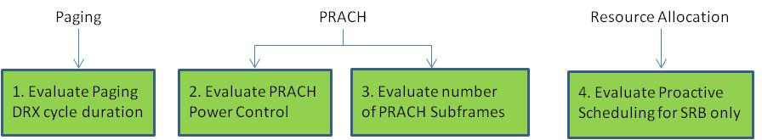
Figure 137: Considerations for improving Connection Setup Delay
A shorter paging DRX cycle duration will reduce delays at the cost of increased UE battery power consumption. Higher initial PRACH preamble transmit power will reduce the requirement for power ramping and multiple preamble transmissions but may increase uplink interference. Increased PRACH subframes will reduce delay and increase PRACH capacity but will reduce the number of Resource Blocks available to the PUSCH. Proactive Scheduling for signaling procedures will help to reduce delay with minimal impact upon uplink interference levels.

Field Results
Figure 138 illustrates an example extract from a UE logging tool which can be used to quantify mobile originating Connection Setup Delay. In practice, the delay should be averaged across a large number of samples.
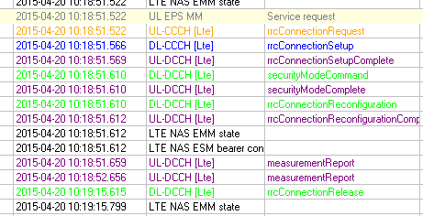
Figure 138: Example Connection Setup Delay
In this example, the Setup Delay is given by 51.612 – 51.522 = 90 ms. This result is aligned with the expectation presented in Table 162.

Inactivity Timer

Introduction
The RRC inactivity timer determines the duration that a connection remains in RRC connected mode after application data has been transferred. The duration of the inactivity timer has an impact upon:
- Cell Load
- Signalling Load
- Latency
- Drop Connection Ratio
Long inactivity timers increase cell load because connections are held in RRC Connected mode for longer, i.e. the average number of RRC connections in a cell increases. The maximum number of RRC Connections supported by a cell represents one of the main capacity bottlenecks. Inactivity timers are often reduced at special events to reduce the probability of loading the cell to its maximum capability.
Short inactivity timers increase signalling load because connections make more frequent transitions between RRC Idle and Connected modes. The signalling load can impact the core network more than the RAN if the inactivity timer is reduced across a large number of eNodeB. Reducing the inactivity timer at a small number of eNodeB will have minimal impact upon core network signalling load.
Long inactivity timers tend to reduce latency because there is an increased probability of the UE being in connected mode when it becomes necessary to transfer application data, i.e. the delay associated with RRC connection setup is avoided.
Short inactivity timers tend to reduce the drop connection ratio because UE spend less time in RRC Connected mode so have a lower probability of dropping. The dropped connections which are avoided by reducing the inactivity timer are generally those which are not noticed by the end user because the connection is inactive at the time of the drop. KPI in the form of ‘minutes per drop’ are not affected because both the minutes and the drops decrease when reducing the inactivity timer.
The RRC inactivity timer can be configured with a low value at special events where traffic volumes are particularly high. For example, the wide area network could be configured with a 10 second inactivity timer, while special event sites could be configured with a 5 second inactivity timer. At high load scenarios, the benefit of a reduced RRC connection load outweighs any of the drawbacks.

Typical Issues
Issues associated with the RRC inactivity timer may include:
- Admission Control blocking due to number of RRC Connections
Long inactivity timers increase the cell load in terms of the number of RRC connections. Cells have a limited capability in terms of the number of supported RRC connections. This means that long inactivity timers can lead to admission control blocking during either RRC connection setup or during incoming handovers.
- Ping-Pong between RRC Idle and Connected modes
Short inactivity timers increase the probability of releasing a connection to RRC Idle mode before the end-user has finished an ongoing data session, e.g. while browsing the internet. This means that a new RRC connection must be setup when the next burst of application data needs to be transferred. This ping-pong generates additional signaling load as well as increased latency.

Performance Analysis
The impact of the RRC inactivity timer upon RRC connection load can be quantified using the counters shown in Table 163. Decreasing the inactivity timer should decrease the results from both of these counters. The results from these counters can also be compared against the maximum capability of the cell.
Counter Id | Counter Name | Comments
M8051C55 | RRC_CONNECTED_UE_AVG | Average and maximum number of RRC connections loading a cell
M8051C56 | RRC_CONNECTED_UE_MAX | Average and maximum number of RRC connections loading a cell
Table 163: Counters used to record RRC connection load
The impact of the RRC inactivity timer upon ping-pong between RRC Connected and Idle modes can be quantified using any of the state transition counters. For example, the counter which records the number of RRC Connection Setup Complete messages can be studied. This counter is shown in Table 164.
Counter Id | Counter Name | Comments
M8007C14 | SIGN_CONN_ESTAB_COMP | Number of RRC Connection Setup Complete messages
Table 164: Counter used to record the number of RRC Connection Setup messages
The LTE_5119g KPI can be used to study the impact upon the Drop Ratio. There are different versions of this KPI depending upon the software being used. The LTE19B version of the KPI is shown below:

E-UTRAN E-RAB Drop Ratio (LTE_5119g) =
100 * (ERAB_REL_HO_PART + ERAB_REL_ENB - ERAB_REL_ENB_RNL_INA - ERAB_REL_ENB_RNL_RED + EPC_EPS_BEARER_REL_REQ_RNL + EPC_EPS_BEARER_REL_REQ_OTH + ERAB_REL_EPC_PATH_SWITCH - ERAB_REL_TEMP_QCI1 - ERAB_REL_DOUBLE_S1 + ERAB_REL_ENB_INI_S1_GLOB_RESET + ERAB_REL_MME_INI_S1_GLOB_RESET + ERAB_REL_ENB_INI_S1_PART_RESET + ERAB_REL_MME_INI_S1_PART_RESET + ERAB_REL_S1_OUTAGE)
/
(ERAB_REL_ENB + ERAB_REL_HO_PART + EPC_EPS_BEARER_REL_REQ_NORM + EPC_EPS_BEARER_REL_REQ_DETACH + EPC_EPS_BEARER_REL_REQ_RNL + EPC_EPS_BEARER_REL_REQ_OTH + ERAB_REL_EPC_PATH_SWITCH
- ERAB_REL_TEMP_QCI1 + ERAB_REL_SUCC_HO_UTRAN + ERAB_REL_SUCC_HO_GERAN + ERAB_REL_ENB_INI_S1_GLOB_RESET + ERAB_REL_MME_INI_S1_GLOB_RESET + ERAB_REL_ENB_INI_S1_PART_RESET + ERAB_REL_MME_INI_S1_PART_RESET + ERAB_REL_S1_OUTAGE
)

Parameter Definition
The RRC inactivity timer is configured using the inactivityTimer parameter shown in Table 165. This parameter has a default value of 30 seconds although it is common to use a reduced value of 10 seconds. The minimum value of the inactivity timer is 1 seconds.
Parameter | Object | Range | Default
inactivityTimer | LNCEL | 1 to 65535 s, step 1 s | 30 secs
Table 165: Parameter used to configure the RRC inactivity timer

Optimization Procedure
The optimization process is relatively straightforward, i.e. the inactivity timer is reconfigured and the impact upon the cell load, signalling load and drop ratio is studied. This general process is illustrated in Figure 139.
Figure 139: High level procedure for reducing the RRC inactivity timer

Field Results
Figure 140 illustrates the impact upon RRC connection load when reducing the RRC inactivity timer from 10 seconds to 5 seconds. In this case, the average number of RRC connections reduces from approximately 24 to approximately 18. This represents a 25 % reduction.
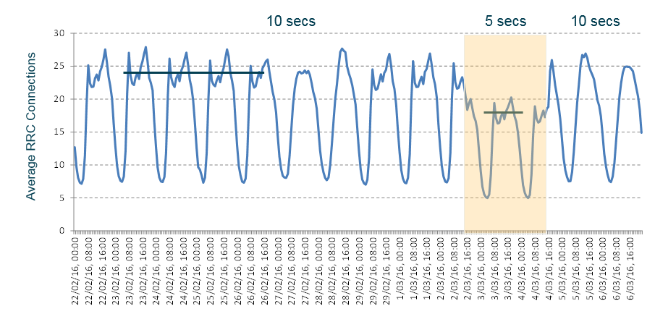
Figure 140: Impact of RRC inactivity timer upon RRC connection load
Figure 141 illustrates the impact upon the number of RRC connection setups when reducing the RRC inactivity timer from 10 seconds to 5 seconds. This represents the quantity of Ping-Pong between RRC Idle and Connected modes. There is an increase in connection setups of approximately 33 % when reducing the inactivity timer to 5 seconds. This indicates an increased signalling load.
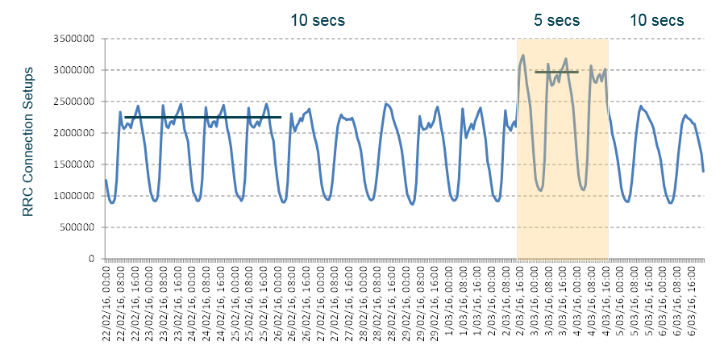
Figure 141: Impact of RRC inactivity timer upon number of RRC connection Setups
The increased signaling load can also be monitored from the MME. Figure 142 illustrates the impact upon the number of Service Request messages received by the MME when decreasing the inactivity timer from 10 seconds to 5 seconds. The number of messages received by the MME increases by approximately 33 %. This result was obtained by changing the inactivity timer for all cells connected to the MME. The impact would be less if the inactivity timer was changed for only a subset of cells.
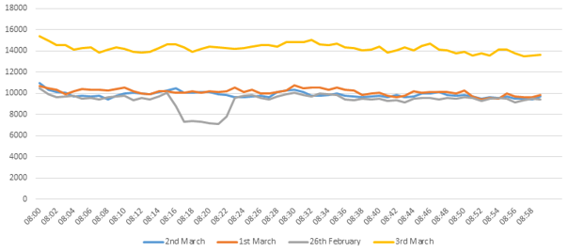
10 second RRC inactivity
5 second RRC inactivity
Figure 142: Impact of RRC inactivity timer upon MME Signalling
Figure 143 illustrates the impact upon connection drop ratio when the RRC inactivity timer is reduced from 10 seconds to 5 seconds. In this case, the drop ratio is reduced by approximately 50 %. However it should be recognized that the drops which are avoided are most likely to be those which are not noticed by the end-user, i.e. drops during periods of inactivity.
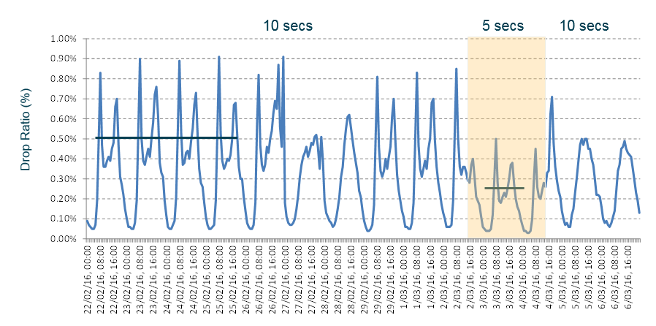
Figure 143: Impact of RRC inactivity timer upon Drop Ratio

CS Fallback

Introduction
CS Fallback provides a solution for circuit switched voices services when UE are connected to the LTE network. The solution involves moving the UE across to a network which supports circuit switched voice. CS Fallback can manage both mobile originated and mobile terminated connections. Variants of CS Fallback are illustrated in Figure 144.
Figure 144: Signalling flow for Connection Setup Delay (mobile terminated)
The simplest solution is the Release with Redirection. In this case, the eNodeB redirects the UE towards a target RF carrier defined by a REDRT parameter object. This solution does not require the definition of neighbour cells.
3G system information can be included within the RRC Release message but currently this system information is not automatically populated by the 3G network. RAN Information Management (RIM) provides a solution for an RNC to signal its System Information content to an eNodeB. Tools are available to generate the ASN encoded 3G system information, so it can be inserted within the eNodeB databuild. Scripting is required to generate cell specific versions which can be applied across the network. The benefit of including 3G system information is a reduced connection establishment delay. It avoids the UE having to acquire the 3G system information prior to sending its RRC Connection Request to the RNC.
Similarly, 2G System Information can be included within the RRC Release message. RAN Information Management (RIM) between the eNodeB and BSC has been supported since early releases.
Measurement based Redirection involves the UE completing measurements from the target layer prior to receiving the redirection command. This helps to improve reliability in terms of ensuring that the target layer has coverage. This solution requires the definition of 3G neighbours. These 3G neighbours can be automatically populated using UE based ANR.
The inter-system handover variant moves the UE directly into CELL_DCH on the 3G network. This solution also requires the definition of 3G neighbours and inter-system measurements prior to leaving the LTE network. The benefit of using an inter-system handover is a reduced connection establishment delay, i.e. it removes the requirement for RRC connection establishment on the 3G network.
In addition, CS Fallback may involve a change in the registered Location Area. A change in Location Area triggers the UE to complete a Location Area Update procedure before establishing its speech call connection. This increases call setup delay. A change in registered Location Area depends upon the TAC/LAC mapping within the MME. If the TAC/LAC mapping provides a LAC which corresponds to the actual LAC on the 2G/3G network, then the registered Location Area will not change.

Typical Issues
Issues with CS Fallback can be linked to:
- No coverage on target layer
If CS Fallback is completed without measurements, then it is possible that the blind redirection moves the UE to a layer without coverage. The impact of redirecting towards a layer without coverage is scenario dependent. For example, if the UE is redirected towards UMTS900 but there is only UMTS2100 coverage then the impact is small, and the UE selects the UMTS2100 layer with minimal delay. However, if the UE is redirected towards UMTS900 but there is only GSM coverage then the impact is more significant because it takes longer for the UE to move across to the GSM layer.
- Weak coverage on target layer
If CS Fallback is completed without measurements, then it is possible that the blind redirection moves the UE to a weak coverage layer while there are stronger coverage layers available. Redirecting towards a weak coverage layer increases the probability of connection setup failures and connection drops on the target layer.

- Increased Call Setup Delays
Call setup delays are increased with CS Fallback because the UE first has to make the transition from 4G before call setup can begin on 3G or 2G. The call setup delay is dependent upon the scenario but is influenced by: whether or not measurements are completed prior to the transition to 3G or 2G; whether or not system information is included within the release with redirection message; whether an inter-system handover is completed rather than a release with redirection; whether or not a location area update has to be completed on the target system before call setup can begin.

Performance Analysis
Call setup delay is an important metric for CS Fallback. It requires UE logging to capture the complete signalling procedure. It is typically measured from the Extended Service Request message on 4G to the Alerting message on 3G or 2G.
Call Setup Success Rate is another important metric for CS Fallback and is also difficult to measure without UE logging. It is difficult because call setup starts on the 4G network but the 4G network has no knowledge of whether or not the call setup completes successfully on the 3G or 2G network. Core network counters can be used to quantify success rates for mobile terminated connections. Mobile originated connections appear as normal calls starting on the 3G and 2G networks so cannot be separated from all other mobile originated calls.
The eNodeB counter database includes the counters shown in Table 166 The primary use of these counters is to record the number of CS Fallback attempts. There are a number of success counters which can help to quantify the success rate of the 4G part of the overall procedure.
Counter Id | Counter Name | Comments
M8013C46 | UE_CTX_SETUP_ATT_CSFB | Initial context setup for CSFB
M8013C48 | UE_CTX_SETUP_SUCC_CSFB | Initial context setup successes for CSFB
M8013C51 | UE_CTX_MOD_ATT_CSFB | Initial context modif. attempts for CSFB
M8013C53 | UE_CTX_MOD_SUCC_CSFB | Initial context modif. successes for CSFB
M8016C11 | CSFB_REDIR_CR_ATT | CSFB attempts with RRC Conn. Release (total and RRC Connected only)
M8016C12 | CSFB_REDIR_CR_CMODE_ATT
M8016C13 | CSFB_REDIR_CR_EMERGENCY_ATT | CSFB attempts with RRC Release (emerg)
M8016C32 | CSFB_PSHO_UTRAN_ATT | CSFB attempts with PS ISHO
Table 166: Counters associated with CS Fallback

Parameter Definition
CS Fallback with Redirection is enabled using the actCSFBRedir parameter shown in Table 167.
Parameter | Object | Range | Default
actCSFBRedir | LNBTS | Disabled (0), Enabled (1) | Disabled (0)
actEmerCallRedir | LNBTS | Disabled (0), Enabled (1) | Disabled (0)
csFallBPrio | REDRT | 1 to 6, step 1 | -
emerCallPrio | REDRT | 1 to 6, step 1 | -
Table 167: Parameter used to enable CS Fallback with Redirection
The target layer for redirection is identified using the csFallBPrio parameter from within the REDRT object. Each REDRT object specifies a target network layer and the csFallBPrio parameter prioritizes that network layer for CS Fallback. Similarly, the emerCallPrio parameter determines the target layer for emergency CS Fallback calls.
The inclusion of 3G System Information requires the systemInformationListWCDMA parameter structure to be populated. System information can be populated for up to 16 3G cells. The UE is provided with the scrambling code and the ASN encoded system information
Parameter | Object | Range | Default
systemInformationListWCDMA - sysInfo | LNBTS | Not defined | -
systemInformationListWCDMA - physCellId | LNBTS | 0 to 511 | -
Table 168: Parameters used to specify 3G system information within the 4G databuild
Similarly, GSM System Information can be included using the LNADJG parameter, systemInfoListGeran. In the case of GSM, system information is configured at a neighbor level rather than at a eNodeB level.
CS Fallback with measurement based redirection and CS Fallback with inter-system handover can be enabled using the parameters shown in Table 169. Both of these capabilities require 3G neighbors to be defined within the databuild. In addition, one or more LNHOW objects must be created. 3G neighbors can be generated automatically using UE based ANR.
Parameter | Object | Range | Default
actHOtoWcdma | LNBTS | False (0), True (1) | False (0)
actCsfbPsHoToUtra | LNBTS | False (0), True (1) | False (0)
preventPsHOtoWcdma | LNBTS | None (0), NonVoiceOnly (1), All (2) | None (0)
csfbPsHoAllowed | LNRELW | Allowed (0), Forbidden (1) | Forbidden (1)
psHoAllowed | LNRELW | Allowed (0), Forbidden (1) | Allowed (0)
Table 169: Parameters used to enable CS Fallback with measurement based redirection and CS Fallback with inter-system handover
Table 170 provides example parameter configurations for CS Fallback with Measurement based Redirection and CS Fallback with inter-system handover.
Parameter | CS Fallback with Measurement based Redirection | CS Fallback with Inter-System Handover
actHOtoWcdma | True (1) | True (1)
actCsfbPsHoToUtra | True (1) | True (1)
preventPsHOtoWcdma | NonVoiceOnly (1) | NonVoiceOnly (1)
csfbPsHoAllowed | Allowed (0) | Allowed (0)
psHoAllowed | Forbidden (1) | Allowed (0)
Table 170: Parameters used to enable CS Fallback with measurement based redirection and CS Fallback with inter-system handover

Optimization Procedure
Figure 145 illustrates a set of options for reducing call setup delay and improving reliability for CS Fallback.
Figure 145: Options for reducing call setup delay and improving reliability for CS Fallback
The LAC/TAC mapping within the MME can have a significant impact upon call setup delay. If the UE is not registered with the correct LAC when connected to the 4G network, the UE will have to complete a Location Area Update procedure on 2G/3G prior to starting call setup. This Location Area update is likely to increase call setup delay by ~ 1 second.
The inclusion of system information within the RRC Release message can potentially reduce call setup delay by ~800 ms. UE based upon Qualcomm chipsets may include SIB skipping capabilities which allow the UE to remember SIB from previously visited cells. Thus, if the UE has already visited a specific 3G target cell, the UE may not have to re-read the SIB prior to establishing an RRC connection. The inclusion of system information is made more practical with RAN Information Management (RIM) features available for 2G and 3G.
Enabling Deferred Measurement Control Reading (DMCR) on the 3G network can also help to reduce call setup delays. This feature informs the UE that it can enter RRC Connected mode without having to read SIB11/12. These SIB are typically relatively large and are broadcast in multiple segments. Avoiding the requirement to read them means that UE do not have to wait in RRC Idle mode for so long. The flag used to indicate that DMCR is enabled is broadcast within 3G SIB 3.
The 4G paging DRX cycle duration will have an impact upon mobile terminated call setup delays. A short cycle will reduce delays but will also have a negative impact upon UE battery life because UE will wake-up to listen for paging messages more frequently.
The reliability of CS Fallback can be improved by instructing the UE to complete measurements prior to making the transition to the target 2G or 3G layer. These measurements are likely to increase the call setup delay. Measurements can be included as part of the Release with Redirect or Inter-System Handover procedures. Both cases require the creation of 2G/3G neighbours. UE based ANR for 3G neighbours feature helps to automate the planning procedure. The eNodeB will redirect/instruct handover towards the first layer reported by the UE. This layer may not be the best layer (depends upon the order in which the UE sends its measurement reports). Coverage thresholds should be used to exclude layers with weak coverage. This forces the eNodeB to wait for the UE to report a layer which has relatively good coverage.

Field Results
Figure 146 illustrates some example average call setup delays for CS Fallback towards 3G. Examples are included for Release with Redirection (without the inclusion of 3G system information but with correct LAC/TAC mapping in the MME); Measurement based Redirection and Inter-System Handover.
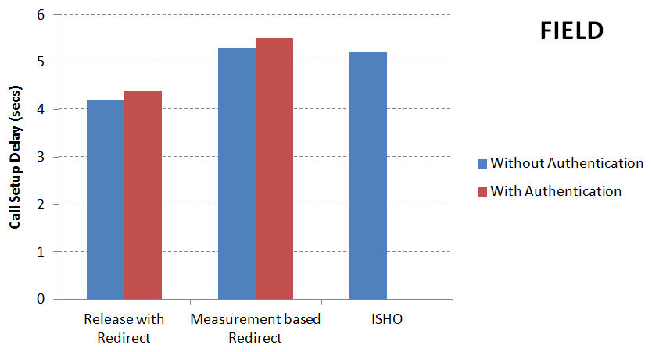
Figure 146: Call setup delays for CS Fallback towards 3G
The general trend is that call setup delay increases when measurements are completed prior to the transition to 3G. Figure 147 illustrates the time spent on 4G for each scenario. These results illustrate that measurements increase the setup delay by ~ 1 second. Lab testing showed an increase of only 0.5 second for the measurements, indicating that measurements consume more time when completed in the field environment. The Inter-System Handover scenario spends the greatest time on 4G because the eNodeB has to complete handover preparation with the RNC prior to sending the handover command to the UE.
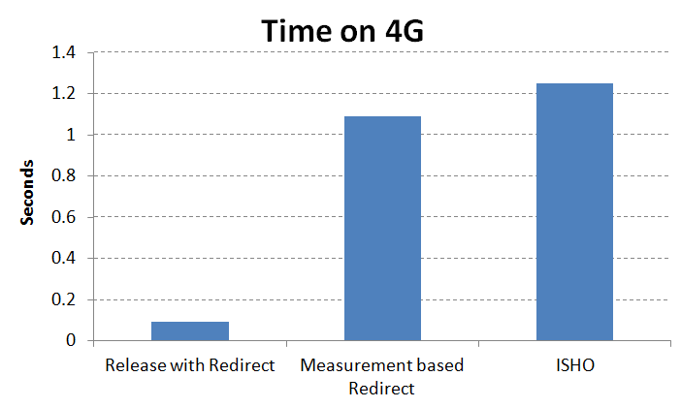
Figure 147: Time spent on 4G when completing CS Fallback towards 3G
Figure 148 illustrates the time spent on 3G during call setup for each scenario.
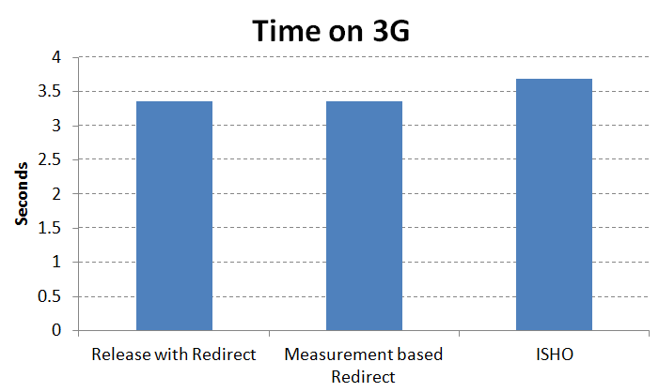
Figure 148: Time spent on 3G during call setup when completing CS Fallback towards 3G
It is generally expected that the time spent on 3G should be lower for the Inter-System Handover scenario. This is because the UE avoids RRC Idle mode on 3G and also avoids the RRC connection establishment procedure. However, when completing CS Fallback with Inter-System Handover, the UE completes some additional signalling procedures on 3G prior to sending the CM Service Request message, e.g. the UE completes the UE Capability Information procedure. These additional procedures increase the call setup delay for the Inter-System Handover scenario.
Figure 149 illustrates the time spend in 3G RRC Idle mode for each scenario. The UE spends ~800 ms in RRC Idle mode for the Release with Redirect and Measurement based Redirect scenarios.
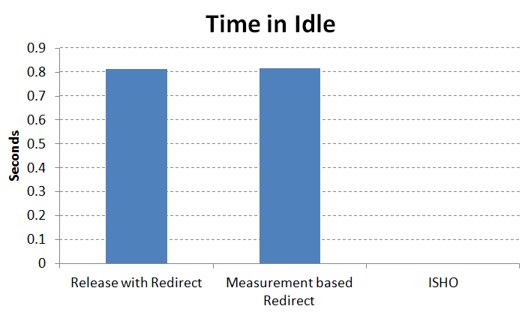
Figure 149: Time spend in 3G RRC Idle mode when completing CS Fallback towards 3G

VoLTE

Introduction
VoLTE provides support for packet switched voice services across the LTE network. The performance of VoLTE is typically compared against the performance of voice services on GSM and UMTS. This means there is a requirement for VoLTE performance to either equal or exceed the speech call performance on GSM and UMTS.
The primary performance metrics are call setup success rate and call drop ratio, i.e. accessibility and retainability. There is also likely to be some focus on call setup delays and voice quality. These metrics are often quantified from UE log files. Quantifying performance from network statistics has the benefit of targeting real end-users at real locations (rather than a drive test team quantifying only vehicular performance). The drawback of network statistics is that some metrics are not readily available, e.g. voice quality and call setup delays. The accessibility calculation is also an approximation to some extent, e.g. it may not include RRC connection establishment, or it may not capture drops between RRC connection establishment and E-RAB setup.
VoLTE optimisation should start with an evaluation of the existing strategy, design and implementation. A typical set of topics to be evaluated is shown in Figure 150. The strategy should be reviewed to gain an understanding of the basis upon which the design has been developed, and to identify any areas which may benefit from being changed.

Figure 150: General radio network activities required for VoLTE deployment

The set of features associated with VoLTE is relatively large. There is a subset of features which are directly associated with VoLTE. For example, Robust Header Compression is directly applicable to VoLTE connections. There is another subset of features which are indirectly associated with VoLTE, e.g. UE based ANR for 3G neighbours is useful when using SRVCC towards UMTS.
The set of features directly associated with VoLTE is shown in Table 171. The majority of features are optional although some are strongly recommended.
Id | Name | Software Release | Requirement
LTE10 | EPS Bearer for Conversational Voice | RL20 | Mandatory
LTE7 | Support of Multiple EPS Bearers | RL20 | Mandatory
LTE11 | Robust Header Compression | RL20 | Strongly Recommended
LTE572 | IMS Emergency Session | RL30 | Optional
LTE571 | Controlled Uplink Packet Segmentation | RL30 | Recommended
LTE42 | DRX in RRC Connected Mode | RL30 | Recommended
LTE872 | SRVCC to WCDMA | RL40 | Strongly Recommended to have at least one enabled
LTE873 | SRVCC to GSM | RL40 | Strongly Recommended to have at least one enabled
LTE534 | ARP based Admission Control for E-RAB | RL40 | Optional
LTE497 | Smart Admission Control | RL40 | Optional
LTE907 | TTI Bundling | RL50 | Recommended
LTE1198 | RSRQ Triggered Mobility | RL60 | Optional
LTE1406 | Extended VoLTE Talk Time | RL70 | Optional
LTE1127 | Service based Mobility Trigger | RL70 | Optional
LTE1617 | RLF Triggered Handover | RL70 | Strongly Recommended
LTE2112 | Dedicated Mobility Thresholds for SRVCC | RL70 | Optional
LTE1321 | E-RAB Modification - GBR | FL15A | Recommended
LTE2430 | QCI1 Establishment Triggered Protection Timer | FL15A | Recommended
LTE64 | Service based Handover Thresholds* | FL15A | Recommended
LTE1942 | Dedicated VoLTE Inter-Frequency Target Frequency List | FL15A | Optional
LTE1569 | QCI 1 specific RLF and Re-establishment Control | FL16 | Optional
LTE2098 | VoLTE UL Coverage Boosting | FL16 | Recommended
LTE2162 | SRVCC for Network Deployments Not Supporting PSHO | FL16 | Optional
- | Disabling VoLTE DRX in Poor Coverage (actQci1RfDrx) | FL16 | Recommended
LTE2832 | SRVCC due to Admission Control Rejection | FL16A | Optional
LTE3290 | SRVCC Trigger Enhancement | FL17A | Optional
LTE2572 | RSRQ based B2 | FL17A | Optional
LTE3303 | Enhanced VoLTE, CA and RF Quality Monitoring | FL17A | Optional
LTE3443 | VoLTE Triggered SRVCC to GSM | FL18 | Optional
LTE3127 | SRVCC to GSM Measurement Optimisation | FL18 | Optional
LTE3692 | VoLTE Robustness Enhancements | FL18 | Optional
LTE3723 | VoLTE Quality Triggered Inter-Frequency Mobility | FL18A | Optional
LTE2774 | Source rate based UL grant assignment for VoLTE | LTE18A | Optional
LTE4244 | VoLTE coverage extension by codec rate adaptation | LTE19 | Optional
* includes the ability to disable RRC Connection Release with Redirection for VoLTE calls
Table 171: Features directly associated with VoLTE
Each of these features has its own set of parameters which must be configured during the design process. Many parameters will require subsequent optimisation once VoLTE traffic has increased and network statistics are able to identify areas for improvement.
VoLTE capacity should be studied to gain an understanding of the impact upon network load and to identify the bottlenecks which are most likely to cause either hard blocking or increased delay. The impact of VoLTE services upon data services should also be considered because VoLTE resource allocations will have higher priority than data service resource allocations.

Typical Issues
Typical issues associated with VoLTE are:
- Enabling VoLTE increases the LTE Drop Ratio
The LTE connection drop ratio is likely to increase when VoLTE is enabled because the average connection holding time will increase. The impact may be small and may not be visible if the number of VoLTE users is low. Data users have a relatively low probability of dropping because their connections tend to be short. This is especially true for smart phones which generate large numbers of small data transfers. VoLTE connections have longer holding times so have an increased probability of dropping. Performance can be normalised against the holding time by generating a KPI in the form of ‘minutes per drop’. Otherwise, the VoLTE and data connection drop ratios should be studied separately, and the VoLTE drop ratio compared against the equivalent performance on the GSM and UMTS networks.
- Pre-Alerting & Alerting Phase SRVCC not supported/enabled in the Core Network
Alerting Phase SRVCC is an optional feature in the core network (depending upon the core network vendor there may be two features: pre-Alerting Phase SRVCC and Alerting Phase SRVCC). If this feature is not enabled, connection establishments will fail when SRVCC is triggered during the call setup procedure, i.e. before the terminating phone has been answered by the end-user. The impact can be alleviated by triggering SRVCC relatively late. This reduces the probability of triggering SRVCC so reduces the probability of requiring Alerting Phase SRVCC. However, triggering SRVCC relatively late also increases the probability of dropping connections due to poor coverage. Ultimately, there is a strong requirement to have Alerting Phase SRVCC enabled in the core network.

- Call Setup Failures due to ongoing Handover Procedure
VoLTE call setup success ratio may be degraded due to ongoing handover procedures. If a handover becomes necessary during E-RAB Setup, the eNodeB may interrupt the ongoing E-RAB Setup procedure and send the E-RAB SETUP RESPONSE message in which the eNodeB shall indicate an appropriate cause value, e.g.,” S1 intra system Handover triggered”, “S1 inter system Handover triggered” or “X2 Handover triggered”. Therefore, the MME needs to resend the E-RAB SETUP REQUEST when it receives the Path Switch Request after the failed E-RAB setup (same for E-RAB release or modify procedure) – feature implemented in Nokia MME. In case the SGW is changed due to the HO then the MME should send the CREATE BEARER RESPONSE message to the SGW indicating rejected E-RAB with cause 110 “Temporarily rejected due to handover/TAU/RAU procedure in progress“and PGW should re-initiate rejected EPS bearer procedure after HO is completed – feature implemented Nokia PGW.
- Release with Redirection causing Dropped Calls
SRVCC should be triggered prior to RRC Connection Release with Redirection. If the triggering thresholds are too close then Release with Redirection can be triggered before the SRVCC procedure has completed. This generates a dropped connection from the perspective of the VoLTE user (although some VoLTE Drop Call KPI do not include Release with Redirections as drops). LTE64 Service based Handover Thresholds feature allows RRC Connection Release with Redirection to be disabled for VoLTE connections. Otherwise, a reasonable margin should be allowed between the SRVCC and Release with Redirection triggering thresholds.
- Releases due to Inactivity during Ringing causing Setup Failures
If a terminating phone is not answered while ringing then it can fall to RRC Idle mode. Likewise, the originating phone can fall to RRC Idle mode while the terminating phone is ringing. This transition to Idle mode can generate call setup failures. For example, if Idle Mode Load Balancing is enabled then UMTS could be allocated a high cell reselection priority causing the UE to move to UMTS Idle mode during call setup – resulting in a setup failure. There is a solution for this issue with the LTE2430 QCI1 Establishment Triggered Protection Timer feature.
- IP Counters generate unexpected results
Throughput results based upon the counters IP_TPUT_VOL_DL_QCI_1 and IP_TPUT_VOL_UL_QCI_1 can generate unexpected results due to the way in which the counters are specified to increment. These counters are more applicable to bearers used for data services rather than voice. They are not incremented for subframes that empty the buffer. In the case of the voice service, packets are relatively small and the buffer can be emptied during most subframes. This means the counters are only incremented from time-to-time and the results can appear quite spurious.

- Reduction in Cell Throughput Metric
Enabling VoLTE on moderate to low loaded cells may lead to a reduced result from the Cell Throughput metric. This is not an indication of reduced Cell Capacity. Cell Throughput is defined as data volume divided by active subframes. The introduction of VoLTE can increase the number of active subframes by X % and increase the data volume but Y %. The value of X may be greater than the value of Y because VoLTE transfers small but frequent packets. This can also be viewed as a reduction in average Cell Throughput because VoLTE introduces low throughput connections which tend to decrease the average.
- KPI definitions
KPI definitions are evolving and improving with each software release. This can create complications because KPI definitions for earlier software releases may not be ideal, and step changes in performance may be observed when upgrading between software releases. An example of this occurs with LTE_5572 E-UTRAN E-RAB QCI1 Drop Ratio, RAN View. This KPI had version ‘a’ for software releases up to RL70, version ‘b’ for FL15A, version ‘c’ for FL16, version ‘d’ for FL16A and version ‘f’ since FL17A. So in this example, the KPI definition is changed with each software release which may cause step changes in performance and may raise questions regarding its accuracy.

Performance Analysis
VoLTE performance can be quantified using data from drive testing and network statistics. Drive testing captures the end-user perspective which isn’t always possible to quantify from network statistics, e.g. the time-stamps for call setup delay must come from a UE log file when quantifying the end-user perspective. Table 172 provides a list of typical metrics.
Metric | Source
Call Setup Delay | UE log file
Voice Quality | UE log file
Call Setup Success Ratio | UE log file
QCI 1 E-RAB Setup Success Ratio | Network statistics
VoLTE Total Traffic (Erlangs) | Network statistics
Average Voice Call Duration | Network statistics
QCI 1 E-RAB Drop Ratio, RAN View | Network statistics
QCI 1 E-RAB Drop Ratio, End-User View | Network statistics
QCI 1 E-RAB Normal Release Ratio, End-User View | Network statistics
ISHO with SRVCC to 3G Attempts | Network statistics
ISHO with SRVCC to 2G Attempts | Network statistics
ISHO with SRVCC to 3G Success Ratio | Network statistics
ISHO with SRVCC to 2G Success Ratio | Network statistics
Table 172: Metrics used to quantify VoLTE performance
Improvements in call setup delay are one of the key differentiators for VoLTE. Obtaining an accurate result requires these delays to be measured from UE log files. The reference points used to measure the delay depend upon whether the call is initiated from RRC Idle mode or RRC Connected mode:
- delays can be measured from NAS: SERVICE REQUEST to SIP: RINGING when the call is initiated while the UE is in RRC Idle mode
- delays can be measured from SIP: INVITE to SIP: RINGING when the call is initiated while the UE is in RRC Idle mode
UE log files can also be used to quantify voice quality if the logging tool offers a MOS measurement capability.
It can also be useful to measure the call setup success ratio from drive testing. UE log files are able to capture failures which are not visible to the network, e.g. if the eNodeB fails to receive the PRACH preambles then it will not record a failure, whereas a UE log file will record a failure. UE log files also allow SIP signalling messages to be used as reference points for call setup attempts and successes whereas the eNodeB does not have visibility of specific SIP messages. The drawbacks of quantifying call setup success rates from drive testing is that the sample size may be limited, the UE geographic location may not be representative of many end-users and the exercise is relatively expensive.
The E-RAB Setup Success Ratio for QCI 1 bearers is quantified using the LTE_5204d KPI. This KPI (shown below) includes counters which account for the QCI 1 bearer being either the initial or an additional E-RAB
LTE_5204d E-UTRAN E-RAB Setup Success Ratio, QCI1
100 * SUM(ERAB_INI_SETUP_SUCC_QCI1 + ERAB_ADD_SETUP_SUCC_QCI1 – ERAB_REL_TEMP_QCI1) / SUM(ERAB_INI_SETUP_ATT_QCI1 + ERAB_ADD_SETUP_ATT_QCI1_EX_RTR – ERAB_ADD_SETUP_ATT_QCI1_HO)

The QCI 1 E-RAB is usually setup after the non-GBR E-RAB for application data and SIP signalling at the originating UE so the ‘additional’ E-RAB counters are incremented. The QCI 1 E-RAB can be setup as the initial E-RAB at the terminating UE. The relevant counters are presented in Table 173. The attempt counters can also be used to quantify the volume of VoLTE call attempts. The LTE_5205c KPI is used for this purpose.

Counter Id | Counter Name | Comments
M8006C188 | ERAB_INI_SETUP_ATT_QCI1 | Setup attempts
M8006C197 | ERAB_ADD_SETUP_ATT_QCI1 | Setup attempts
M8006C334 | ERAB_ADD_SETUP_ATT_QCI1_EX_RTR | Setup attempts
M8006C335 | ERAB_ADD_SETUP_ATT_QCI1_HO | Setup attempts
M8006C301 | ERAB_REL_TEMP_QCI1 | Applicable to over-booking (LTE2832)
M8006C206 | ERAB_INI_SETUP_SUCC_QCI1 | Setup successes
M8006C215 | ERAB_ADD_SETUP_SUCC_QCI1 | Setup successes
Table 173: Counters associated E-RAB Setup Success Rate for QCI 1
VoLTE traffic volume can be quantified using the VoLTE Total Traffic KPI (LTE_1067c). This KPI provides a measure of VoLTE Erlangs assuming a 1 hour measurement period. If the counter measurement period is not 1 hour then one of the 60 values appearing in the denominator should be adjusted to match the number of minutes in the measurement period.
LTE_1067c VoLTE Total Traffic
SUM[ERAB_IN_SESSION_TIME_QCI1] / (60 × 60)

The average VoLTE call duration can be quantified using LTE_1153f. This KPI divides the total aggregated VoLTE call duration by the number of releases.
LTE_1153f Average Voice Call Duration
SUM(ERAB_IN_SESSION_TIME_QCI1) /
SUM(erab_rel_enb_qci1 + erab_rel_ho_part_qci1
+ epc_eps_bear_rel_req_n_qci1 + epc_eps_bear_rel_req_d_qci1
+ epc_eps_bear_rel_req_r_qci1 + epc_eps_bear_rel_req_o_qci1
+ erab_rel_epc_path_switch_qci1 - erab_rel_temp_qci1
+ erab_rel_succ_ho_utran_qci1 + erab_rel_succ_ho_geran_qci1
+ erab_rel_enb_ini_s1_g_r_qci1 + erab_rel_mme_ini_s1_g_r_qci1
+ erab_rel_enb_ini_s1_p_r_qci1 + erab_rel_mme_ini_s1_p_r_qci1
+ erab_rel_s1_outage_qci1)

The VoLTE Drop Ratio KPI are currently changing with each software release. The RAN view KPI is given by LTE_5572. This KPI evolves from version ‘a’ in RL70 to version ‘f’ in FDD-LTE17A (remains applicable to FL18A). The most recent versions are shown below. It is important to recognize that the ‘RAN View’ KPI captures drops initiated by the eNodeB. It does not capture EPC initiated drops which can represent a significant proportion of drops from the end-user perspective. So the result from this KPI can appear optimistic.

LTE_5572c E-UTRAN E-RAB QCI1 Drop Ratio, RAN View (End Release FDD-LTE16)
100 * SUM(ERAB_REL_HO_PART_QCI1 + ERAB_REL_ENB_QCI1 - ERAB_REL_ENB_RNL_INA_QCI1 -ERAB_REL_ENB_RNL_RED_QCI1 - ERAB_REL_ENB_RNL_RRNA_QCI1) /
SUM(ERAB_REL_ENB_QCI1 + ERAB_REL_HO_PART_QCI1 + EPC_EPS_BEAR_REL_REQ_N_QCI1 +EPC_EPS_BEAR_REL_REQ_D_QCI1 + EPC_EPS_BEAR_REL_REQ_R_QCI1 + EPC_EPS_BEAR_REL_REQ_O_QCI1 +ERAB_REL_EPC_PATH_SWITCH_QCI1)

LTE_5572d E-UTRAN E-RAB QCI1 Drop Ratio, RAN View (End Release FDD-LTE16A)
100 * SUM(ERAB_REL_HO_PART_QCI1 + ERAB_REL_ENB_QCI1 - ERAB_REL_ENB_RNL_INA_QCI1 -ERAB_REL_ENB_RNL_RED_QCI1 - ERAB_REL_ENB_RNL_RRNA_QCI1 - ERAB_REL_TEMP_QCI1) /
SUM(ERAB_REL_ENB_QCI1 + ERAB_REL_HO_PART_QCI1 + EPC_EPS_BEAR_REL_REQ_N_QCI1 +EPC_EPS_BEAR_REL_REQ_D_QCI1 + EPC_EPS_BEAR_REL_REQ_R_QCI1 + EPC_EPS_BEAR_REL_REQ_O_QCI1 +ERAB_REL_EPC_PATH_SWITCH_QCI1 - ERAB_REL_TEMP_QCI1)
LTE_5572f E-UTRAN E-RAB QCI1 Drop Ratio, RAN View (End Release FDD-LTE18A)
100 * SUM(ERAB_REL_HO_PART_QCI1 + ERAB_REL_ENB_QCI1 - ERAB_REL_ENB_RNL_INA_QCI1 -ERAB_REL_ENB_RNL_RED_QCI1 - ERAB_REL_ENB_RNL_RRNA_QCI1 - ERAB_REL_TEMP_QCI1 + erab_rel_enb_ini_s1_g_r_qci1 + erab_rel_enb_ini_s1_p_r_qci1 + erab_rel_s1_outage_qci1) /
SUM(erab_rel_enb_qci1 + erab_rel_ho_part_qci1
+ epc_eps_bear_rel_req_n_qci1 + epc_eps_bear_rel_req_d_qci1
+ epc_eps_bear_rel_req_r_qci1 + epc_eps_bear_rel_req_o_qci1
+ erab_rel_epc_path_switch_qci1 - erab_rel_temp_qci1
+ erab_rel_succ_ho_utran_qci1 + erab_rel_succ_ho_geran_qci1
+ erab_rel_enb_ini_s1_g_r_qci1 + erab_rel_mme_ini_s1_g_r_qci1
+ erab_rel_enb_ini_s1_p_r_qci1 + erab_rel_mme_ini_s1_p_r_qci1
+ erab_rel_s1_outage_qci1)

LTE_5572g E-UTRAN E-RAB QCI1 Drop Ratio, RAN View
100 * SUM(ERAB_REL_HO_PART_QCI1 + ERAB_REL_ENB_QCI1 - ERAB_REL_ENB_RNL_INA_QCI1 -ERAB_REL_ENB_RNL_RED_QCI1 - ERAB_REL_ENB_RNL_RRNA_QCI1 – ERAB_REL_ENB_RNL_PREEM_QCI1 - ERAB_REL_TEMP_QCI1 + erab_rel_enb_ini_s1_g_r_qci1 + erab_rel_enb_ini_s1_p_r_qci1 + erab_rel_s1_outage_qci1) /
SUM(erab_rel_enb_qci1 + erab_rel_ho_part_qci1
+ epc_eps_bear_rel_req_n_qci1 + epc_eps_bear_rel_req_d_qci1
+ epc_eps_bear_rel_req_r_qci1 + epc_eps_bear_rel_req_o_qci1
+ erab_rel_epc_path_switch_qci1 - erab_rel_temp_qci1
+ erab_rel_succ_ho_utran_qci1 + erab_rel_succ_ho_geran_qci1
+ erab_rel_enb_ini_s1_g_r_qci1 + erab_rel_mme_ini_s1_g_r_qci1
+ erab_rel_enb_ini_s1_p_r_qci1 + erab_rel_mme_ini_s1_p_r_qci1
+ erab_rel_s1_outage_qci1)

The ERAB_REL_HO_PART_QCI1 counter is incremented at the source cell during a handover when a target cell admits only a subset of bearers which excludes the QCI1 bearer, i.e. only partial handover is completed and the QCI1 bearer is dropped during the handover procedure.
The ERAB_REL_ENB_QCI1 counter is incremented whenever there is an eNodeB initiated release of a QCI 1 bearer (regardless of the cause).
These first two counters are summed on the numerator. A series of counters are then subtracted to removed releases which are not categorised as drops.
The ERAB_REL_ENB_RNL_INA_QCI1 counter captures the number of releases due to inactivity. These releases can occur during the call setup phase if the terminating phone is left ringing. There is no air-interface activity during the ringing phase so the RRC inactivity timer can expire and the UE can be released to Idle mode. This does not correspond to a drop nor a call setup failure. The call can be successfully established if the terminating phone is subsequently answered.
The ERAB_REL_ENB_RNL_RED_QCI1 counter captures releases caused by redirections. These are not counted as drops within the KPI because these redirections are under the control of the eNodeB and are intentional from the eNodeB perspective. However, these redirections are drops from the end-user perspective.
The ERAB_REL_ENB_RNL_RRNA_QCI1 counter captures releases caused by pre-emptions due to a lack of radio resources. These are not counted as drops because the pre-emptions are under the control of the eNodeB. However, these pre-emptions are drops from the end-user perspective.
The ERAB_REL_TEMP_QCI1 counter captures releases of QCI1 bearers which have been only temporarily admitted due to overbooking being applied.
The denominator of the KPI captures the sum of all releases, i.e. those initiated by both the eNodeB and the EPC. The EPC initiated releases are captured by the EPC_EPS_BEAR_REL_REQ_*_QCI1 counters. The denominator also includes the ERAB_REL_EPC_PATH_SWITCH_QCI1 counter to capture releases caused by failed S1 Path Switch Requests.
The User Perspective Drop Ratio KPI is given by LTE_1263. This KPI evolves from version ‘c’ in RL70 to version ‘j’ in FDD-LTE17A (remains applicable to FL18A). Some of these versions are shown below.
LTE_1263f QCI1 Drop Ratio, User Perspective
(End Release FDD-LTE16)
100 * SUM(EPC_EPS_BEAR_REL_REQ_R_QCI1 + EPC_EPS_BEAR_REL_REQ_O_QCI1 +
ERAB_REL_HO_PART_QCI1 + ERAB_REL_ENB_QCI1 - ERAB_REL_ENB_RNL_INA_QCI1 -
ERAB_REL_ENB_RNL_RED_QCI1 - ERAB_REL_ENB_RNL_RRNA_QCI1) /
SUM(ERAB_REL_ENB_QCI1 + ERAB_REL_HO_PART_QCI1 + EPC_EPS_BEAR_REL_REQ_N_QCI1 + EPC_EPS_BEAR_REL_REQ_D_QCI1 + EPC_EPS_BEAR_REL_REQ_R_QCI1 + EPC_EPS_BEAR_REL_REQ_O_QCI1 + ERAB_REL_EPC_PATH_SWITCH_QCI1)

LTE_1263g QCI1 Drop Ratio, User Perspective
(End Release FDD-LTE16A)
100 * SUM(EPC_EPS_BEAR_REL_REQ_R_QCI1 + EPC_EPS_BEAR_REL_REQ_O_QCI1 +
ERAB_REL_HO_PART_QCI1 + ERAB_REL_ENB_QCI1 - ERAB_REL_ENB_RNL_INA_QCI1 -
ERAB_REL_ENB_RNL_RED_QCI1 - ERAB_REL_ENB_RNL_RRNA_QCI1 - ERAB_REL_TEMP_QCI1) /
SUM(ERAB_REL_ENB_QCI1 + ERAB_REL_HO_PART_QCI1 + EPC_EPS_BEAR_REL_REQ_N_QCI1 +
EPC_EPS_BEAR_REL_REQ_D_QCI1 + EPC_EPS_BEAR_REL_REQ_R_QCI1 +
EPC_EPS_BEAR_REL_REQ_O_QCI1 + ERAB_REL_EPC_PATH_SWITCH_QCI1 -
ERAB_REL_TEMP_QCI1)

LTE_1263j QCI1 Drop Ratio, User Perspective
100 * SUM(epc_eps_bear_rel_req_r_qci1 + epc_eps_bear_rel_req_o_qci1
+ erab_rel_epc_path_switch_qci1 + erab_rel_ho_part_qci1
+ erab_rel_enb_qci1 - erab_rel_enb_rnl_ina_qci1 - erab_rel_enb_rnl_red_qci1
- erab_rel_enb_rnl_rrna_qci1 - erab_rel_temp_qci1 + erab_rel_enb_ini_s1_g_r_qci1
+ erab_rel_mme_ini_s1_g_r_qci1 + erab_rel_enb_ini_s1_p_r_qci1
+ erab_rel_mme_ini_s1_p_r_qci1 + erab_rel_s1_outage_qci1) /
SUM(erab_rel_enb_qci1 + erab_rel_ho_part_qci1 + epc_eps_bear_rel_req_n_qci1 + epc_eps_bear_rel_req_d_qci1 + epc_eps_bear_rel_req_r_qci1 + epc_eps_bear_rel_req_o_qci1 + erab_rel_epc_path_switch_qci1 - erab_rel_temp_qci1 + erab_rel_succ_ho_utran_qci1 + erab_rel_succ_ho_geran_qci1 + erab_rel_enb_ini_s1_g_r_qci1 + erab_rel_mme_ini_s1_g_r_qci1 + erab_rel_enb_ini_s1_p_r_qci1 + erab_rel_mme_ini_s1_p_r_qci1 + erab_rel_s1_outage_qci1)

LTE_5562a quantifies the number of SRVCC attempts towards 3G. This KPI is generated from a single counter:
LTE_5562a ISHO with SRVCC to 3G Attempts
SUM(ISYS_HO_UTRAN_SRVCC_ATT)

Similarly, LTE_5565a quantifies the number of SRVCC attempts towards 2G:
LTE_5565a ISHO with SRVCC to 2G Attempts
SUM(ISYS_HO_GERAN_SRVCC_ATT)

LTE_5564a quantifies the SRVCC success rate towards 3G:
LTE_5564a ISHO with SRVCC to 3G Success Ratio
100 * SUM(ISYS_HO_UTRAN_SRVCC_SUCC) / SUM(ISYS_HO_UTRAN_SRVCC_ATT)

LTE_5567a quantifies the SRVCC success rate towards 2G:
LTE_5567a ISHO with SRVCC to 2G Success Ratio
100 * SUM(ISYS_HO_GERAN_SRVCC_SUCC) / SUM(ISYS_HO_GERAN_SRVCC_ATT)

Parameter Definition
The actConvVoice parameter is used to enable support for QCI 1 bearers. The actMultiBearers parameter is used to enable support for multiple EPS bearers. Both of these parameters must be set to ‘True’ when enabling VolTE. These parameters are shown in Table 174.
Parameter | Object | Feature | Default Value | Recommended Value
actConvVoice | LNBTS | LTE10 | False (0) | True (1)
actMultBearers | LNBTS | LTE7 | False (0) | True (1)
Table 174: Parameters used to QCI 1 Bearers and Multiple EPS Bearers
Once QCI 1 bearers have been enabled, it is necessary to configure the qciTab1 parameter structure within the LNBTS object. The parameters within this structure are shown in Table 175. The relatively short delay target of 80 ms is used by the packet scheduler when prioritising GBR bearers. The DRX profile index provides a pointer towards a set of DRX parameters. These DRX parameters are presented later in this section. The DSCP parameter is used for prioritisation and packet handling across the transport network. TTI Bundling can be enabled/disabled independently for each QCI using the enforceTtiBundling parameter.
The Logical Channel Group Identity (lcgid) is used for Buffer Status Reporting (BSR). It is important that QCI 1 is allocated a different identity relative to non-GBR bearers. This allows the eNodeB to differentiate between buffer status reports for QCI 1 bearers and non-GBR bearers. Signalling bearers should also be allocated a unique logical channel group identity.
Parameter | Object | Default Value | Recommended Value
qciTab1 – delayTarget | LNBTS | 80 ms | 80 ms
qciTab1 – drxprofileIndex | LNBTS | 2 | 2
qciTab1 – dscp | LNBTS | 46 | 46
qciTab1 – enforceTtiBundling | LNBTS | False | True
qciTab1 – lcgid | LNBTS | 1 | 1
qciTab1 – maxGbrDl | LNBTS | 31 kbps | 44 kbps*
qciTab1 – maxGbrUl | LNBTS | 31 kbps | 44 kbps*
qciTab1 - pdcpProfId | LNBTS | 101 | 101
qciTab1 – prio | LNBTS | 2 | 2
qciTab1 - qci | LNBTS | 1 | 1
qciTab1 – qciSupp | LNBTS | Enabled | Enabled
qciTab1 - resType | LNBTS | GBR | GBR
qciTab1 - rlcMode | LNBTS | RLC_UM | RLC_UM
qciTab1 -rlcProfId | LNBTS | 101 | 101
qciTab1 –schedulBSD | LNBTS | 100 ms | 100 ms
qciTab1 -schedulPrio | LNBTS | 5 | 5
* should be calculated according to codec bit rate
Table 175: Parameters used to characterise QCI 1 bearers
The maxGbrDl and maxGbrUl parameters are used for admission control purposes. These parameters do not reflect the actual GBR which is allocated to the bearer. The actual GBR allocation is managed by the core network. The maxGbrDl and maxGbrUl parameters should be set according to the codec bit rate which is provisioned within the core network. The value of 44 kbps is applicable to the 23.65 kbps codec after accounting for the RTP/UDP/IP overheads. Admission Control can be effectively disabled by setting these parameters very high. However, there is then a risk that roamers visiting the network can be allocated high GBR values (according to their home network provisioning) and consume high volumes of air-interface resource.
The PDCP profile index provides a pointer towards a set of PDCP parameters. These PDCP parameters are presented later in this section. The prio parameter defines a priority which is used by the eNodeB during congestion. The RLC layer is configured to use Unacknowledged Mode (UM) because the delays associated with RLC re-transmissions are too great for the voice service. The RLC profile index provides a pointer towards a set of RLC parameters. These RLC parameters are presented later in this section. The scheduling Bucket Size Duration (BSD) and scheduling priority are used when prioritising bearers.
The DRX profiles associated with VoLTE are presented in Table 176. drxProfile2 is applicable to UE which do not support short DRX cycles, while drxSmartProfile2 is applicable to UE which do support short DRX cycles. In the case of VoLTE, both long and short cycles are configured with a period of 40 ms. This indicates that packet aggregation is being used, i.e. speech packets are transferred in pairs rather than individually (the speech codec generates one speech packet every 20 ms). The DRX inactivity timer is configured with a relatively short value of 4 ms to allow rapid transition to the DRX sleep state.

Parameter | Object | Feature | Default Value | Recommended Value
drxProfile2
drxProfileIndex | DRX | LTE42 | 2 | 2
drxInactivityT | DRX | LTE42 | 4 ms | 4 ms
drxLongCycle | DRX | LTE42 | 40 ms | 40 ms
drxOnDuratT | DRX | LTE42 | 6 ms | 6 ms
drxProfilePriority | DRX | LTE42 | 40 | 40
drxRetransT | DRX | LTE42 | 4 | 4
drxSmartProfile2
drxProfileIndex | SDRX | LTE585 | 2 | 2
drxInactivityT | SDRX | LTE585 | 4 ms | 4 ms
drxLongCycle | SDRX | LTE585 | 40 ms | 40 ms
drxOnDuratT | SDRX | LTE585 | 6 ms | 6 ms
drxProfilePriority | SDRX | LTE585 | 40 | 40
drxRetransT | SDRX | LTE585 | 4 | 4
drxShortCycle | SDRX | LTE585 | 40 ms | 40 ms
drxShortCycleT | SDRX | LTE585 | 1 | 1
smartStInactFactor | SDRX | LTE585 | 124 | 124
Table 176: DRX profile parameters for the VoLTE service

The RLC parameters associated with VoLTE are shown in Table 177. If there is a requirement for handovers to and from eNodeB belonging to other vendors then there may be a requirement to increase the Sequence Number length from 5 bits to 10 bits. This increases the RLC overhead but reduces the probability of sequence number ambiguity.

Parameter | Object | Default Value | Recommended Value
rlcProf101 - rlcProfileId | LNBTS | 101 | 101
rlcProf101 - snFieldLengthDL | LNBTS | 5 bits | 5 bits *
rlcProf101 - snFieldLengthUL | LNBTS | 5 bits | 5 bits *
rlcProf101 - tReord | LNBTS | 50 ms | 50 ms
* It may be necessary to increase to 10 bits for interoperability with other vendors
Table 177: RLC parameters for VoLTE

The PDCP parameters associated with VoLTE are shown in Table 178. If there is a requirement for handovers to and from eNodeB belonging to other vendors then there may be a requirement to increase the Sequence Number length from 7 bits to 12 bits. This increases the PDCP overhead but reduces the probability of sequence number ambiguity
Parameter | Object | Default Value | Recommended Value
pdcpProf101 - pdcpProfileId | LNBTS | 101 | 101
pdcpProf101 - rohcMaxCid | LNBTS | 4 | 4
pdcpProf101 - snSize | LNBTS | 7 bits | 7 bits *
pdcpProf101 - tDiscard | LNBTS | 100 ms | 100 ms
* It may be necessary to increase to 12 bits for interoperability with other vendors
Table 178: PDCP parameters for VoLTE

The actPdcpRohc parameter shown in Table 179 is used to enable Robust Header Compression (RoHC). Header compression is important to the VoLTE service to help minimise the overheads generated by the RTP, UDP and IP protocol stack layers. The allocated GBR must be increased if header compression is disabled.
Parameter | Object | Feature | Default Value | Recommended Value
actPdcpRohc | LNBTS | LTE11 | False (0) | True (1)
Table 179: Parameter used to enable Robust Header Compression

The actTtiBundling parameter shown in Table 180 is used to enable TTI Bundling. This parameter enables the feature across a cell. TTI Bundling must also be enabled within the QCI 1 parameter table (see Table 175). TTI Bundling helps to improve the uplink link budget for UE in poor coverage conditions. TTI Bundling may not get triggered if SRVCC is triggered relatively early.

Parameter | Object | Feature | Default Value | Recommended Value
actTtiBundling | LNCEL | LTE587 | False (0) | True (1)
Table 180: Parameter used to enable TTI Bundling

When enabling TTI Bundling, the minimum transport block size and Resource Block allocation must be considered. The parameters used to control these characteristics are shown in Table 181.

Parameter | Object | Default Value | Recommended Value
ulsMinTbs | LNCEL | 104 bits | 72 bits
ulsMinRbPerUe | LNCEL | 3 | 3
Table 181: Parameters to set the minimum transport block size and Resource Block allocation

The minimum transport block size has been reduced relative to the Nokia default to allow the use of MCS 1 with TTI Bundling. UE are allocated 3 Resource Blocks when using TTI Bundling. This means the allocated transport block size is 88 bits when using MCS 1 (shown in Figure 151). Using the Nokia default value of 104 bits would require the allocation of MCS 2.
Figure 151: Extract of Transport Block Size table from 3GPP TS 36.213

Smart Admission Control is enabled using the parameter shown in Table 182. This parameter also enables the use of QCI 2, 3 and 4, as well as enabling ARP based Admission Control for E-RAB. This parameter must be set to ‘True’ if video calls are to be supported using QCI 2 bearers.
Parameter | Object | Feature | Default Value | Recommended Value
actEnhAcAndGbrServices | LNBTS | LTE587 | False (0) | True (1)
Table 182: Parameter used to enable Smart Admission Control

Video calls require the use of multiple GBR bearers, i.e. QCI 1 bearer for audio content and QCI 2 for video content. The parameter shown in Table 183 can be used to enable the use of multiple GBR bearers.
Parameter | Object | Feature | Default Value | Recommended Value
actMultGbrBearers | LNBTS | LTE587 | False (0) | True (1)
Table 183: Parameter used enable Multiple GBR Bearers

Parameters associated with enabling the QCI 1 protection timer are presented in Table 184. The actRrcConnNoActivity parameter is used to enable the feature, whereas the Qci1ProtectionTimer parameter is used to configure the timer itself. This feature can be used to prevent UE being released to RRC Idle mode during call setup when the terminating phone is not answered.
Parameter | Object | Feature | Default Value | Recommended Value
actRrcConnNoActivity | LNBTS | LTE2430 | False (0) | True (1)
Qci1ProtectionTimer | LNCEL | LTE2430 | 30 secs | 30 secs
Table 184: Parameters used to configure the QCI Protection Timer

The actERabModify parameter shown in Table 185 is used to enable GBR E-RAB modification. This can be an important capability when the core network supports services which require a change in the GBR, e.g. answering machine and group call.
Parameter | Object | Feature | Default Value | Recommended Value
actERabModify | LNBTS | LTE1321 | False (0) | True (1)
Table 185: Parameter used to enable GBR E-RAB Modification

The main parameters associated with SRVCC towards UMTS are presented in Table 186. The SRVCC towards UMTS feature is enabled at the LNBTS level using the actSrvccToWcdma parameter. The feature must also be enabled at the neighbour level using the srvccAllowed parameter. When enabling SRVCC it is mandatory to also enable the inter-system handover feature using the actHOtoWcdma parameter. The srvccHoInd parameter should be configured according to the capability of the core network. It is possible that the core network only supports the CS handover.
Parameter | Object | Feature | Default Value | Recommended Value
actSrvccToWcdma | LNBTS | LTE872 | False (0) | True (1)
srvccAllowed | LNRELW | LTE872 | Allowed (0) | Allowed (0)
srvccHoInd | LNADJW | LTE872 | PSandCS (0) | PSandCS (0) *
actHOtoWcdma | LNBTS | LTE56 | False (0) | True (1)
preventPsHotoWcdma | LNBTS_FDD | LTE56 | None (0) | None (0) **
Threshold2Wcdma | LNCEL | LTE56 | -115 dBm | -115 dBm ***
hysThreshold2Wcdma | LNCEL | LTE56 | 0 dB | 0 dB
A2TimeToTriggerActWcdmaMeas | LNCEL | LTE56 | 320 ms | 320 ms
Threshold2a | LNCEL | LTE56 | -96 dBm | -96 dBm **
* will depend upon the core network capability
** will depend upon the CSFB strategy
*** should be set according to channel bandwidth and other mobility thresholds
Table 186: Parameters associated with SRVCC towards UMTS
The RSRP triggering threshold for SRVCC towards UMTS is configured using the Threshold2Wcdma parameter, i.e. the same parameter as that used for PS inter-system handover. SRVCC can also be triggered by RSRQ using the set of RSRQ mobility parameters. The feature LTE2112, Dedicated Mobility Thresholds for SRVCC can be enabled to configure a threshold which is independent to the PS inter-system handover threshold.
The parameters associated with disabling DRX for VoLTE in poor coverage conditions are presented in Table 187. The triggering thresholds are defined in terms of compensated CQI. DRX is disabled when the CQI falls below the Off threshold. DRX is re-enabled when the CQI increases above the On threshold. Appropriate values for the thresholds will depend upon the radio conditions within a specific cell. It is likely that the default values will require optimisation.

Parameter | Object | Default Value | Recommended Value
actQci1RfDrx | LNCEL | False (0) | True (1)
qci1DrxOffThreshold | DRX | 7 | 7 (should be tuned)
qci1DrxOnThreshold | DRX | 9 | 9 (should be tuned)
Table 187: Parameters used to disable DRX for VoLTE in Poor Coverage

Optimization Procedure
Figure 152 illustrates some typical metrics targeted during VoLTE optimization. Some of these metrics require drive testing for complete analysis. Others can be quantified and studied using network statistics.
Figure 152: Areas for VoLTE Optimization
Accessibility requires drive testing for complete analysis, i.e. eNodeB counters are not able to capture the complete call setup procedure. For example, LTE does not have an RRC Connection establishment cause for voice calls so counters are not able to identify which RRC Connection setups are for VoLTE calls. Drive testing also allows drops during call setup to be captured. Failures could result from Admission Control blocking or triggering SRVCC during call setup when alerting phase SRVCC is not supported. Failures could also result from failed radio procedures, e.g. missed paging or failed RRC Connection setup.
Call Setup Delay also requires drive testing for optimization. Network counters and network log files do not capture the end-user perspective of Call Setup Delay. The initial state of the originating and terminating devices has a significant impact upon Call Setup Delay, e.g. if both devices are VoLTE capable and are already in 4G RRC Connected mode then Call Setup Delay is minimized. Call Setup Delays are also impact by DRX cycle durations. The paging DRX cycle duration impacts paging delay, whereas the RRC Connected mode DRX cycle duration can impact signaling delays. Poor radio conditions can impact Call Setup Delay due to the requirement for re-transmissions.
Voice quality optimization requires drive testing to capture the end-user experience. Voice quality is typically quantified using a Mean Opinion Score (MOS) generated from a standardized audio clip. Voice quality can be degraded by poor radio conditions which may result in either delayed or lost packets. The achieved BLER should be checked to determine whether or not it should be reduced. Coverage enhancement features can be used to help improve performance in weak coverage, e.g. TTI Bundling is likely to have an impact upon voice quality at cell edge. The transport network may also be responsible for lost packets if congested although VoLTE packets should be allocated high priority at routers.
The E-RAB Setup Success Ratio represents a measure of accessibility which can be quantified from network statistics. It corresponds to a handshake between the MME and eNodeB which also includes an eNodeB to UE handshake. Failures could be caused by Admission Control blocking or by poor radio conditions. The E-RAB Setup Success Ratio forms a subset of the Accessibility measured during drive testing. This means the result is likely to be optimistic relative to drive testing.
VoLTE drops can be caused by many factors and root cause analysis is required to determine the precise reason. Poor radio conditions can cause drops although these may be recovered by the RRC Connection Re-establishment procedure. Coverage enhancement features can be enabled to help improve performance in weak coverage. Missing neighbors can cause drops if ANR is unable to add the neighbor during the handover procedure. Handovers may fail if the target cell is congested although VoLTE should be able to pre-empt data connections in the target cell. There may be instances where VoLTE has not been enabled in the target cell. If radio conditions become poor very rapidly then it’s possible that RRC Connection Release with Redirection is triggered prior to SRVCC being completed. This causes a drop because the VoLTE connection fails when the RRC Connection is released. It is recommended that RRC Connection Release with Redirection is disabled for VoLTE using LTE64 ‘Service based Handover Thresholds’.
The SRVCC Success Ratio can be relatively poor if the procedure is triggered late and radio conditions degrade before the handover has completed. It may also fail if the target cell is congested, or if the target cell has weak coverage. Counters and log file analysis should be used to determine if SRVCC fails during the preparation of execution phase.

Field Results
Figure 153 illustrates some example call setup delays for VoLTE and compares those delays with CS Fallback and 3G call setup. VoLTE call setup delays can be less than 1 second when both the originating and terminating devices are already in RRC Connected mode with their QCI 5 bearer ready for signaling. When both devices are in RRC Idle mode, VoLTE call setup delays are between 2 and 2.5 seconds.
Figure 153: VoLTE Call Setup Times (seconds)
Figure 154 illustrates example results for VoLTE Call Setup Success Rate. As discussed within the performance monitoring section, VoLTE Call Setup Success Rate can be measured from either UE log files or network statistics. Both approaches have their limitations, i.e. UE log file results are limited to the drive test route, while network statistics are unable to capture the complete call setup procedure.
Figure 154: VoLTE Call Setup Success Ratio
Figure 155 compares QCI 1 drop ratios with the drop ratio for all QCI. The QCI 1 drop ratio is generally higher than that for other QCI due to the longer call holding time, i.e. the probability of a connection dropping increases as the holding time increases. This dependency upon holding time can be normalized by generating a KPI in the form of minutes per drop.
Figure 155: VoLTE Drop Ratio compared to Data Drop Ratio
Figure 156 compares VoLTE drop ratio with 3G circuit switched speech call drop ratio. The performance of these two metrics should be similar when achieving equal user experience with both services. The VoLTE drop call ratio may appear higher if the deployment is new and optimisation has not yet been completed. VoLTE drop call ratio can be increased if the core network does not support alerting phase SRVCC, or if SRVCC is triggered relatively late.
Figure 156: VoLTE Drop Ratio compared to 3G Voice Drop Ratio
Figure 157 compares the UE battery power consumption of VoLTE with other speech services. 3G circuit switched speech is shown to have relatively low battery power consumption. VoLTE can achieve a similar performance when DRX is optimized with 40 ms packet aggregation and a reduced DRX-ON period. The results indicate that ‘over-the-top’ voice applications which run using a non-GBR bearer have high UE battery power consumption.
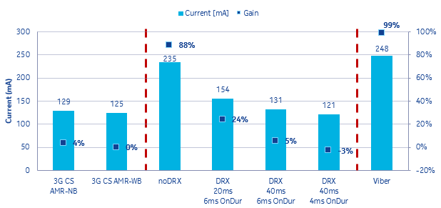
Figure 157: VoLTE Battery Power Consumption
Figure 158 illustrates the impact of DRX upon VoLTE call drop rate for a range of UE models (DRX has a similar impact upon data connections). In general, enabling DRX tends to increase the connection drop rate by a small percentage. The majority of operators accept this increase as a trade-off between UE battery power consumption and drop ratio.
Figure 158: VoLTE Drop Ratio with and without DRX
Figure 159 illustrates an example of the percentage of VoLTE calls using SRVCC. In this example, the percentage of VoLTE calls using SRVCC has decreased over time as the 4G site density has increased and coverage has improved. The percentage can also be affected by changes to the triggering threshold. Triggering early will tend to increase the number of SRVCC procedures but will often improve the success rate. Triggering early may need to be avoided if alerting phase SRVCC is not supported in the core network.
Figure 159: Percentage of VoLTE calls using SRVCC
Figure 160 illustrates an example of the percentage of dropped calls which are caused by alerting phase SRVCC not being supported by the core network. In this case, the percentage of alerting phase drops represents a significant proportion of the total drops. Removing these drops would make the VoLTE drop rate comparable to the 3G circuit switched speech call drop rate.
Figure 160: VoLTE Drops caused by SRVCC during Alerting Phase
Figure 161 illustrates some drive test results which quantify the benefit of using TTI Bundling. TTI Bundling allows speech quality to be maintained at an RSRP which is 2.5 dB weaker than when the feature is disabled, i.e. the uplink link budget is improved by 2.5 dB. TTI Bundling can also help to reduce the PDCCH load.
Figure 161: VoLTE benefit of TTI Bundling

Massive MIMO

Introduction
Active antenna arrays are used to provide an uplink and downlink beamforming capability. Directional and controllable beams are generated by applying phase shifts to the signal transmitted by each antenna element. These directional beams help to improve the signal to noise ratio and reduce intercell interference. Massive MIMO is not intended to increase the number of MIMO layers for an individual UE but can increase the total number of MIMO layers from a cell perspective. Massive MIMO provides support for multi-user MIMO which involves a group of UE sharing the same Resource Block allocation. Each UE has its own set of MIMO layers so the total number of layers can become relatively high, e.g. 8 UE using 2×2 MIMO and sharing the same set of Resource Blocks leads to a total of 16 layers.
In the case of TDD, Massive MIMO was introduced within the timescales of TL18. TDD uses active antenna which have up to 64 transceivers, i.e. 64T64R configurations with 128 antenna elements. TDD software supports both uplink and downlink multi-user MIMO. In the case of FDD, Massive MIMO was introduced within the timescales of FL18A. FDD currently uses active antenna with up to 16 transceivers i.e. 16T16R configurations. The FDD version of Massive MIMO does not support multi-user MIMO within the timescales of FL18A.
The LTE4265 feature presented in Table 188 is a pre-requisite for Massive MIMO on FDD. This feature provides the ability to generate 2 sectors using a single antenna panel. The general concept is illustrated in Figure 162. Each sector provides a separate logical cell with a separate PCI and separate Managed Objects within the databuild. This feature also introduces the FD CPRI interface between the AirScale System Module and the active antenna. This interface transfers data between the upper part of L1 which is located within the System Module and the lower part of L1 which is located within the active antenna.
Feature Id | Feature Name | Available Since | Application or Basic Software
LTE4265 | Split L1 with fixed beam sectorization for 16TRX FDD mMIMO | FL18A | ASW
Table 188: Feature providing Fixed Beam Sectorisation for 16T16R
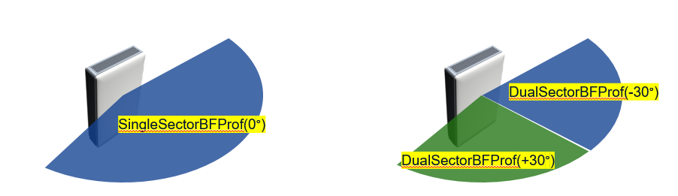
Figure 162: Creating 2 sectors from single antenna panel with LTE4265
Moving the lower part of L1 to the active antenna helps to reduce the bandwidth requirement for the fronthaul transport connection. It also helps to reduce the AirScale processing requirement but increases the active antenna processing requirement. The implementation of beamforming with LTE4265 is categorised as ‘fixed’ beamforming because 2 fixed beams are generated. These beams do not track UE mobility but are fixed to provide wide area coverage for 2 cells.
In terms of active antenna hardware, both the AAFIA and AAFIB antenna panels are supported. These panels are presented in Table 189 and each supports 16 transceivers. The AAFIA arranges the transceivers in a 1 row of 8, whereas the AAFIB arranges the transceivers in 2 rows of 4. LTE4265 does not use the 2 rows for vertical beamforming but arranging the antenna elements in 2 rows allows the antenna to be more compact.
Feature Id | Feature Name | Available Since | Application or Basic Software
LTE4529 | AirScale Dual MAA 16T16R B25/66 200W AAFIA | FL18A | BSW
LTE4607 | AirScale MAA 16T16R B25/66 200W AAFIB | FL18A | BSW
Table 189: Feature providing Fixed Beam Sectorisation for 16T16R
The primary Massive MIMO feature for FL18A is LTE4300 which provides UE Specific Beamforming (USBF) based on UE feedback. This feature (presented inTable 190)) uses Transmission Mode 9 (TM9) which is supported from 3GPP release 10, i.e. UE need to be release 10 or newer and support TM9. The feature supports up to 2 MIMO layers so dual stream transmission with beamforming is supported.
Feature Id | Feature Name | Available Since | Application or Basic Software
LTE4300 | 16TRX FDD mMIMO: DL USBF based on UE feedback | FL18A | ASW
Table 190: Feature providing UE specific Beamforming for FDD Massive MIMO
Within the timescales of FL18A, UE Specific Beamforming requires the use of the AAFIA active antenna (single row of 8 cross polar antenna elements). Support for the AAFIB active antenna (2 rows of 4 cross polar antenna elements) is planned for FL19.

Performance Analysis
The primary objective of Massive MIMO is to improve uplink and downlink spectral efficiency and so improve the uplink and downlink cell throughputs which can be achieved from a specific channel bandwidth. The metrics presented in sections 6.9 and 6.11 should be used to quantify the throughput benefits of Massive MIMO. The following KPI can be used to quantify improvements in spectral efficiency. The ‘180’ factor within these equations corresponds to the bandwidth of a single PRB (180 kHz)

LTE_5748a UL Spectral Efficiency
8 * SUM(PDCP_SDU_VOL_UL) / SUM(PRB_USED_PUSCH) / 180

LTE_5747a DL Spectral Efficiency
8 * SUM(PDCP_SDU_VOL_DL) / SUM(PRB_USED_PDSCH) / 180

Parameter Definition
The main two parameters associated with LTE4265 are presented in Table 191. It is mandatory to configure the actMMimo parameter to ‘true’ when connecting the AirScale System Module to an active antenna capable of supporting Massive MIMO. The mMimoHorizontalSectorBFProf parameter allows the selection between 1 or 2 sectors. In the case of 2 sectors, this cell level parameter also allows the selection between the -30 degree azimuth and +30 degree azimuth, i.e. each of the 2 cells should be configured with a different azimuth.
Parameter | Object | Range | Default | Recommended
actMMimo | LNCEL_FDD | false (0), true (1) | false (0) | true (1)
mMimoHorizontalSectorBFProf | LNCEL_FDD | 10: SingleSectorBFProf(0 degree)  11: DualSectorBFProf(-30 degree)  12: DualSectorBFProf(+30 degree)
Table 191: Parameters associated with Fixed Beam Sectorisation for 16T16R
The key parameters associated with the UE Specific Beamforming feature are presented in Table 192. Many of these parameters are associated with the CSI Reference Signal and CSI Reporting. Massive MIMO for FDD uses the CSI Reference signal and CSI reporting as a substitute for channel reciprocity. The eNodeB transmits the CSI Reference Signal from up to 8 antenna elements. The CSI Reference Signal is not beamformed so it allows the UE to measure the actual propagation channel. The UE uses these measurements to provide feedback regarding a preferred fixed beam position. The set of fixed beam positions are standardised by 3GPP. When using rank 1 or rank 2, there are 32 beams from which the UE can select. This represents a significant difference between Massive MIMO in FL18A using TM9 and Massive MIMO in TL18 using TM8. In the TDD case, the beamforming weights are generated dynamically within the System Module based upon SRS measurements and the beams track the UE mobility, i.e. the beams follow a UE around the cell. In the FDD case, the beamforming weights are fixed within the active antenna and do not change the beam direction as a function of time. The UE switches from one beam to another beam as it moves around the cell.

Parameter | Object | Range | Default | Recommended
dlMimoMode | LNCEL_FDD | 0: SingleTX  10: TXDiv  11: 4-way TXDiv  30: Dynamic Open Loop MIMO  40: Closed Loop Mimo  41: Closed Loop MIMO (4x2)  42: Closed Loop MIMO (8x2)  43: Closed Loop MIMO (4x4)  44: Closed Loop MIMO (8x4) | 10: TXDiv | 44: Closed Loop MIMO (8x4)
csiRepSubmode | LNCEL_FDD | submode1 (1), submode2 (2) | - | submode1 (1)
activatedMimoTM | LNCEL_FDD | TM4 (4), TM9 (9), TM9_maxLayer (10) | - | TM9 (9)
csiRsResourceConf | LNCEL_FDD | rsc0 (0), rsc1 (1), rsc2 (2), rsc3 (3), rsc4 (4), rsc5 (5), rsc6 (6), rsc7 (7), rsc8 (8), rsc9 (9) | - | Planning Value
csiRsSubfrConf | LNCEL_FDD | 3...154, step 1 | 19 | 19
numOfCsiRsAntennaPorts | LNCEL_FDD | 4, 8 | 4 | 8
actCsiRsSubFNonTM9Sch | LNCEL | 0 (false), 1 (true) | 0 (false), | 0 (false),
cqiAperMode | LNCEL | 0:FBT1; 1:FBT2 | 1:FBT2 | 1:FBT2
periodicCqiFeedbackType | LNCEL | wideband (0), UE_selected (1) | wideband (0) | wideband (0)
Table 192: Parameters associated with UE Specific Beamforming based on UE Feedback

The csiRsResourceConf parameter presented in Table 192 is a planning parameter. This parameter can be used to ensure that neighbouring cells allocate different Resource Elements to the CSI Reference Signal. Figure 163 illustrates the set of 5 CSI Reference Signal configurations which are applicable when 8 antenna ports are configured. In this figure, the numerical values represent the antenna ports, i.e. ranging from 0 to 7, while the colours differentiate the set of 5 configurations. Allocating different configurations to neighbouring cells ensures that the CSI Reference Signals do not interfere with each other.
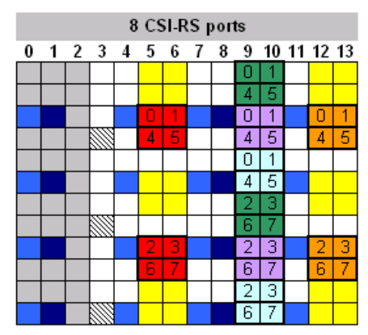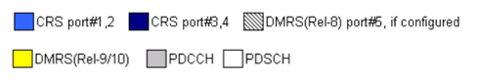
Figure 163: Set of 5 CSI Reference Signal configurations applicable to 8 ports

Some aspects of TM9 limit the capacity benefit which can be achieved. The CSI Reference Signal generates a significant overhead towards the PDSCH. It is a wideband Reference Signal so it is transmitted across the complete channel bandwidth. It has a configurable periodicity to help manage the overhead. Devices which are older than release 10, cannot be configured with TM9 nor with the CSI Reference Signal. The CSI Reference Signal punctures the downlink data transmitted towards those non-TM9 UE, i.e. some of the Resource Elements within which the UE expects to receive its PDSCH are actually CSI Reference Signals. The impact of the CSI Reference Signal upon non-TM9 devices can be managed using the actCsiRsSubFNonTM9Sch parameter. This parameter can be used to determine whether or not non-TM9 UE are allocated resources during subframes which contain the CSI Reference Signal. This avoids the puncturing issue but restricts the number of subframes available to non-TM9 devices.

Simulation Results
Figure 164 illustrates throughput distributions to compare the throughput performance of TM4 and TM9. These graphs illustrate that TM4 performs better than TM9 when coverage conditions are good. In this case, TM9 throughputs are restricted by the CSI Reference Signal and Demodulation Reference Signal overheads. TM9 provides better performance at locations with weak coverage where the link budget benefits from the increased antenna gain provided by beamforming.
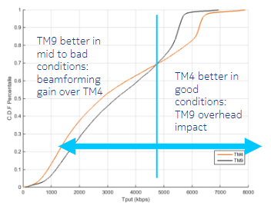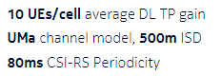
Figure 164: Throughput distributions for TM4 and TM9
Figure 165 compares the throughputs achieved by TM4 and TM9 as an average across the cell area and towards cell edge. TM9 provides only a small improvement in average cell throughput but provides a significant improvement in cell edge performance.
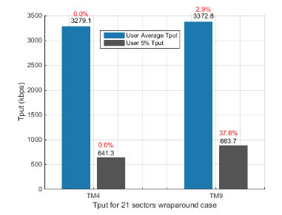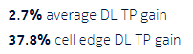
Figure 165: TM4 and TM9 Throughputs for average and cell edge radio conditions
It is expected that the performance benefits of Massive MIMO for FDD will improve once Multi-User MIMO is supported. This is planned for the LTE19 software release

4G-5G Interworking

Introduction
Interworking between 4G and non-standalone 5G began from LTE18A. Supported features cover areas such as 5G bearer support, call establishment and mobility.

Guidelines
5G guidelines, including 4G-5G interworking support are stored at the 5G NPO Radio Wiki page.

License Assisted Access

Introduction
Licence-Assisted Access (LAA) utilises supplemental downlink carriers in unlicensed spectrum in the 5GHz band. It is theoretically possible to support up to 7 LAA Scells, thus offering very high downlink data rates. Interference coordination with other systems, e.g. WiFi, that may be present in the allocated channels is implemented in Nokia products.

Guidelines
LAA topics are stored on the LTE Radio Wiki Small Cells page.

Minimisation of Drive Testing

Introduction
Minimisation of Drive Testing (MDT) is a solution for collecting data from the population of mobile subscribers. UE are requested to provide measurement reports which reflect the UE perspective of network performance. This offers benefits over traditional drive testing solutions: it is significantly less expensive than drive testing and it reflects the experience of real subscribers at real locations, rather than a test device along a specific drive route.
There are two general categories of MDT: Immediate MDT and Logged MDT. Immediate MDT refers to the UE completing its measurements while in RRC Connected Mode. These measurements are reported to the network immediately after they have been recorded. Logged MDT refers to the UE completing its measurements while in RRC Idle Mode. The UE stores these measurements and reports them to the network at a later time, i.e. after entering RRC Connected Mode.
Figure 166 illustrates example RSRP and RSRQ plots from MDT. These allow the coverage to be evaluated in terms of both signal strength and quality. They can be used to help evaluate the requirement for RSRQ mobility and also to configure mobility thresholds. This type of plot is also useful in terms of identifying the location of the traffic. This is critical information when deploying small cells and attempting to determine the best site locations.
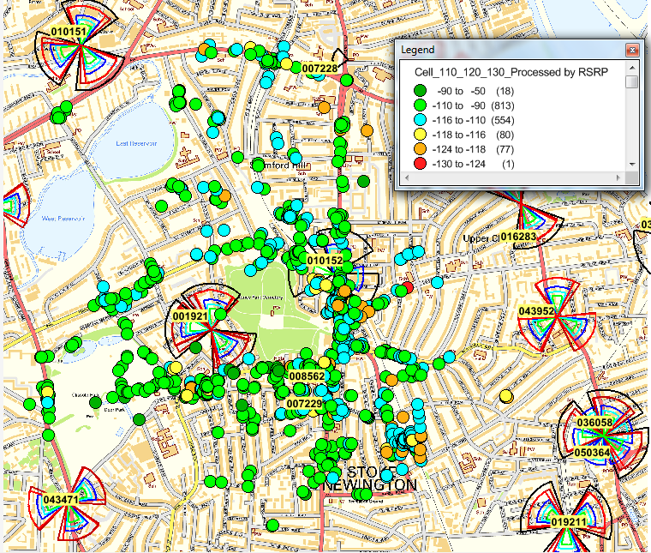
Figure 166: RSRP and RSRQ plots from MDT
Both Logged and Immediate MDT can be activated from NetAct TraceViewer. It is possible to configure the system to only record measurements from UE which have a GPS capability. Even when this option is selected, a large percentage of the measurements will not have GPS coordinates, i.e. devices have not managed to achieve a GPS lock at the time of the measurements. These measurements can be filtered off when plotting on a map. Alternatively, it may not be necessary to have GPS for the analysis. The measurements can be used to generate cell level distributions of RSRP and RSRQ.
When completing focused analysis on a small number of cells then it is practical to export the data from the TraceViewer application. The exported data must be parsed to extract the measurements and GPS coordinates. When completing a large scale analysis then it is no longer practical to export from TraceViewer. In that case, the preferred solution is to extract the data Megaplexer and it can be post processed using AVA.
The feature set associated with MDT is presented in Table 193. The first version of MDT relied upon configuring the UE with periodic measurements and capturing those measurements within the TraceViewer application, i.e. Immediate MDT. The FL15A feature introduced Logged MDT allowing measurements to be recorded while UE are in RRC Idle Mode. FL16 introduced the capability to capture GPS information. It also provided options regarding user consent and anonymization of the recorded data.
Id | Name | Software Release
LTE678 | MDT (Minimization of Drive Testing) | RL30
LTE1308 | MDT – UE Measurement Logs | FL15A
LTE1049 | MDT Cell Trace Enhancements | FL16
LTE953 | MDT – UE Radio Link Failure Report Evaluation | FL16A
Table 193: Features associated with Minimisation of Drive Testing (MDT)
The FL16A feature extended the scope of MDT to include Radio Link Failure information. This refers to the UE reporting information about dropped calls. The information reported can include: the serving cell PCI at the time of the drop, serving cell and neighbouring cell Reference Signal measurements, location, category of drop and cause of radio link failure.

Use Cases
The set of use cases associated with MDT include:
- evaluating the user experience of RSRP and RSRQ across the network. This can be studied for each network layer
- identify locations with poor RSRP or RSRQ for subsequent optimisation
- identifying hotspot locations to support the introduction of small cells, or other capacity upgrade solutions
- identifying locations with high radio link failures, and categorising the failure mechanisms for subsequent optimisation
- generating cell level distributions of RSRP and RSRQ for each network layer

Internet of Things (IoT)

Introduction
3GPP has introduced 3 solutions to serve the Internet of Things (IoT) market:
- EC-GSM: 2G solution introduced with Nokia GSM17
- LTE-M: 4G solution introduced with Nokia FDD-FL17A
- NB-IoT: 4G solution introduced with Nokia FDD-FL17A
All three solutions focus upon supporting large numbers of low cost devices. These devices typically support low throughput and non-time sensitive applications. Activity factors may be very low, e.g. one small data transfer per day, allowing a battery life in the order of 10 years. All IoT solutions are capable to providing deep indoor coverage. This is largely achieved by using repetitions to increase the probability of successful reception.
There are also non-3GPP solutions serving the IoT market, e.g. SigFox and LoRa. These solutions were developed in advance of the 3GPP solutions, providing a rapid time-to-market for operators wishing to have an early IoT network deployment. Nokia does not produce SigFox nor LoRa products but offers planning and dimensioning services to support these technologies.

Guidelines
The optimisation of IoT solutions is outside the scope of this document. Documentation dedicated to the various IoT solutions is available from the NPO Mobile Radio Community, IoT Wiki pages which can be found at this link.
The LTE Capacity Solutions Guidelines [2] includes a section to describe the impact of enabling LTE-M or NB-IoT upon the capacity of the legacy LTE network.

