SIUs 02/TCU 02 are the cornerstones of the RBS site in a newly deployed or migrated mobile IP RAN network
It provides a common interface between RBS (GSM, WCDMA, CDMA, LTE, single or multiple standards, legacy or third-party equipment) and IP/Ethernet over IP over E1/T1 transport networks.
The SIU 02/TCU 02 can act as a bridge or router, as needed. Multiple bridge and routing instances can be configured at the same time.
It makes it easy to migrate from legacy transport (i.e., E1/T1) to next-generation high-speed transport (Ethernet), while reducing operational expenses through shared transport for 2G, 3G, and 4G radio standards.
The SIU 02/TCU 02 is an integral part of the multi-standard RBS 6000 (GSM/WCDMA/LTE). Bandwidth is dynamically shared across all radio technologies, optimizing maximum capacity for HSPA and LTE services.
SIU 02/TCU 02 provides dynamic aggregation of the radio access network (RAN) and site traffic flows:
ϖ Ericsson GSM Abis Packet over IP Traffic.
ϖ WCDMA NodeB lub over IP traffic.
ϖ LTE eNodeB IP traffic (S1, X1).
ϖ Legacy RBS TDM traffic via Circuit Emulation Services (CES).
ϖ CDMA.
ϖ IP traffic from other computers on the RBS site.
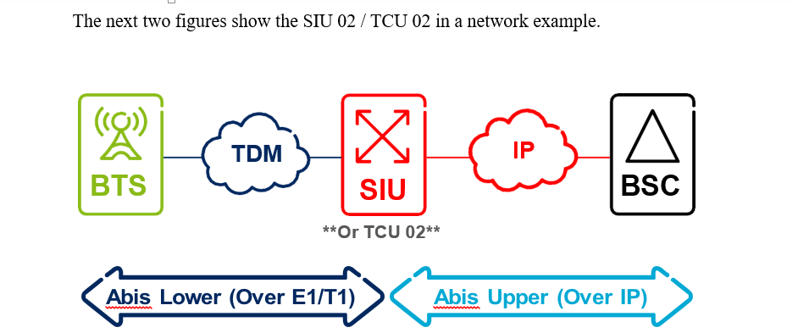
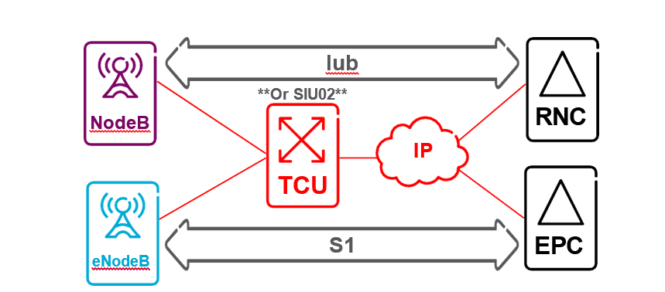
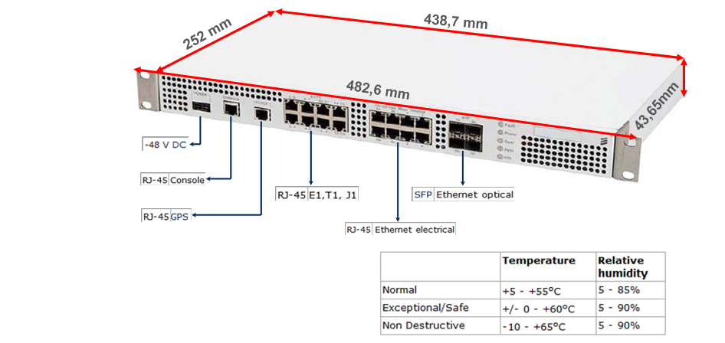
The CONSOLE interface (Ethernet 10Base-T/100Base-TX) is used for the connection of a Local Maintenance Terminal (LMT). Connector type: RJ-45. The connector has built-in LED indicators. The indicator on the right lights up when a link is established and flashes during activity.
The CLOCK interface includes the clock input and output interfaces. Both interfaces use 1PPS signals with RS-422 electrical levels. Connector type: Modular 10/10.
The SIU 02 has eight connectors for all sixteen E1/T1 transmission interfaces. Each connector supports two E1 or T1 transmission interfaces. E1 2048 kBps 120 Ω and T1 1544 kBps 100 Ω interfaces are supported. E1 2048 kBps 75 ohm is achieved by adding 120/75 ohm balunes. Connector type: RJ-45. The E1/T1 connectors have two built-in LED indicators, one for each interface. The indicator lights up when the transmission path is running (no signal loss (LOS) or frame alignment loss (LOF) is detected).

Eight 10/100/1000 Mbps Ethernet connector positions (numbered 0 through 7) are available for Ethernet interfaces. Connector type: RJ-45. The connectors marked 0a, 1a, 2a, and 3a are connected to the corresponding SFP connectors (marked 0b, 1b, 2b, and 3b). Combined interfaces allow Ethernet or SFP to be used at the same time, and which one is used is determined by your configuration. The Ethernet connectors have two built-in LED indicators. The indicator on the left lights up when a link is established and the indicator on the right flashes during the activity.
Four 100/1000 Mbps SFP (Small Pluggable Form Factor) connector positions are available (numbered 0 through 3). The 0b, 1b, 2b, and 3b marks indicate which Ethernet connector (0a, 1a, 2a, and 3a) you are connected to.
Combined interfaces allow SFP or Ethernet to be used at the same time, and which one is used is determined by your configuration.
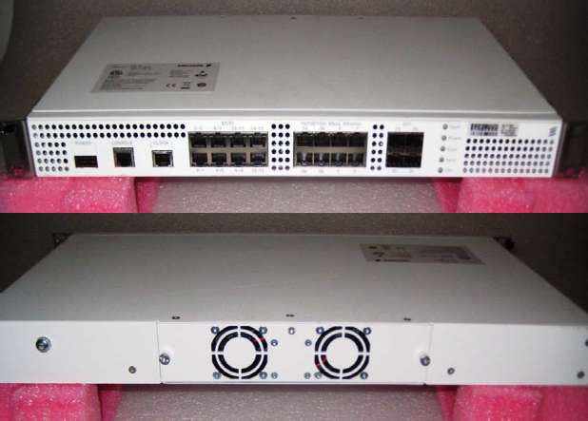
The IUS 02 has a ventilation module with two supervised fans at the back of the unit. If one fan fails, the remaining fan is throttled and an alarm is sent to the OSS. Defective fan modules can be replaced during planned maintenance without interrupting operation.

TCU
The TCU 02 has a PWR port, with -48 VDC and follows the same instructions as the SIU 02 power port. The TCU 02 has a SYNCH port. This port follows the same instructions as the SIU 02 CLOCK port. The TCU 02 has an LMT port, which is used to connect any laptop/computer for local access. This port follows the same instructions for the SIU 02 CONSOLE port. The TCU 02 has 4 E1/T1 ports, called ET_A to ET_D. These ports follow the same instructions for the 02 E1/T1 SIU ports. The TCU 02 has 4 Ethernet ports, called TN_A to TN_D. These ports follow the same instructions for the Ethernet SIU 02 ports. The TCU 02 has 4 SFP ports, called TN_E to TN_H. These ports follow the same instructions for SFP SIU 02 ports. The ports and indicators can be seen in the figure below.
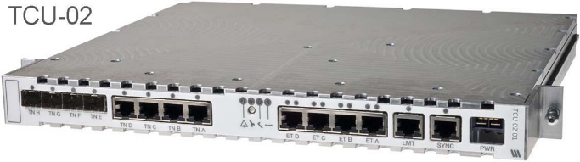
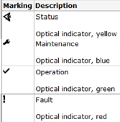

Abis over IP

The Packet Abis over IP function is used for transmission between BSC and BTS, instead of a dedicated Time Division Multiplexing (TDM) network (E1/T1-based transmission). Compared to TDM networks, Packet Abis over IP provides significantly higher throughput per bandwidth resource, as it uses the same packet frame as the Packet Abis over TDM feature. Bandwidth is used more efficiently by allowing signaling, speech, and data to share the same broadband connection. Transmission capacity is used as a pool of resources, and it is also possible to share transport with other services (such as 3G) when using Packet Abis over IP.
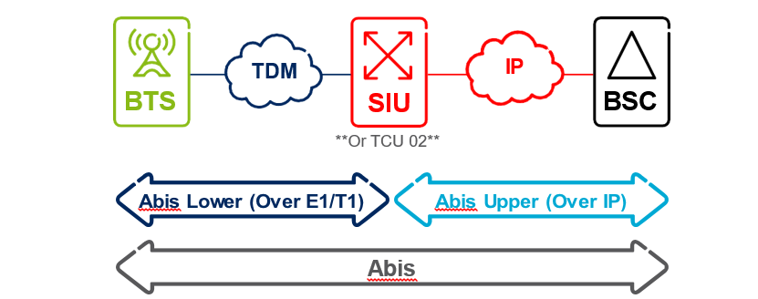
PTP Frequency Synchronization provides the synchronized client portion on the 02/TCU 02 SIU. When PTP is used over UDP, the synchronized client initiates an association with the PTP master by requesting unicast message subscriptions. When the subscription has been granted, the PTP master begins sending synchronization messages.
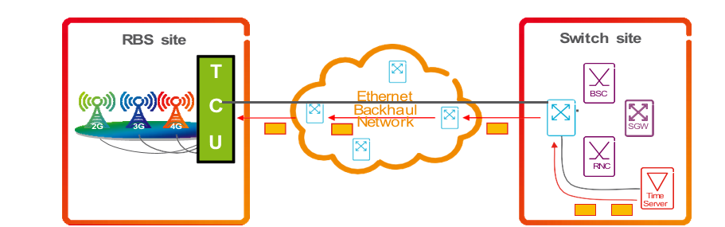

SIU 02 / TCU 02 Local Connection
The SIU 02 / TCU 02 local connection procedure is very simple. To connect a laptop/computer to SIU 02/TCU 02, locate the console port to SIU 02 or LMT (TCU 02) and plug in the Ethernet cable. Configure the laptop/computer with an IP that belongs to the 192.168.1.0/24 subnet. The laptop/computer will need an SSH or TELNET client to connect to the 02/TCU 02 SIU. See the figure below for more details.
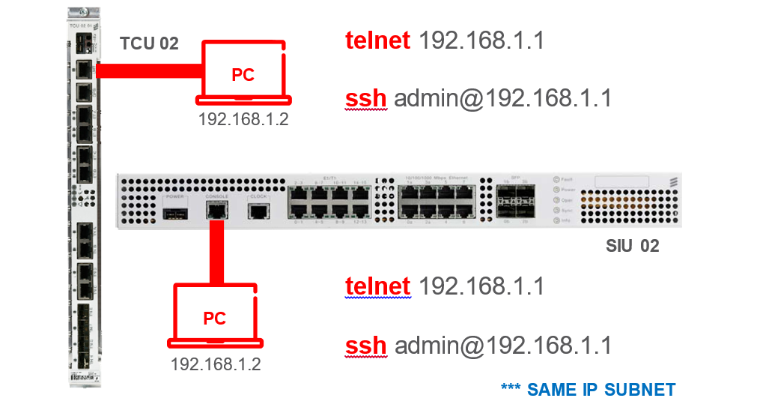

This command displays the card data
CO6733_SIU-OSmon> getmoattribute STN=0,Equipment=0

This command displays the version of the Integration Reference Point (IRP) that is currently in use and a list of supported IRP versions.
CO6733_SIU-OSmon> getirpversion

This command displays the current status of the E1T1 (GSM) port.
CO6733_SIU-OSmon> getmoattribute STN=0,E1T1Interface=0

This command displays the current status of the electrical port.
CO6733_SIU-OSmon> getmoattribute STN=0,EthernetInterface=0

This command displays the temperature of the SIU/TCU
CO6733_SIU-OSmon> gettemperature

This command shows the services that are integrated into the card
CO6733_SIU-OSmon> showInterfaceMapping

This command displays the arp table
CO6733_SIU-OSmon> showmacfwtable all

This command displays the OAM IP, which is the management IP (VLAN, SIU, OAM)
CO6733_SIU-OSmon>getmoattribute STN=0,IPInterface=INT_OAM;

This command displays the PTP IP, which is the synchronization IP that comes from the 10.96.173.4 PBX
CO6733_SIU-OSmon>getmoattribute STN=0,Synchronization=0,TimeServer=Time_Server_1

This command shows the PGW ip 10.21.38.3
CO6733_SIU-OSmon>getmoattribute STN=0,TGTransport=all

This command shows the connectivity between CSR and SIU
CO6733_SIU-OSmon>Getneighbors

The correspondence of the three types of IP is checked with a:
CO6733_SIU-OSmon> ping 10.85.244.166

This command checks the time the synchrony expires
CO6733_SIU-OSmon> calexpdate

This command displays active alarms
CO6733_SIU-OSmon> getalarmlist

This command displays the alarm log
CO6733_SIU-OSmon> syslog read -s alarms

Change speed on a port:
starttransaction 1
setmoattribute 1 STN=0,EthernetInterface=2 mode AUTO
commit 1 forcedCommit
endtransaction 1

Change a port's service
startTransaction 1
setmoattribute 1 STN=0,EthernetInterface=6 portNumber 1
commit 1 forcedcommit
endTransaction 1

BACKUP
Start Session 1
backup 1 sftp://anonymous:123@IP DE LA PC/NL6704.xml -u
getsessionstatus 1
endsession 1

https://forms.office.com/Pages/ResponsePage.aspx?id=t3MfOZClrUOY8IsFCYrMyCk3PQSzTzVEhGUA8hdpfYtUQVNGUzIwVUdFTlRaTDhORjRNNzNMOExPOS4u

https://forms.office.com/Pages/ResponsePage.aspx?id=t3MfOZClrUOY8IsFCYrMyCk3PQSzTzVEhGUA8hdpfYtUOEVGV1ZDQzY3SDVNNkkxVzhBR1QwTEhWUC4u

