This picture shows where the BMC chip is located. The compartment can also have a sticker with firmware numbers on it. You need to remove the sticker after which you can flip open the containment unit. Just take the chip out, and insert it back again.
Please carefully take note of how the old chip was seated.
There is a small dot on one of the corners on top of the chip. You need to insert the new one exactly like the old one otherwise you would risk damaging the chip/board.
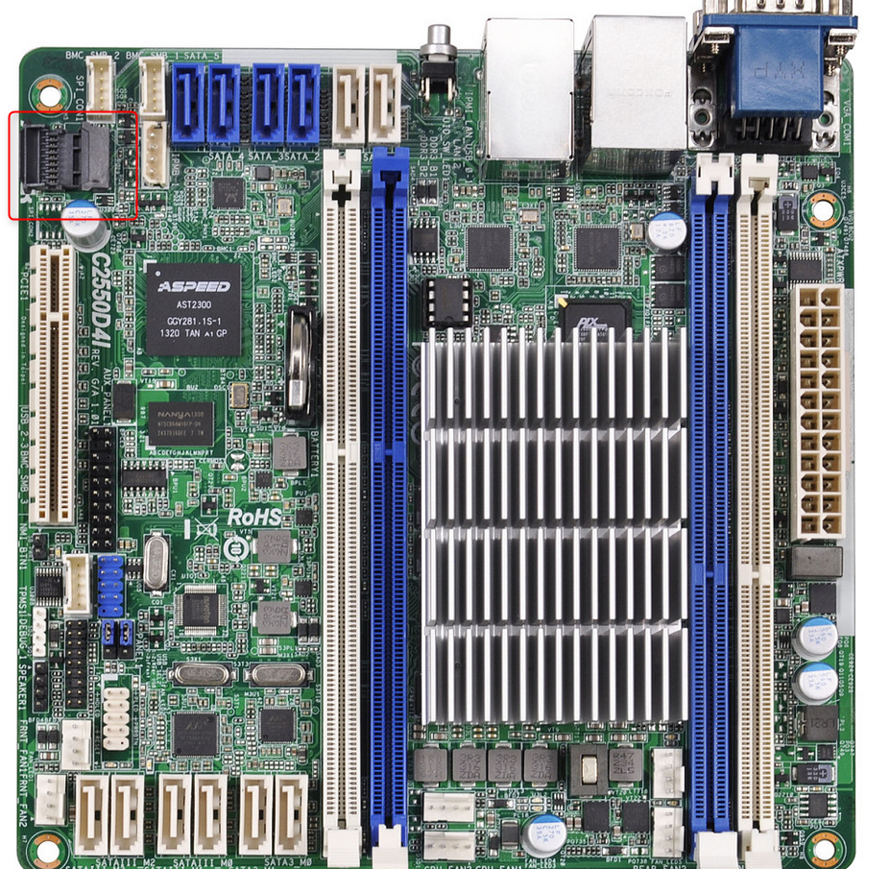
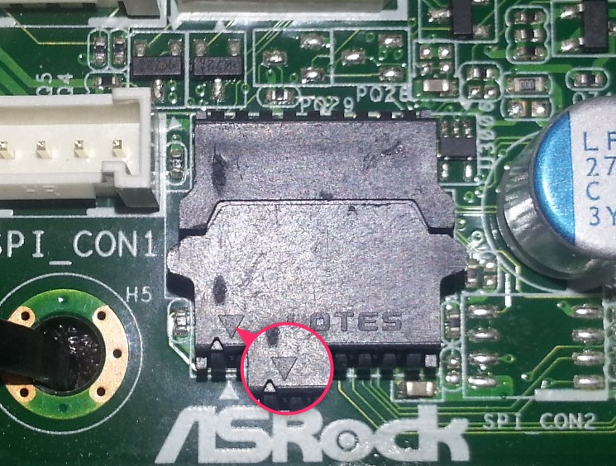
There is a small triangle on the Bmc chip compartment. This indicates pin no. 1 of the chip. The BMC chip itself has a small dot in one of the corners. This also indicates pin no. 1 of the chip.
When inserting the BMC chip the Dot on the chip must correspond with the position of the triangle. Otherwise the board will not work.
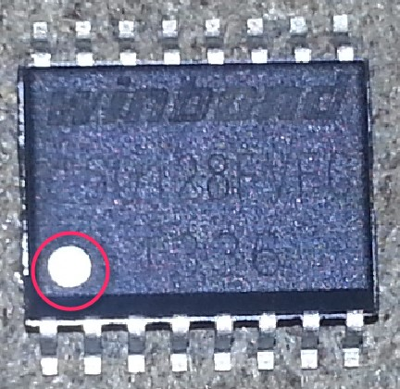

ASRockRack TSD

