When VSP send a Battery alert” periodic life is over”
That not mean don’t work anymore
Normal procedure is to extend the lift time for 360 day, as long the battery not in fail condition.

Procedure to extend the time
-----------------------------------------------------------------------------------------------
Start login to the SVP
Start The SVP Menu
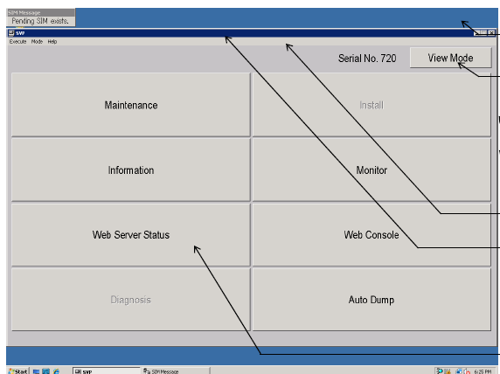
Change to Modify Mode
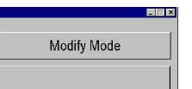
Select Install
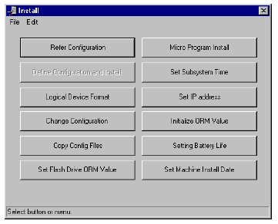
Select the “Sitting Battery Life”
Mark all the Battery
Select “Set”
Set the Remained Battery Life to 360
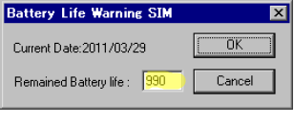
The press ok
Now the Lifetime is extended with 360 days, System will still monitoring the battery,

