Pre info.
- Batteries on HDS-VSP systems are only to be replaced when log files describe a defect battery unit.
HDS-VSP systems has a battery cycle monitoring feature, that recommend battery maintenance
after a predefined period.
Good practice is to extend this period in case there isn’t reported or logged any defect battery.

- Please follow this procedure to extend the battery lifetime.
- Procedure to extend the time

- Start login to the SVP menu
- Start The SVP Menu
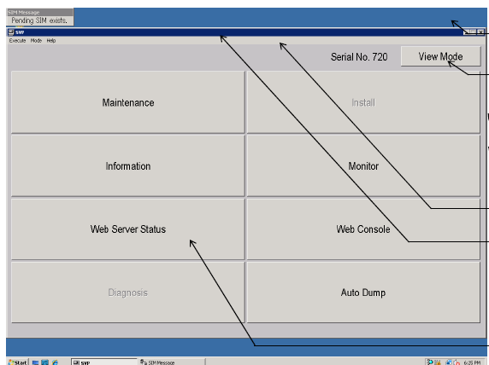

- Select ‘Modify Mode’
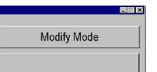

- Select Install
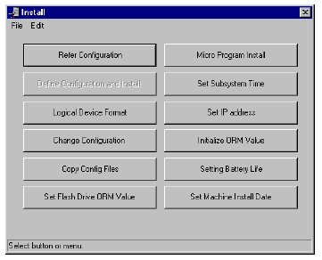
- Select the “Sitting Battery Life”

- Mark all the Battery
- Select “Set”

- Set the Remained Battery Life to 360 days
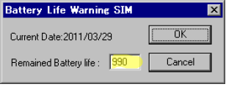

- The press ok
Now the Lifetime is extended with 360 days, System will still be monitoring the battery,

