Installing a FortiGate in NAT mode
Professional with more than 20 years of experience in the technical and commercial areas in various markets.

Installing FortiGate in NAT mode in just a few steps.

Connecting network devices
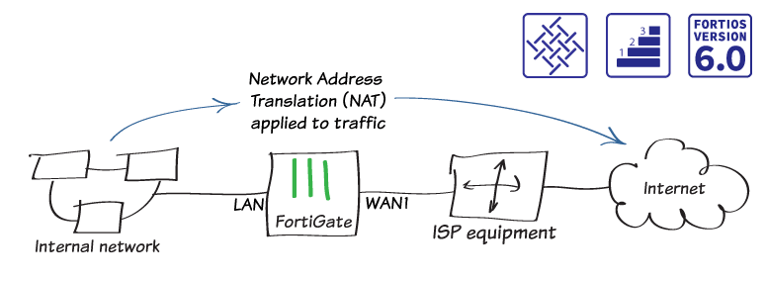Installing a FortiGate in NAT 5 mode

First, in this example you connect and configure a new FortiGate in NAT mode, in order to securely connect a private network to the Internet.
In NAT mode, you install as a gateway or router between two networks. Typically, you configure Firewall between a private network and the Internet, as it allows FortiGate to hide the IP addresses of the private network using NAT.
Consequently, NAT mode is the most used operational mode in implementations.

Configuring Interfaces on the FortiGate Firewall
- At first, to edit the internet-facing interface (wan1 in the example), go to Network > Interfaces.
- Second, set the estimated bandwidth for the interface based on your internet connection.
- Also, set the role to WAN.
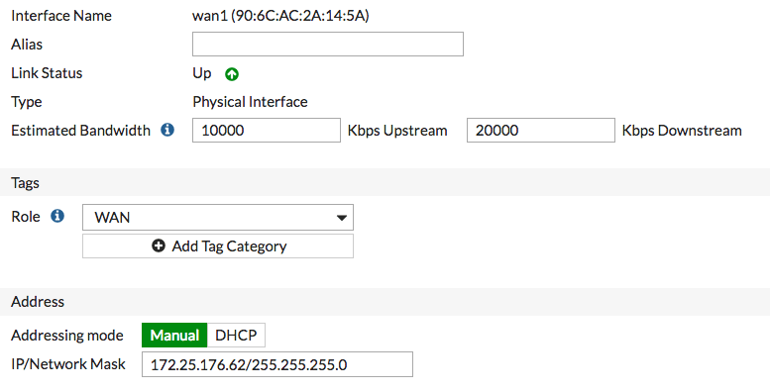Configuration Screen
- First of all, to determine which addressing mode to use, verify that your ISP provides an IP address for you to use, or that your ISP equipment uses DHCP to assign IP addresses.
  - Whereas if your ISP provides an IP address, set the addressing mode to Manual and set the netmask / IP to that IP address.
  - On the other hand, if your ISP equipment uses DHCP, set the Addressing mode to DHCP to allow the equipment to assign an IP address to WAN1.
- Edit the lan interface, which is called internal in some FortiGate models.
- Set the function to LAN.
- Set the Addressing mode to Manual and set the Netmask/IP to the private IP address you want to use for the FortiGate.
- Still, if you need to assign IP addresses to devices on your internal network, enable DHCP Server.
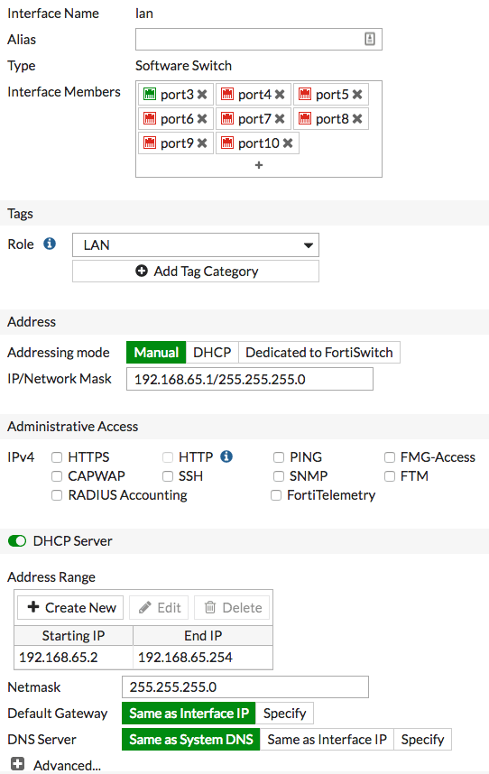Firewall Interface Screen

Adding a default route in FortiGate Firewall
- To create a new default route, go to Network > Static Routes. Typically, you only have one default route. If the static route list already contains a default route, you can edit it or delete the route and add a new one.
- Set Destination to Sub-Net and leave the destination IP address set to 0.0.0.0/0.0.0.0.
- Set Gateway to the IP address provided by your ISP and Interface to the web interface.
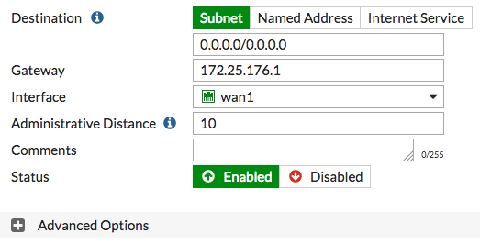Added Routes

